View and Manage accounts in RunOnweb

Go to runonweb.com

1. Introduction
In this tutorial, you will learn how to view and manage the accounting.

2. Go to purchase Menu
Go to the Purchase menu.
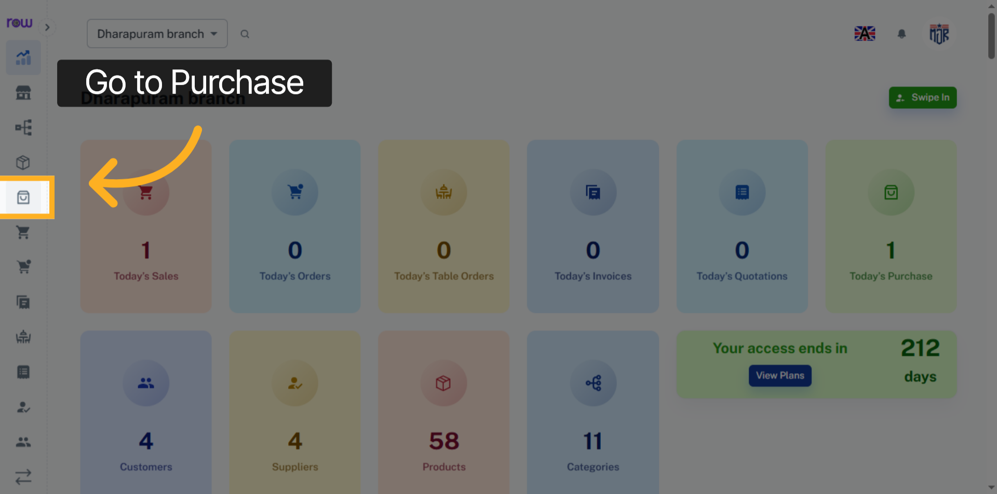

3. Purchase list Screen
You can view the purchases list after the purchase is successfully created.
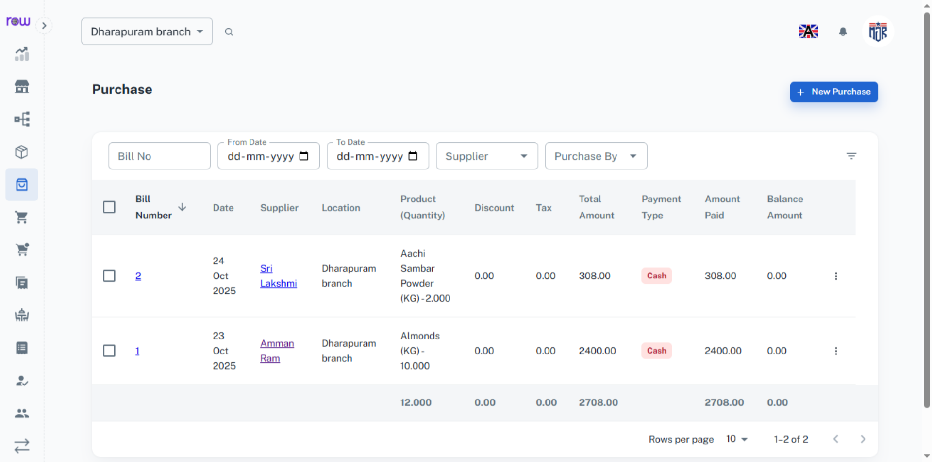

4. Go to sale Menu
Go to sale menu
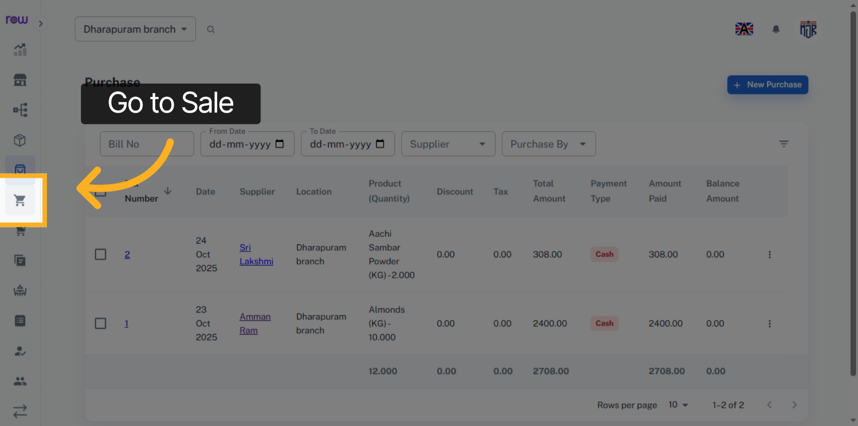

5. Sales list Screen
You can view the sales list after the sale is successfully created.
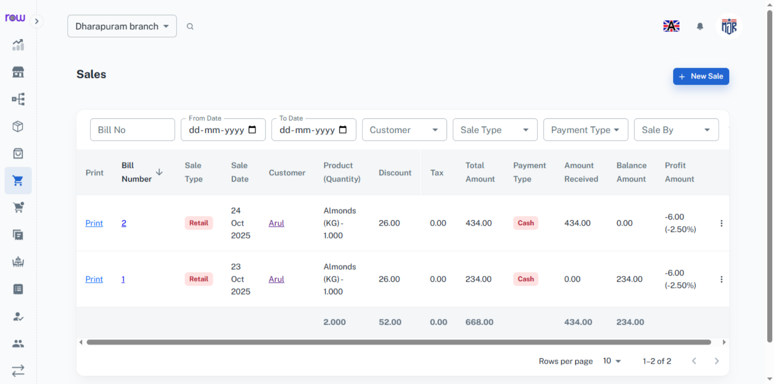

6. Go to Expense Menu
Go to Expense menu
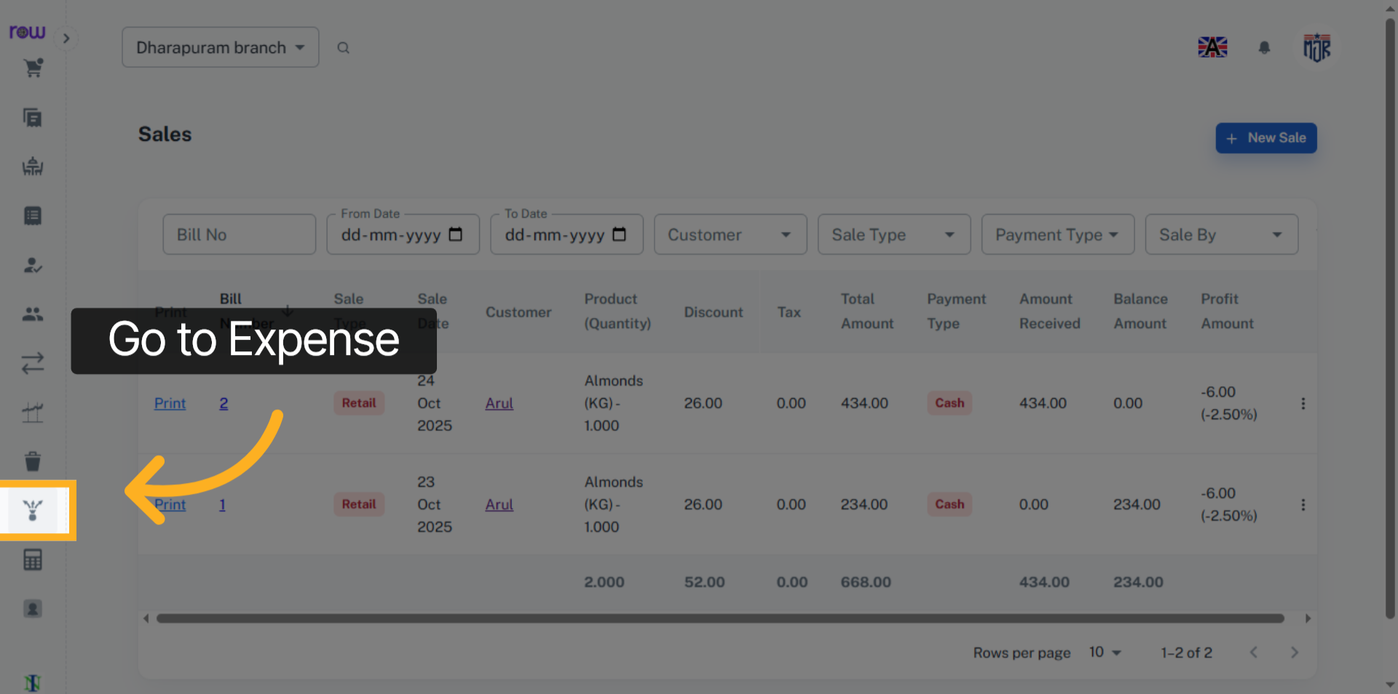

7. Expenses list Screen
You can view the expenses list after the expense is successfully created.
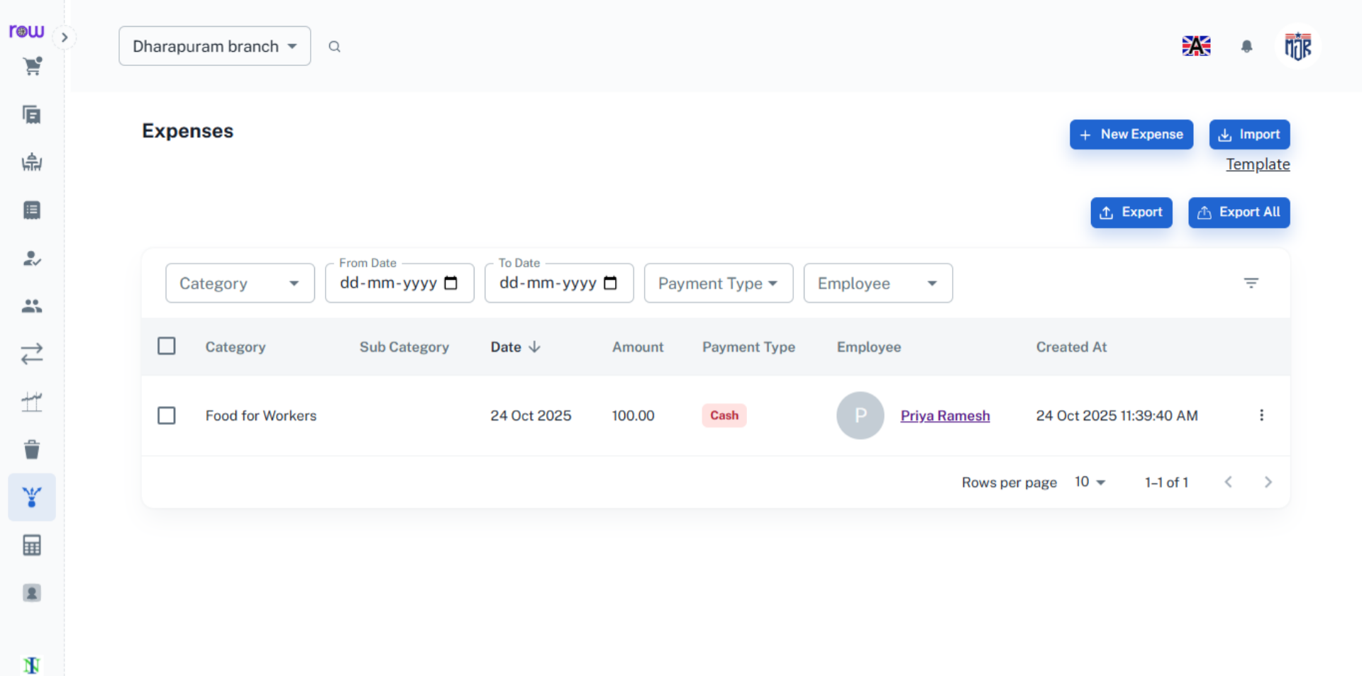

8. Open Accounts menu
Go to the Accounts menu.
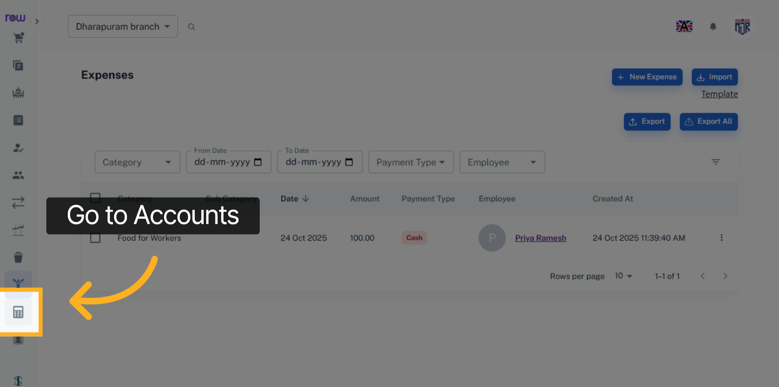

9. Accounts Screen
You can view the accounting reports such as Day Book, Ledger, Balance Sheet, Trial Balance, Profit and Loss and all other accounts in the accounts section.
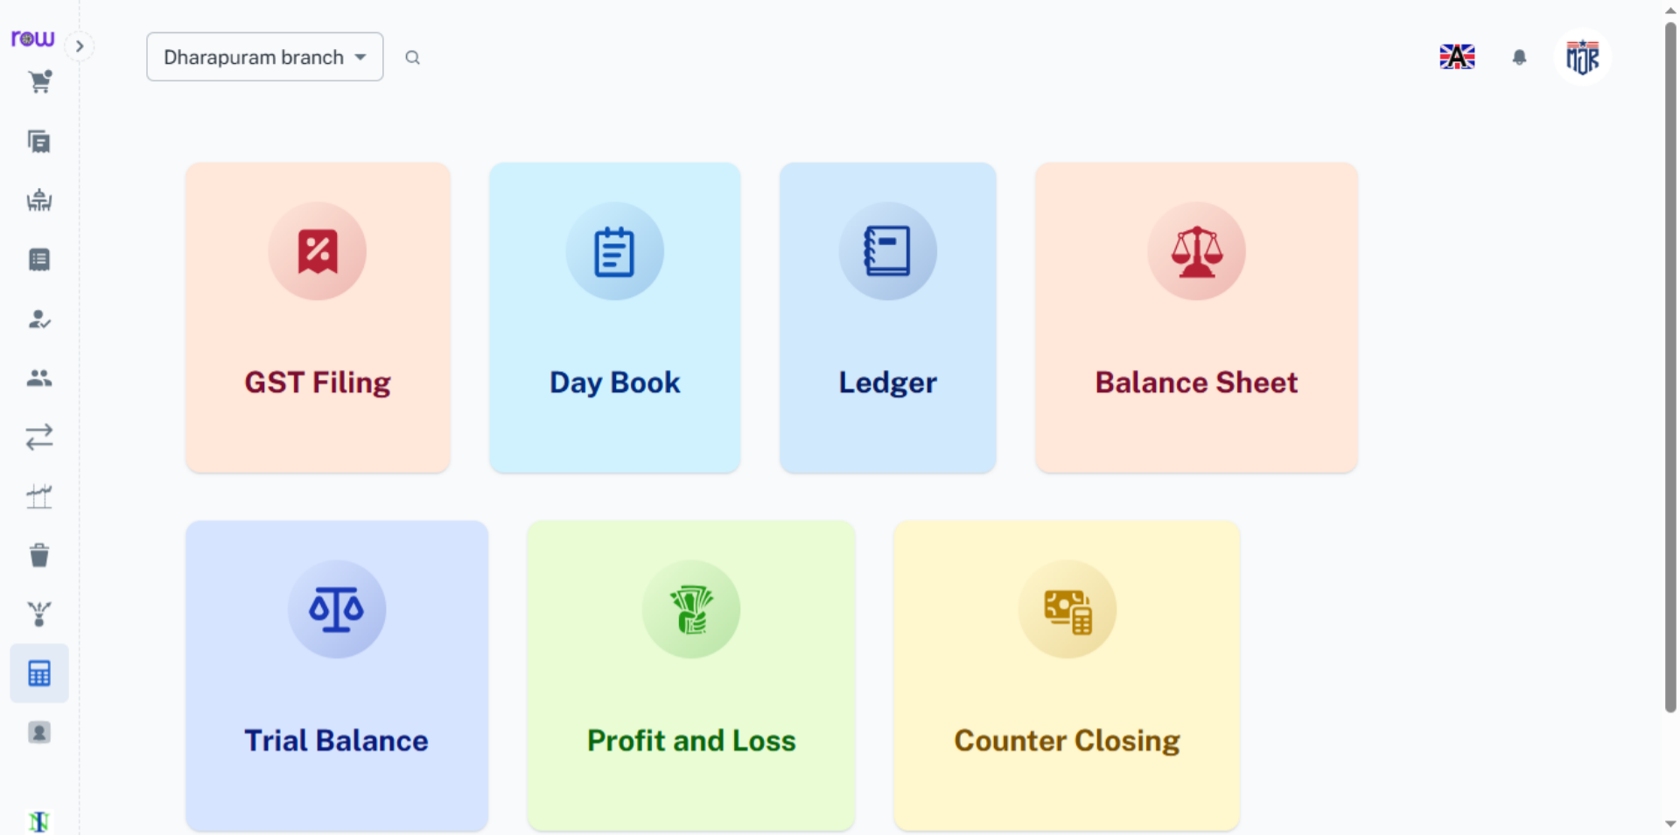

10. Day Book
The created purchases, sales, and expenses are recorded and reflected in the Day Book.
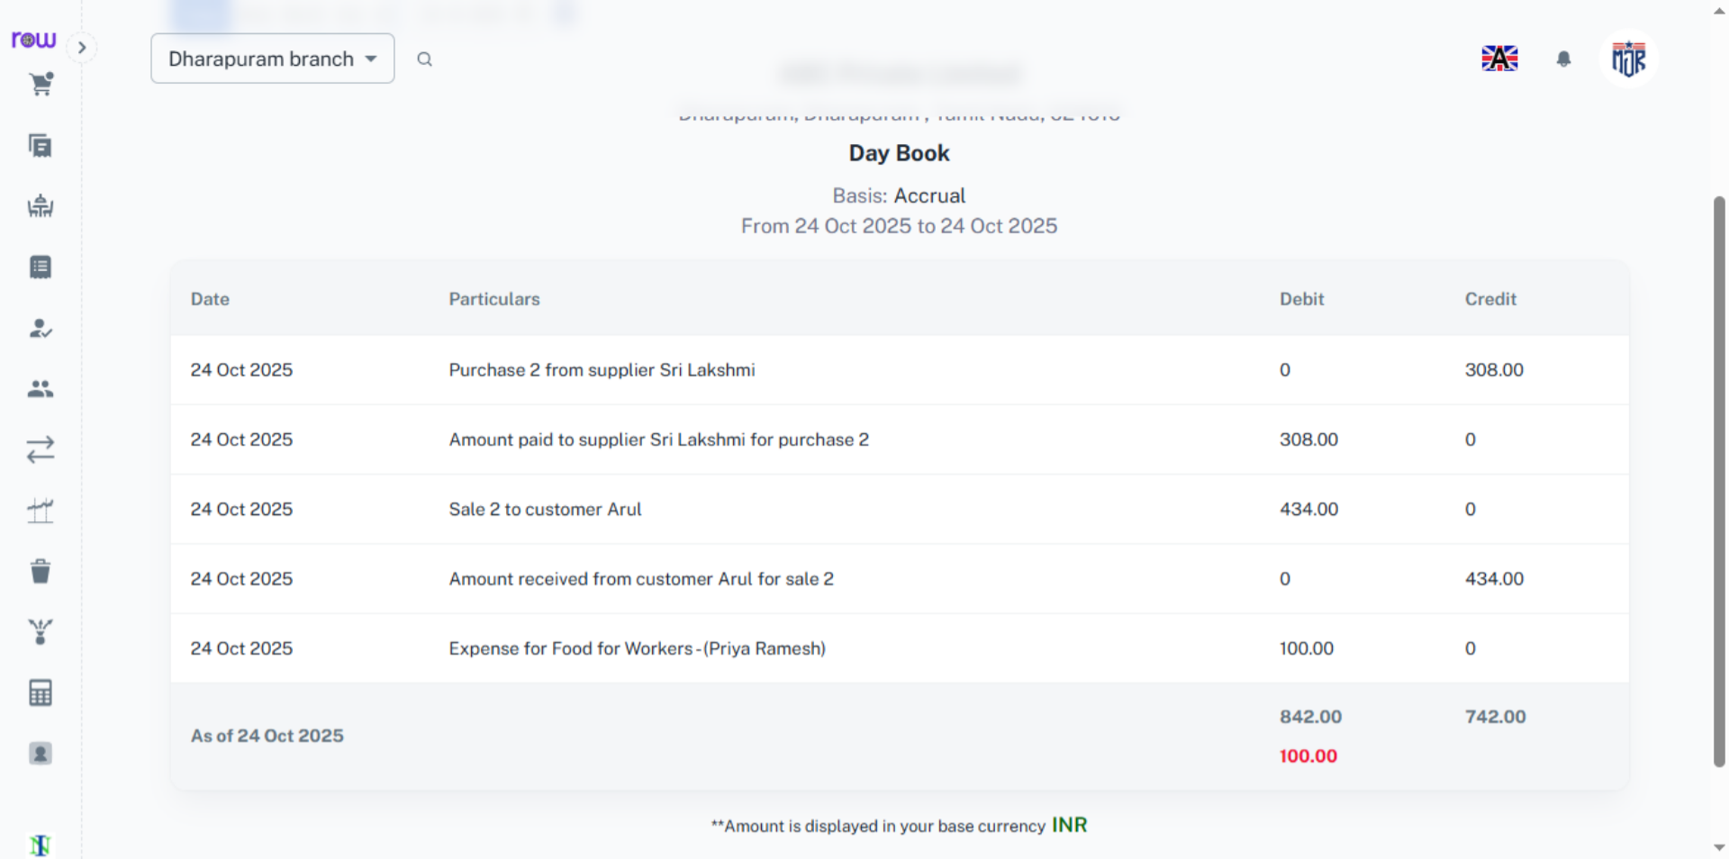

11. Ledger
The created purchases, sales, and expenses are recorded and reflected in the Ledger.
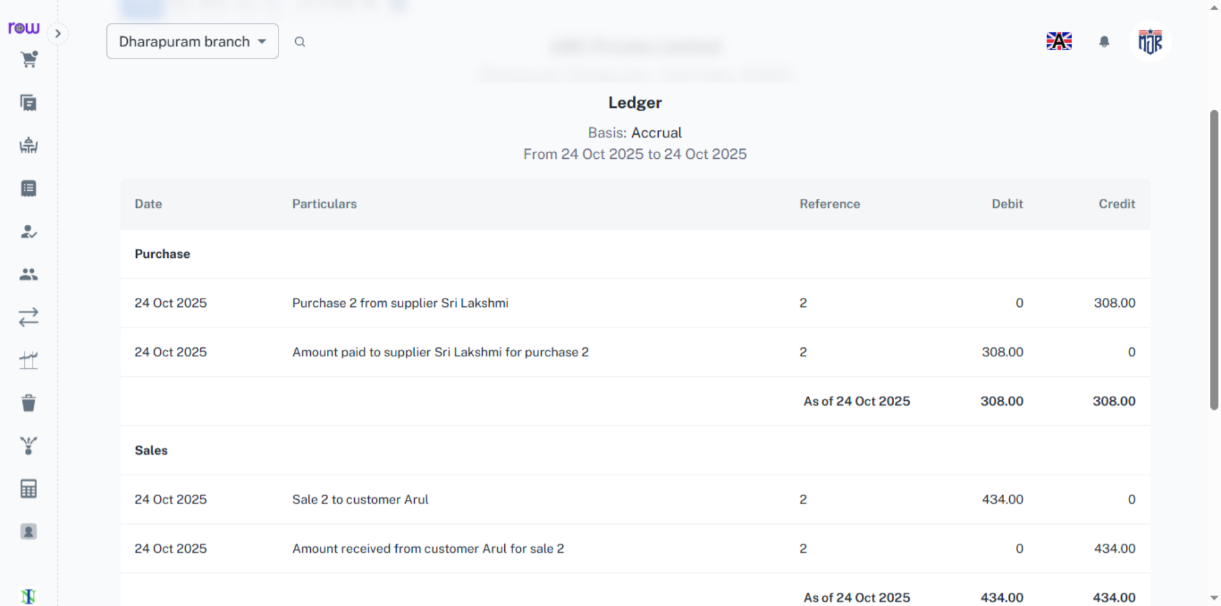

12. Balance Sheet
The created purchases, sales, and expenses are recorded and reflected in the Balance sheet.
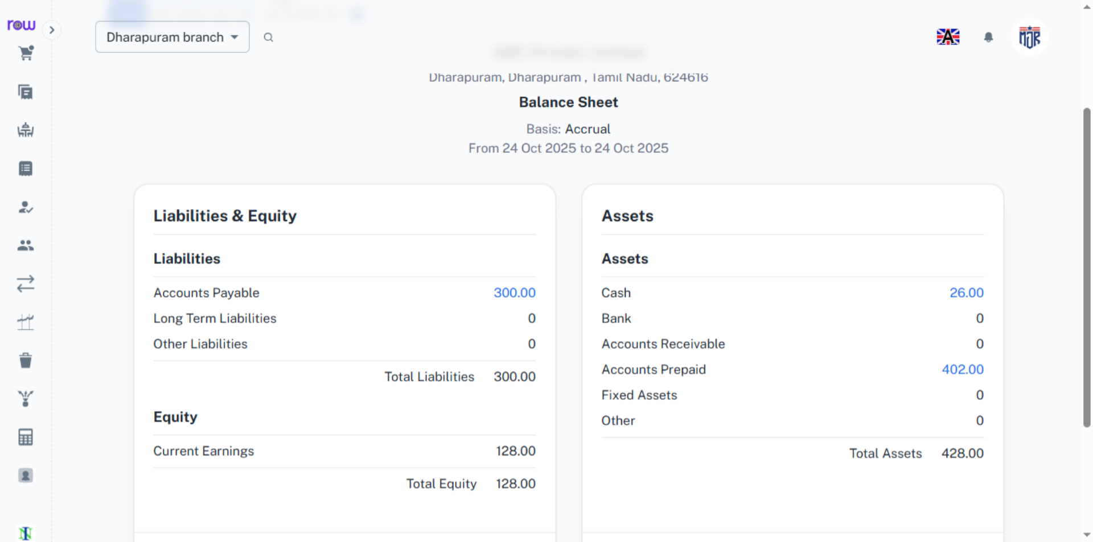

13. Trial Balance
The created purchases, sales, and expenses are recorded and reflected in the Trial balance.
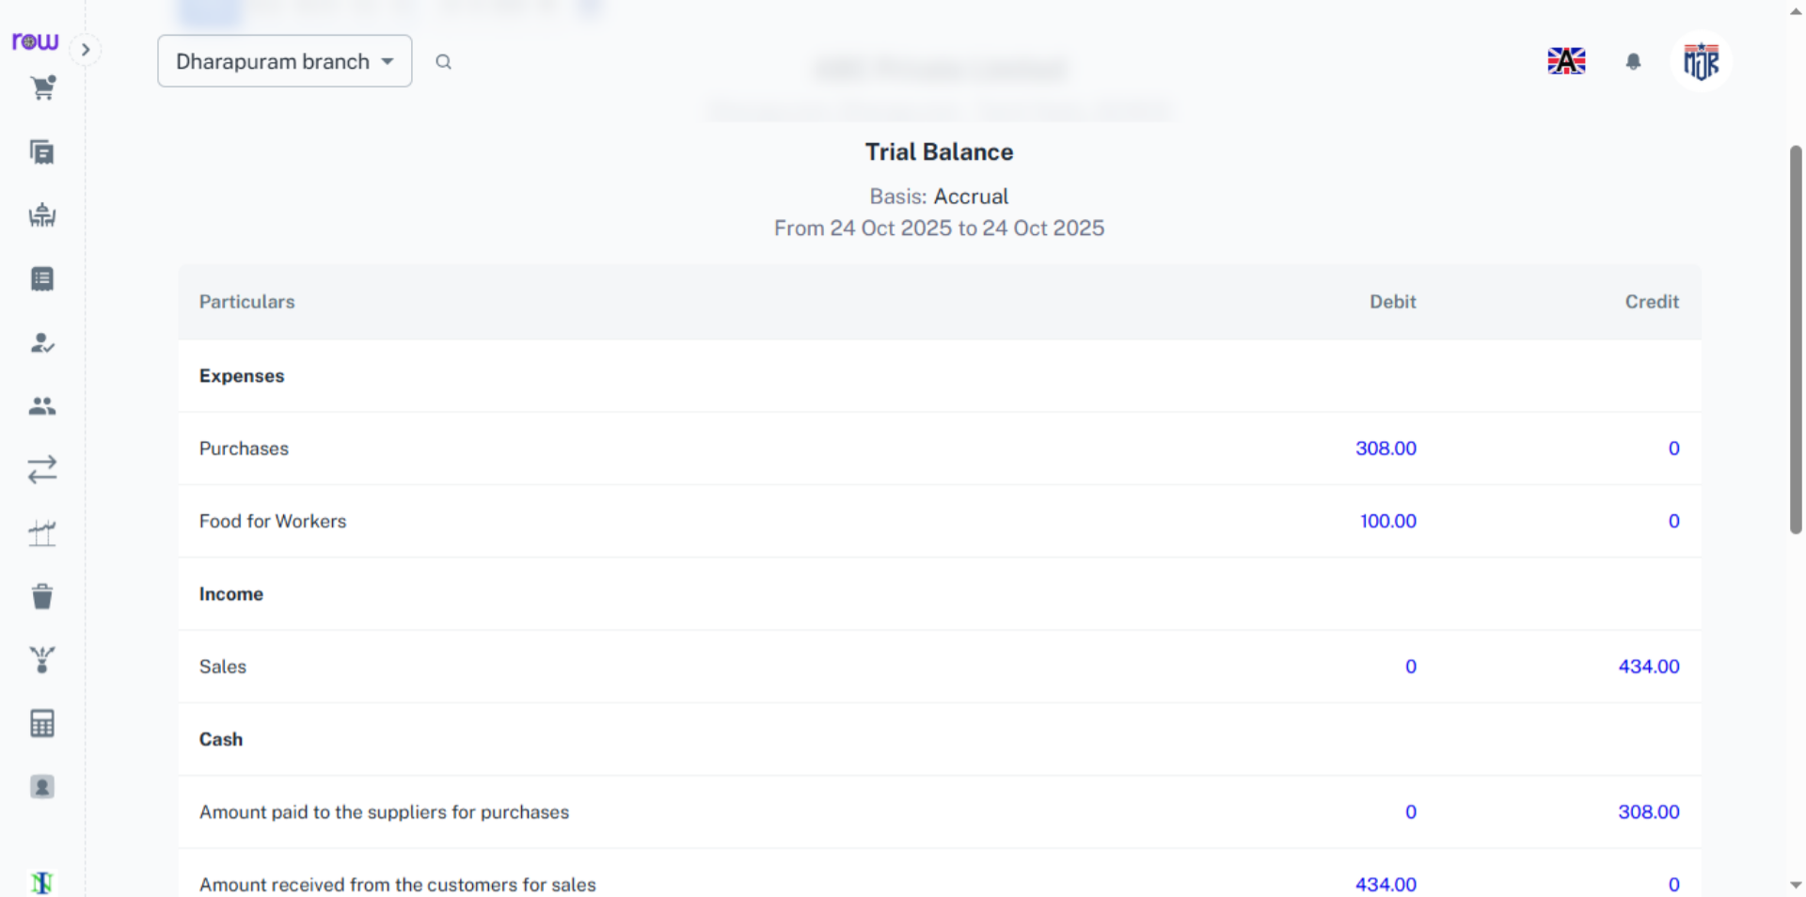

14. Profit and Loss
The created purchases, sales, and expenses are recorded and reflected in the Profit and Loss. Similarly, you can view orders, invoices, quotations, and more in the Accounts. In addition to the Day Book, Ledger, Trial Balance, Balance Sheet, and Profit and Loss, you can access various other accounting reports in the Accounts section.
