Create, Print and Scan barcode for products in RunOnweb

Go to runonweb.com

1. Introduction
In this tutorial, you will learn how to create a barcode for products.

2. Go to Products
Click Products to go to the Product List screen.
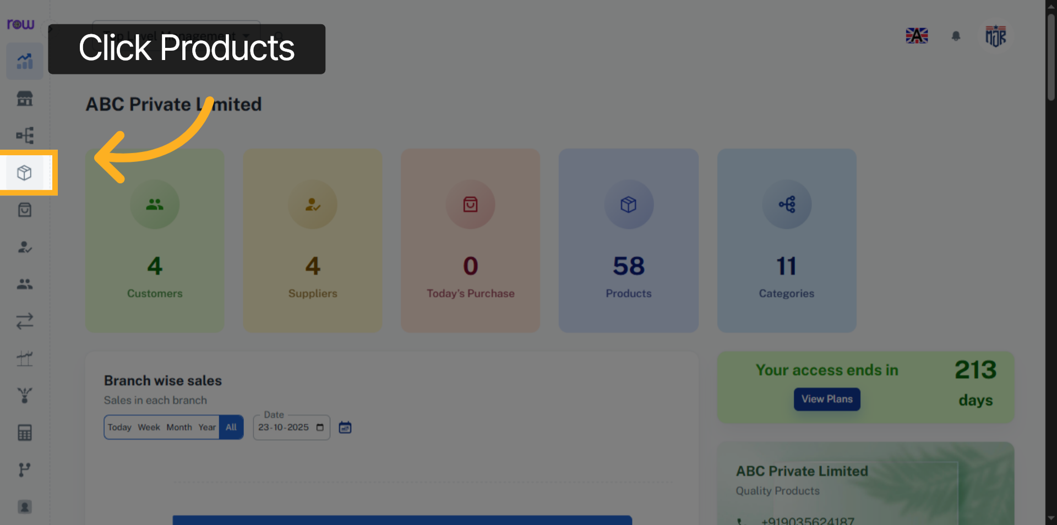

3. Products
You can see the products list here.
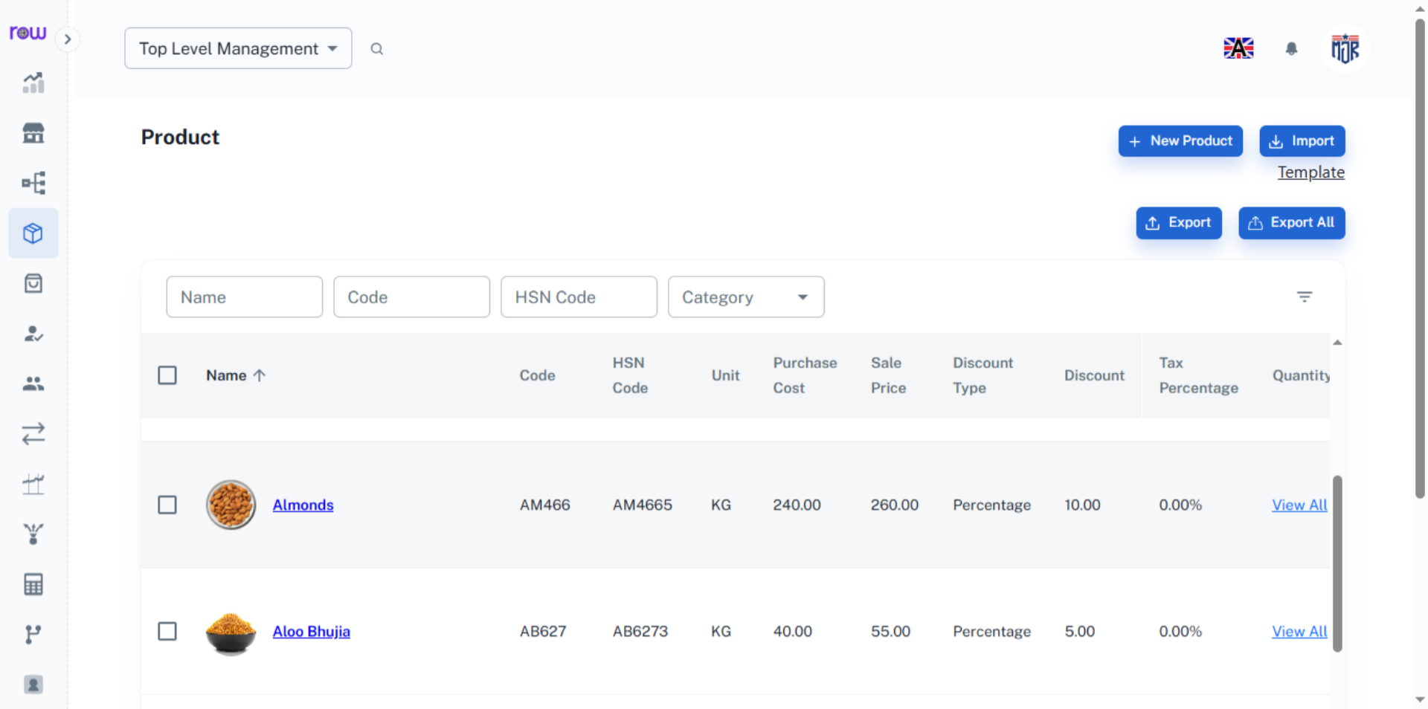

4. Actions
Click Action to view the options.
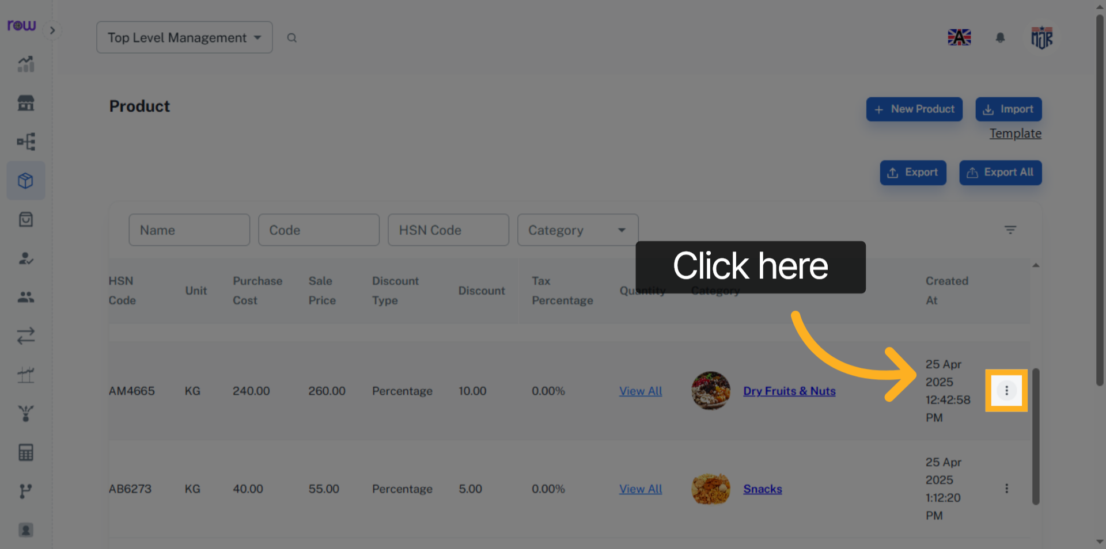

5. Choose Barcode
Click the Barcode to generate and print the barcode.
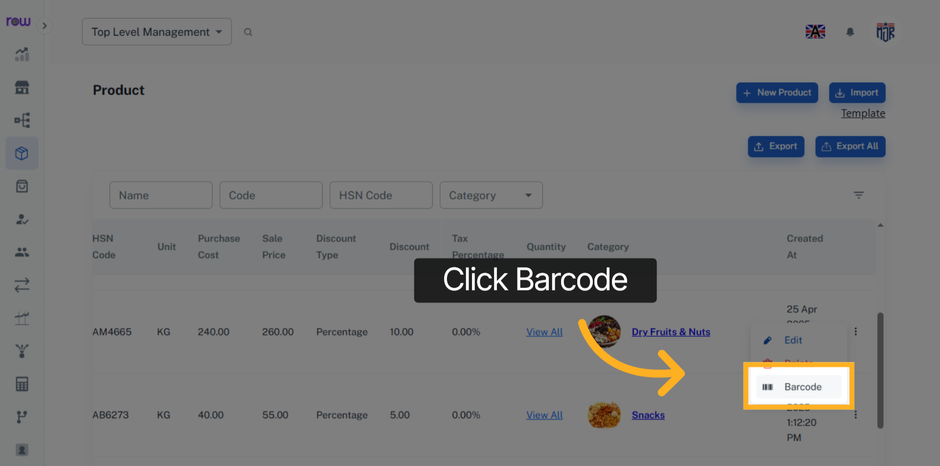

6. Open Barcode
You can see the generated barcode for the product.
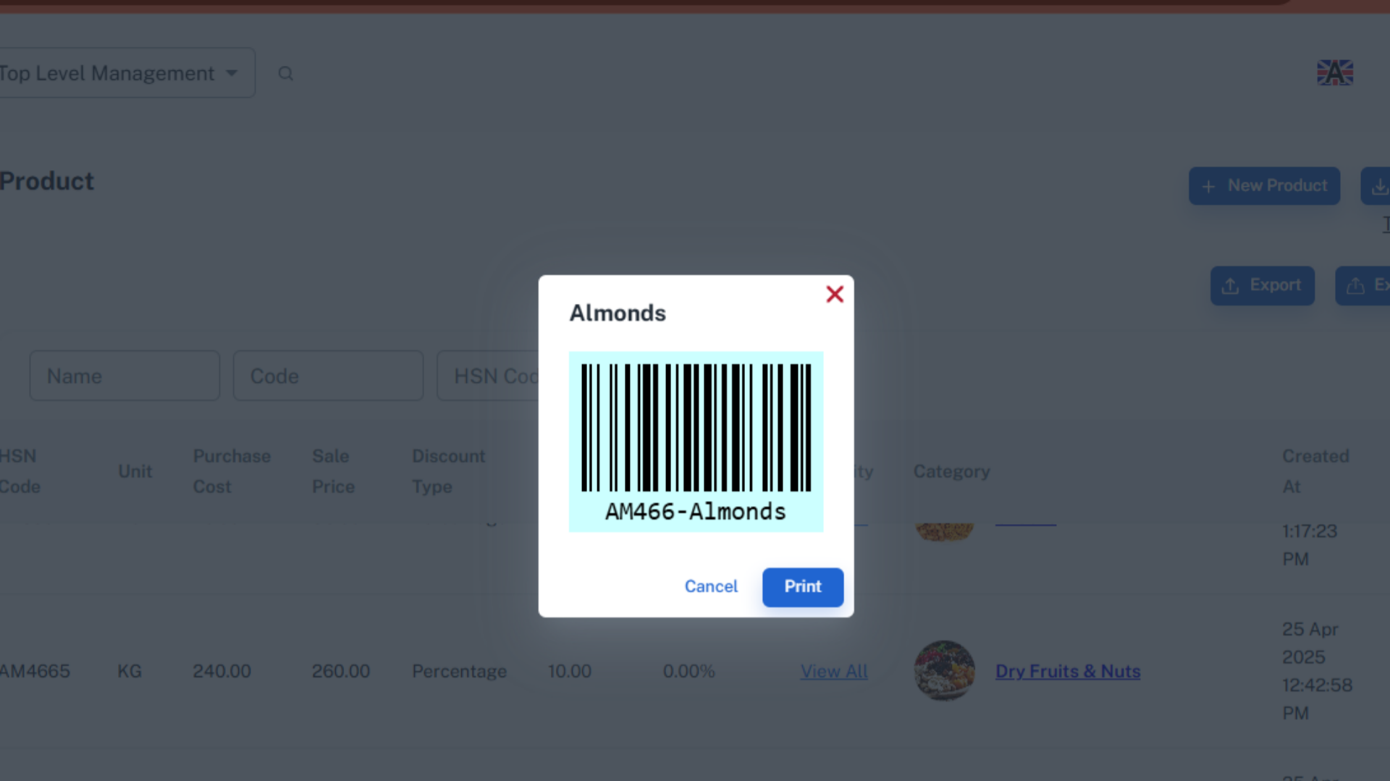

7. Print
Click Print to print the barcode.
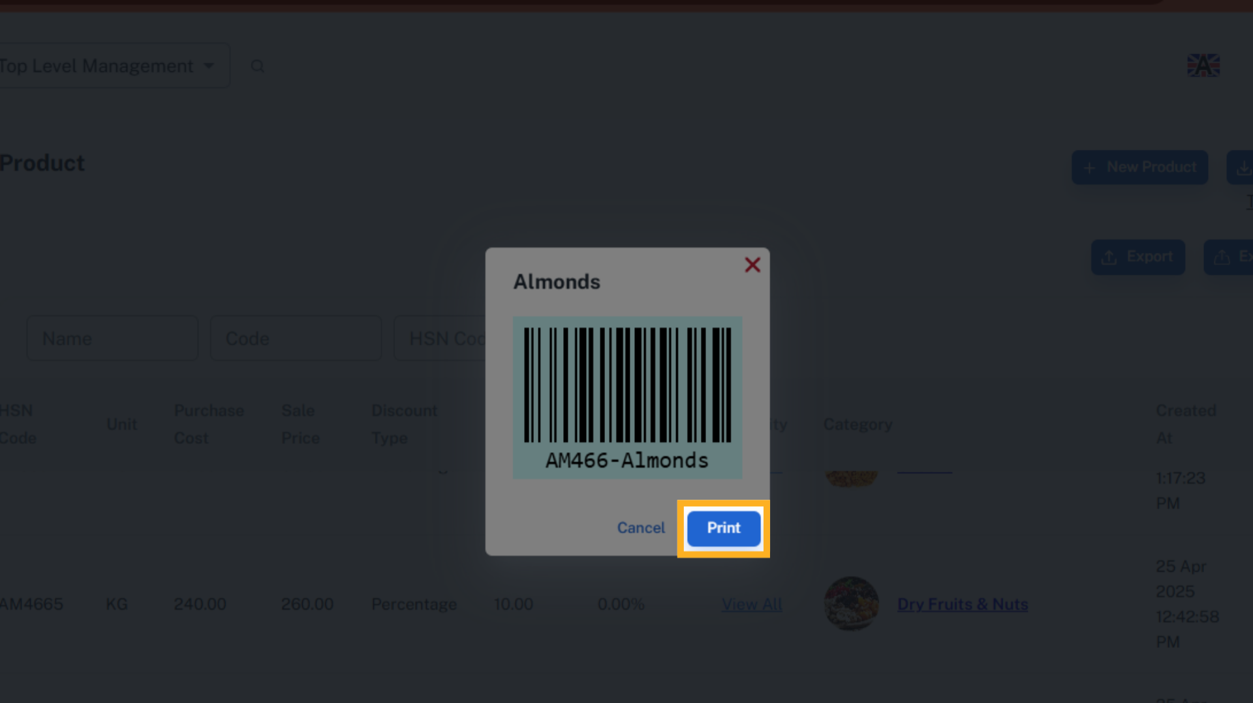

8. New Sale Screen
Go to Sale and click New Sale. Add the product by scanning the barcode of the product.
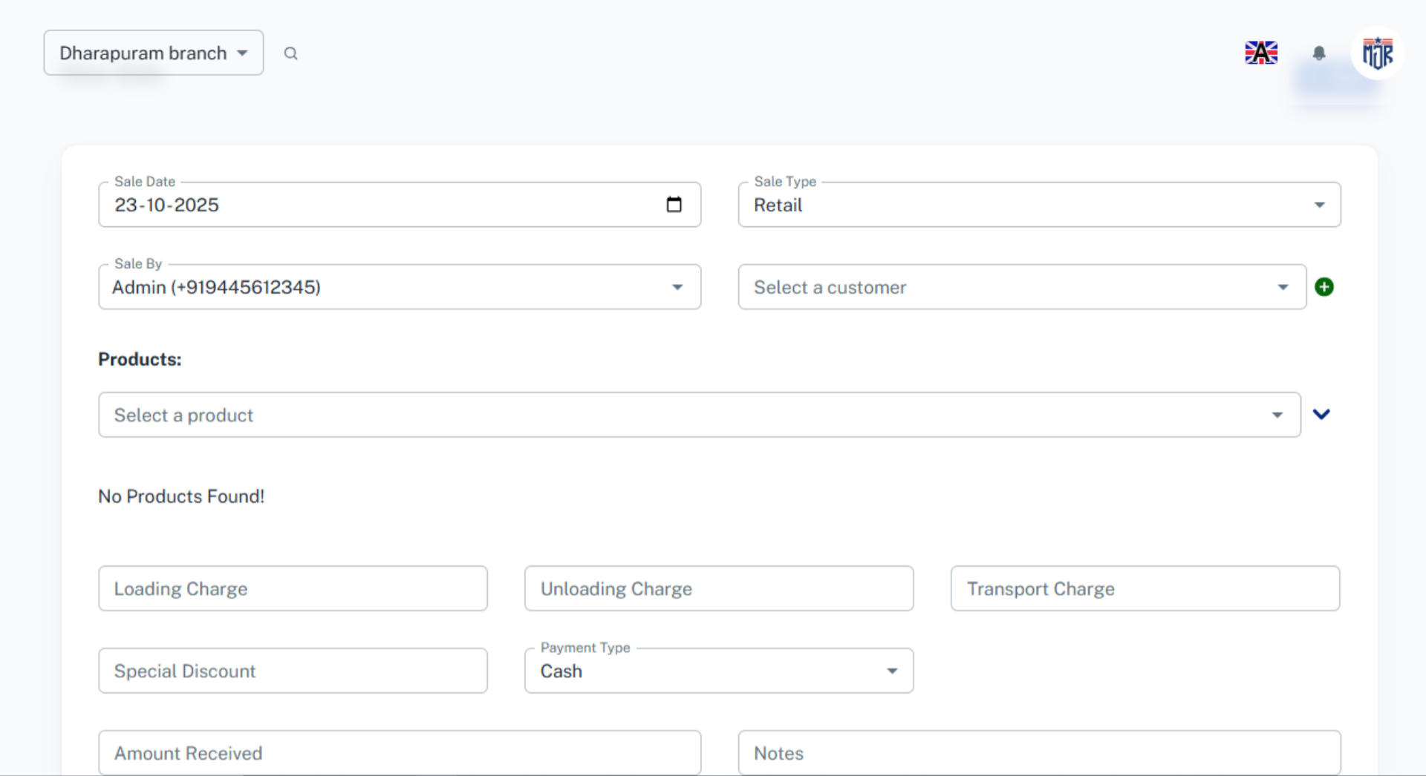

9. Products
Here, the product has been successfully added by scanning its barcode. Similarly, you can add the product in orders, invoices, purchases, quotations, wastage, transfers, and stock.
