Generate, Download and Print bill in RunOnweb

Go to runonweb.com

1. Introduction
In this tutorial, you will learn how to print a bill and how to change a template of the bill.

2. Profile Menu
Click the profile to view the options.
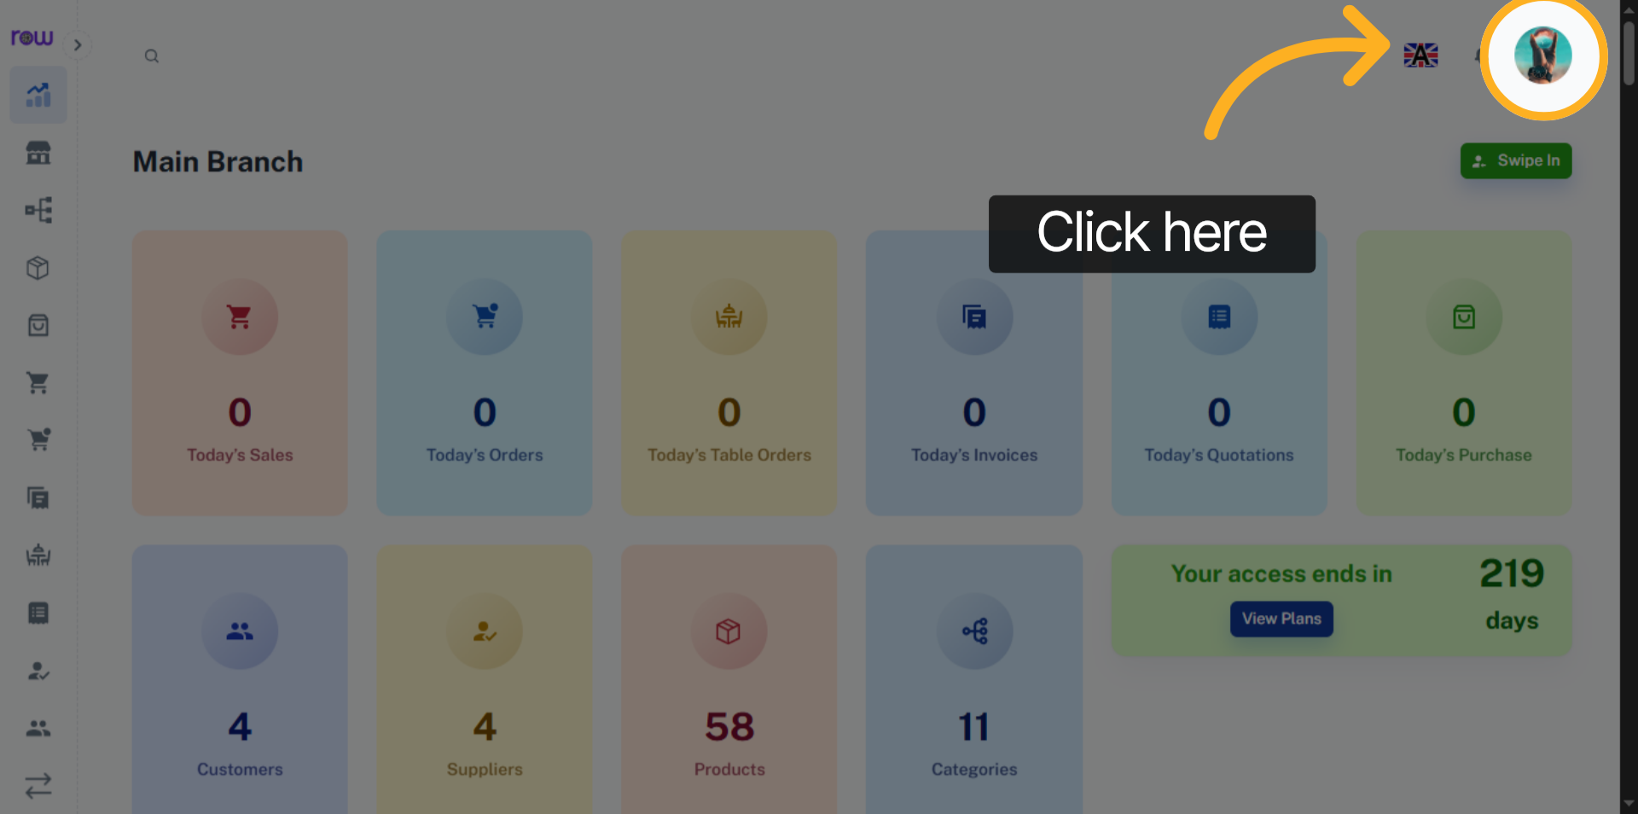

3. Settings Menu
Click the settings menu to open the settings.
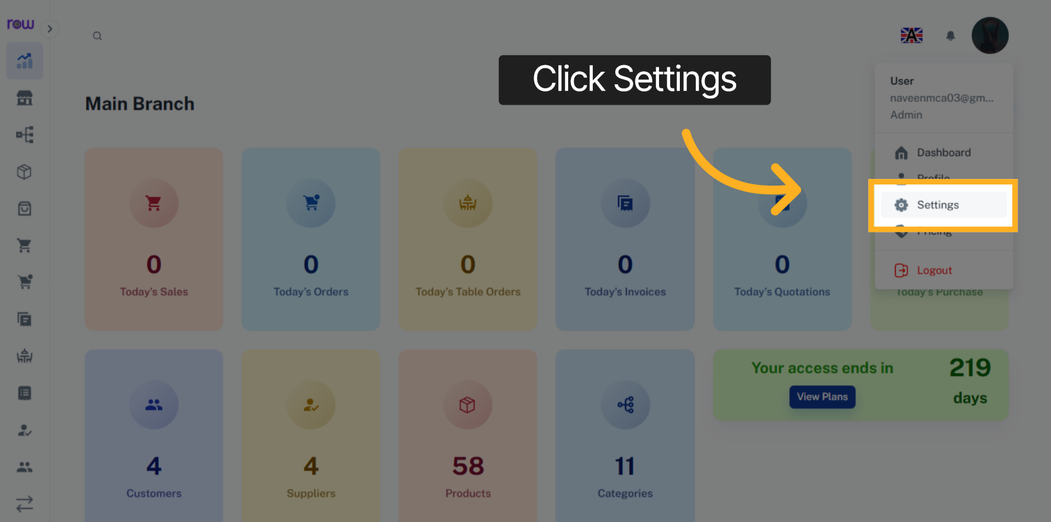

4. Bill Template
You can view the bill template that is currently applied.
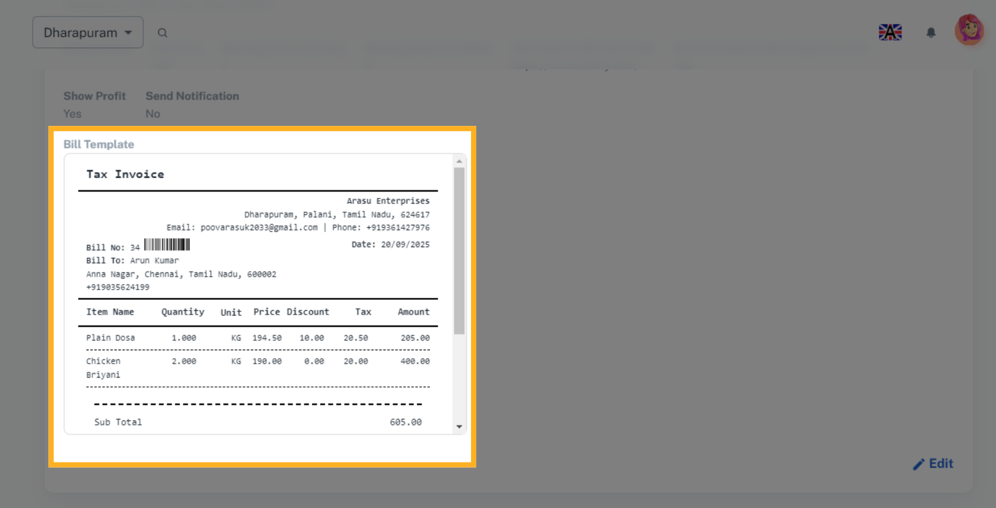

5. Edit
Click the Edit button to edit the bill template.
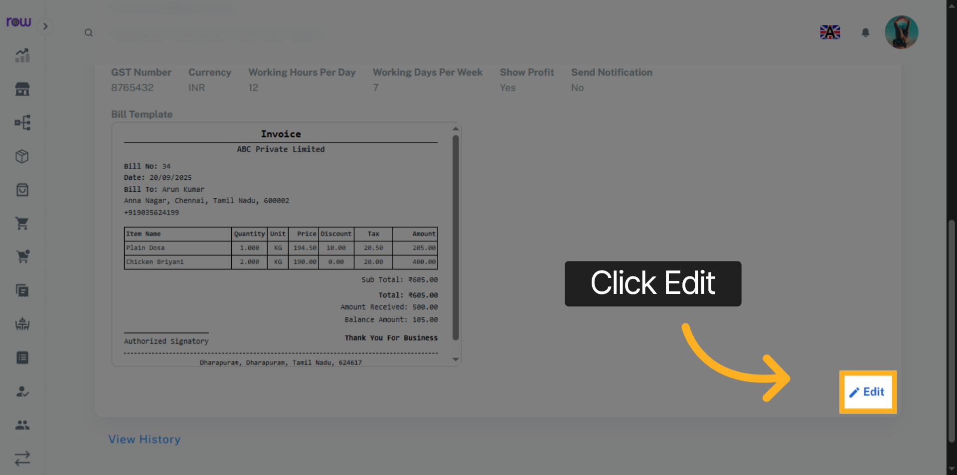

6. Template
Click the Bill Template to change it.
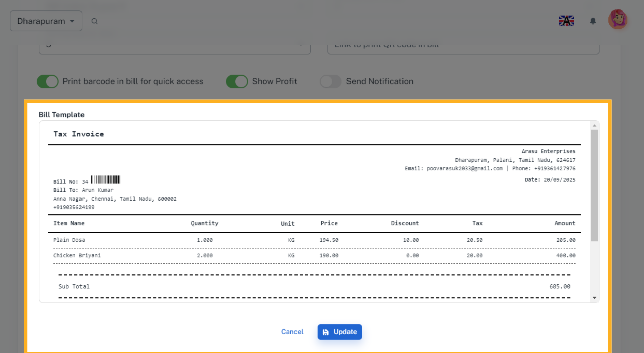

7. Template Selection
You can view 10 templates in different styles and choose the one that best suits your needs.
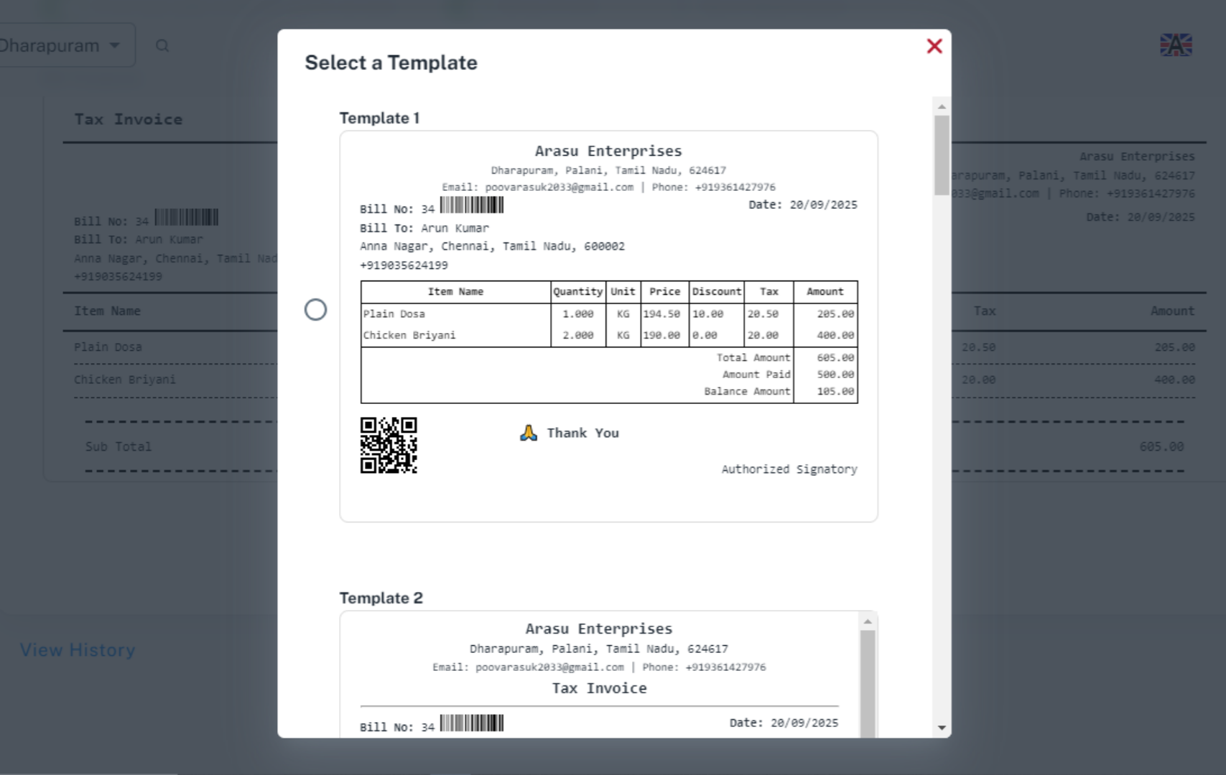

8. QR code Link
Please enter the link to print the QR code in the bill. otherwise, the QR code will not be displayed.
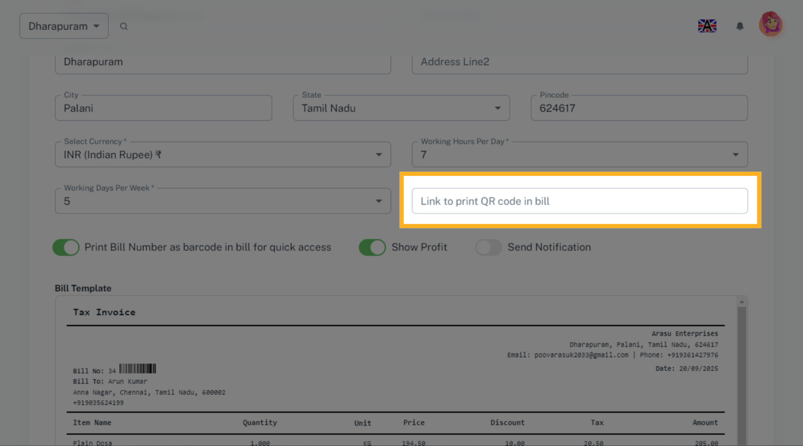

9. Barcode Printing
In Settings, enable this option to display the bill number as barcode in the bill for quick access.
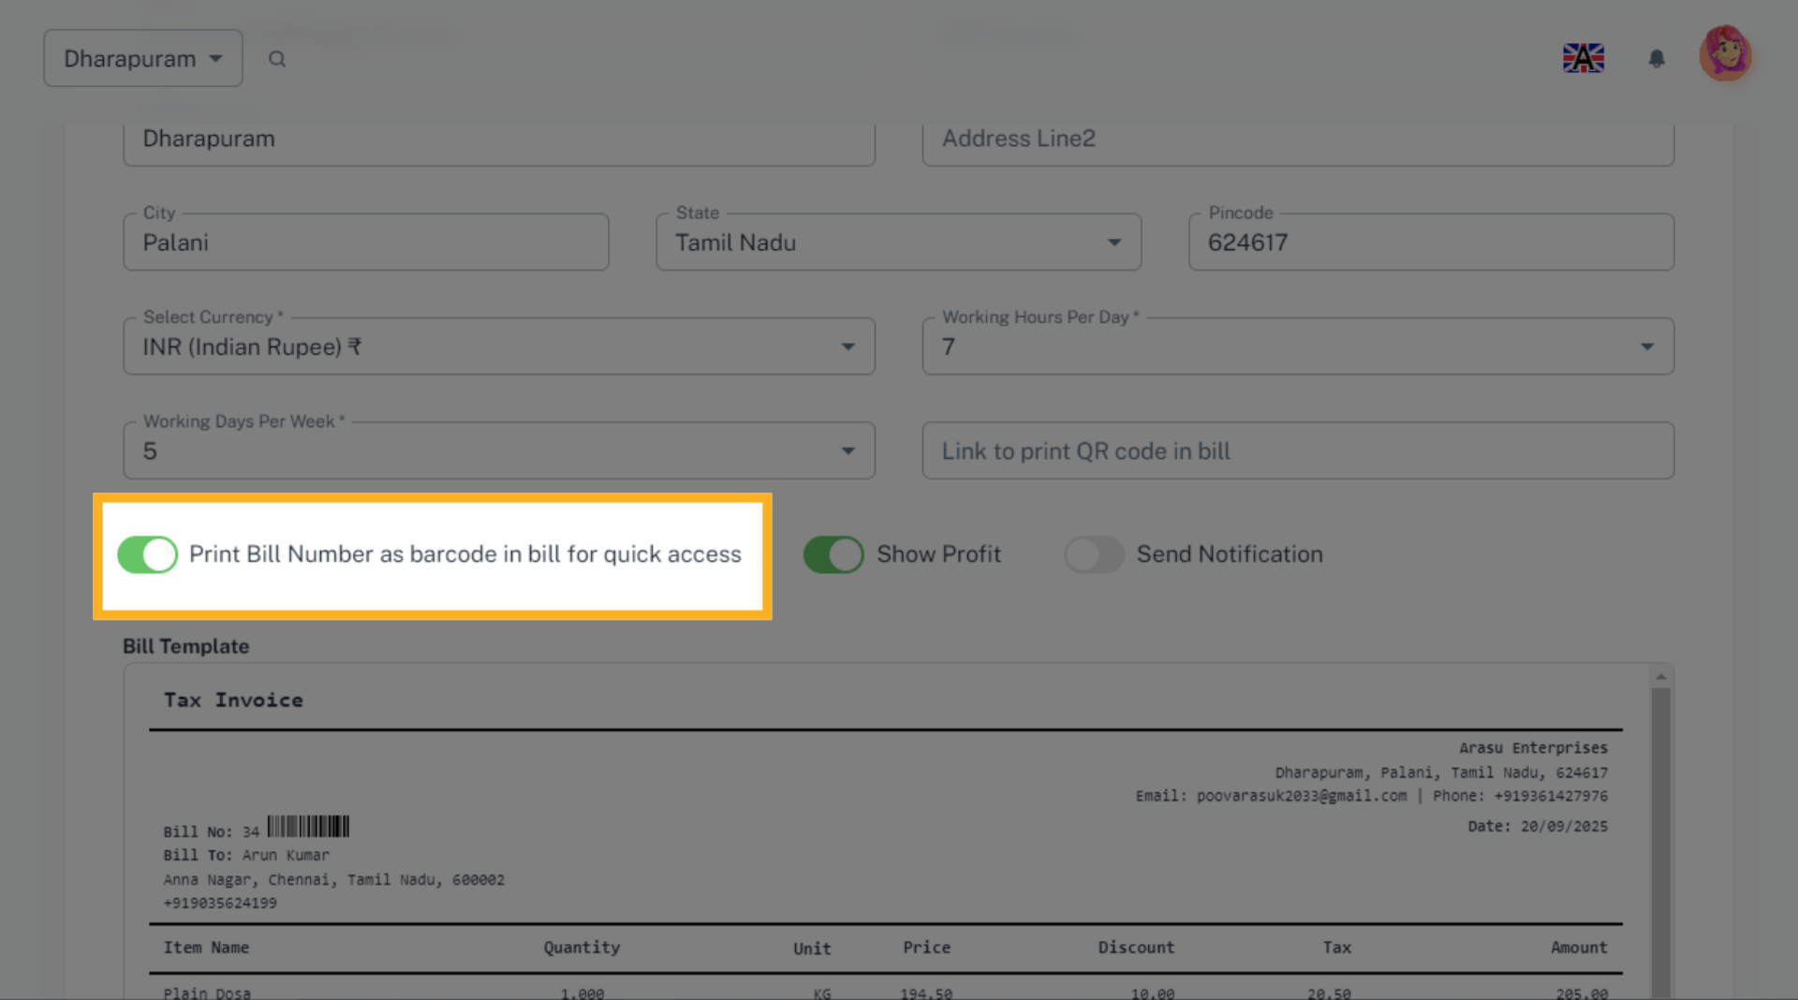

10. Update Template
Click the Update button to save the changes.
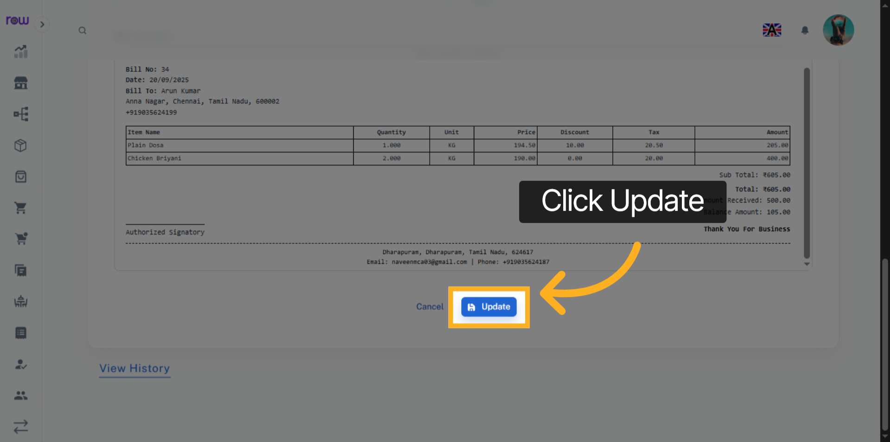

11. View History
Click View History to see the history of the templates.
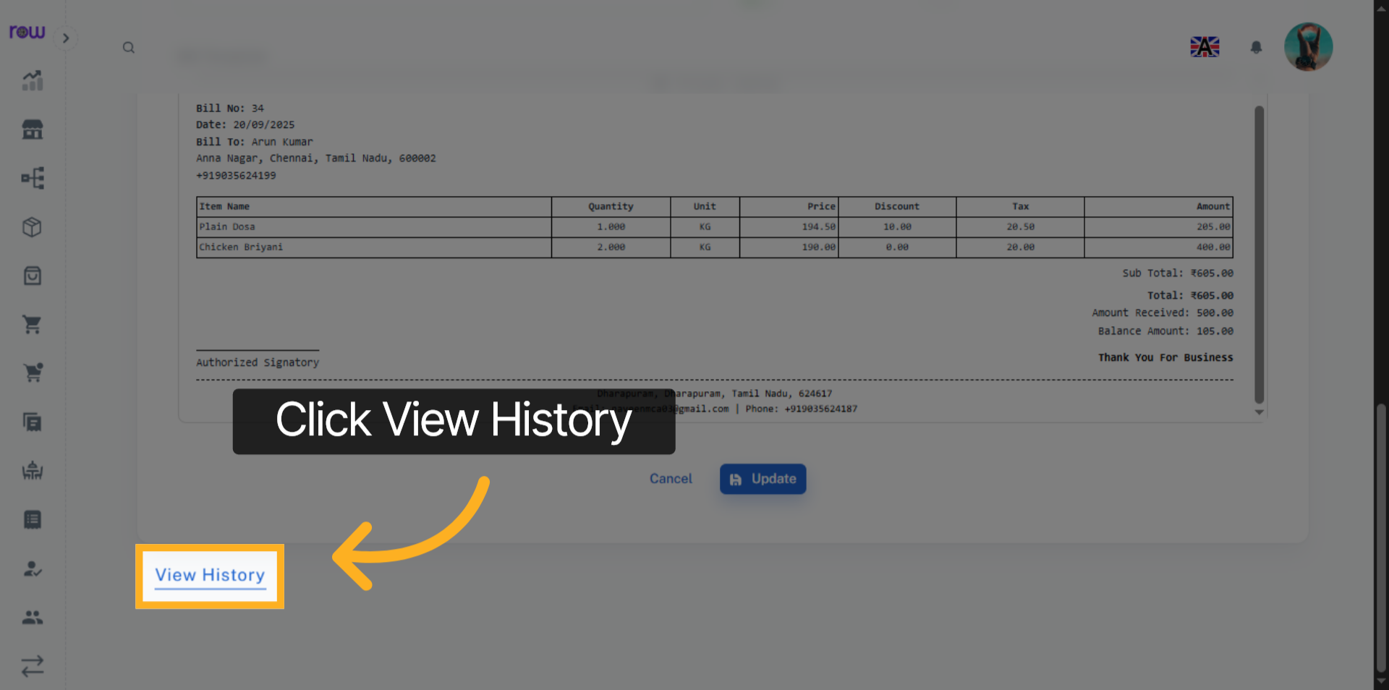

12. History
You can view the template history here.
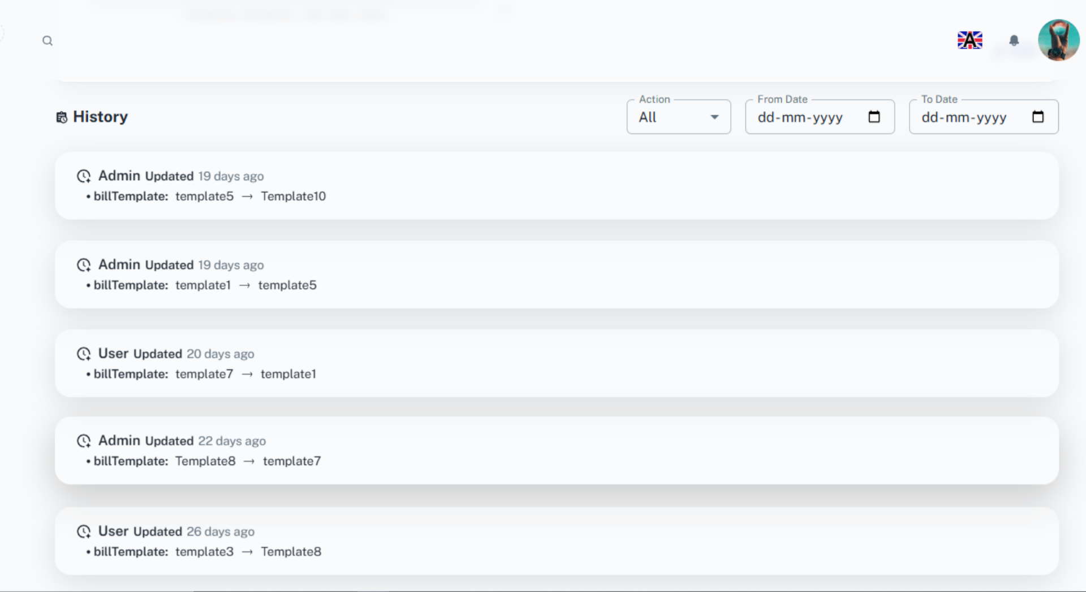

13. Sales list Screen
Go to the Sales List screen. You can view the sales list here.
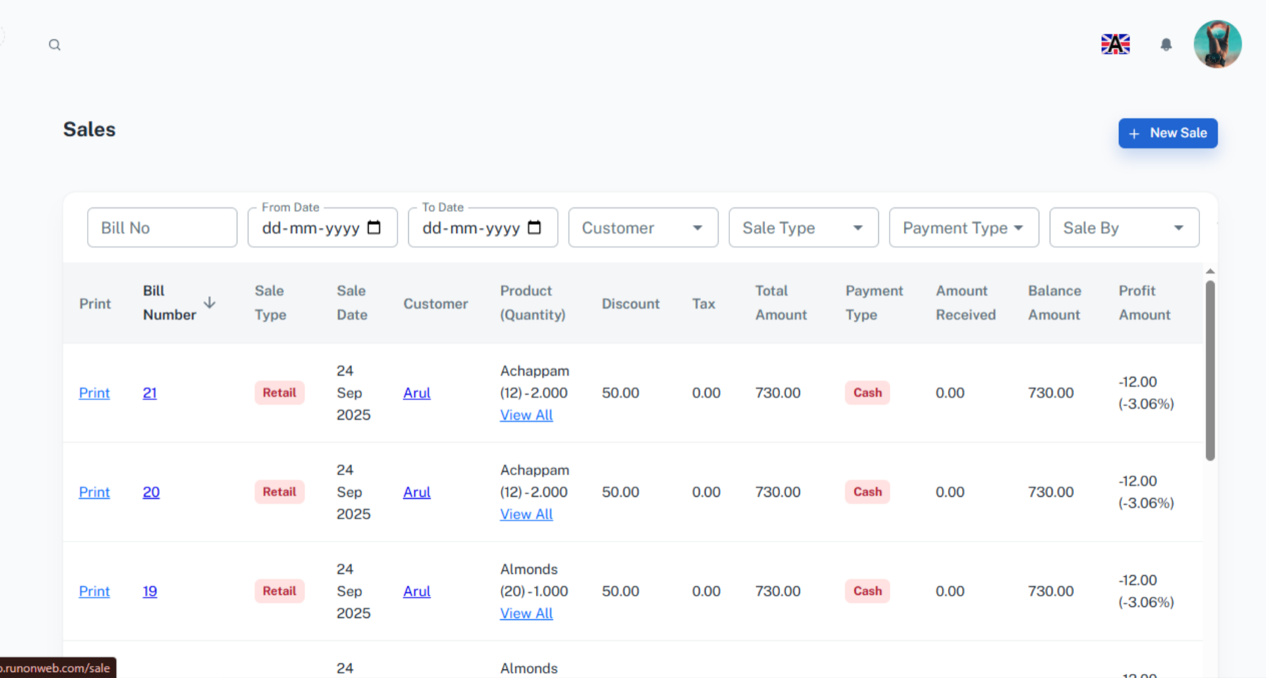

14. Print
Click Print to generate and view the bill.
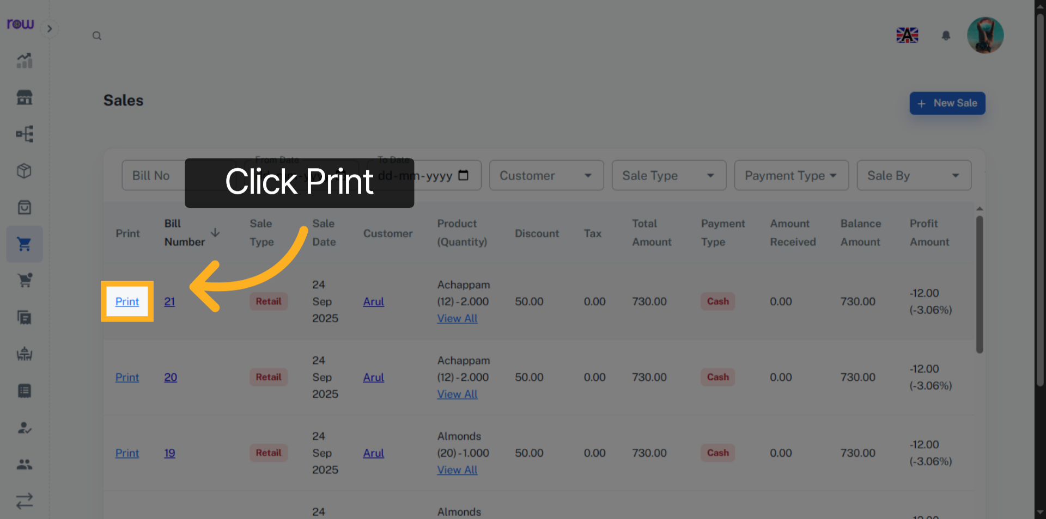

15. Print Section
You can view, download, and print the bill here. Likewise, you can generate a bill for an order, quotation, or invoice.
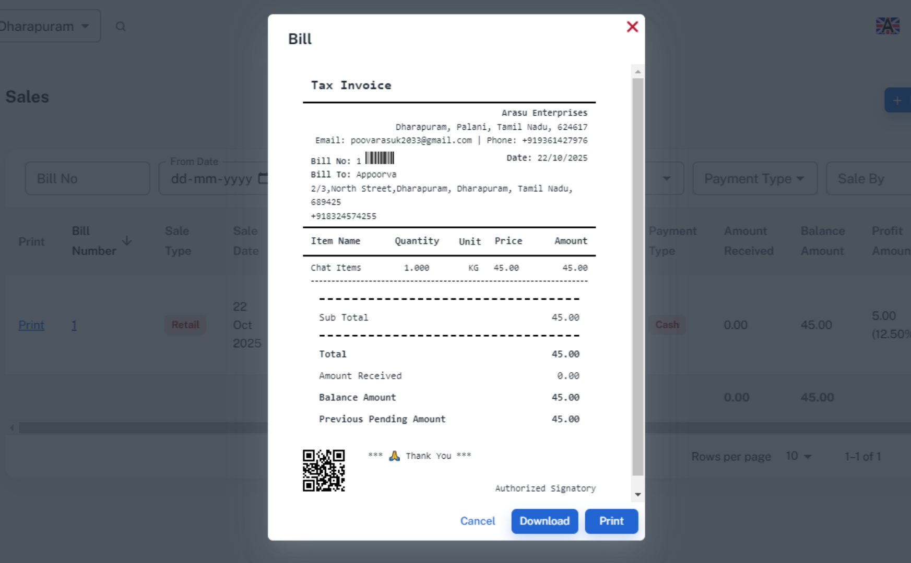

16. Transfer Bill
Go to the Transfer List screen. You can view the Transfers list here.
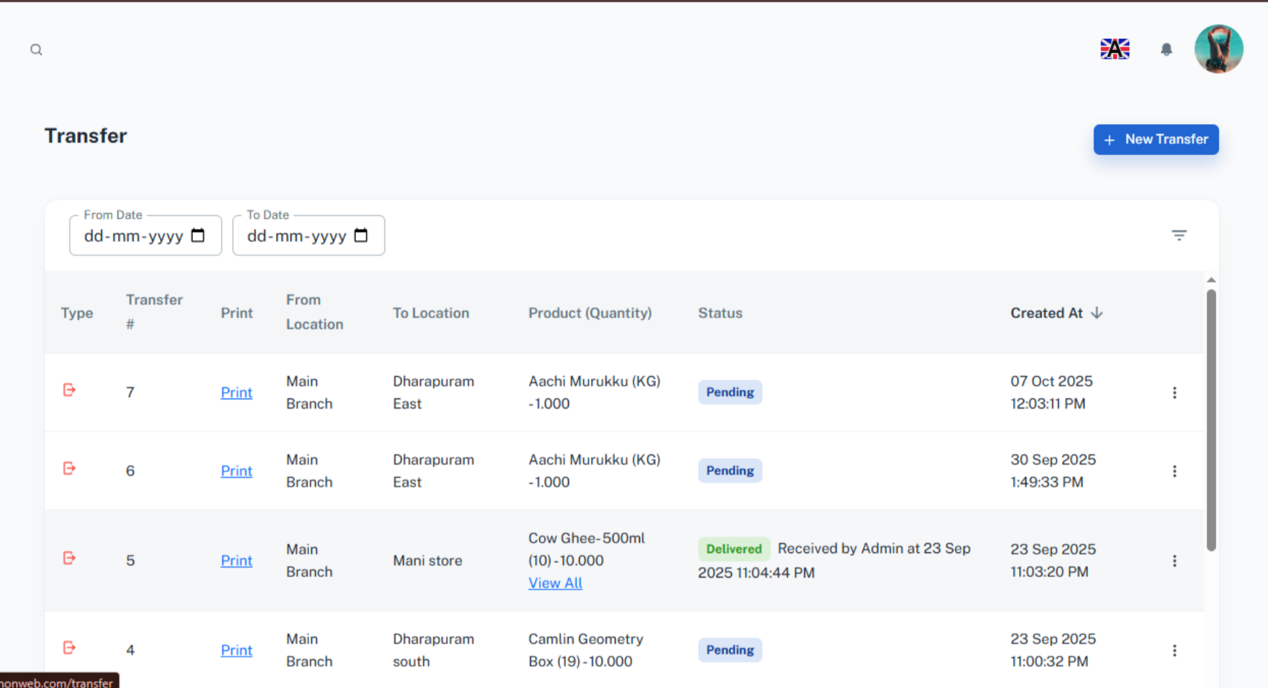

17. Print
Click Print to generate and view the bill.
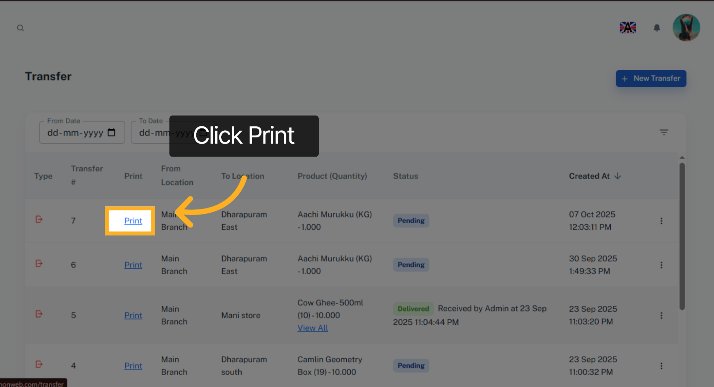

18. Transfer Bill
You can view, download, and print the transfer bill here.
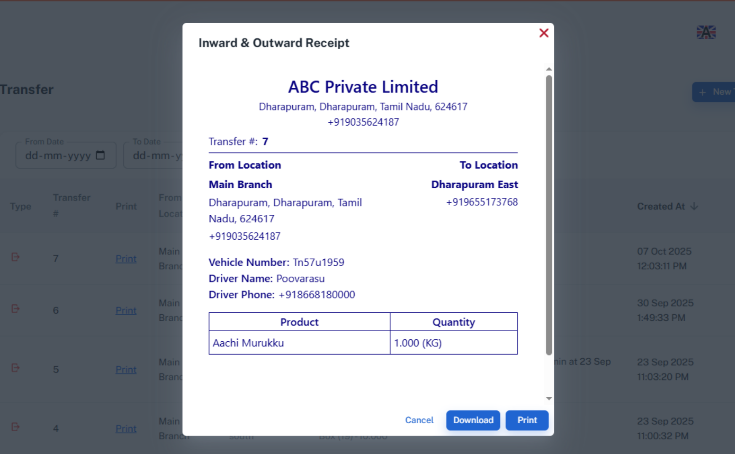

19. Employee salary Screen
Go to the Employee Salary screen. You can view the employee salary list here.
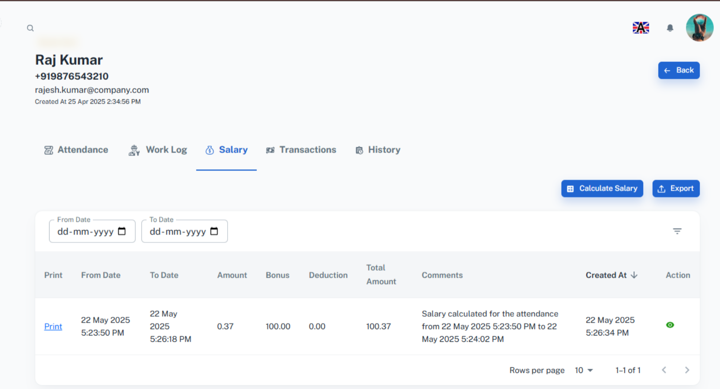

20. Salary Bill
Click print to generate and view the bill
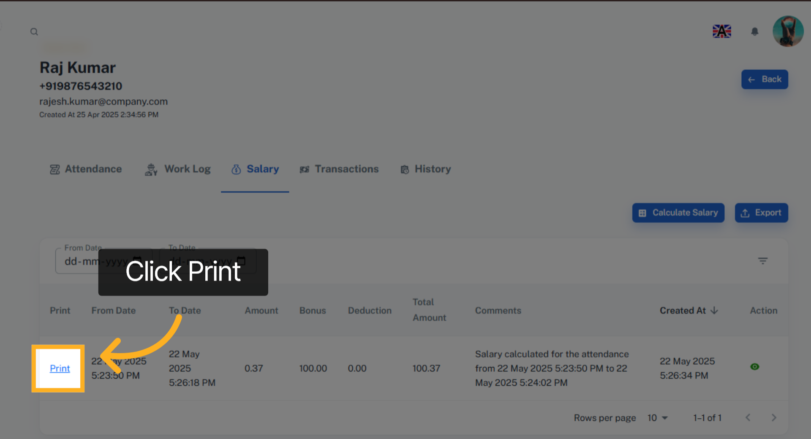

21. Bill
You can view, download, and print the salary bill here.
