Create and Manage Customers in RunOnWeb

Go to runonweb.com

1. Introduction
In this tutorial you learn how to create and manage the Customers.

2. Select Customer
Select Customer menu to open the Customer list Screen.
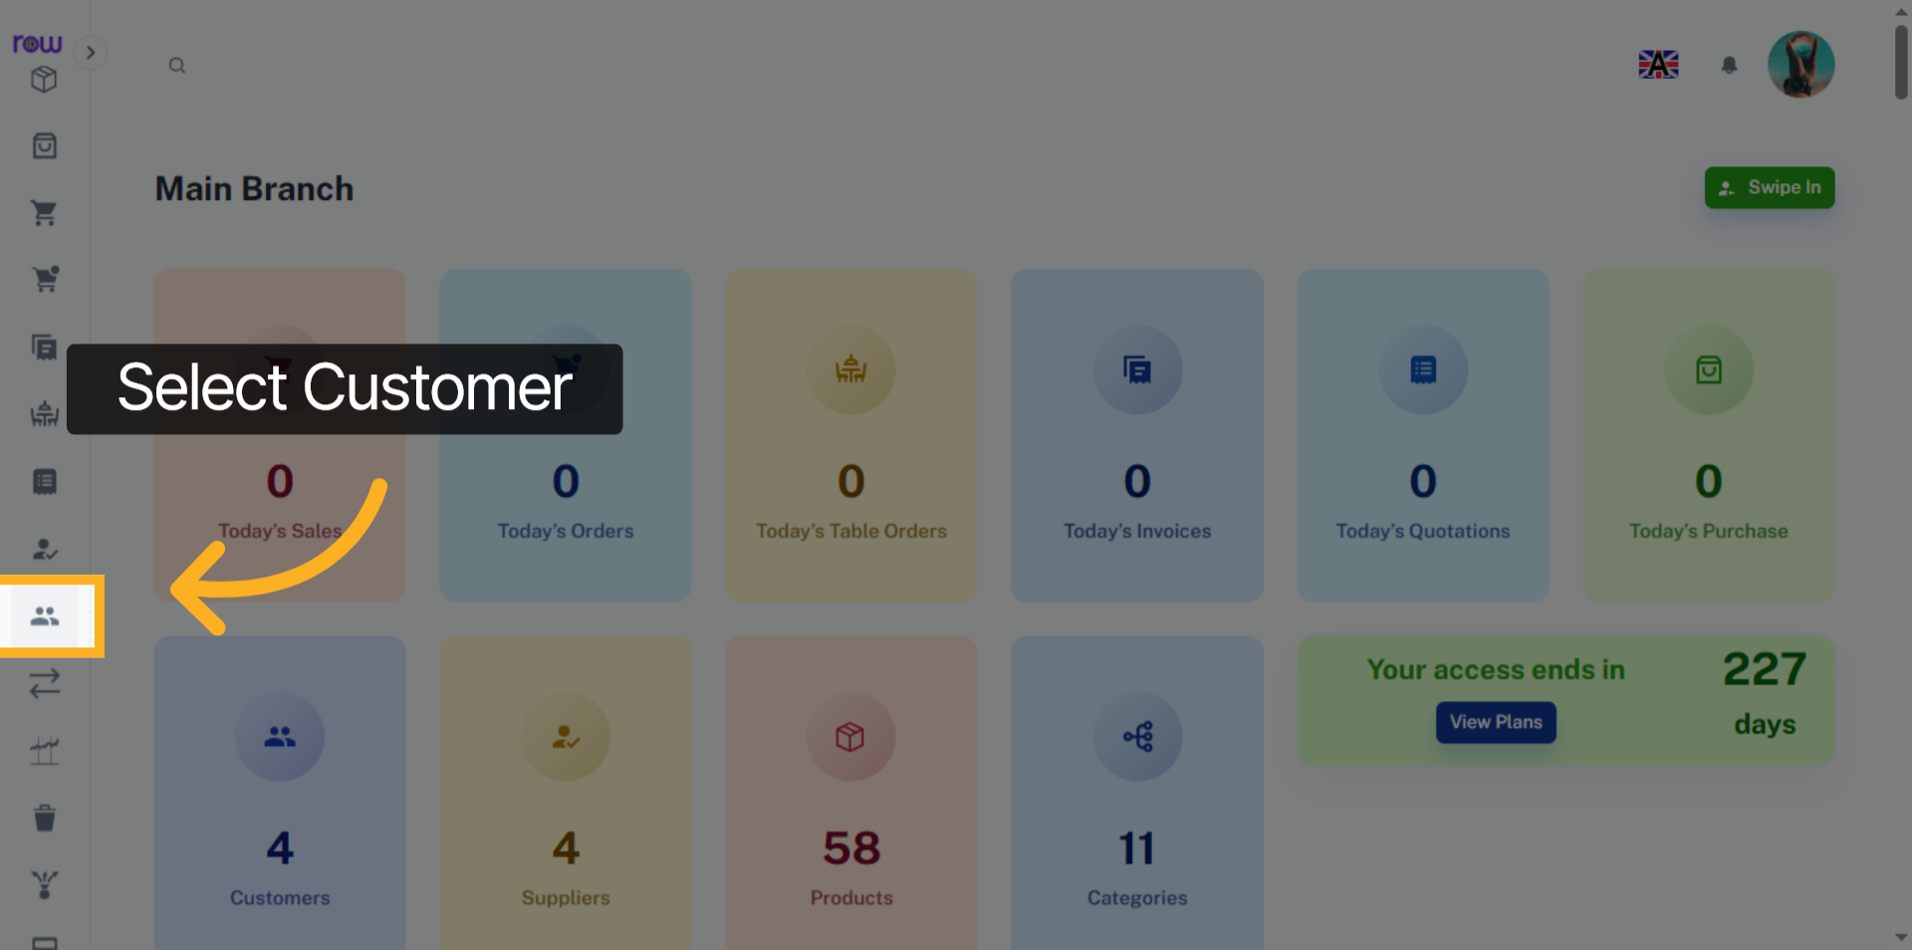

3. New Customer Button
Click the New Customer button to create a new Customer.
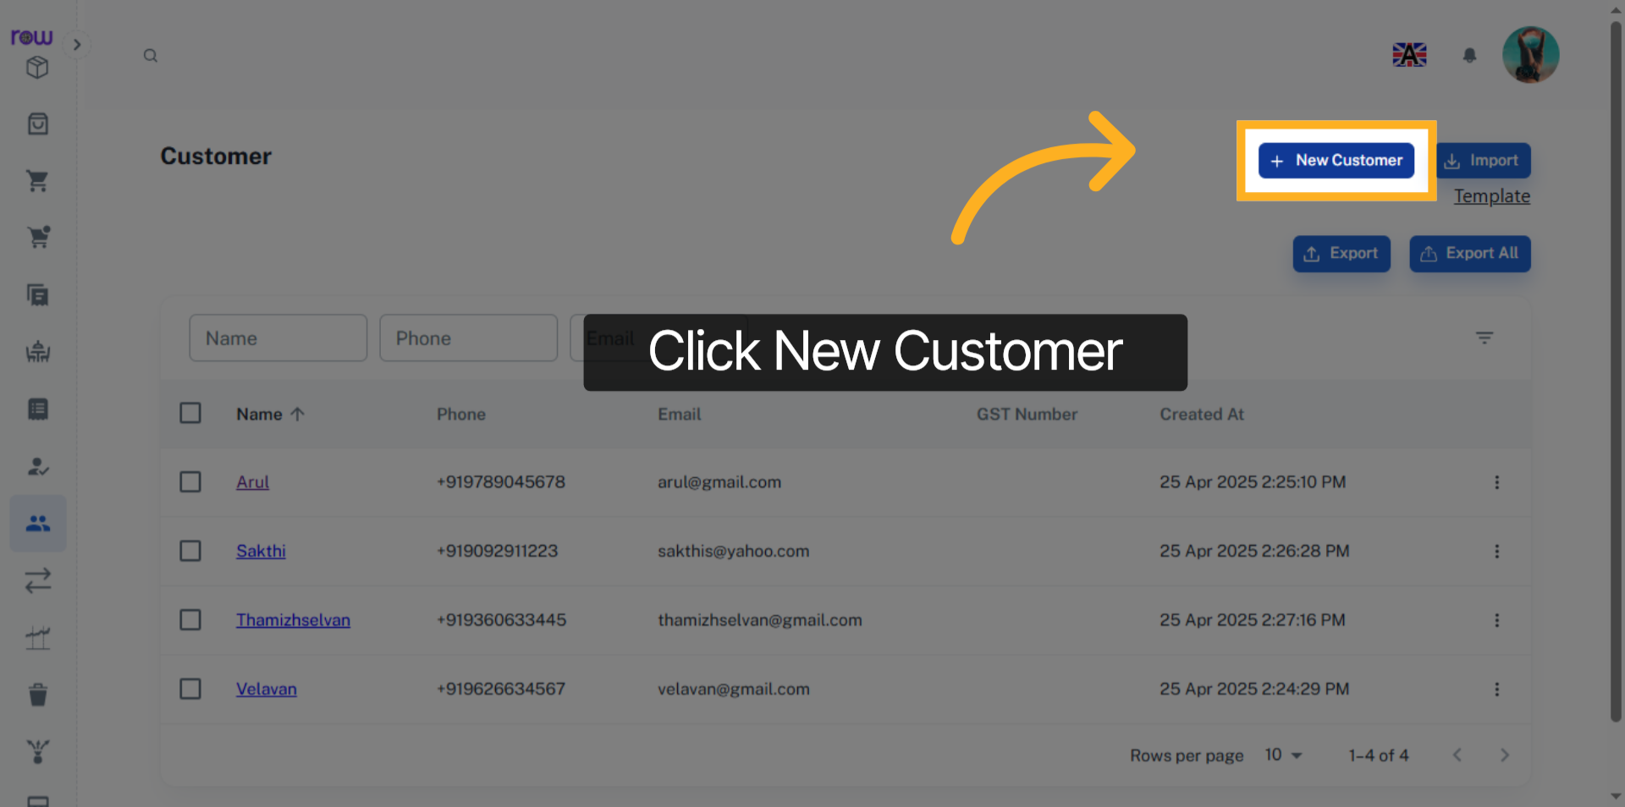

4. Necessary Fields
Please enter the new Customer details.
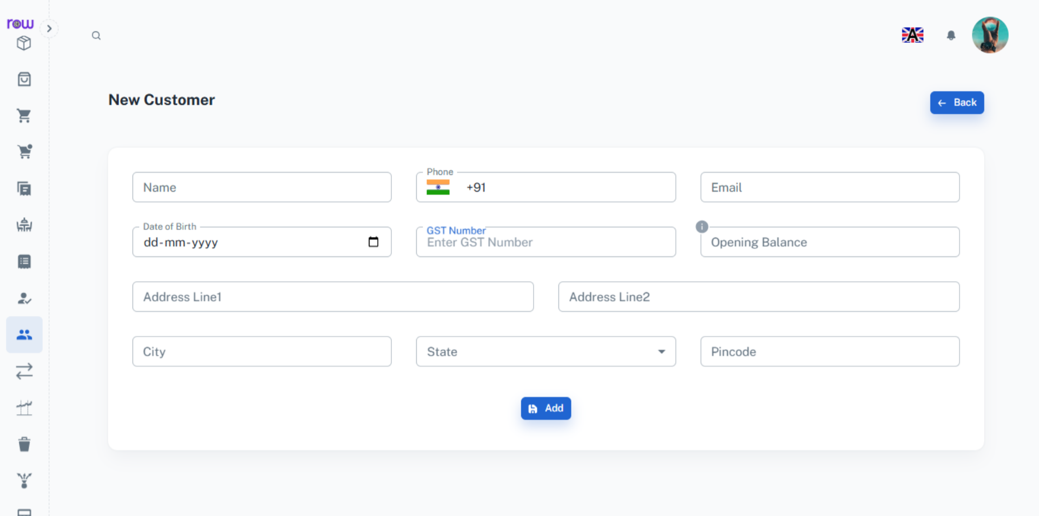

5. Add
Click Add button to create the new Customer.
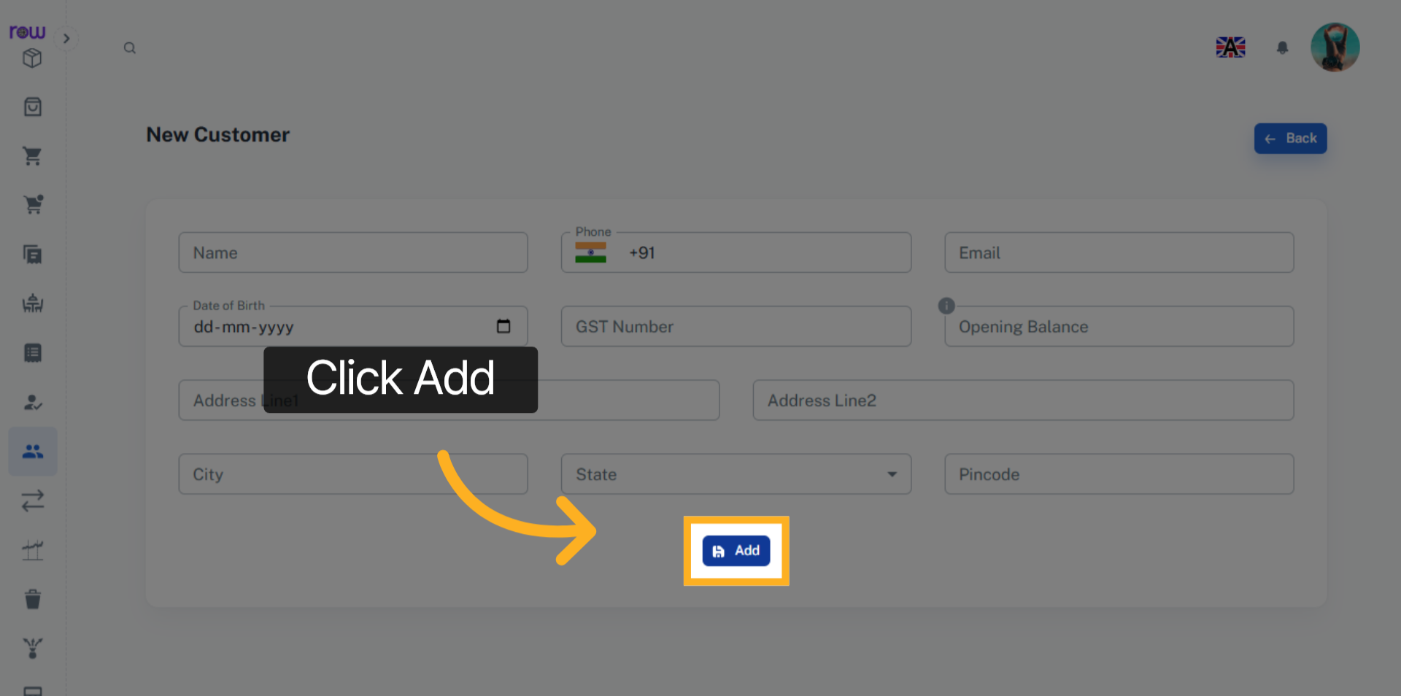

6. Customer Screen
You will be redirected to the Customers List screen after a new Customer is successfully created.
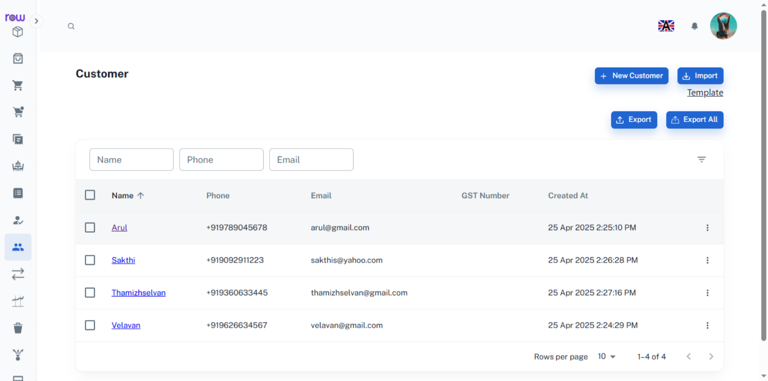

7. Customer Details
Click the Customer name to view and edit the Customer’s details.
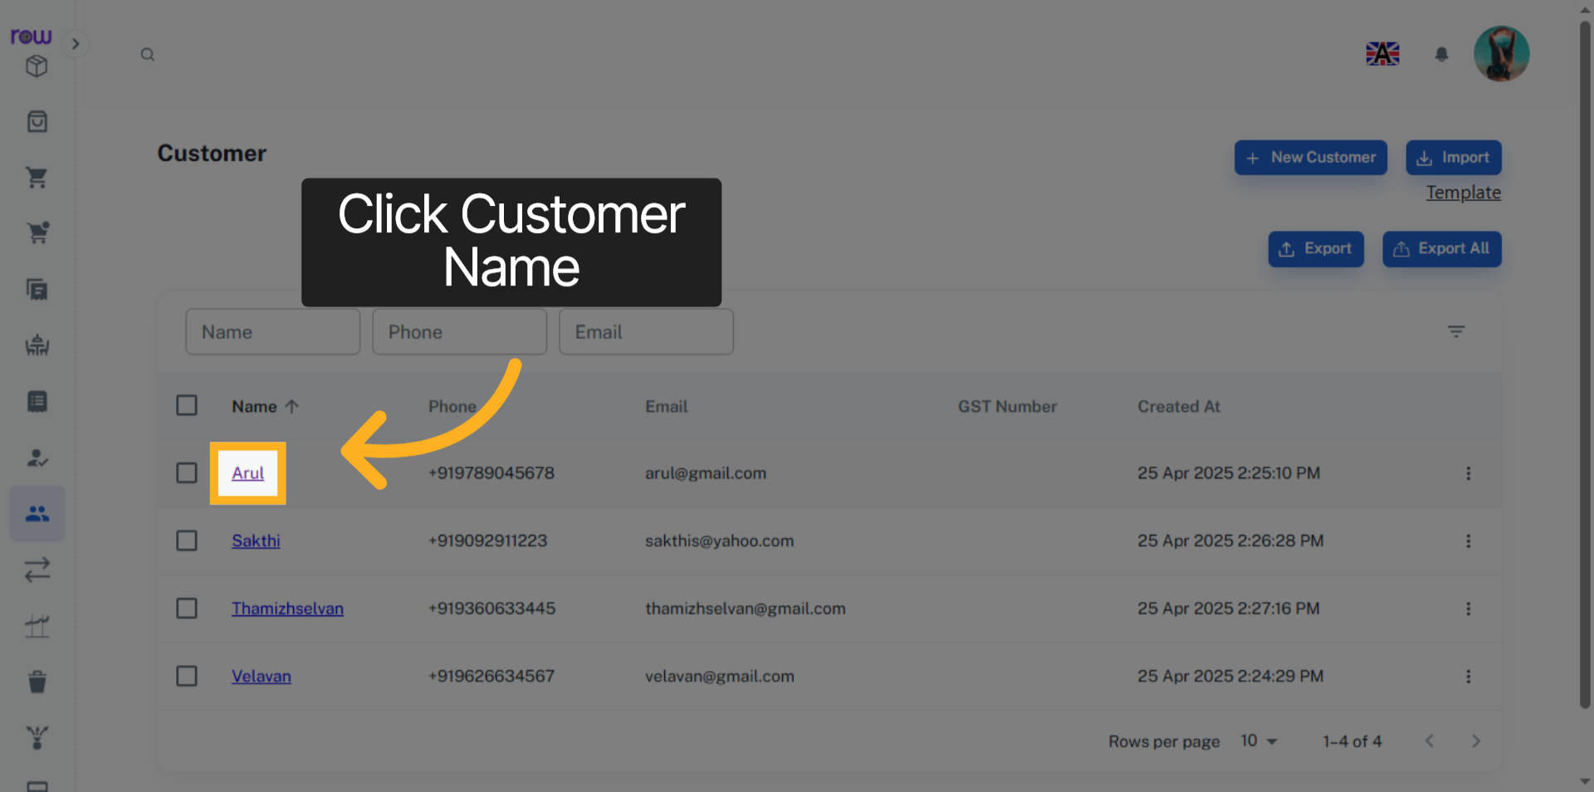

8. Customer
You can view the Customer’s email, phone number, address and balance amount on this page.
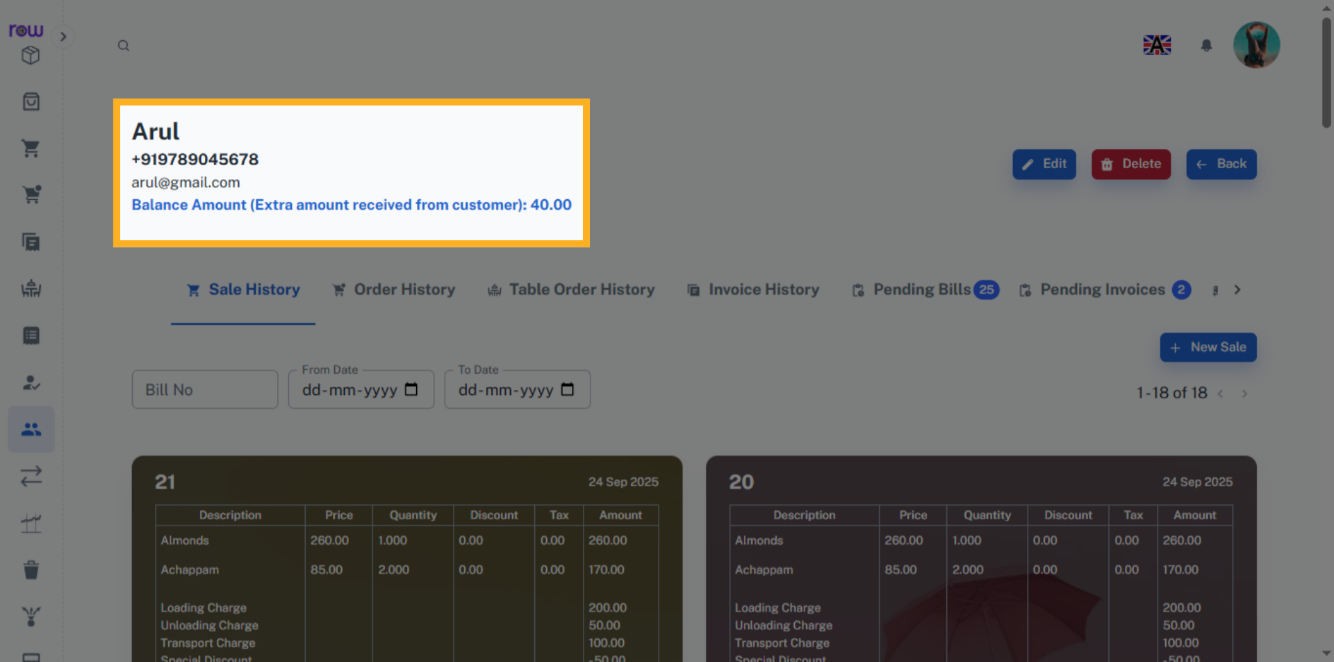

9. Edit Customer
Click the Edit button to edit the Customer details.
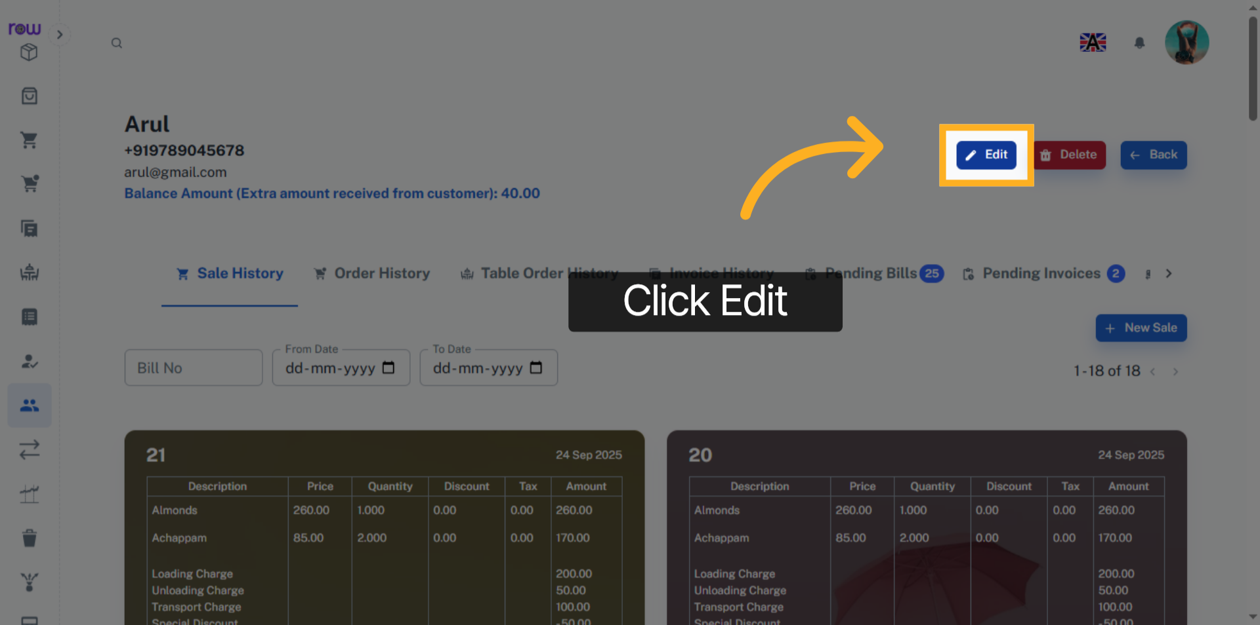

10. Edit Customer Details
You can edit the Customer’s details here.
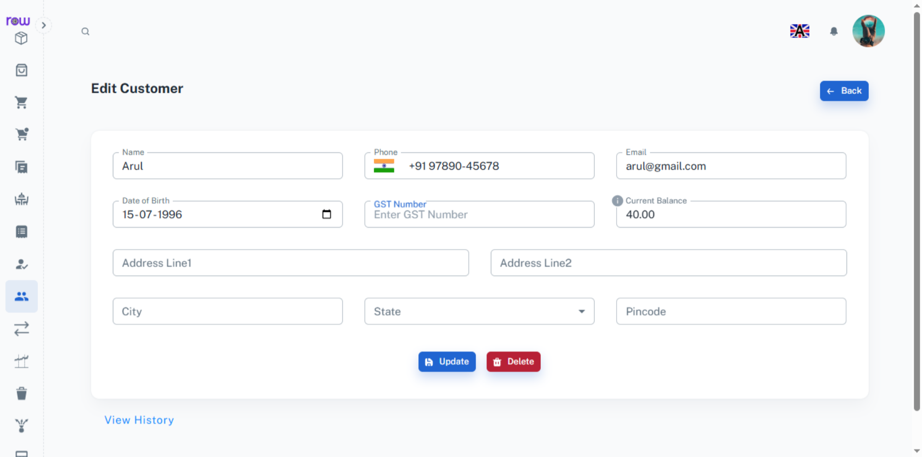

11. Update
Click Update to save the Changes.
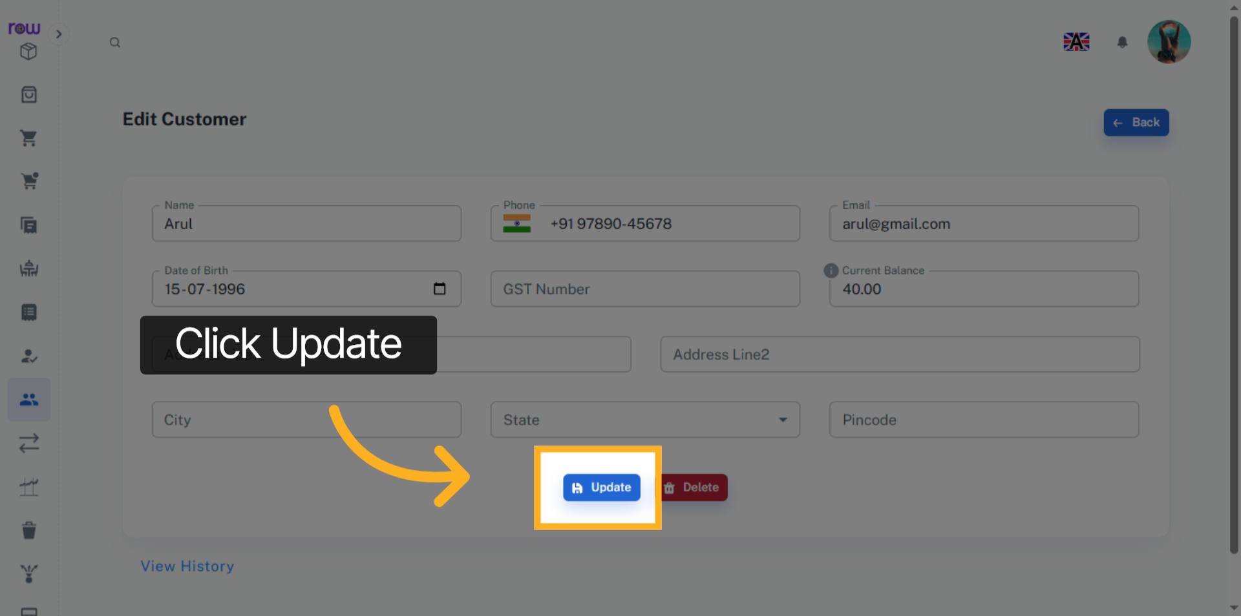

12. Delete Customer
Click the Delete button to delete the Customer.
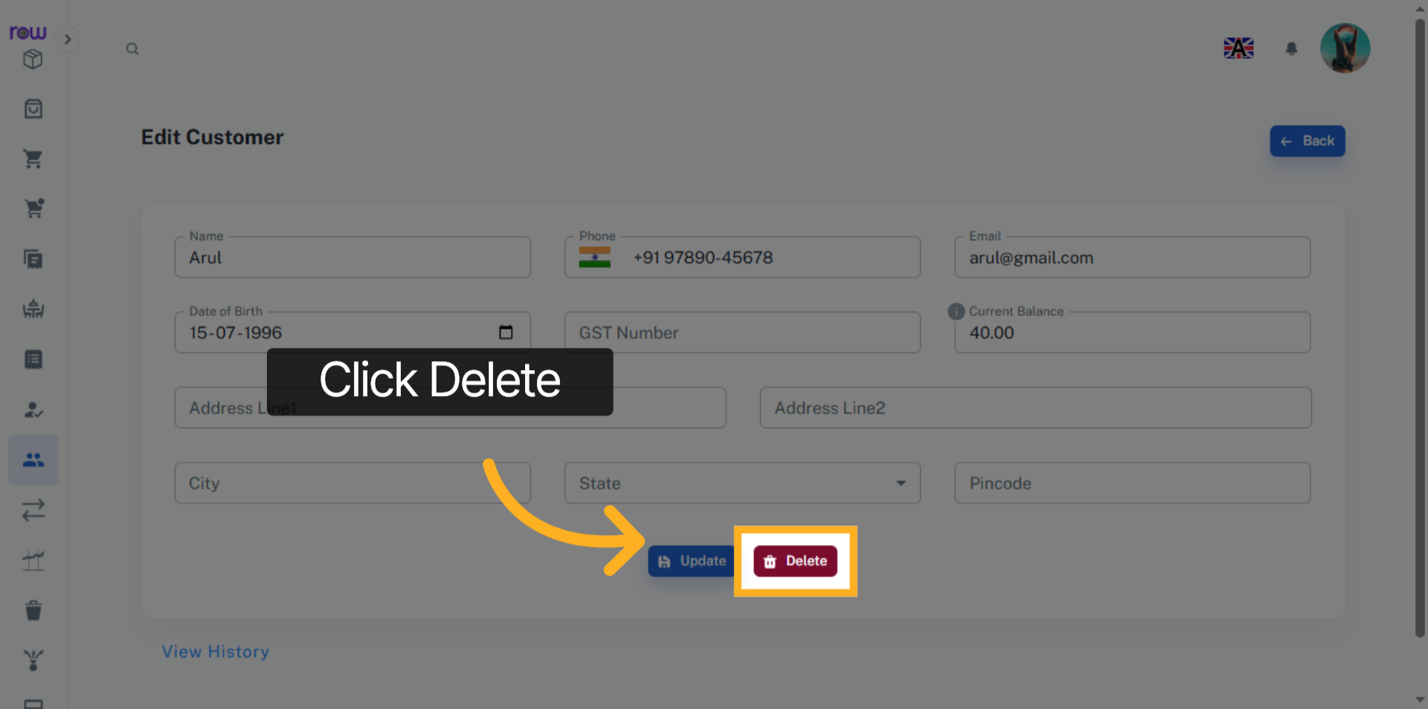

13. View History
Click the View History link to see the Custom’s history.
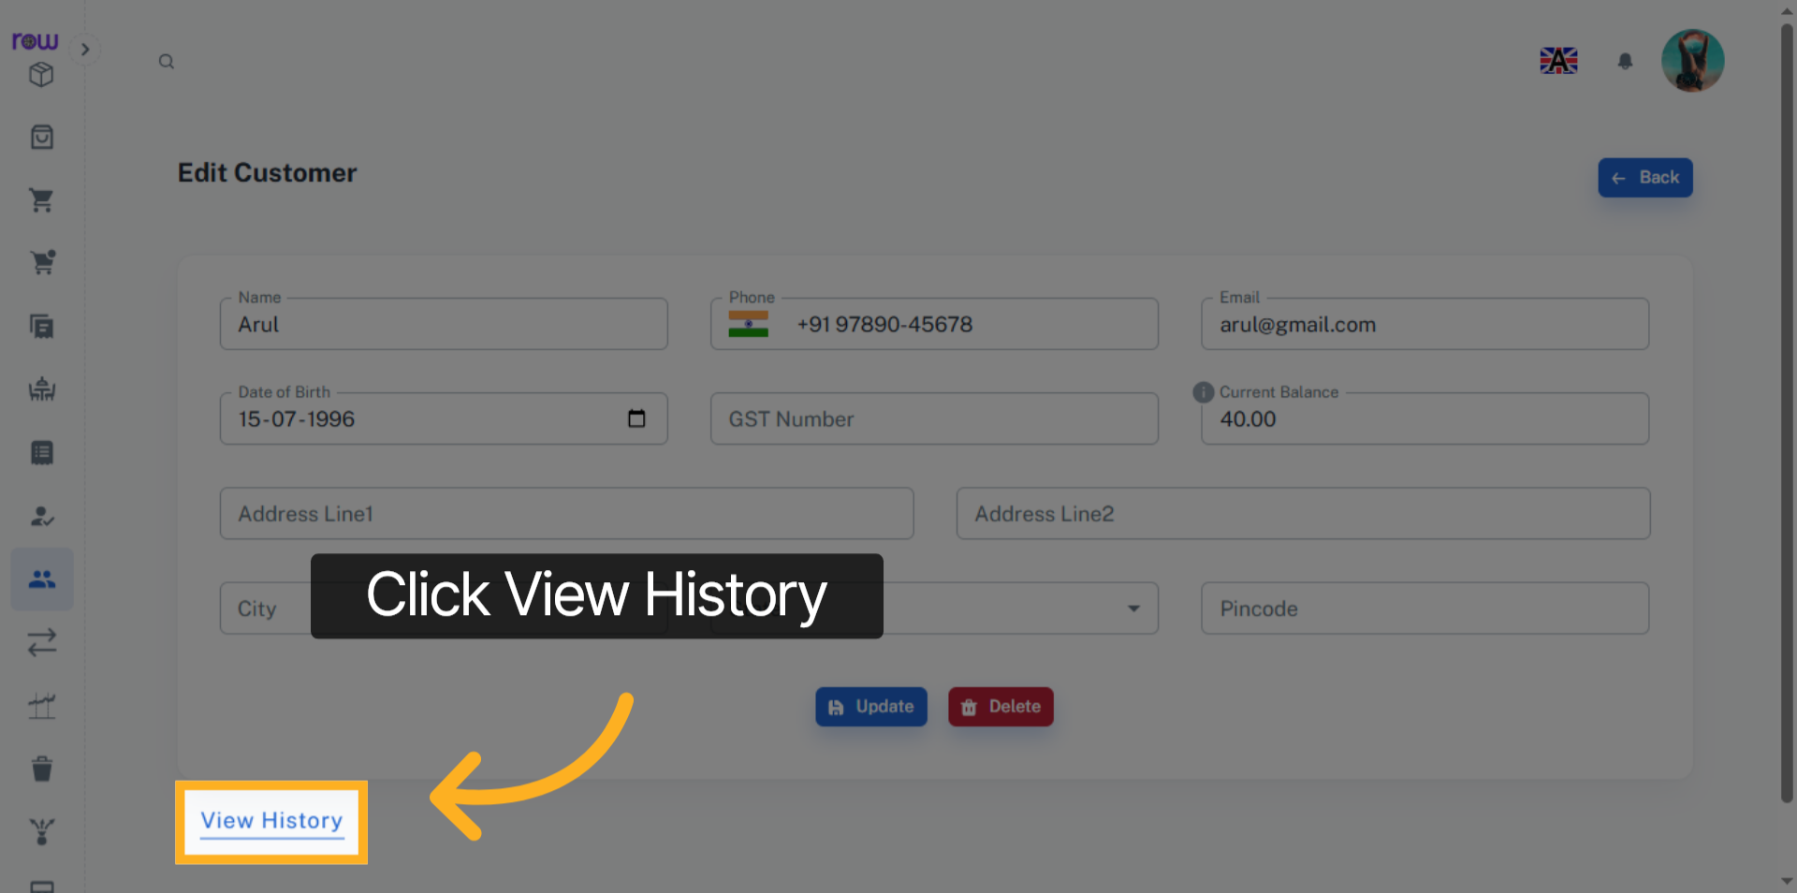

14. Features
You can also view the Sales History, Order History, Table Order History, Invoice History, Pending Bills, Pending Invoices and Transactions of a customer.
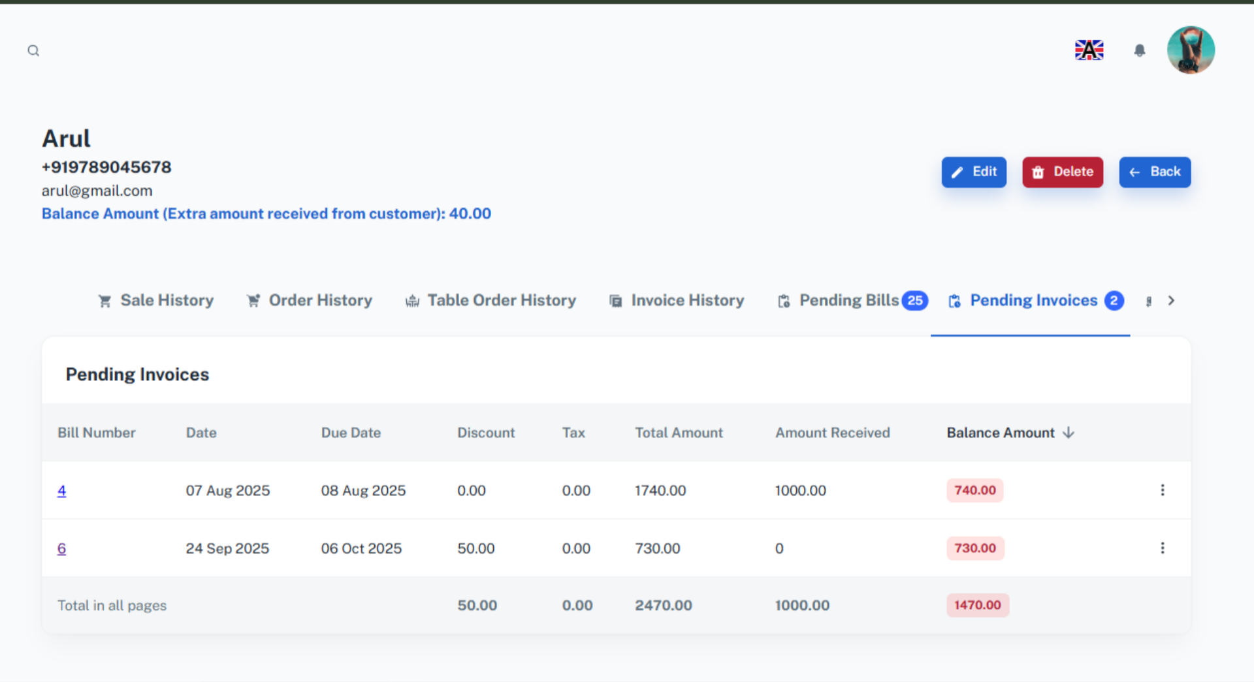

15. Pay
You can make payments in the transactions tab.
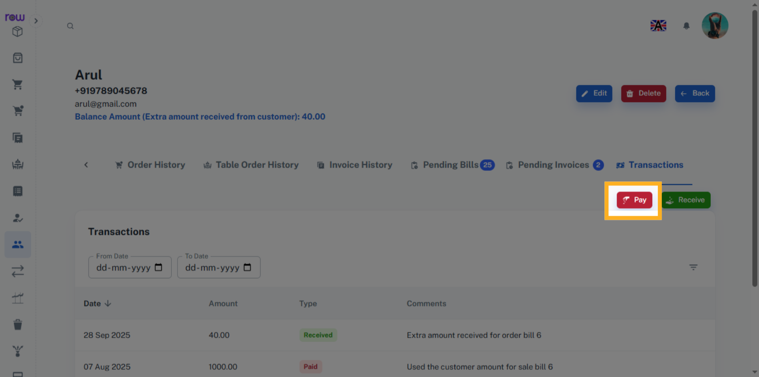

16. Payments
You can pay the customer if they have a balance amount. The amount paid will be reduced from their balance. If the customer does not have any balance, the payment cannot be processed.
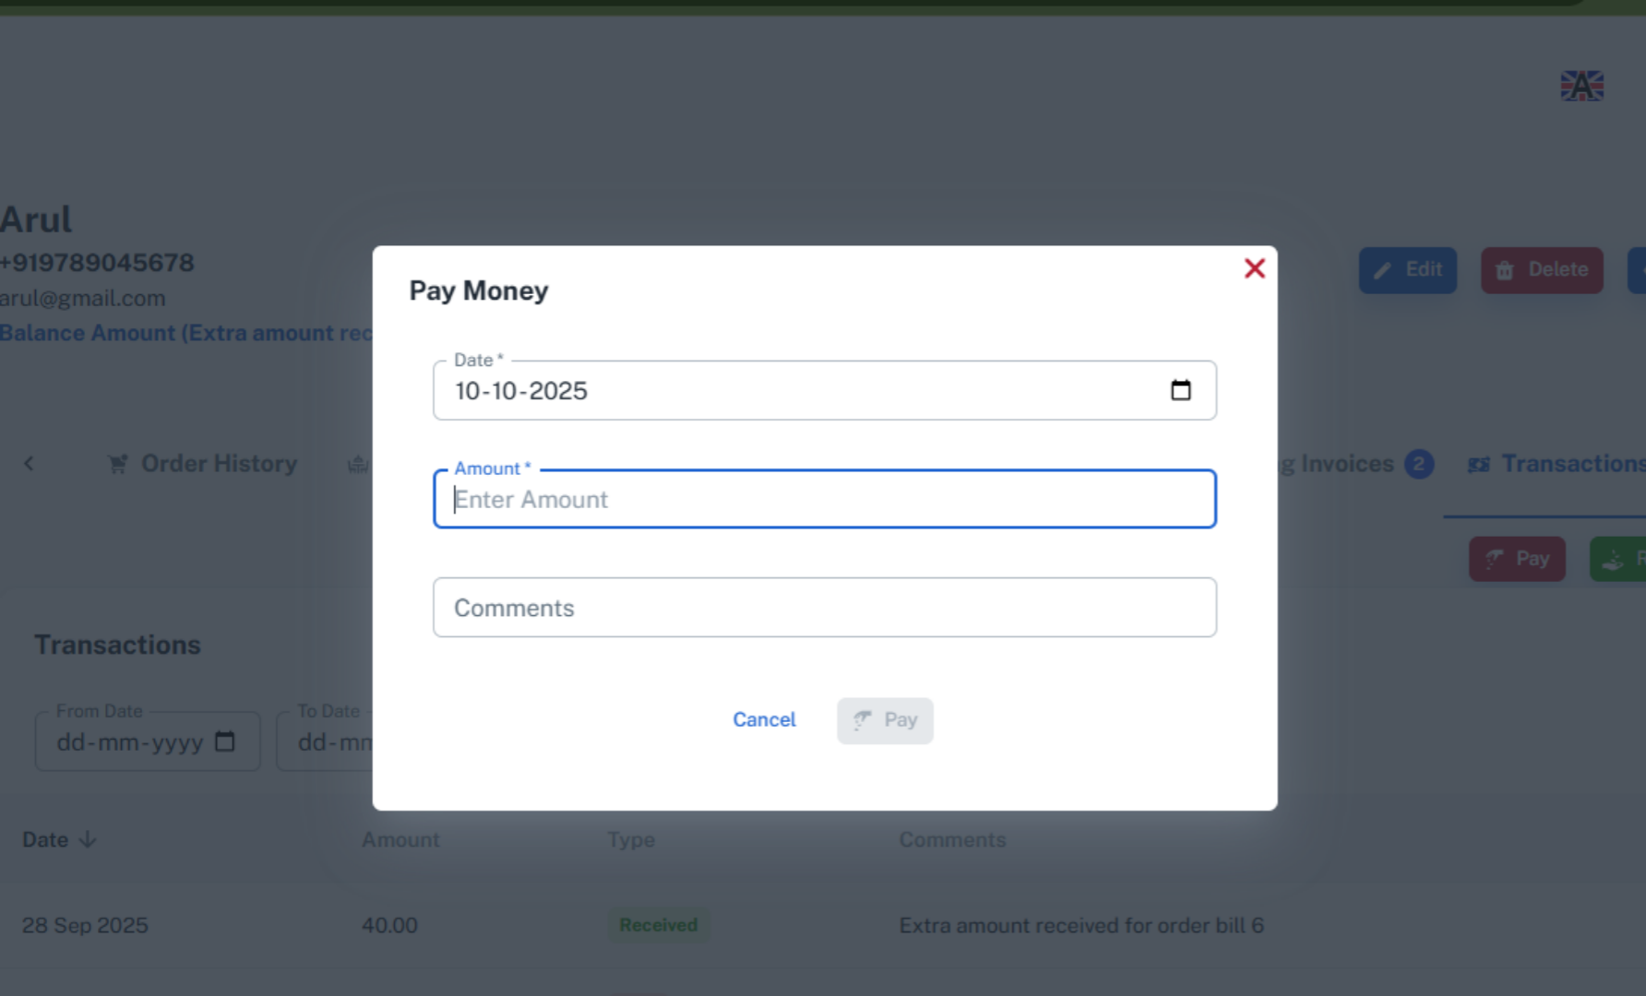

17. Receive
You can receive payments in the transactions tab.
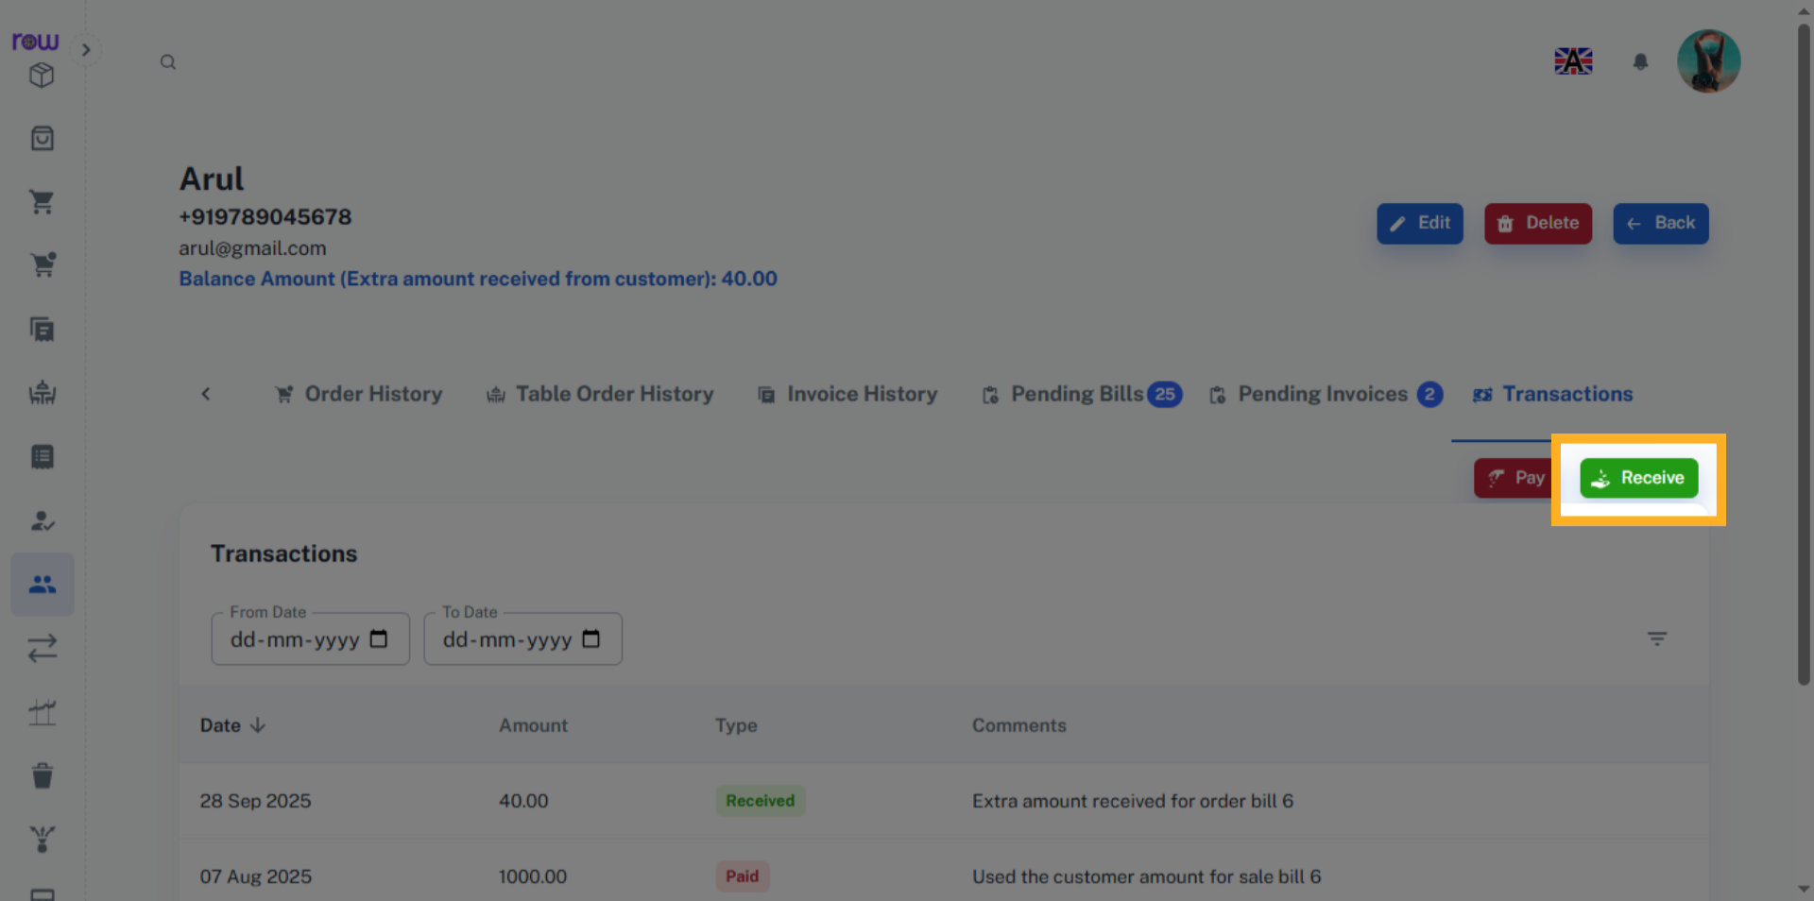

18. Payments
Enter the amount to be received from a customer. You may also clear pending bills by selecting them. The amount will be automatically allocated, and the pending bills will be cleared from the pending bills list. The Extra amount received will be added to the customer balance.
