Generate an E-Way Bill in Runonweb

Go to runonweb.com

1. Introduction
In this tutorial, you will learn how to generate an e-way bill.
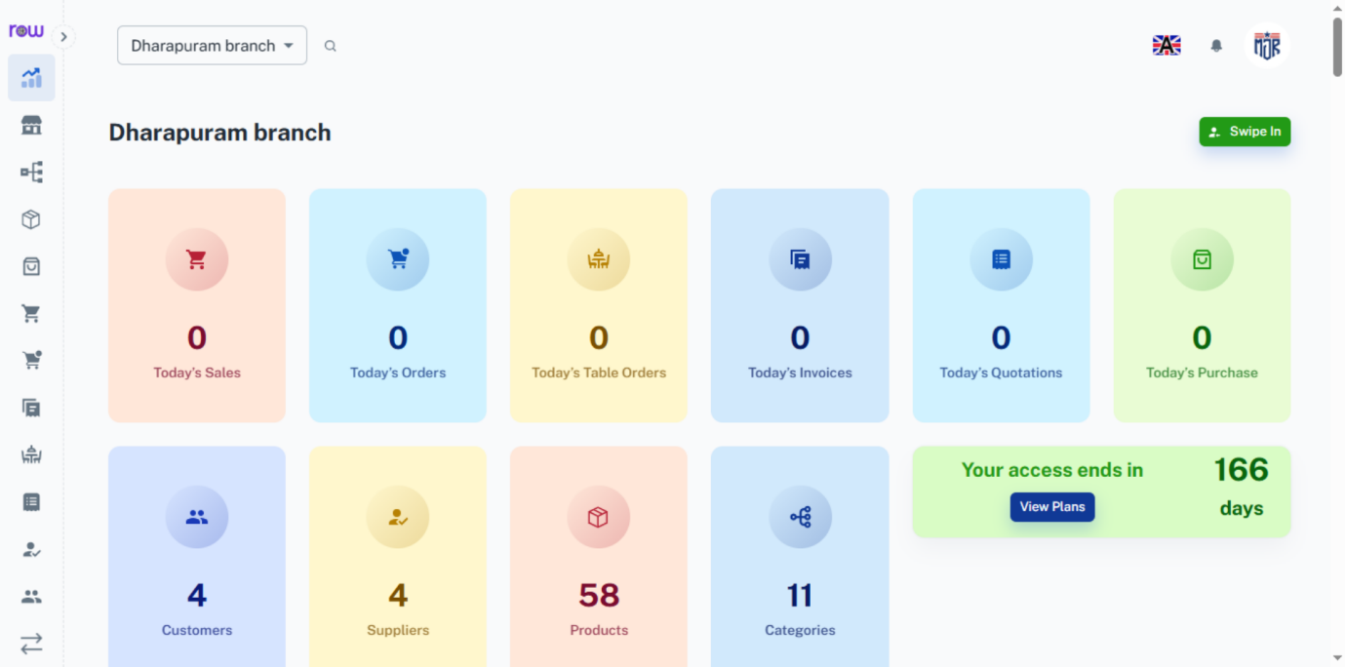

2. Click Sales
Click Sale to go to the sales list screen.
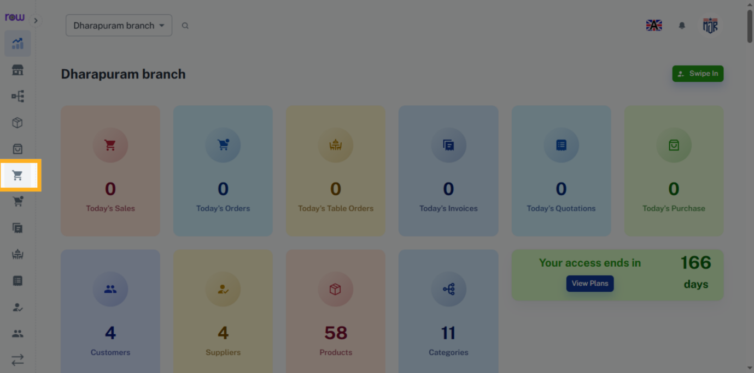

3. Sales List Screen
On the sales list screen, click the bill number to edit the sale.
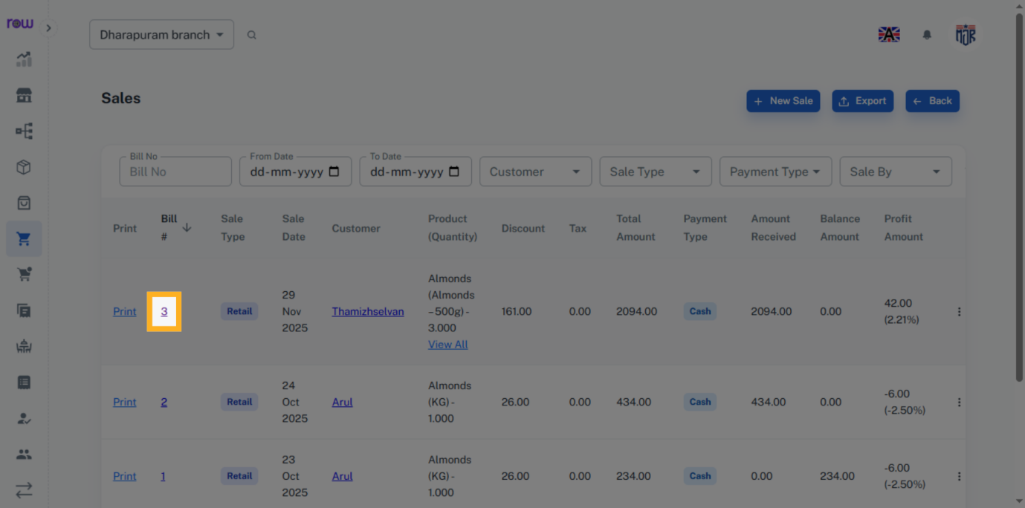

4. Sales Edit Screen
You can see the sales edit screen here.
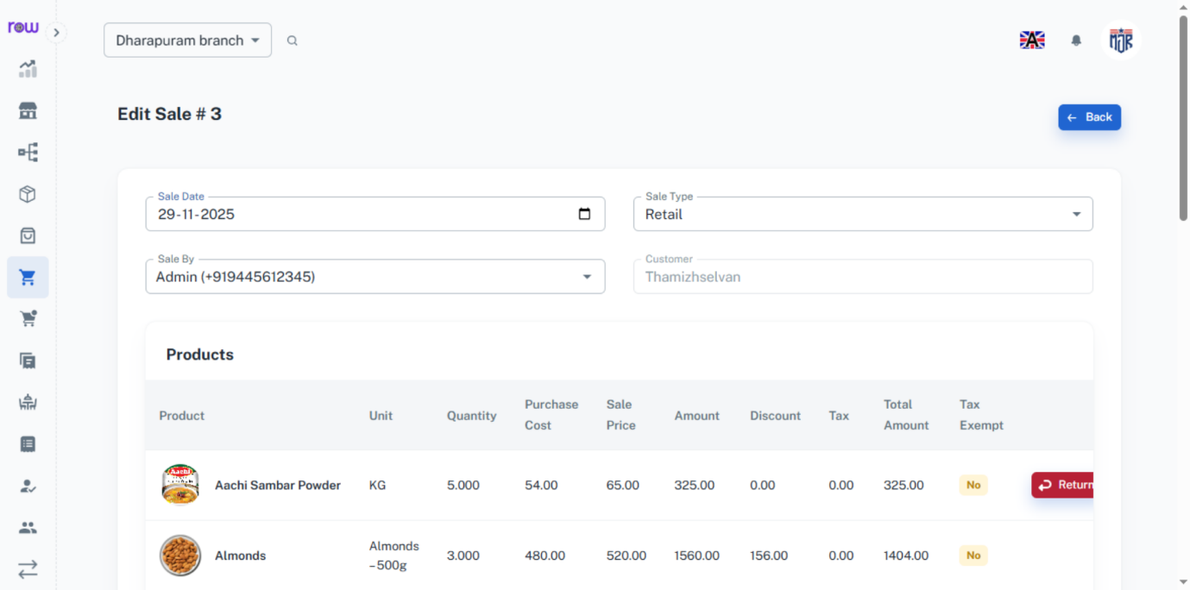

5. Sales Edit Screen
Scroll down on the sale edit screen to see the Generate E-invoice & E-way Bill button, and click it to view the options.
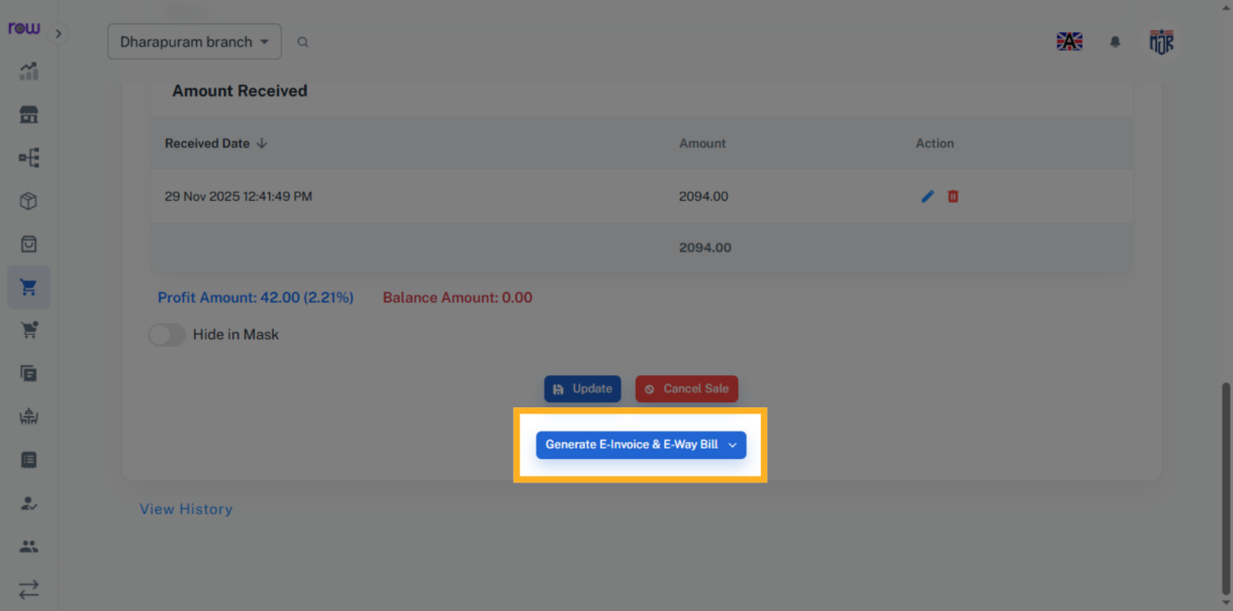

6. Bill Options
You can see the options to generate an e-invoice and an e-way bill here.
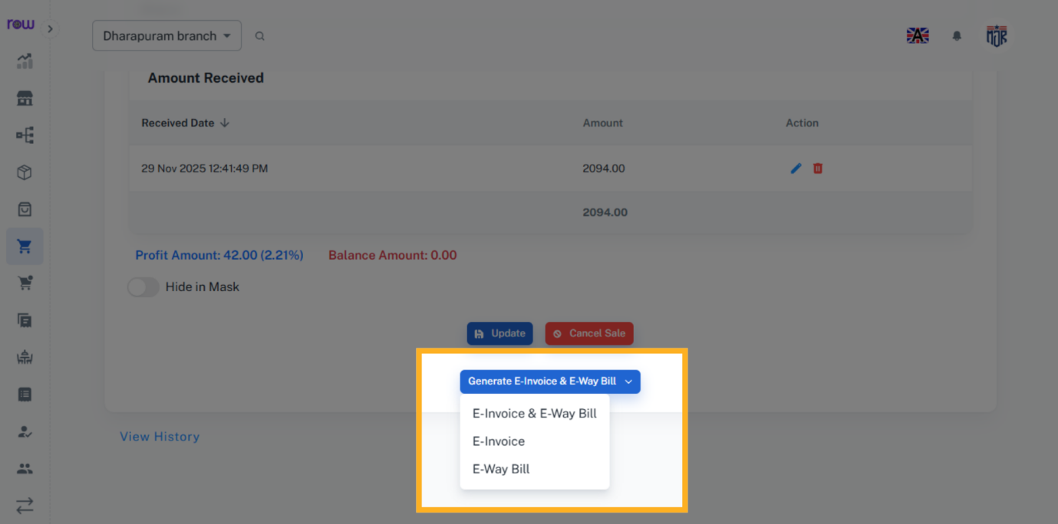

7. E-invoice and E-way Bill
If you want both an e-way bill and an e-invoice, click E-invoice and E-way Bill.
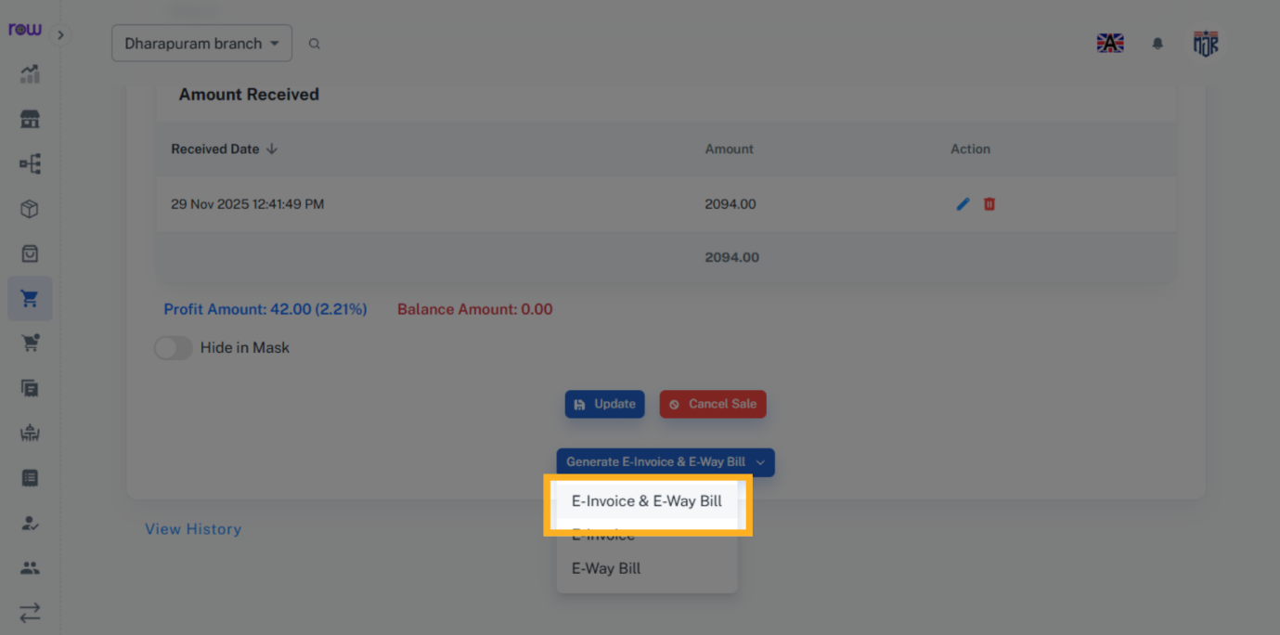

8. E-Way Bill
Click E-way Bill to generate an e-way bill.
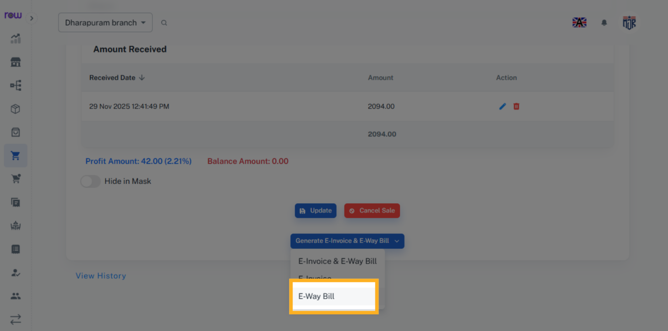

9. E-Way Bill
Fill in the necessary details and click generate to generate the E-way Bill.
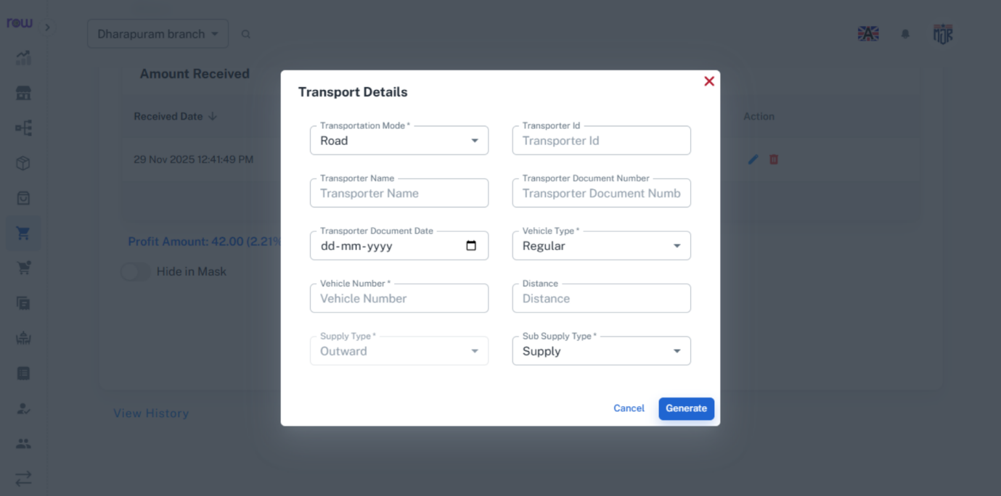

10. E-Way Bill
The e-way bill generated for sale. Likewise You can generate an e-way bill for purchase, order, and invoice using the same procedure.
