Create and Manage Employee in RunOnWeb

Go to runonweb.com

1. Introduction
In this tutorial, you will learn how to create and manage employees.

2. Employee Menu
Select the Employee menu to start creating a new employee.
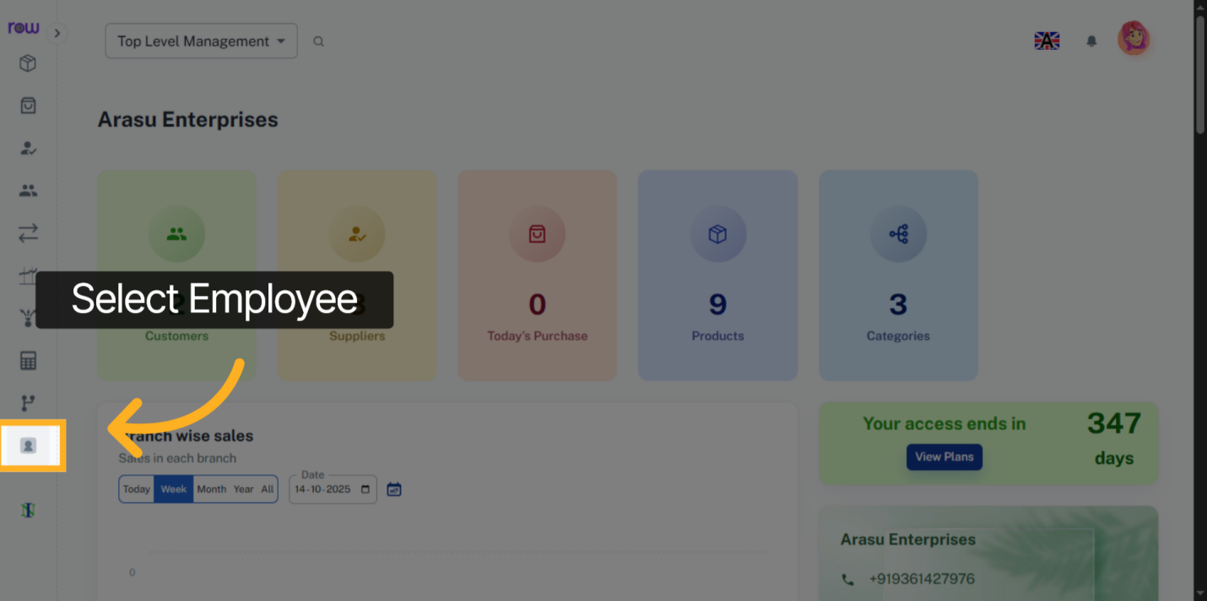

3. New Employee Button
Click the New Employee button.
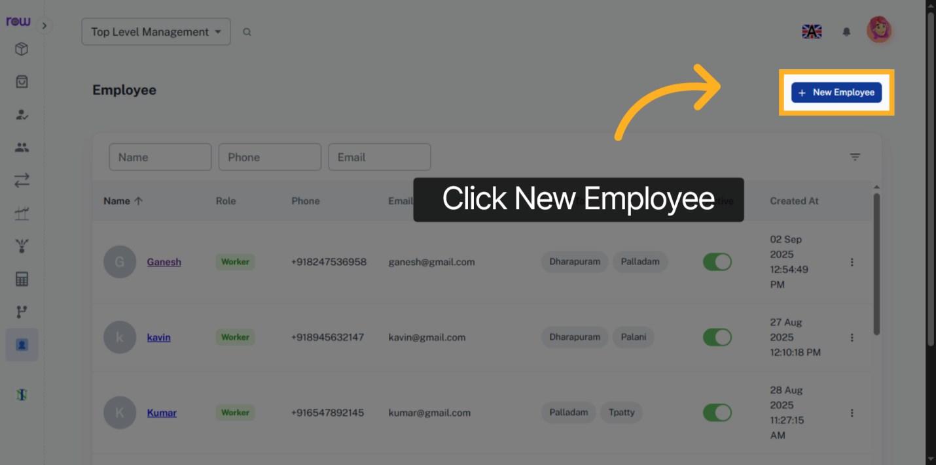

4. New Employee Screen
Enter the required details of the Employee.
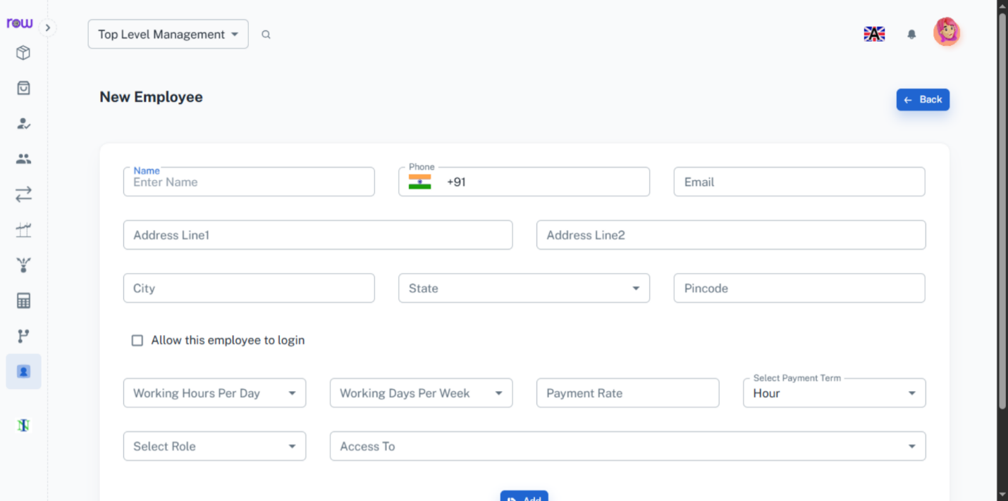

5. Check Box
Select this checkbox to Allow this employee to login and access the Portal .
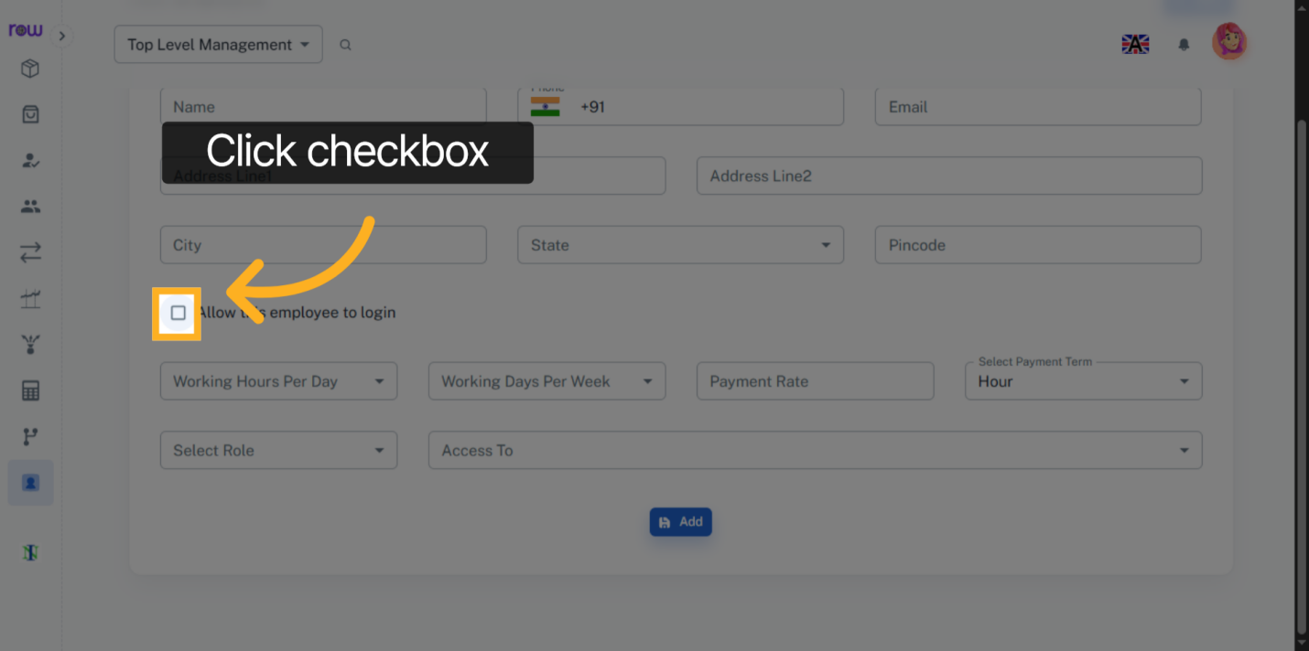

6. Required Fields
You can create a username and password for this employee, if the checkbox is Checked.
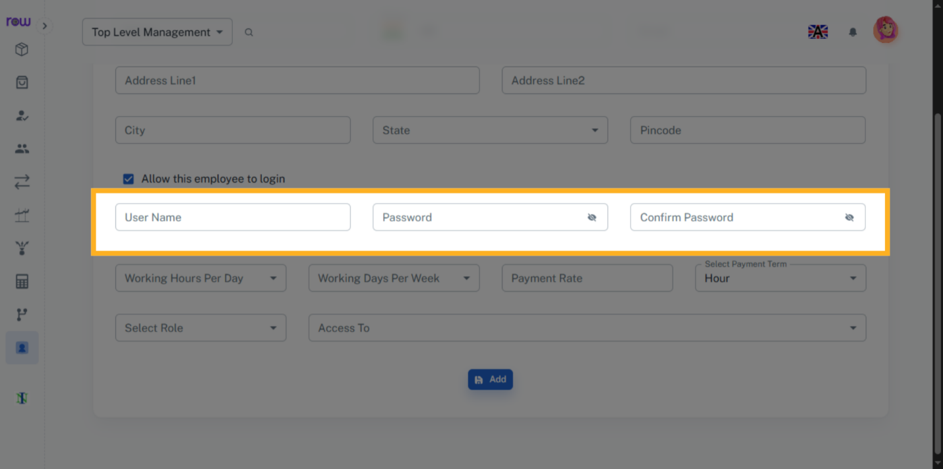

7. Working Hours
Select the Working hours per day for an employee.
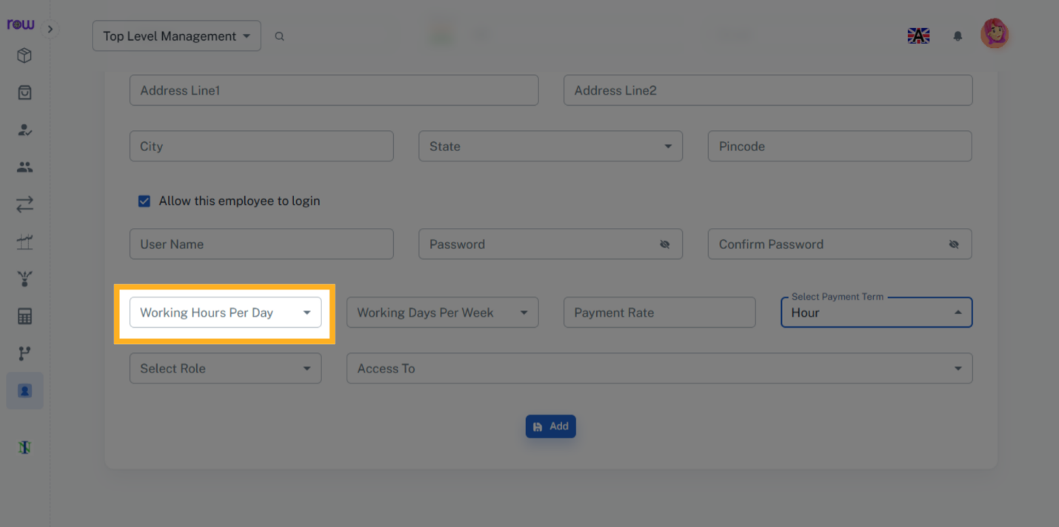

8. Working Days
Select the Working days per week for an employee.
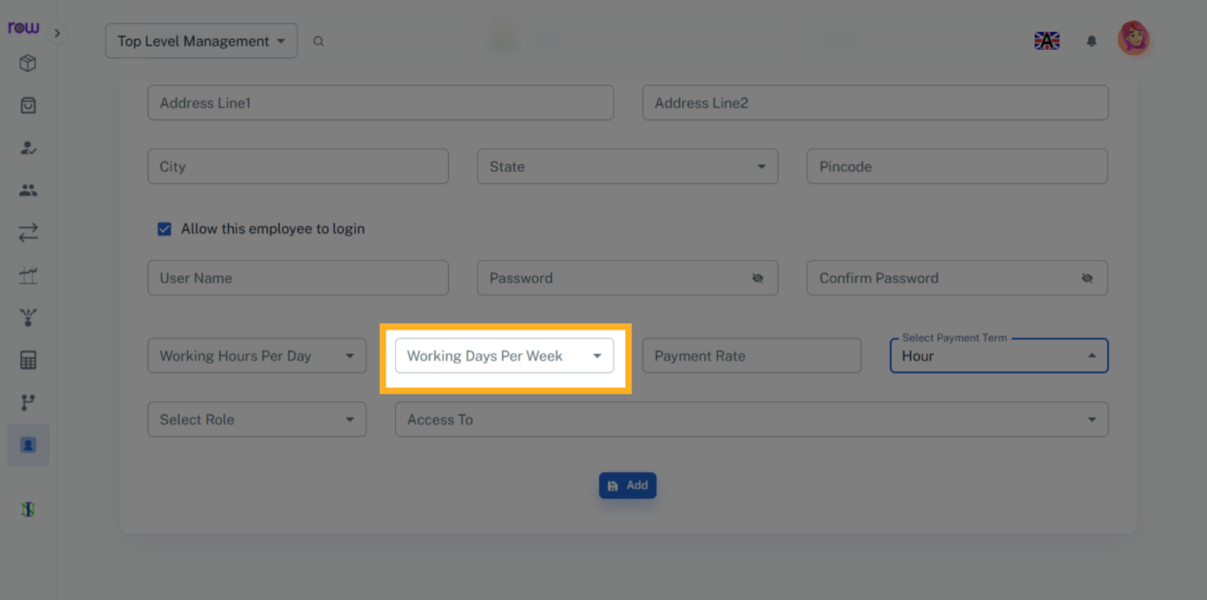

9. Payment Rate
Select the payment rate for an employee.
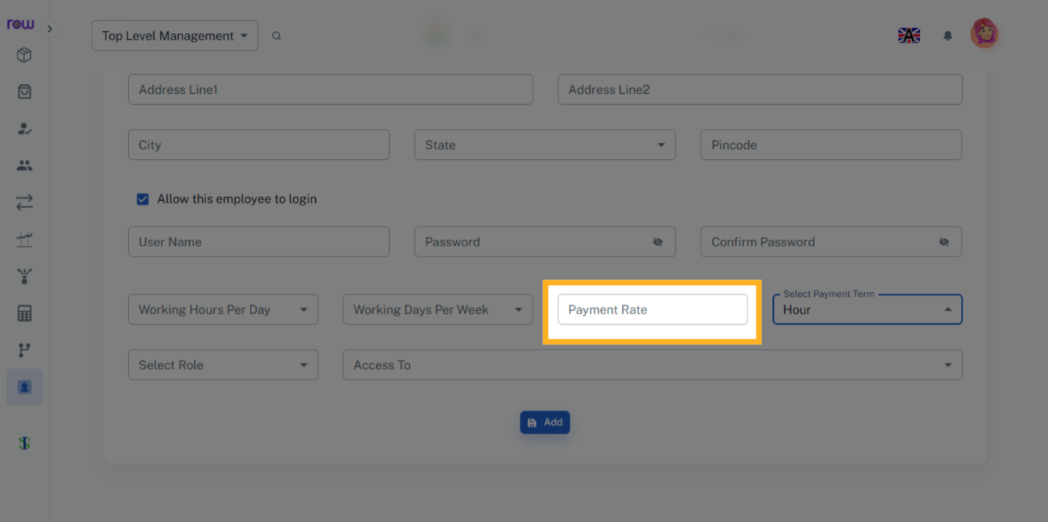

10. Payment Term
The salary will be calculated for this employee based on the selected payment term and the entered payment rate.
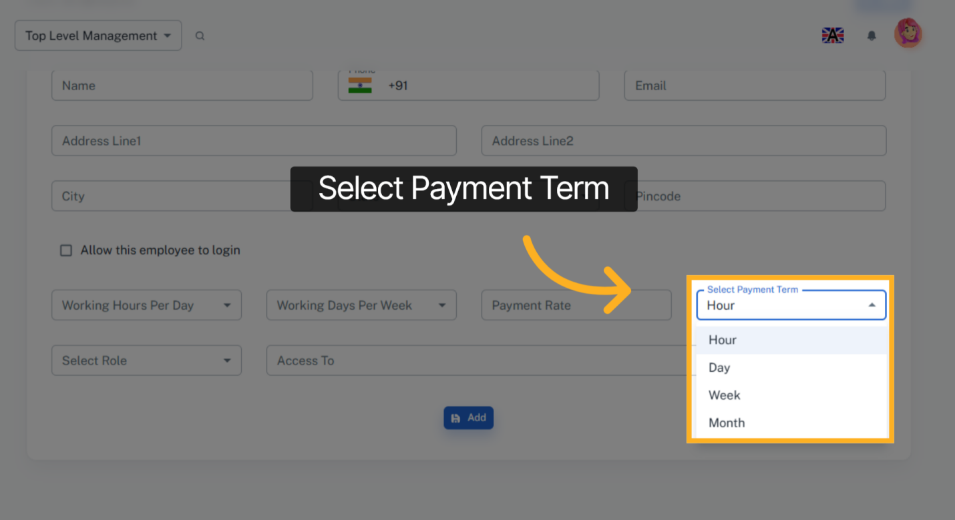

11. Select Role
Select the role of this employee.
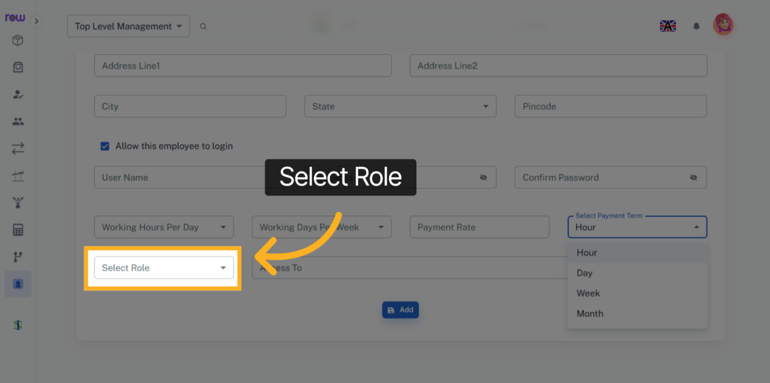

12. Select Access To
Select the access to for this employee. This employee can be able to log in to the branches only selected here.
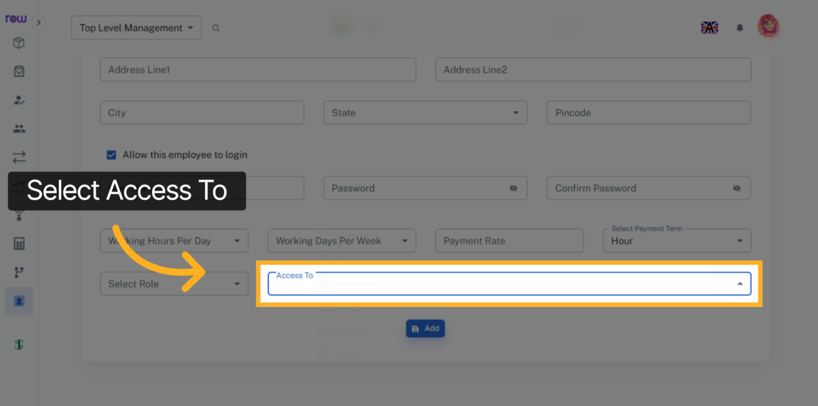

13. Add
Click the Add button to create the employee.
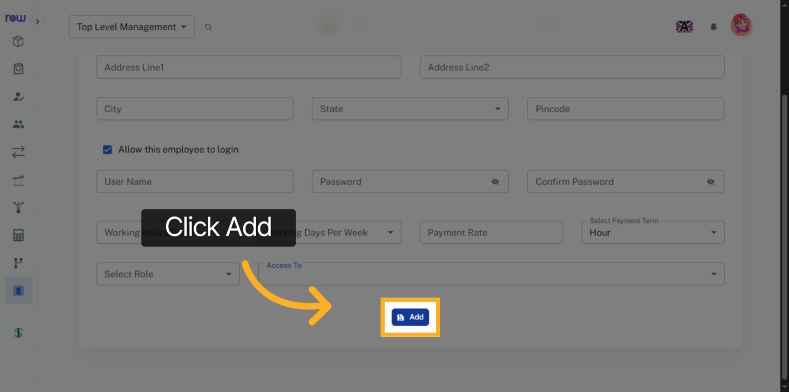

14. Employee List Screen
You will be redirected to the Employee List screen after a new employee is successfully created.
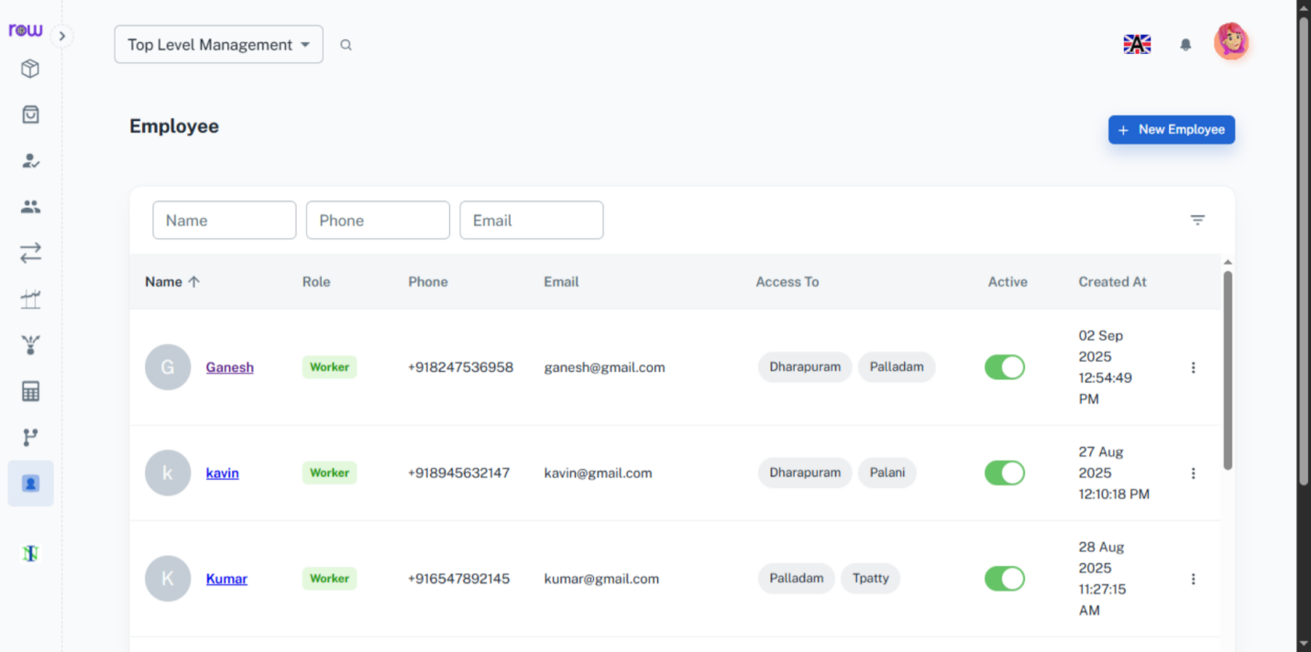

15. Select Employee Name
Click the employee name to view and update their details.
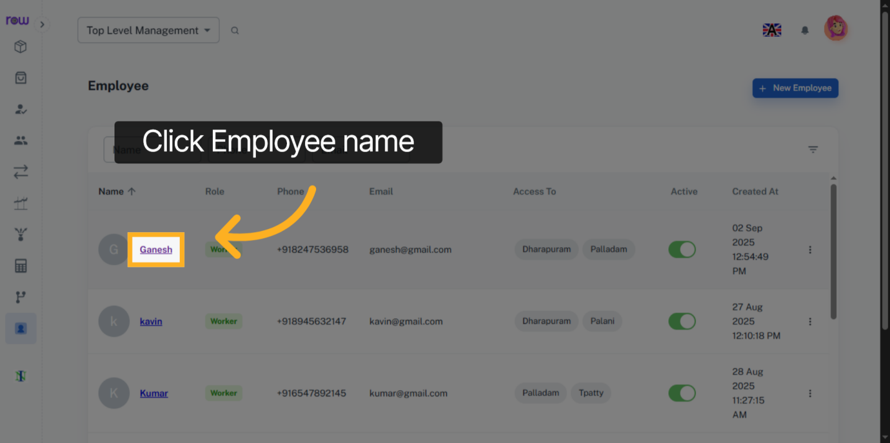

16. Employee Details
You can view the employee’ name, phone number, email, and address.
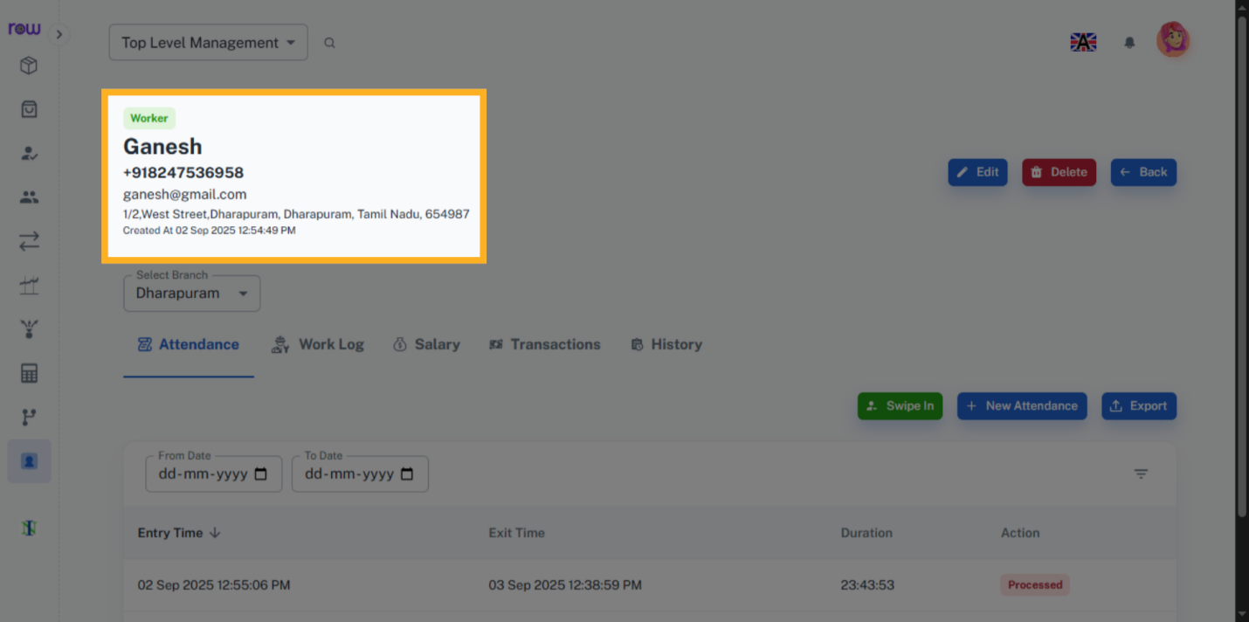

17. Edit
Click the Edit button to edit the employee details.
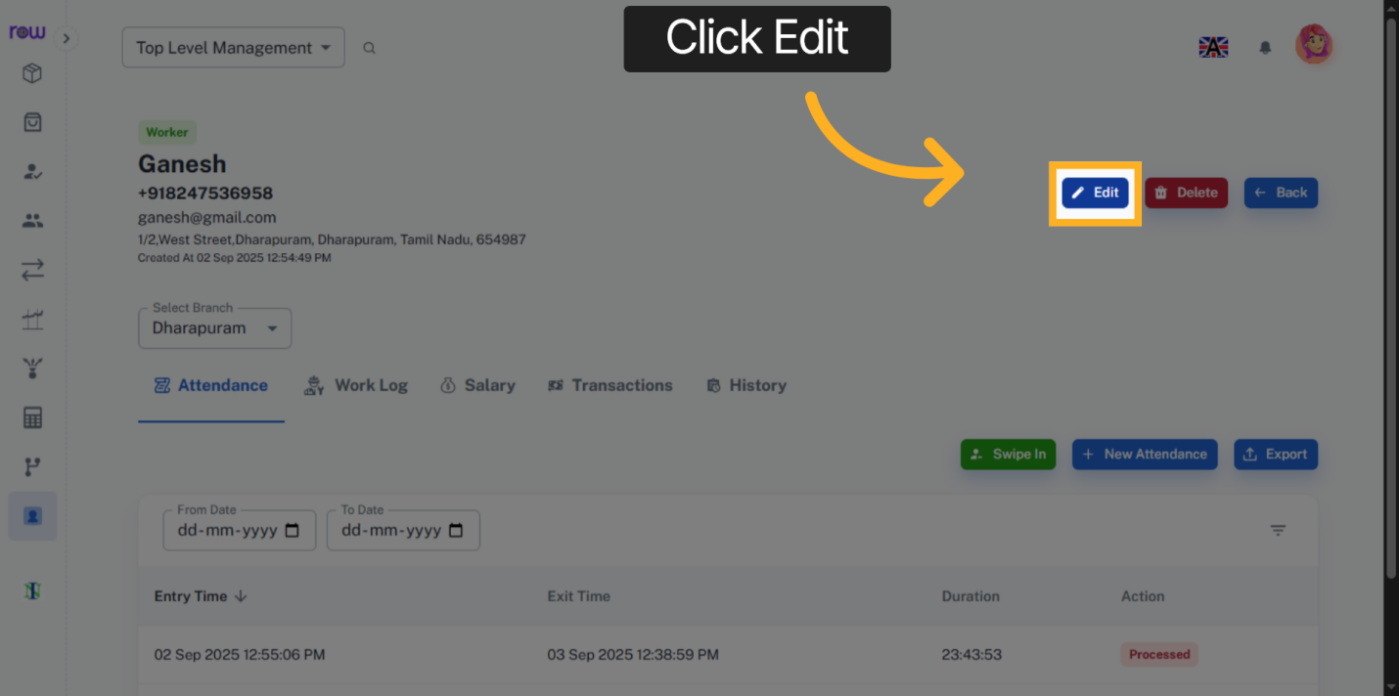

18. Update Employee Details
Click the Update button to save the changes.
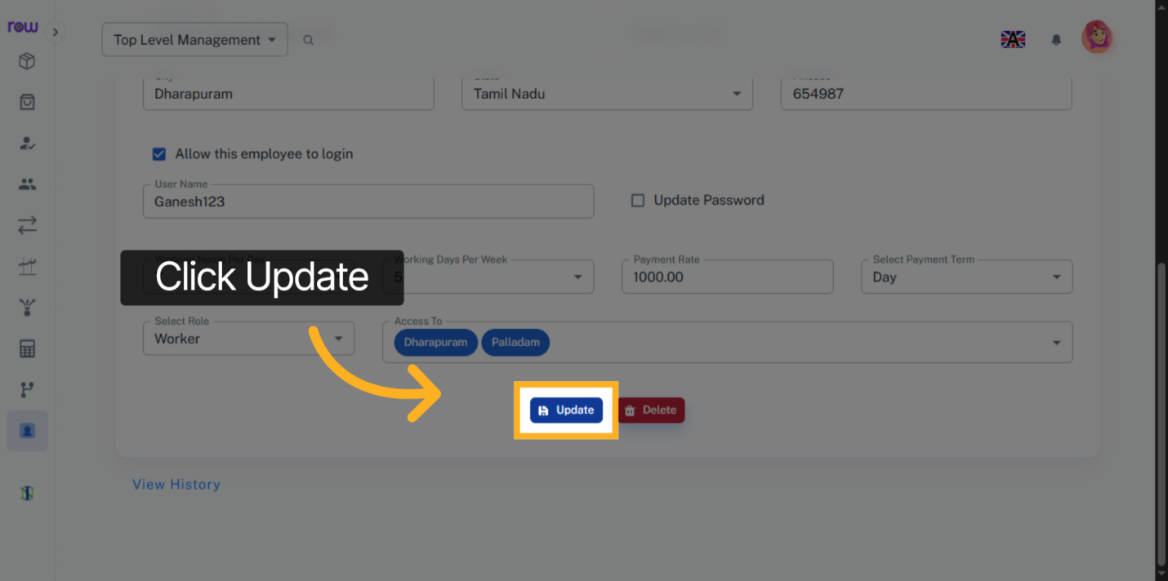

19. Delete Employee
Click the Delete button to remove the employee.
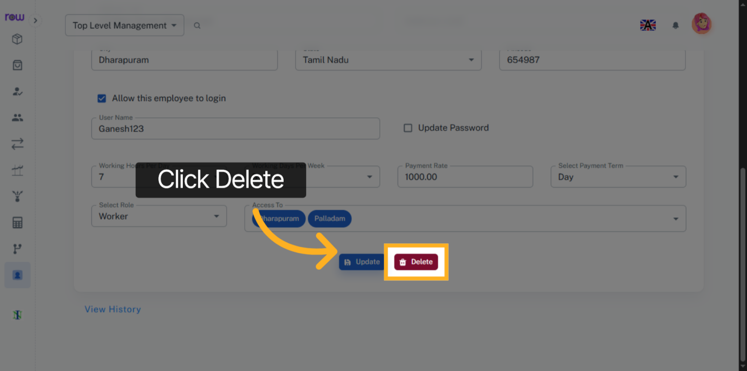

20. History
Click the View History link to see the employee history.
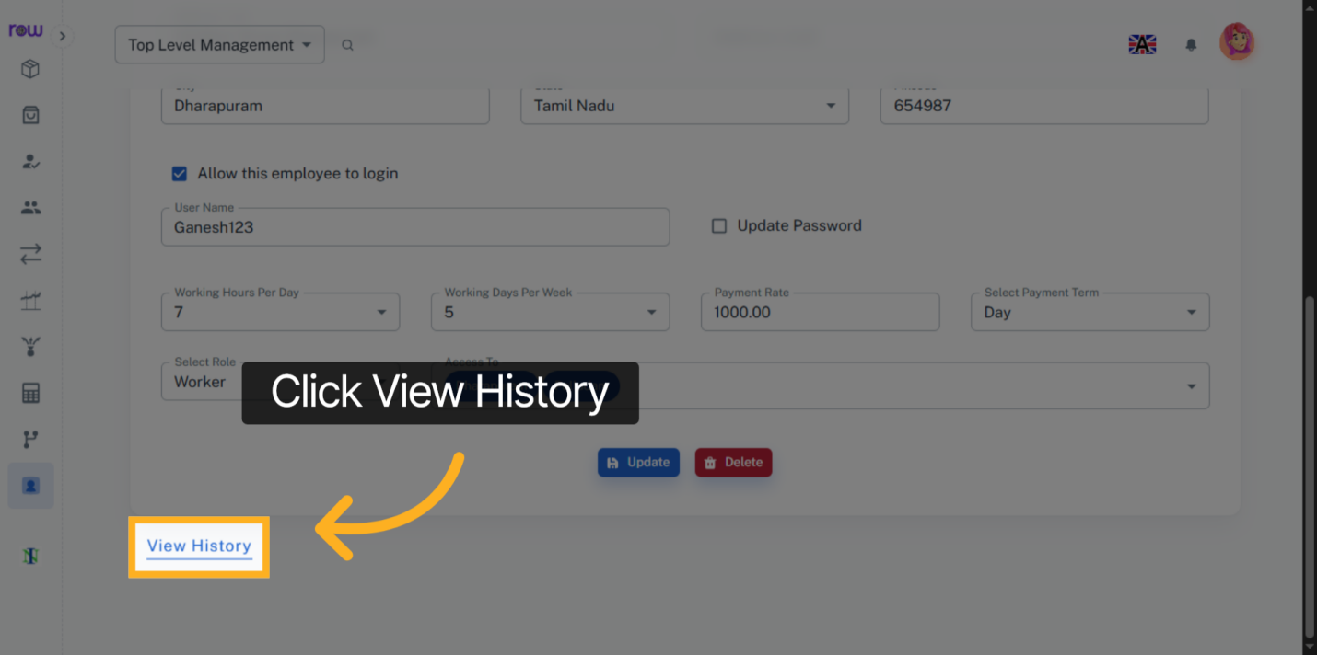

21. Select Branch
You can view the employee details for a specific branch by selecting the branch.
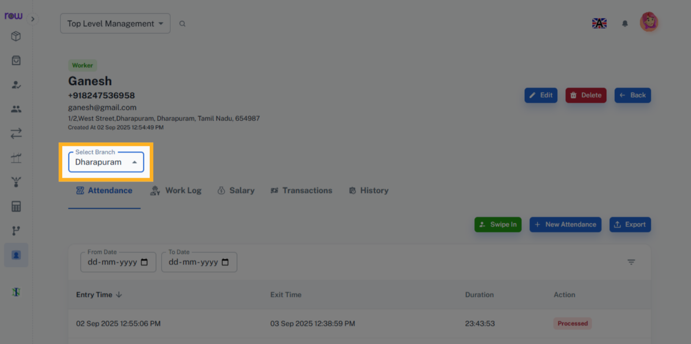

22. Swipe In and Swipe out
You can swipe in or swipe out this employee.
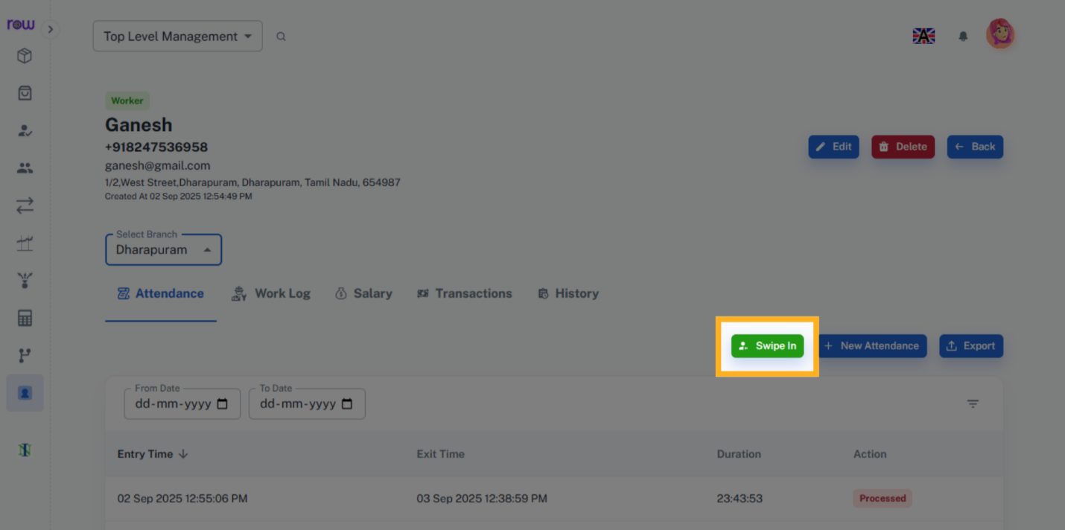

23. Attendance
Attendance is calculated based on the swipe-in and swipe-out times. You can also add, remove and update attendance.
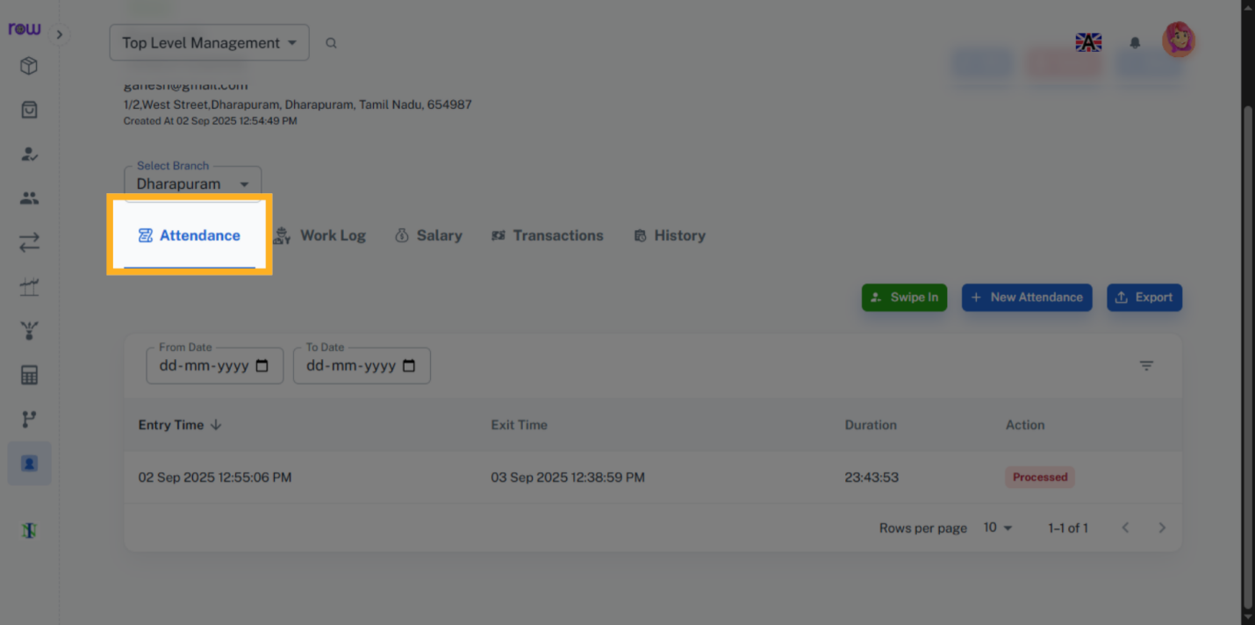

24. Attendance Details
You can view the employee’ attendance details here.
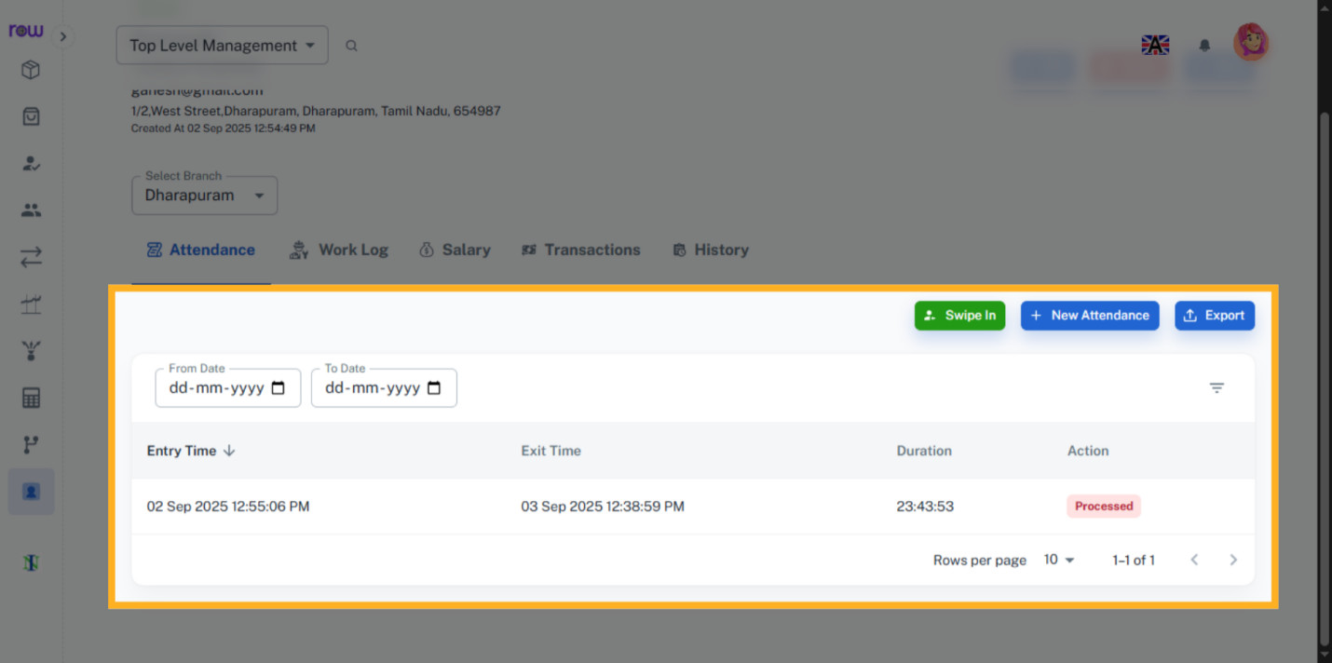

25. New Attendance
Click New Attendance button to creating a new attendance.
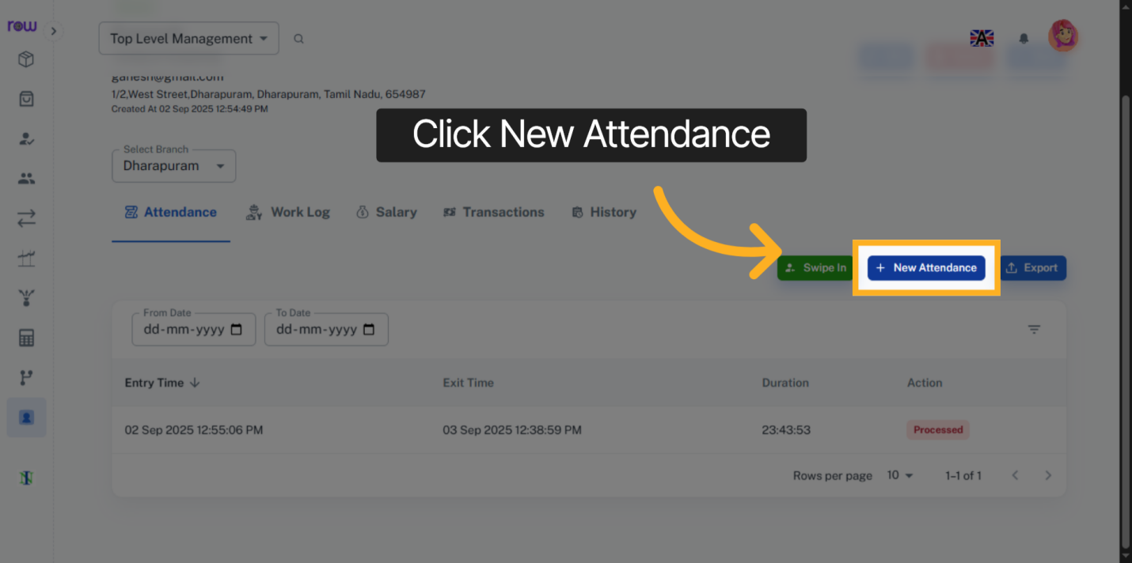

26. New Attendance Entry
Select the Entry Time and Exit Time.
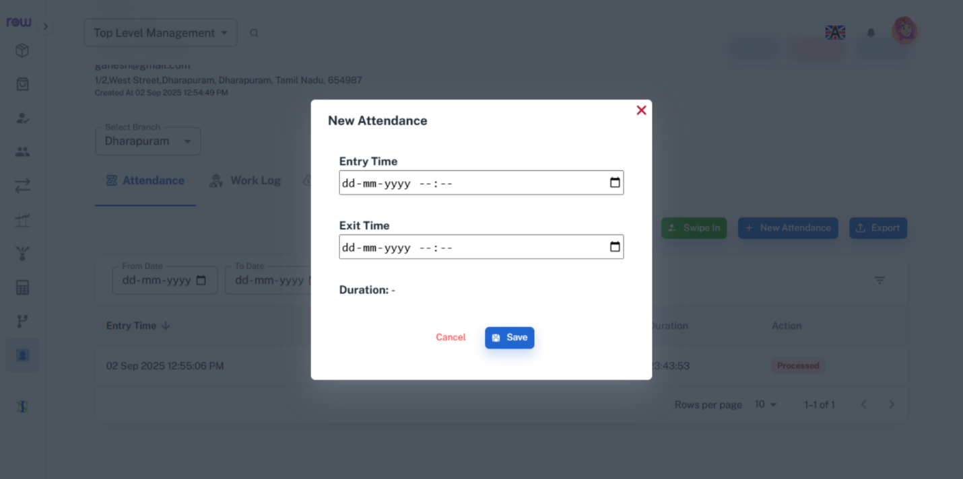

27. Work Log
If an employee worked on producing a product without marking attendance, and a production unit has been created for that product, you can enter the work-log. Based on the product and its production unit recorded in the work-log, the stock of raw materials will decrease, and the stock of the finished product will increase.
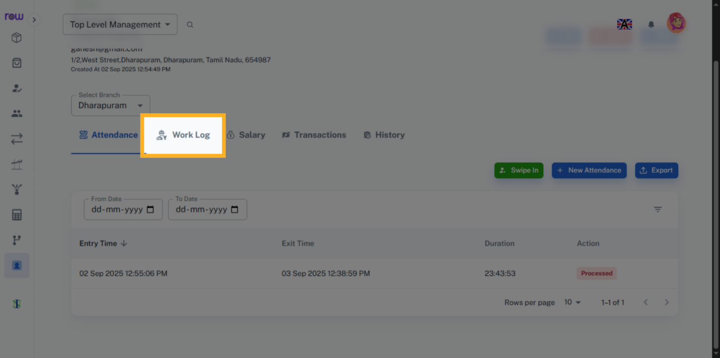

28. Work Logs
You can view the work-log of an employee.
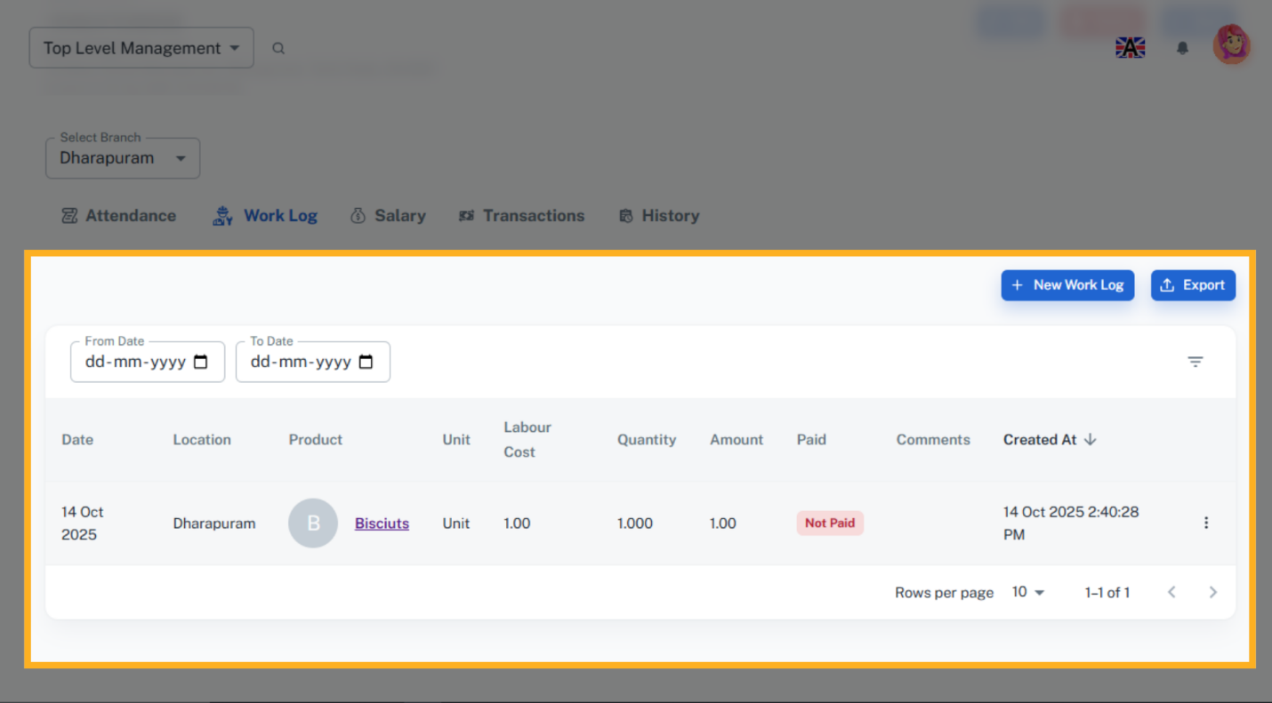

29. New Work Log
Click the New Worklog button to creating a new worklog.
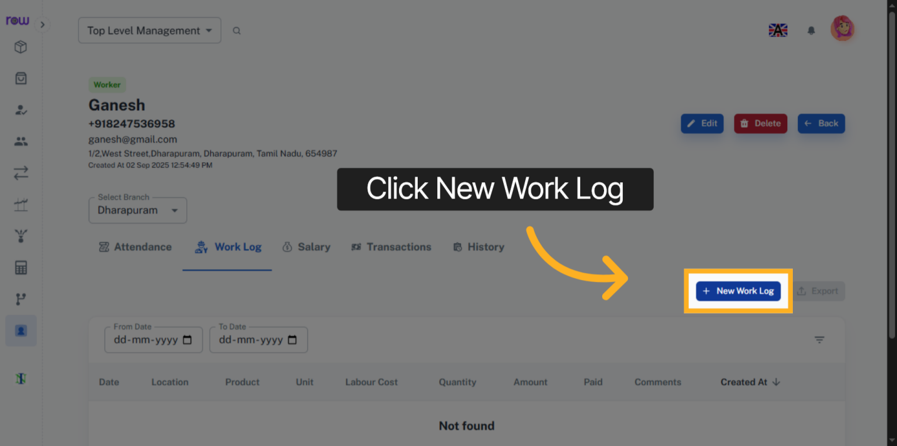

30. New Work Log Details
In the worklog, the amount is calculated based on the selected product, labor cost per unit, and quantity of the product. you can also the change the amount if needed.
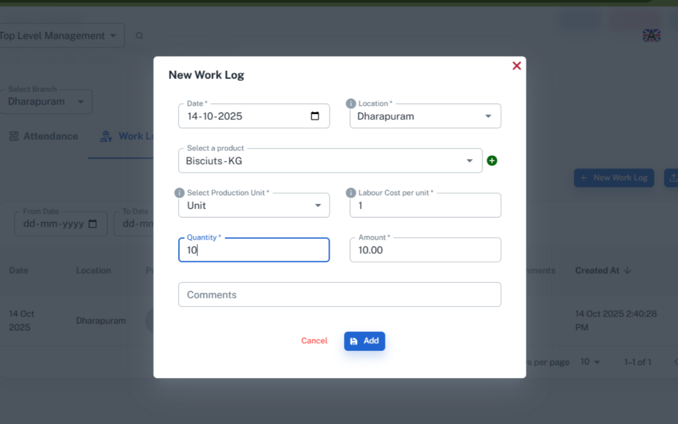

31. Salary
Click Salary to view an employee salary details.
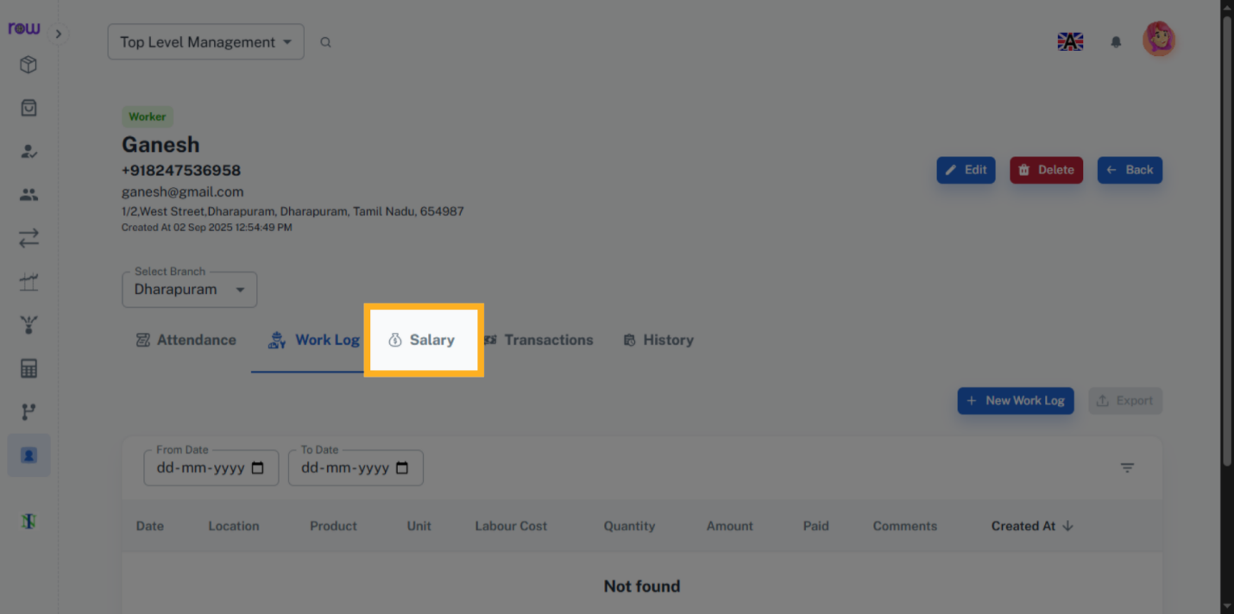

32. Employee Salary Details
You can view the salary details of an employee.
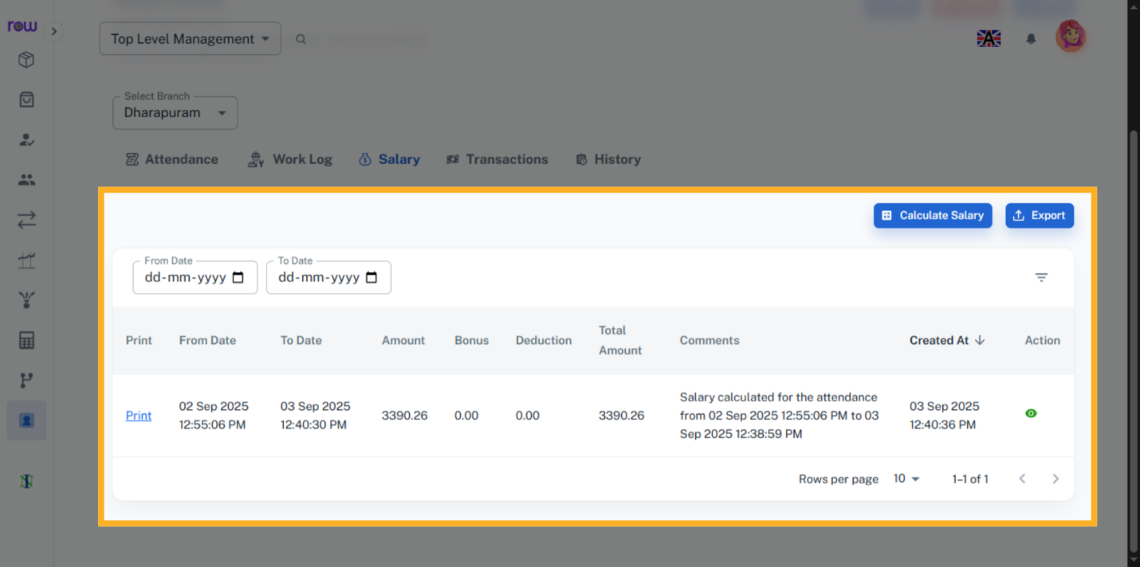

33. Calculate Employee Salary
Click the Calculate Salary button to calculate the employee salary.
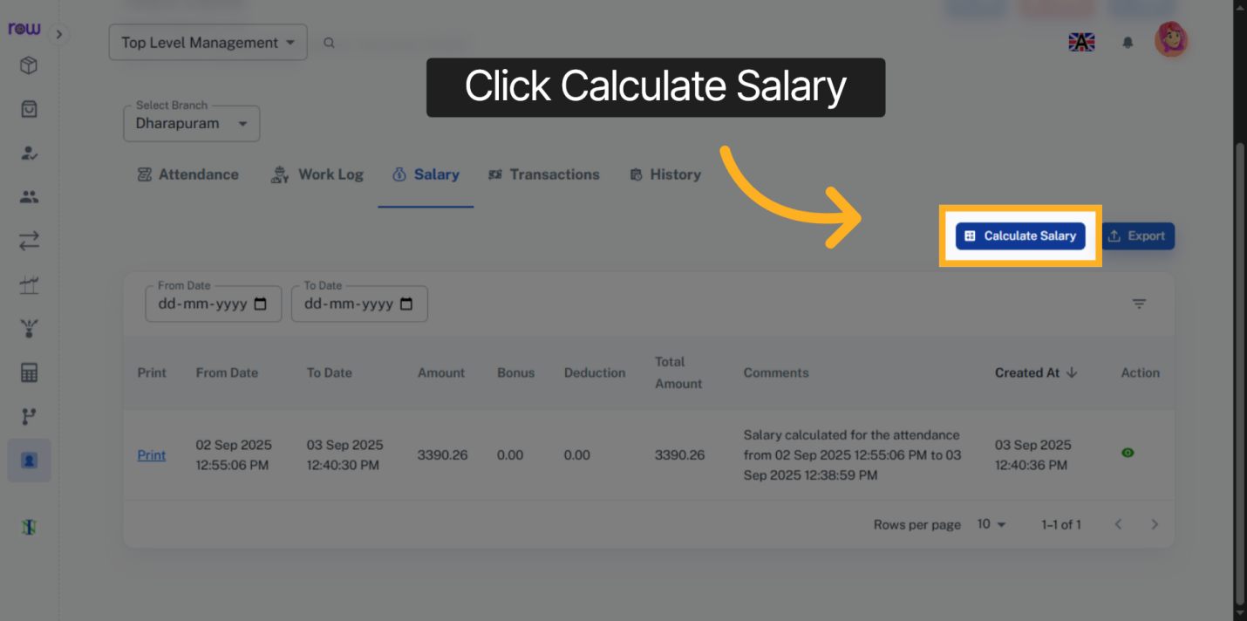

34. Salary Calculation
The salary is calculated based on the attendance and work-log of the employee.
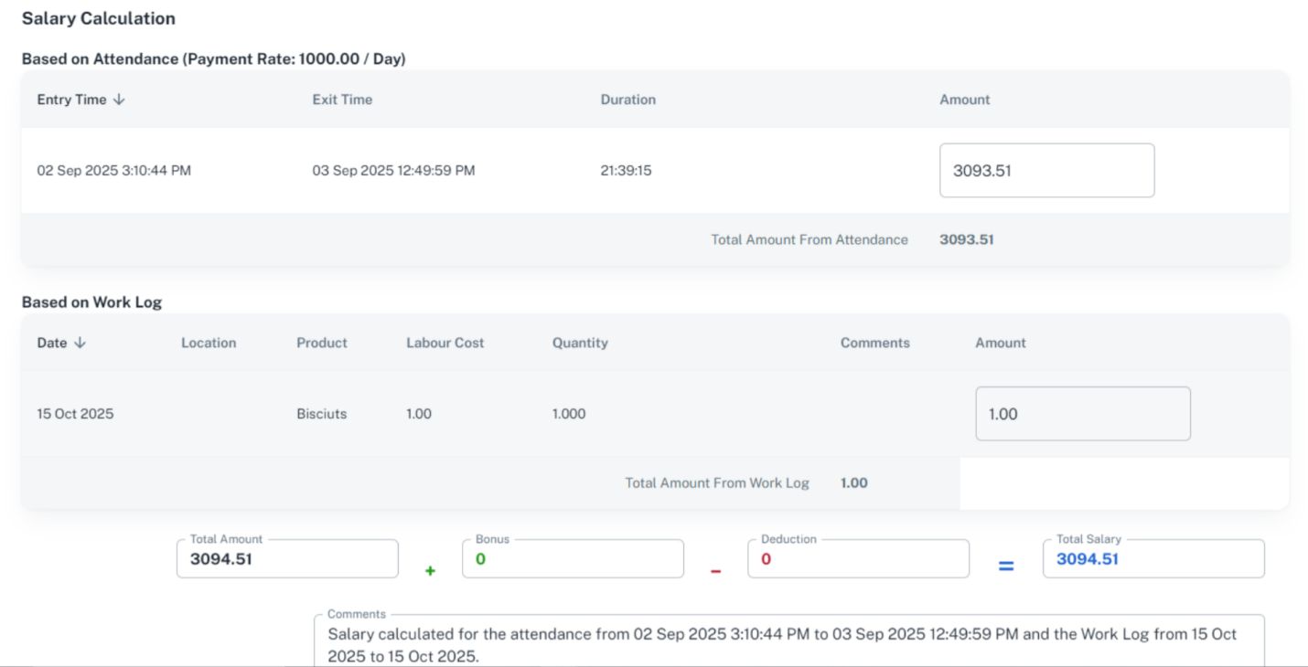

35. Transactions
Click Transaction to view the employee transactions.
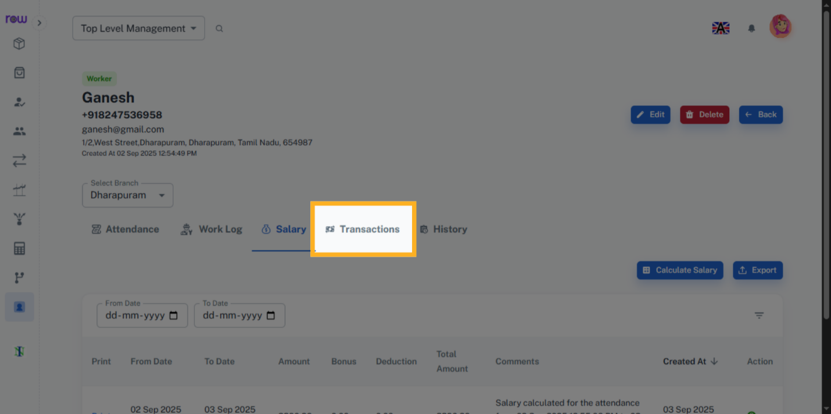

36. Employee Transaction
You can view the employee transactions here. You can also pay and receive payments here.
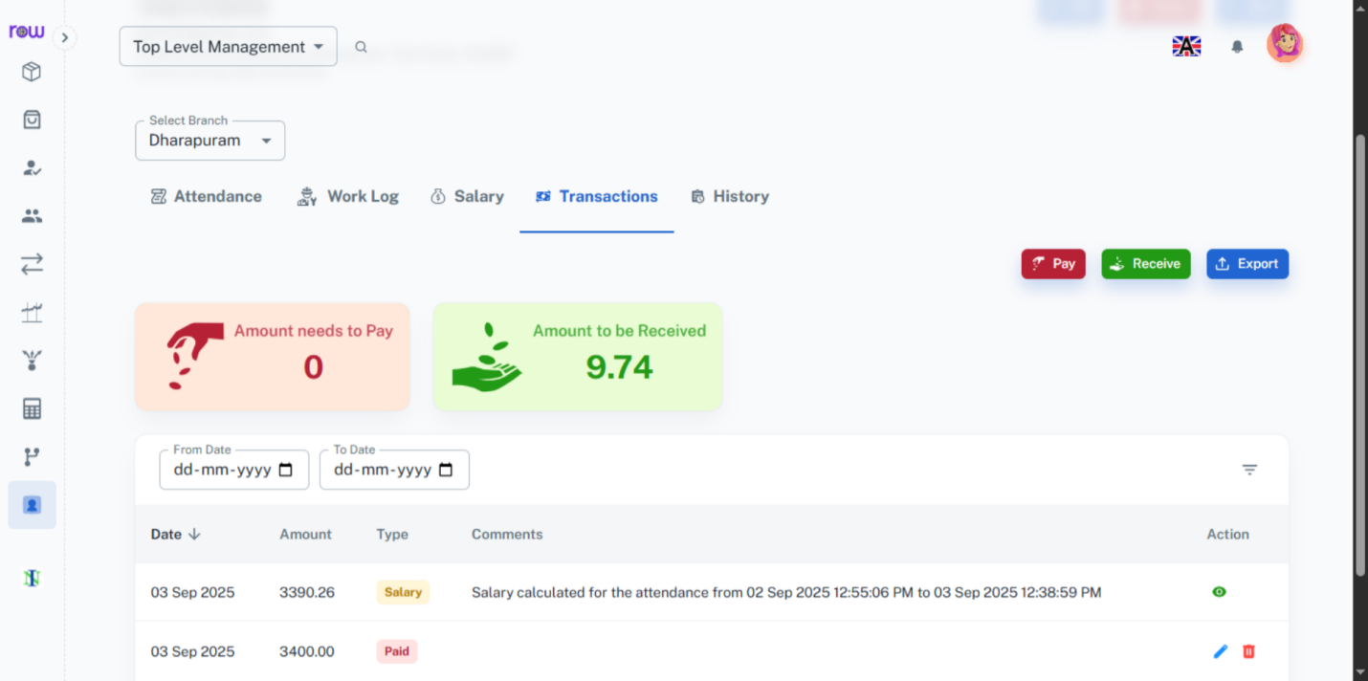

37. Pay
Click Pay button to make a payment.
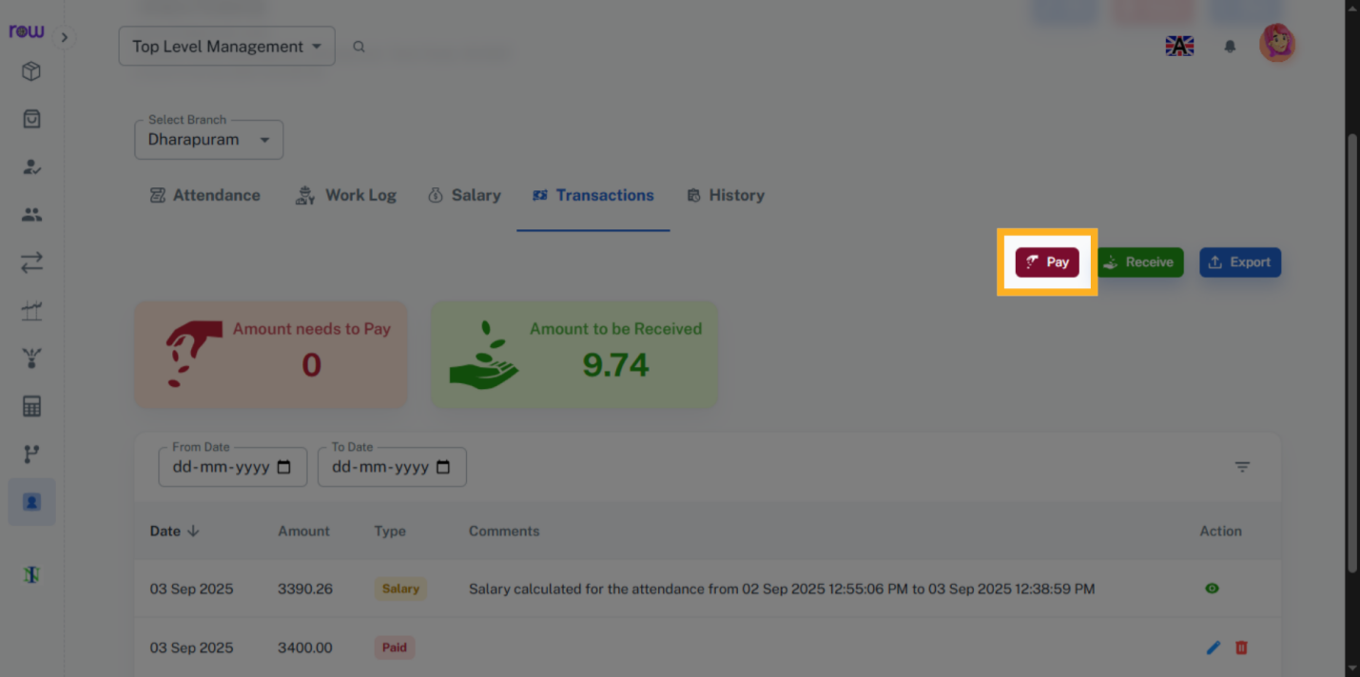

38. Payment
Enter the amount to be paid to the employee.
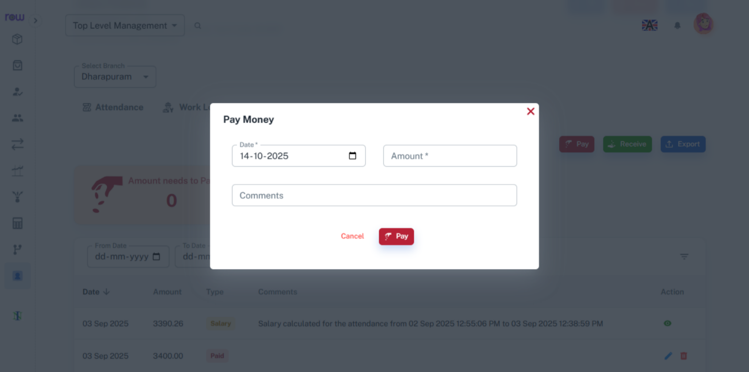

39. Receive
Click the Receive button to receive the payment.
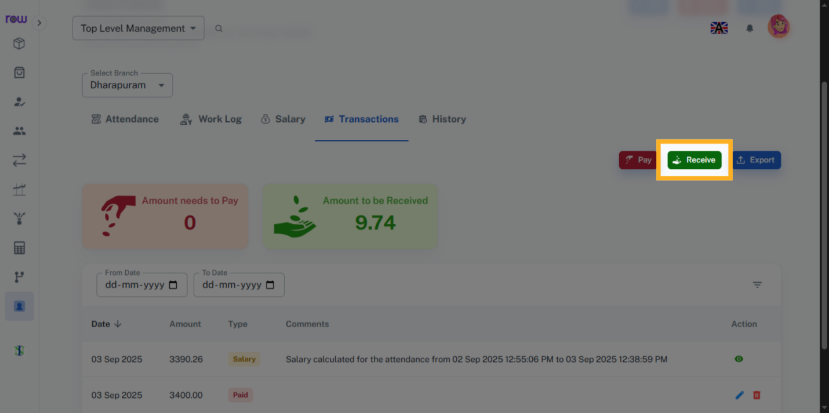

40. Payment
Enter the amount to be received from the employee.
