Create and Manage Expenses in RunOnWeb

Go to runonweb.com

1. Introduction
In this tutorial you learn how to create and manage expenses.

2. Expense Menu
Click the Expense menu to open the Expense list screen.
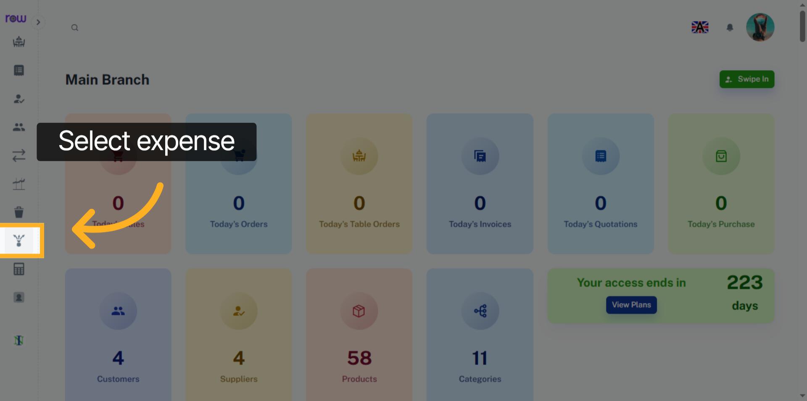

3. New Expense Button
Click the new Expense Button to start creating a new Expense.
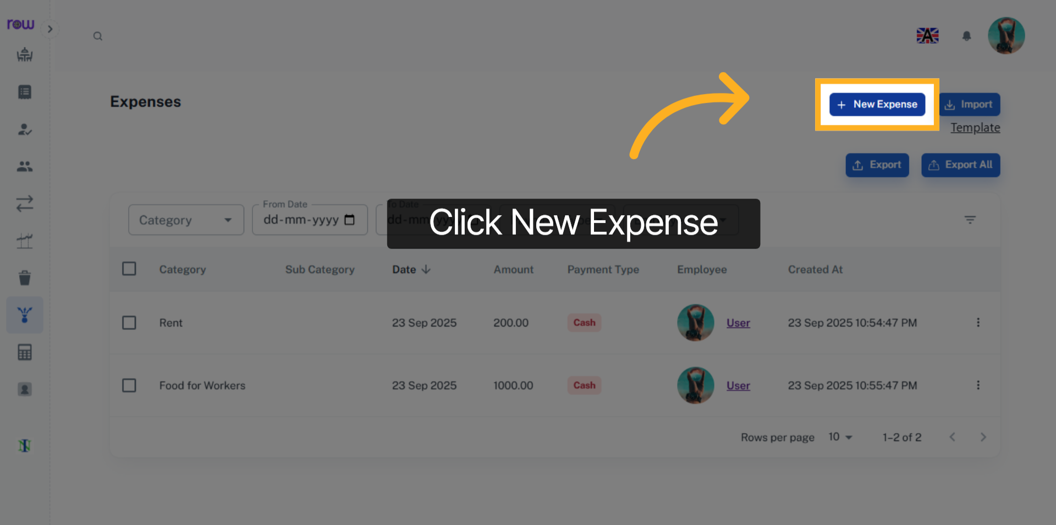

4. New Expense Screen
Date and Payment type is already filled in, you can update them if needed.
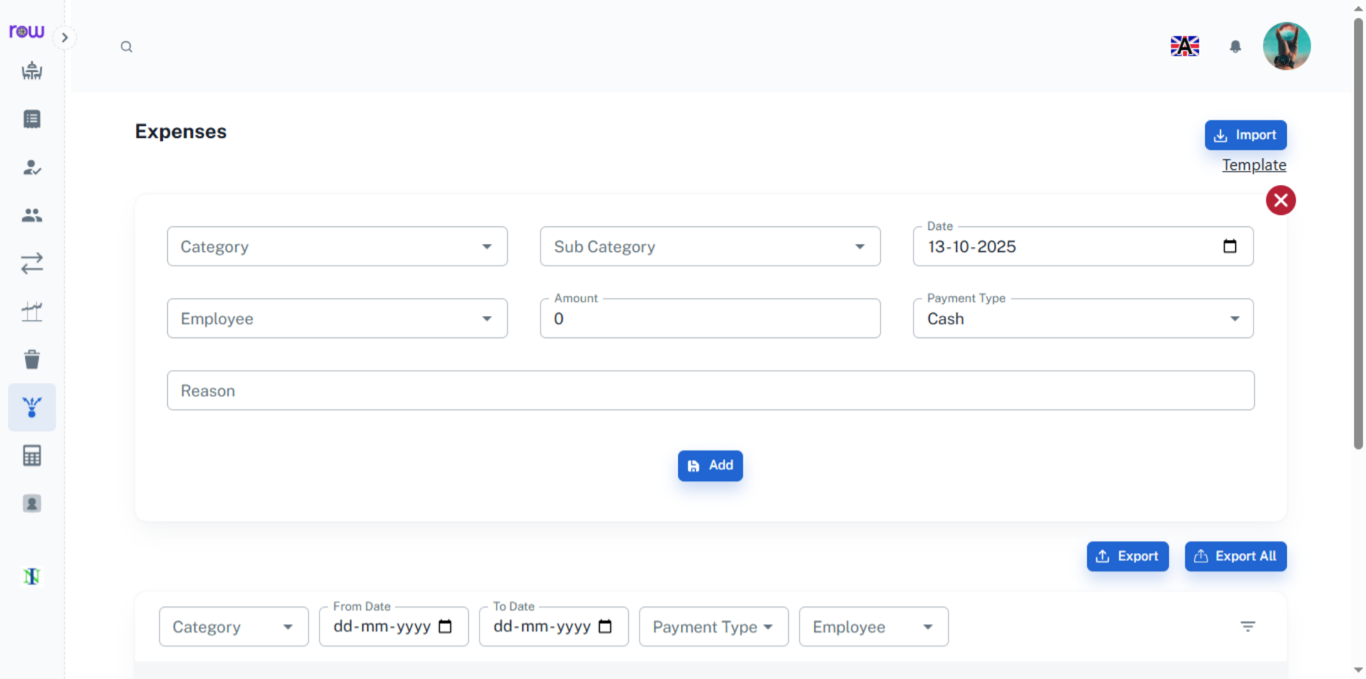

5. Choose Category
Search and select the category for the Expense.
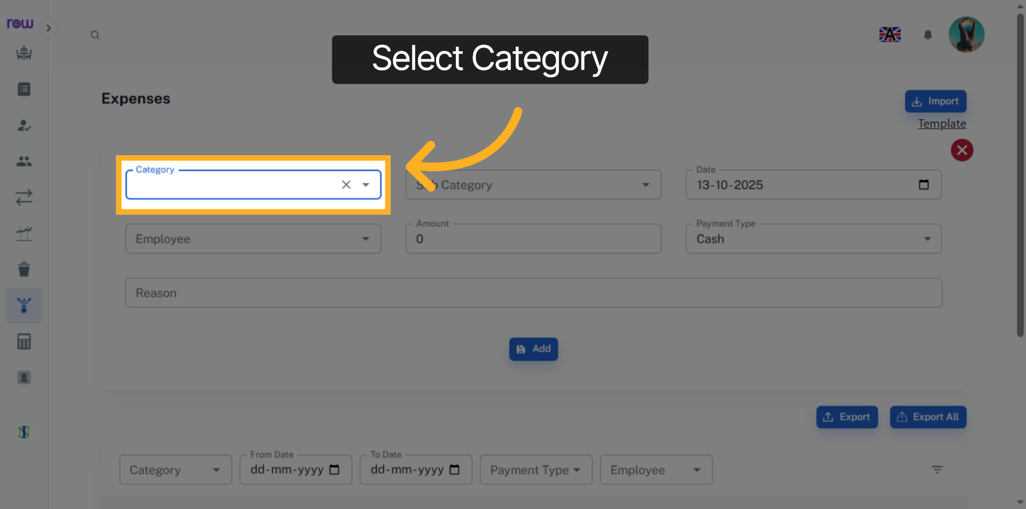

6. Choose Subcategory
Search and select the appropriate subcategory corresponding to the chosen category. Selection of a subcategory is not mandatory.
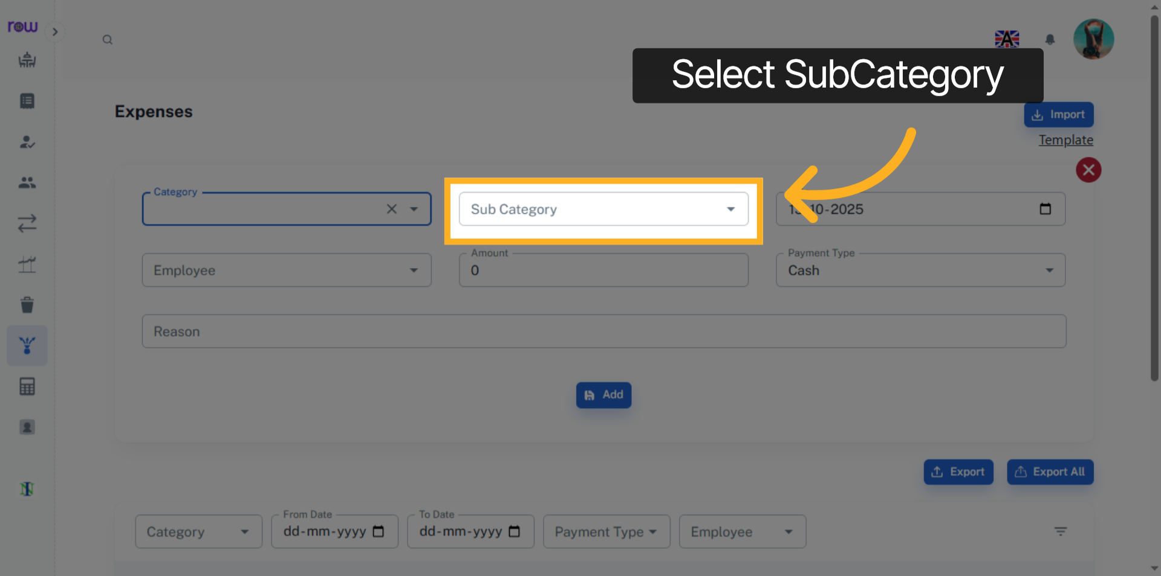

7. Choose Employee
If you are Spending an expense for an employee, please select that employee; otherwise, this field is not required.
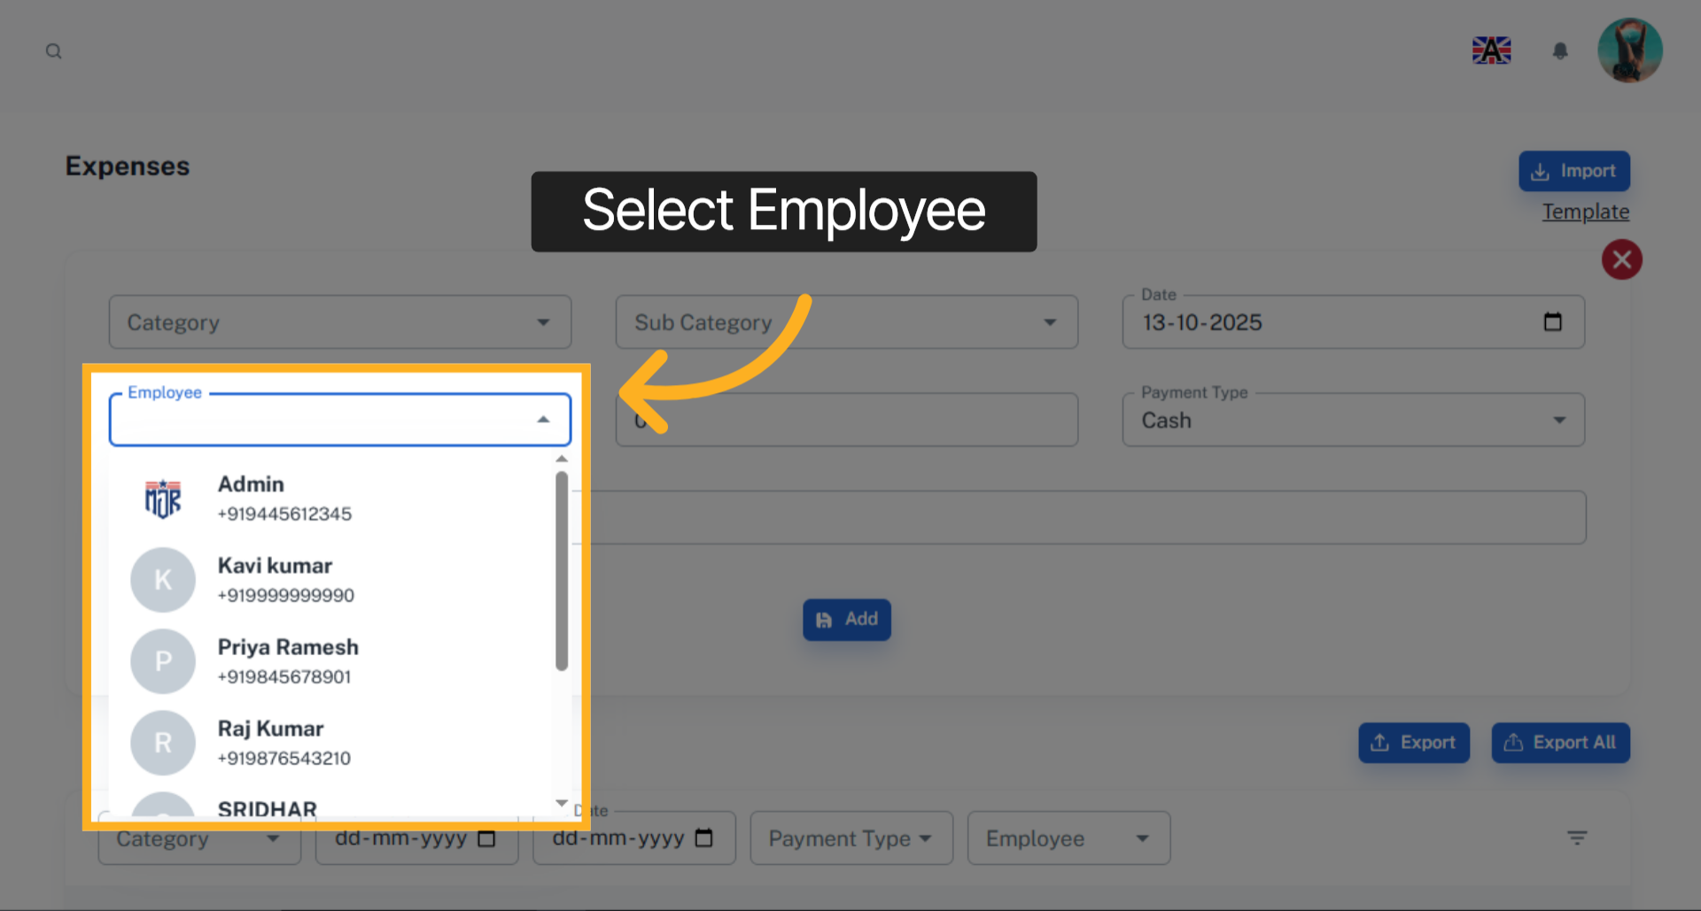

8. Add Amount
Enter the amount.
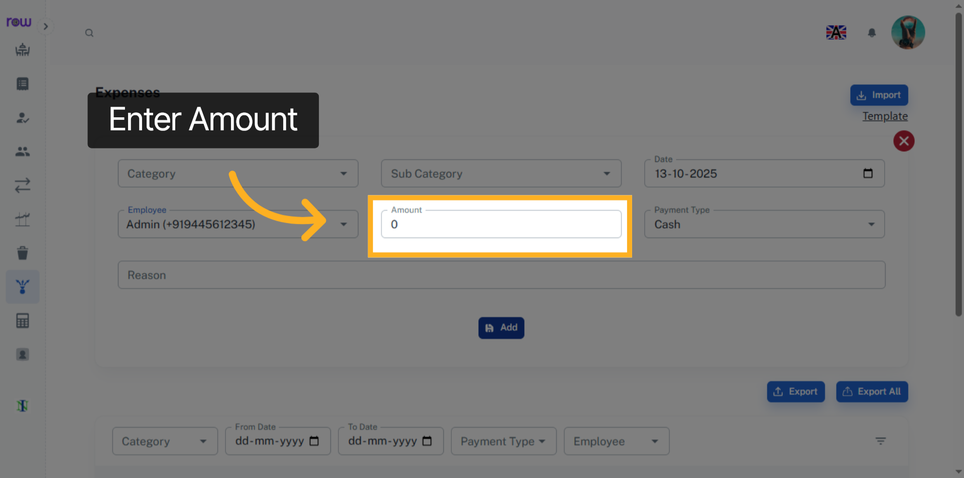

9. Add
Click the Add button to create the Expense.
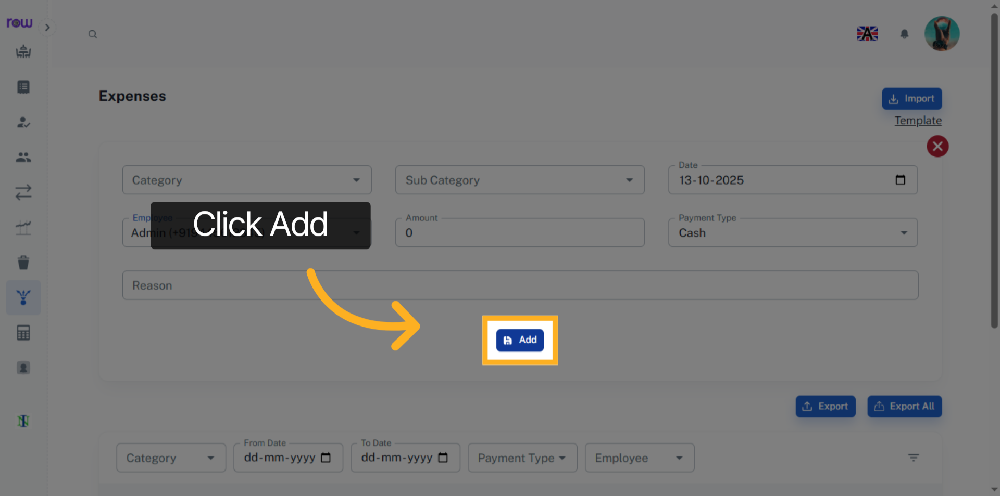

10. Expense list Screen
You will be redirected to the Expense List screen after the Expense is successfully created.
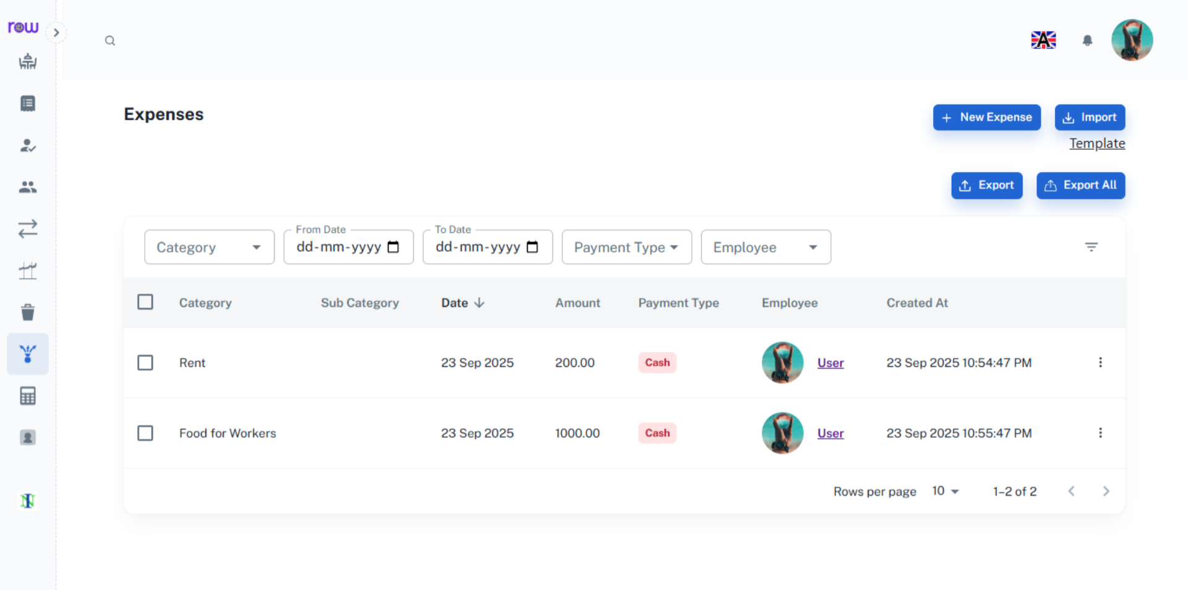

11. Accounts Menu
The expenses are recorded in the Accounts section. You can view their reflection in the Day Book, Ledger, Balance Sheet, Trial Balance, and Profit and Loss, etc,.
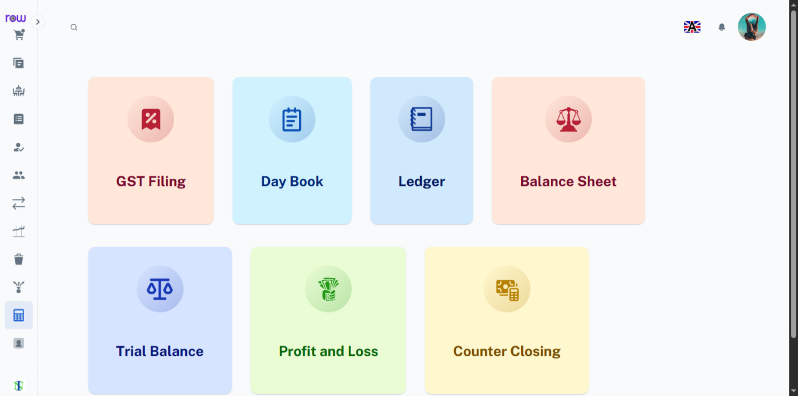

12. Day Book
You can see the expenses record in Day Book.
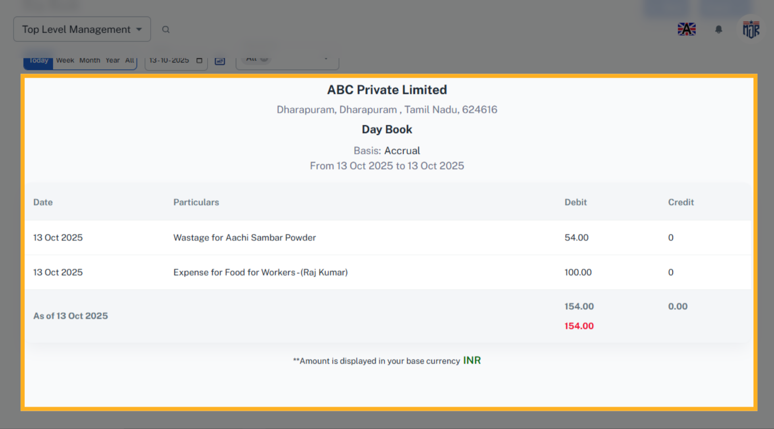

13. Ledger
You can see the expenses record in Ledger.
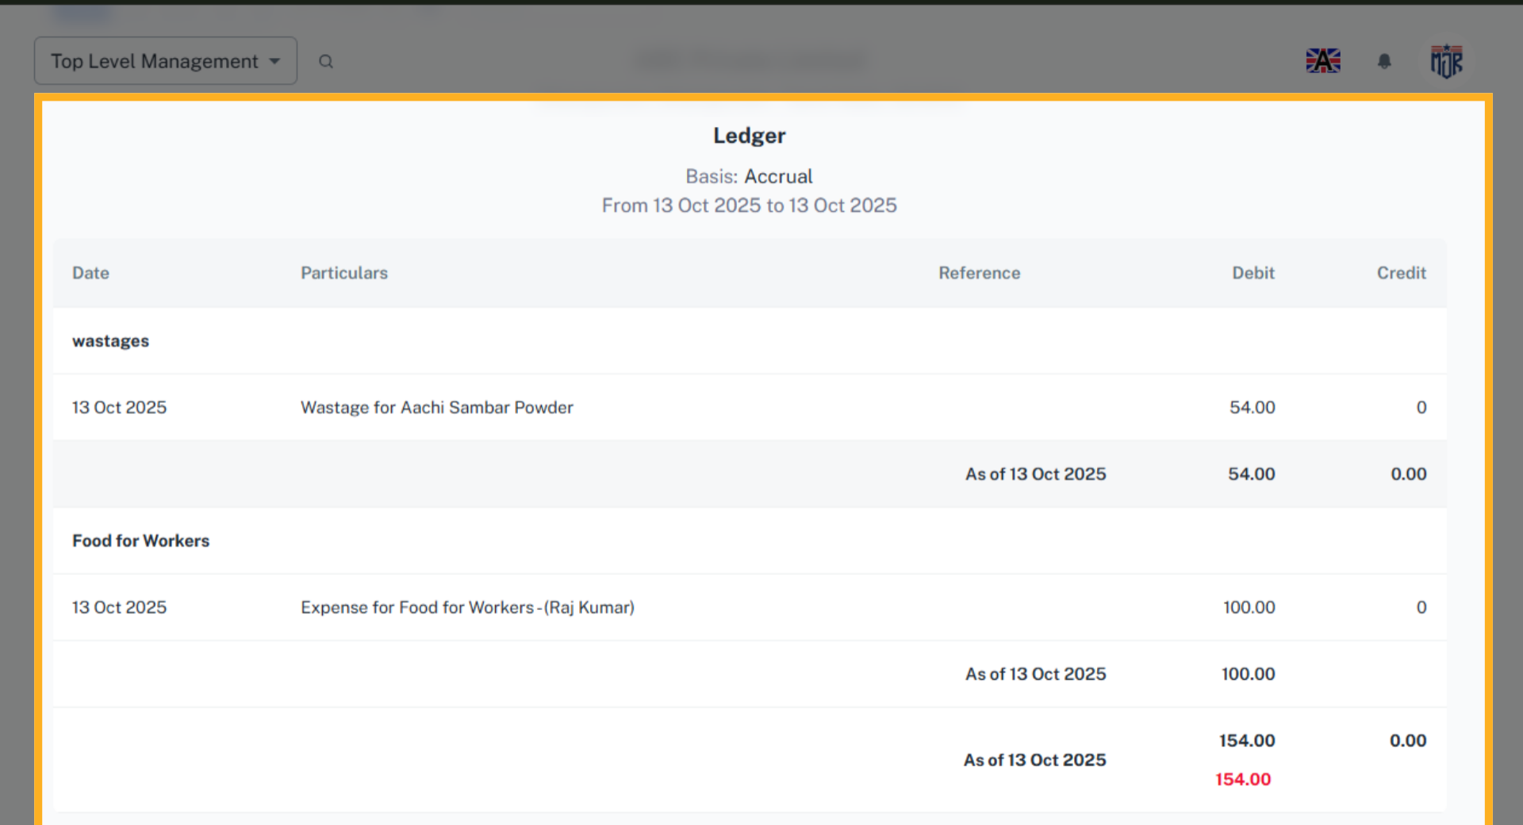

14. Profit and Loss
You can see the expenses record in Profit and Loss.
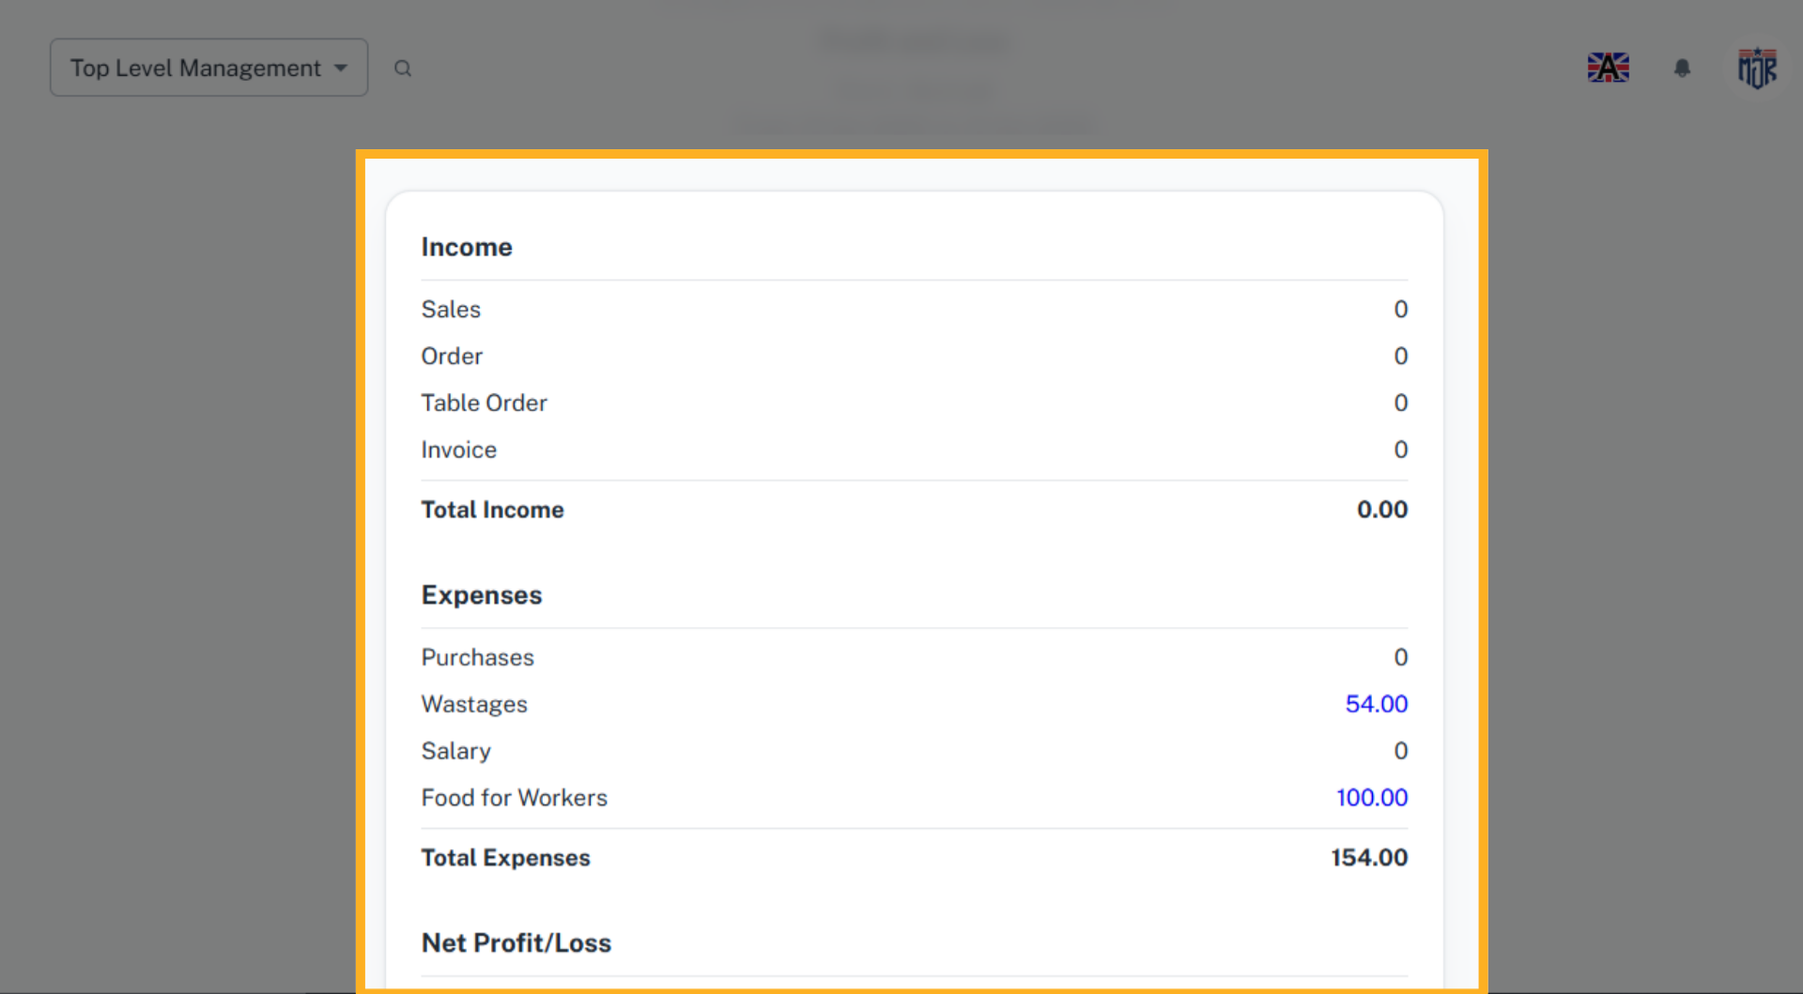

15. Trial Balance
You can see the expenses record in Trial Balance and in all Other Accounts.
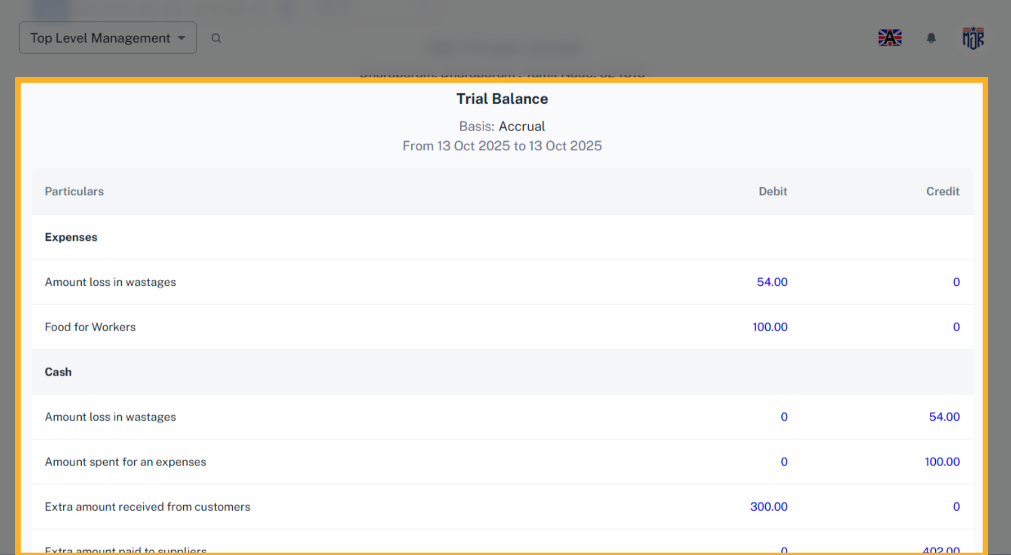

Expenses will be recorded in all the accounting sections.



