Create and Manage Invoices in Runonweb

Go to runonweb.com

1. Introduction
In this tutorial, you will learn how to create, update, and cancel an Invoice, as well as generate an e-invoice and an e-way bill for the Invoice.

2. Invoice Menu
Select the Invoice menu to open the Invoice list screen.
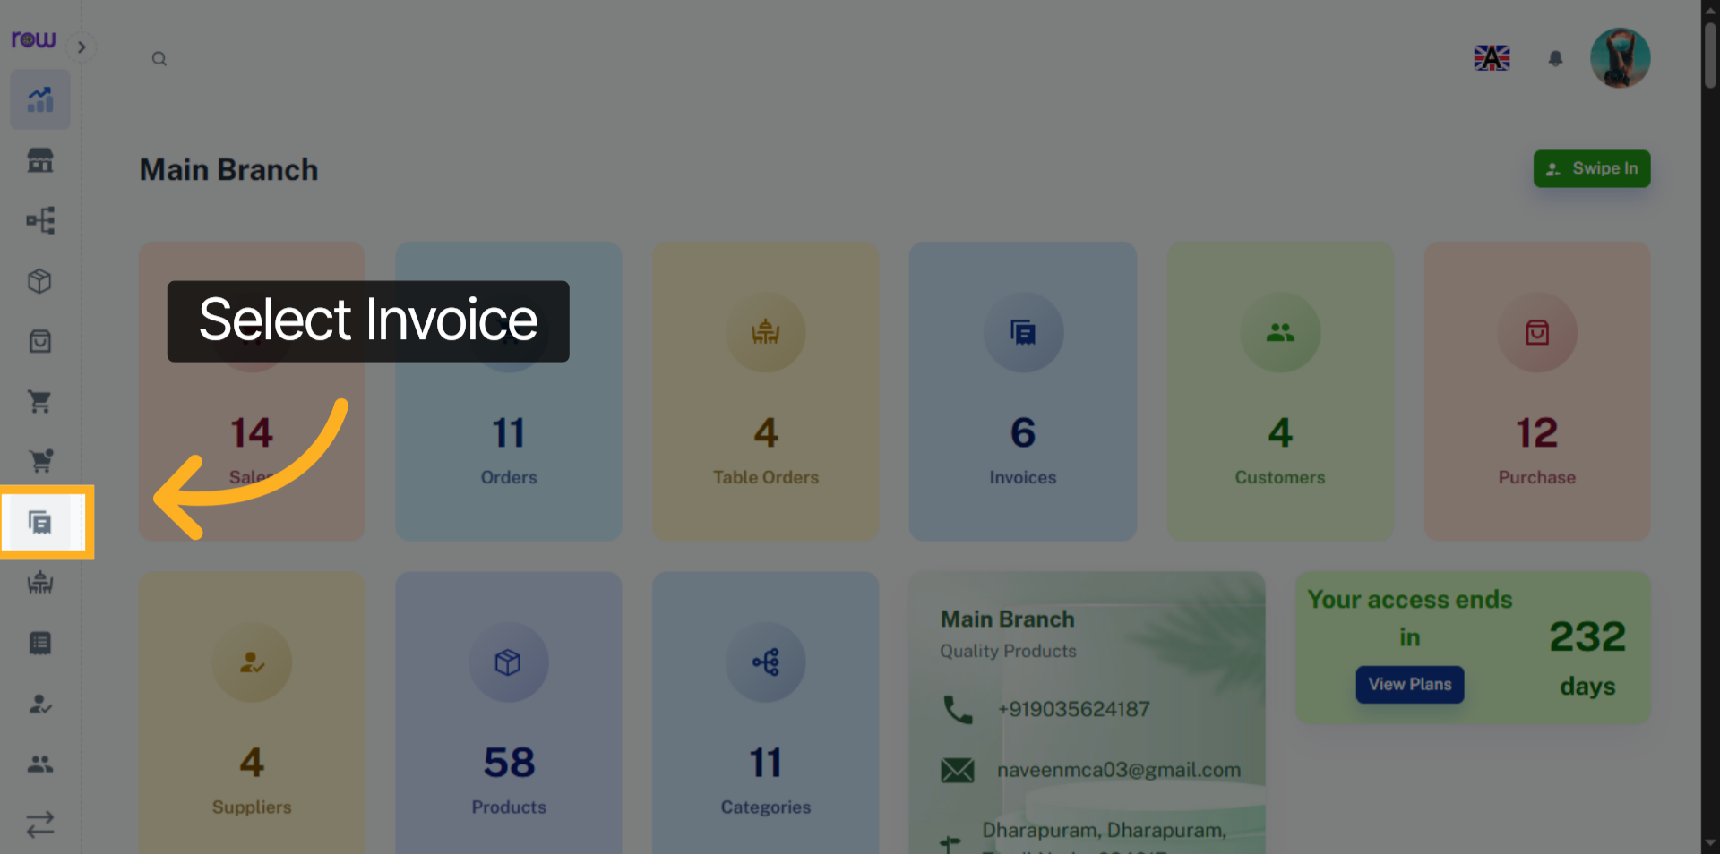

3. New Invoice Button
Click the New Invoice button to start creating an Invoice.
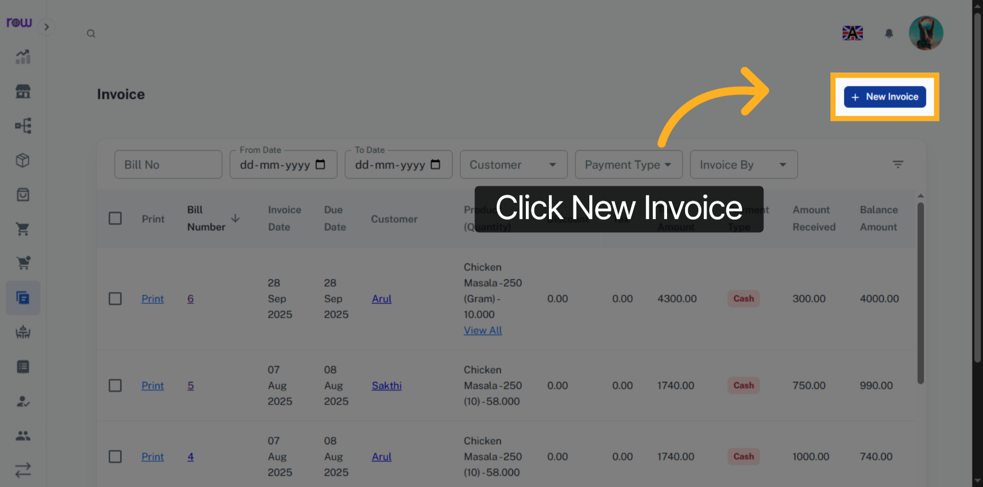

4. New Invoice
Invoice date, Invoice by ,Due date are already filled in. You can update them if needed.
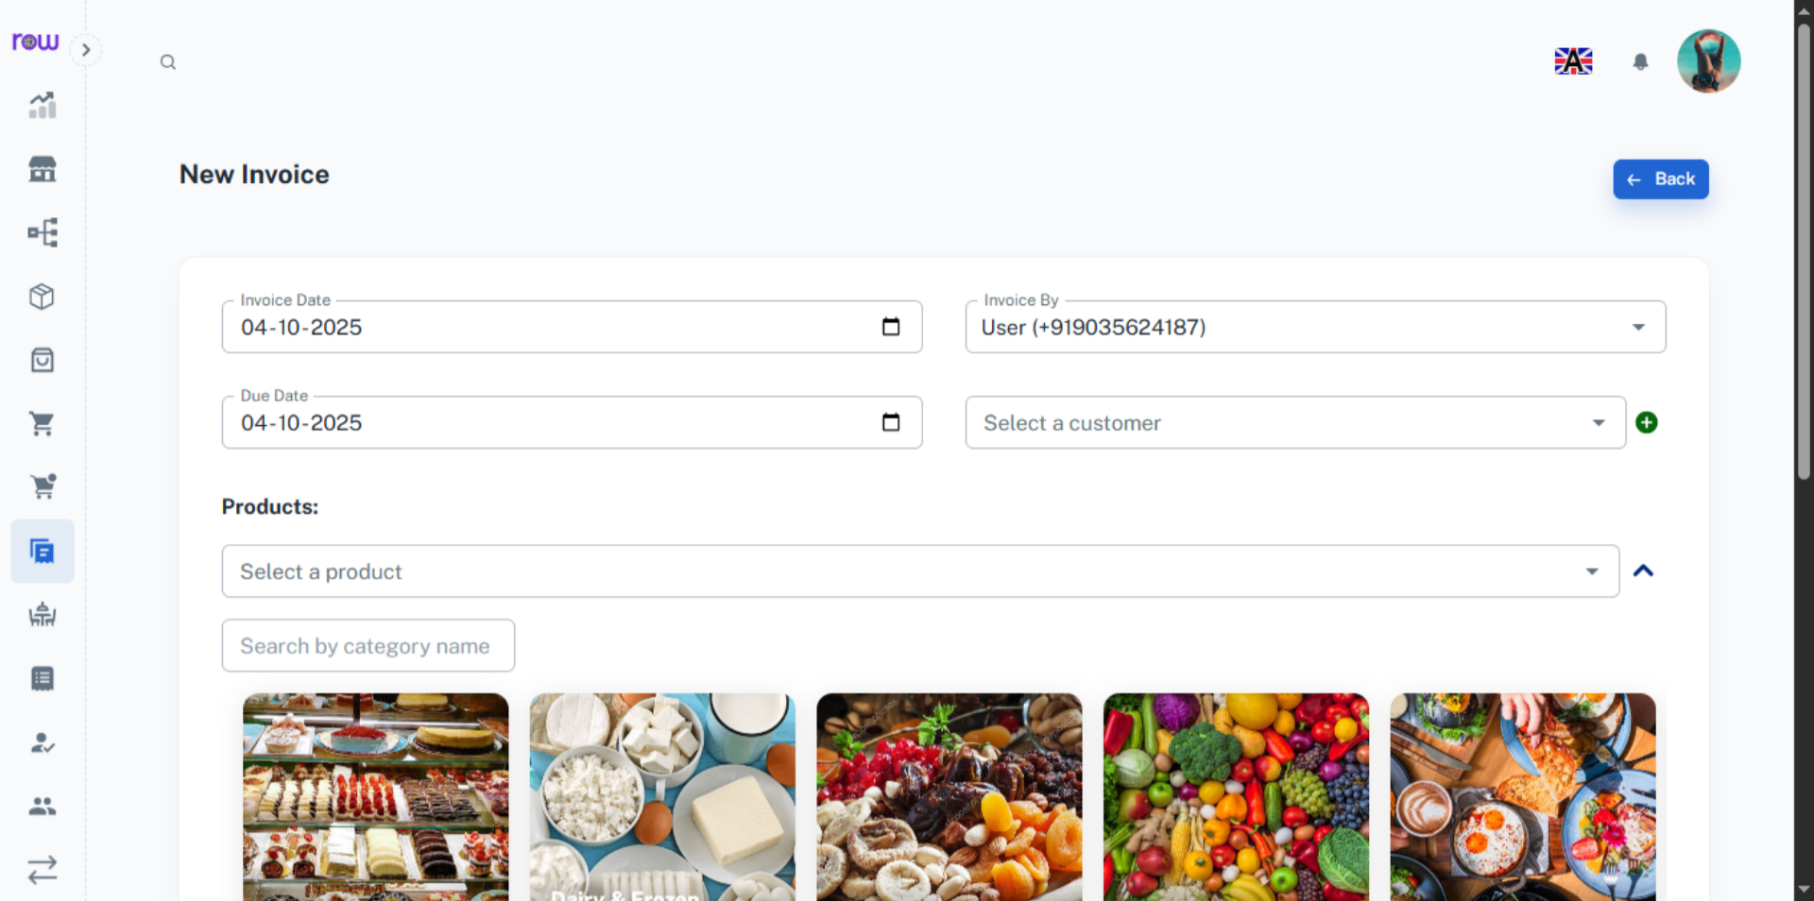

5. Select a customer
Search and select an existing customer.
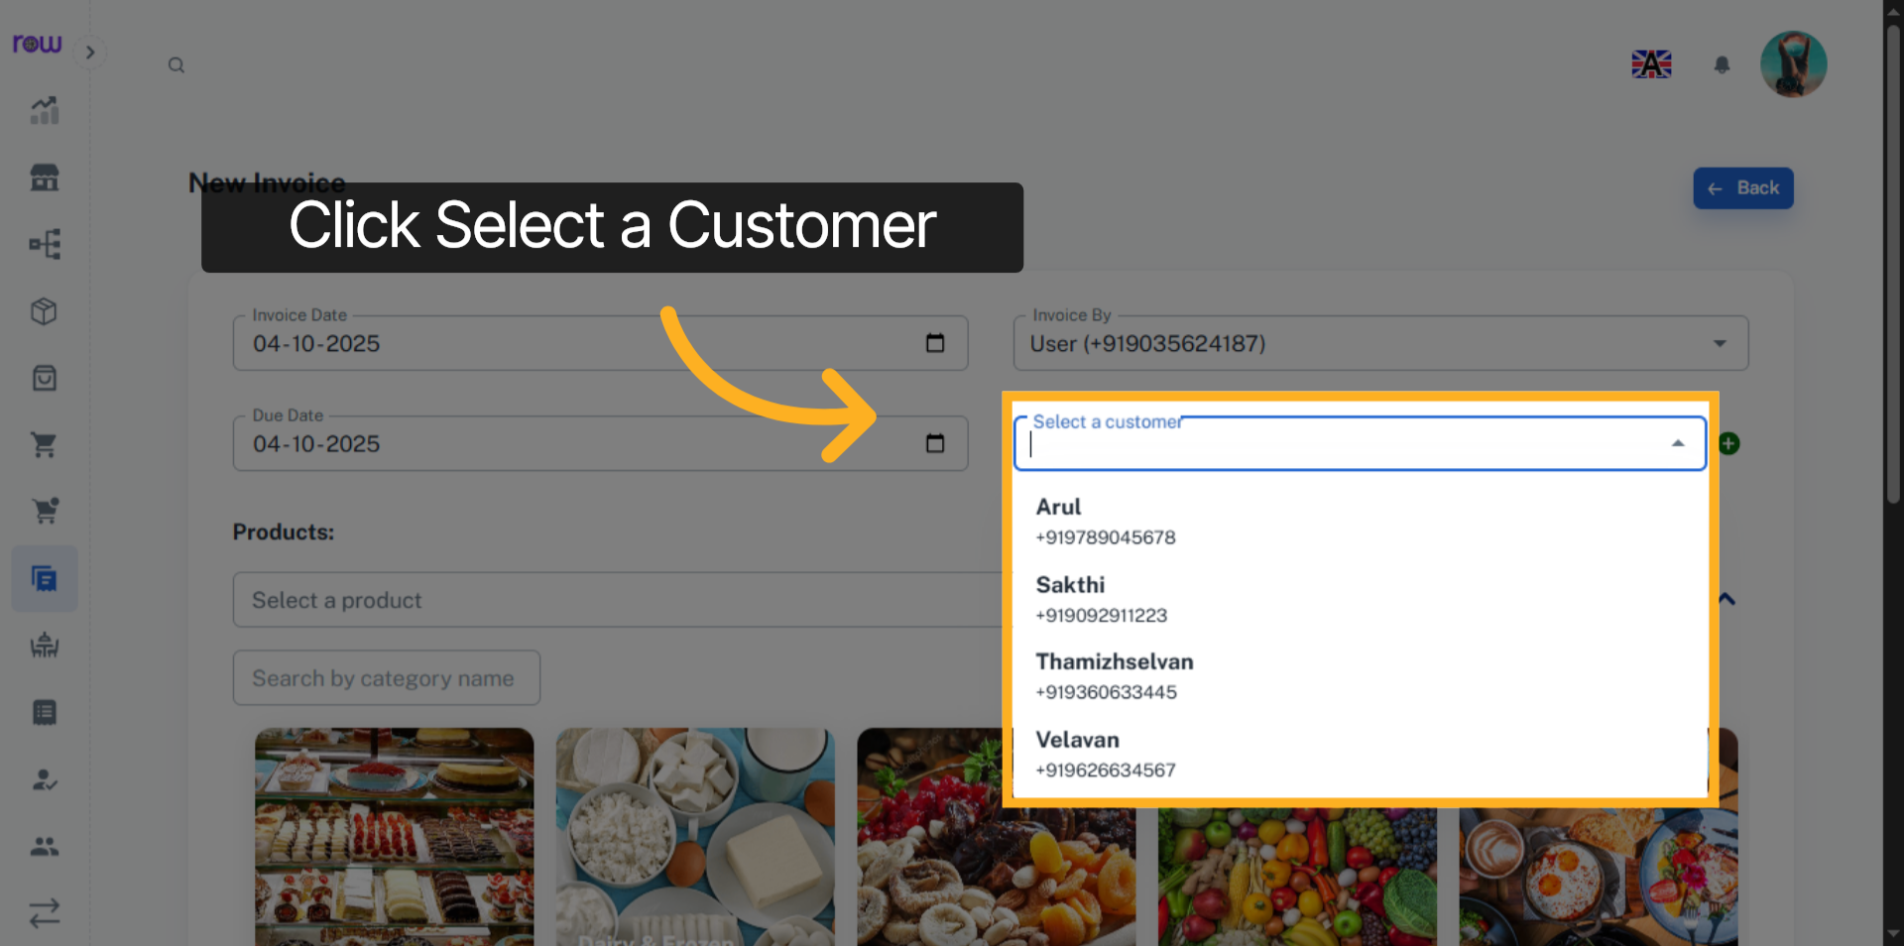

6. Create new customer
Click + icon to add a new customer
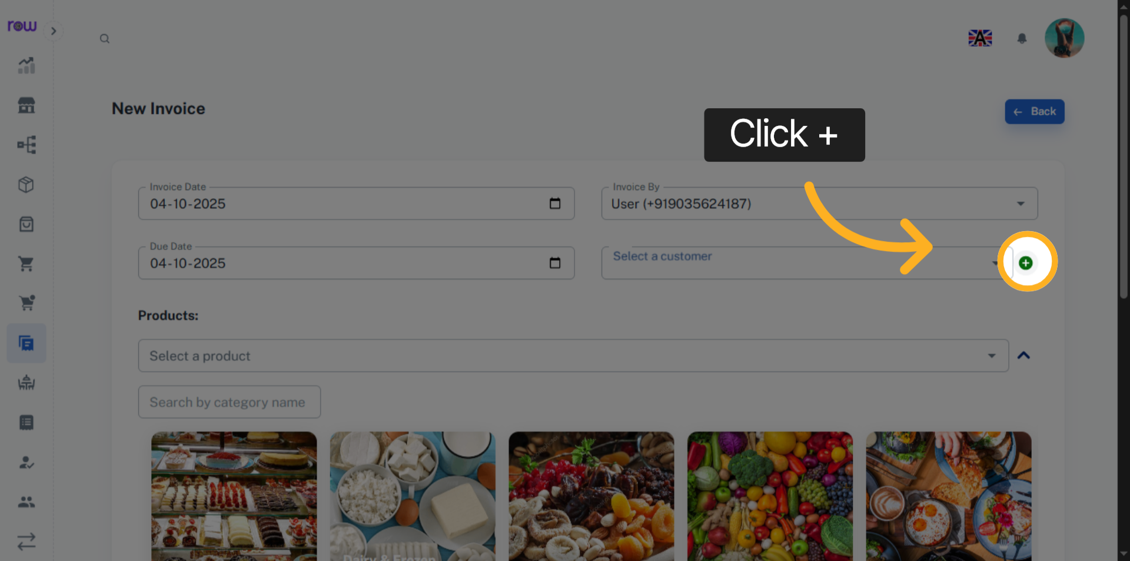

7. New Customer Page
Enter the new customer details and click Add to save and select the customer.
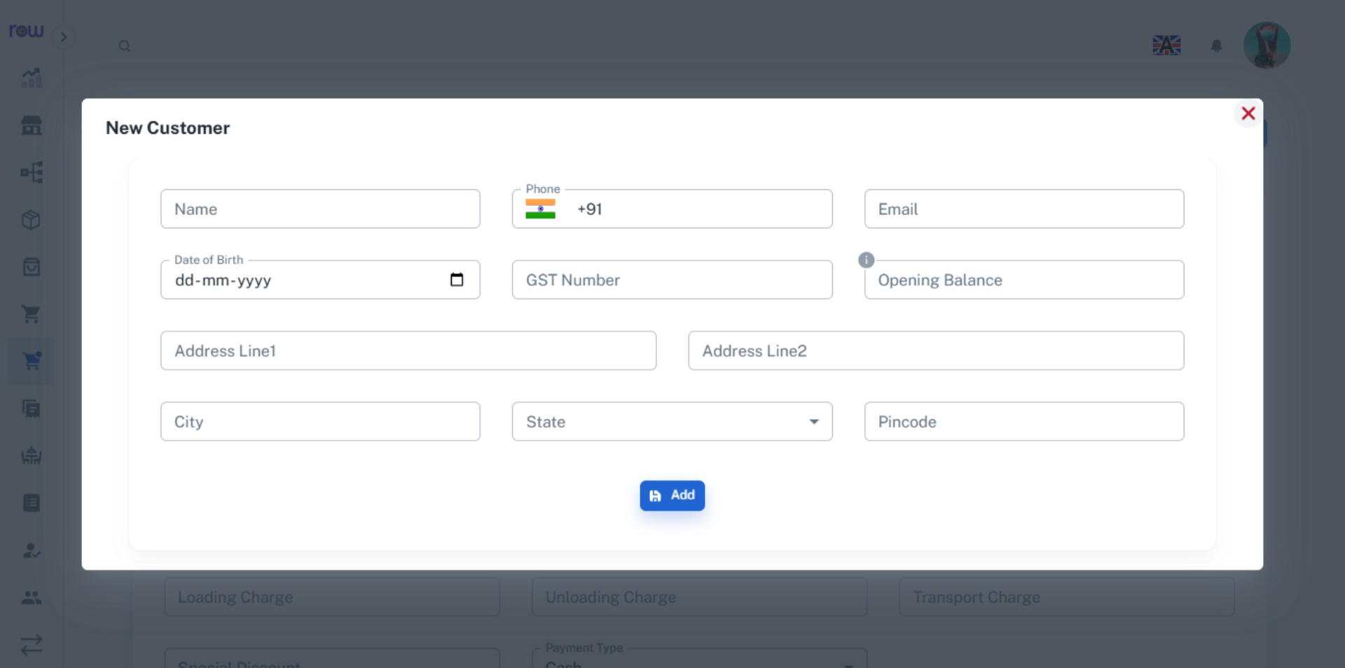

8. Select a product
Select a product from the dropdown. You can search by product name or code.
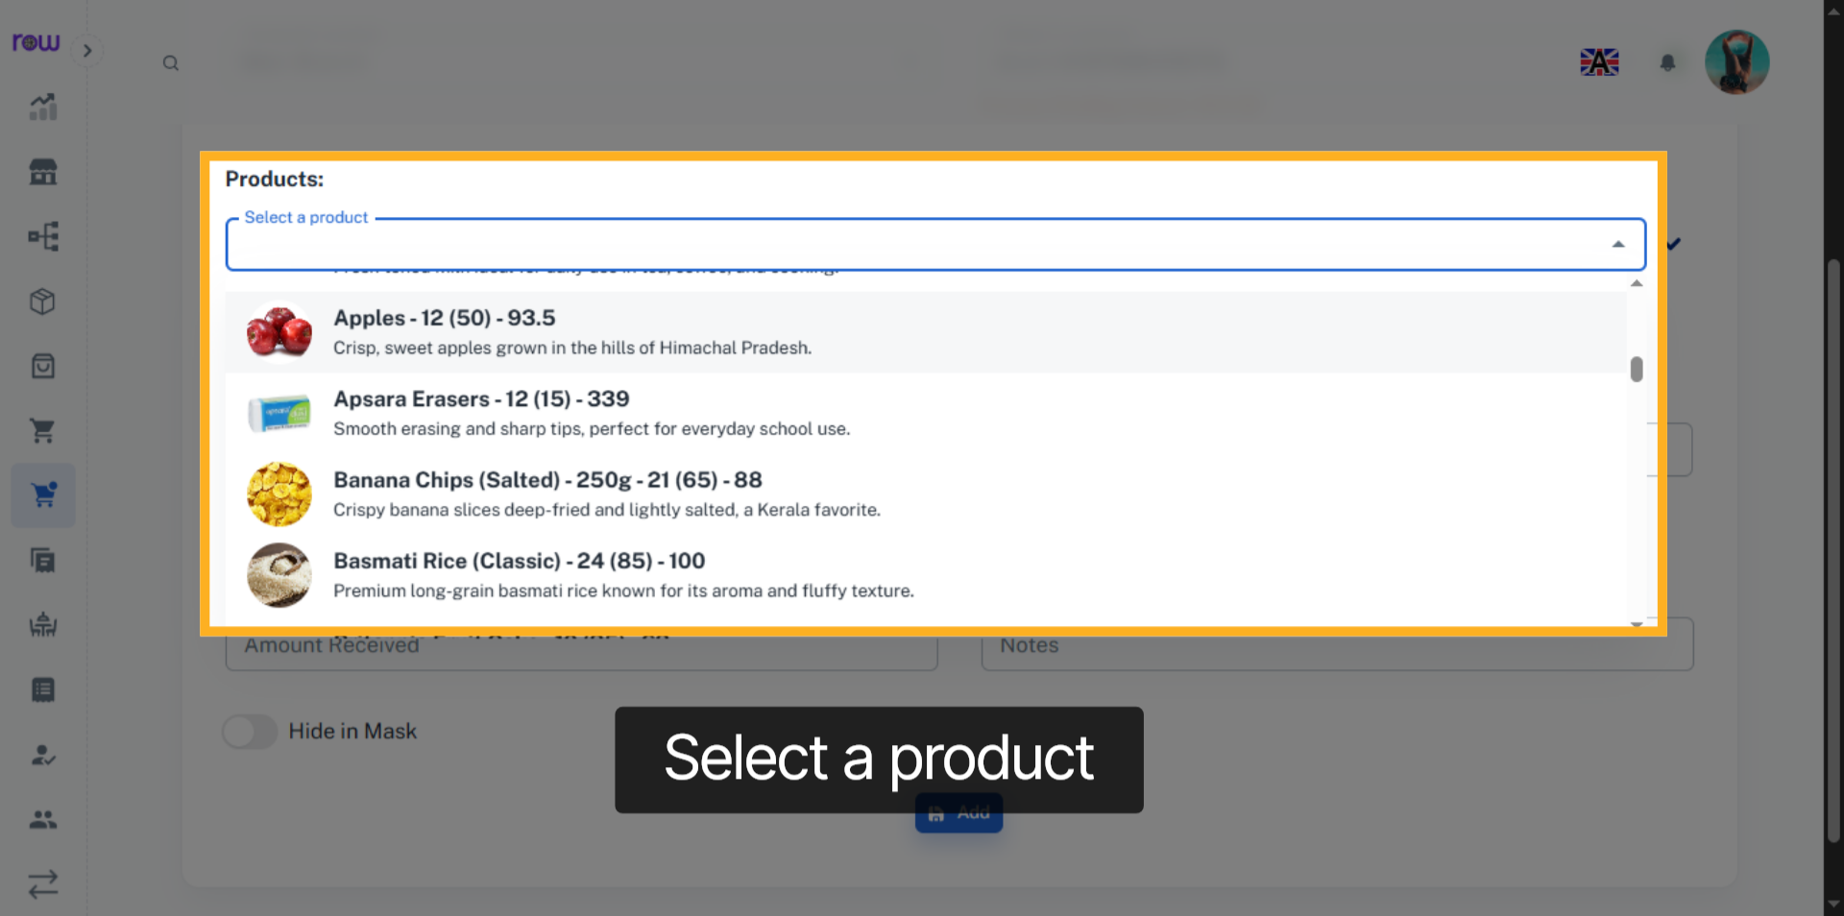

9. Product Selection Dropdown
Or click the arrow to find a product by its category.
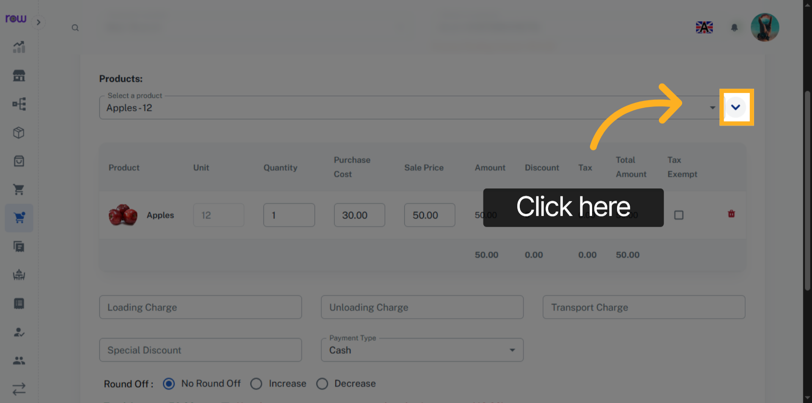

10. Select the product category
select the product by its category
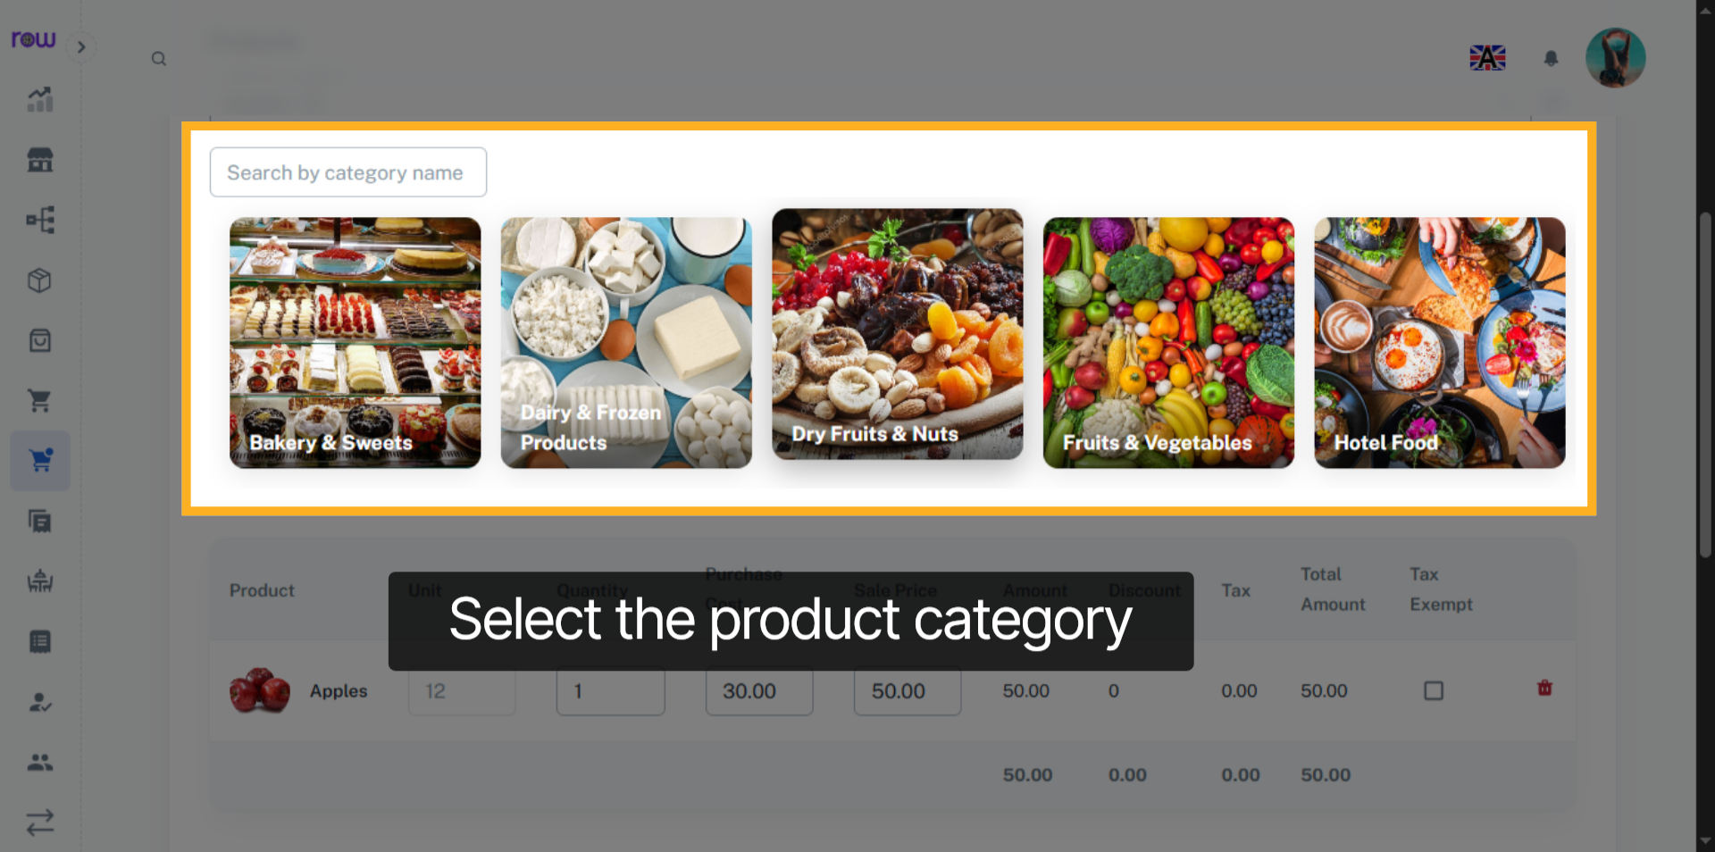

11. Select Product
Select Product
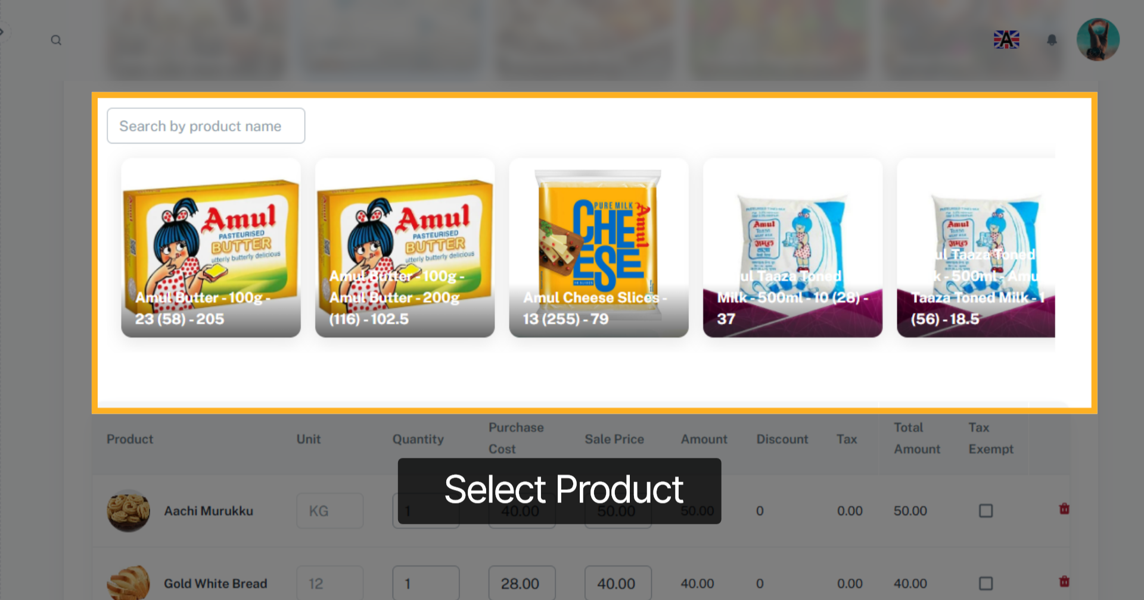

12. Selected Product List
After product selection you can update the quantity, Purchase cost and Sale price of the products.
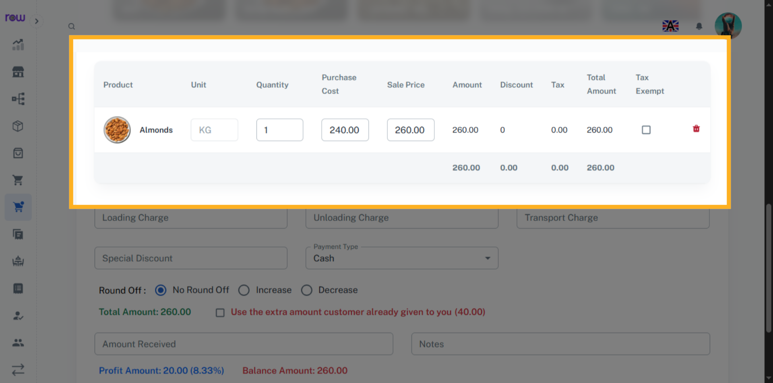

13. Tax Exempt Checkbox
Select the checkbox to exempt the tax for a product.
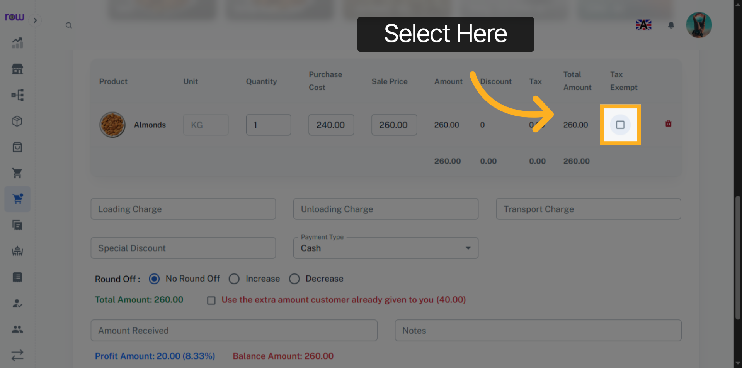

14. Other Optional Fields
Enter loading charge, unloading charge, transport charge and Special discount if applicable.
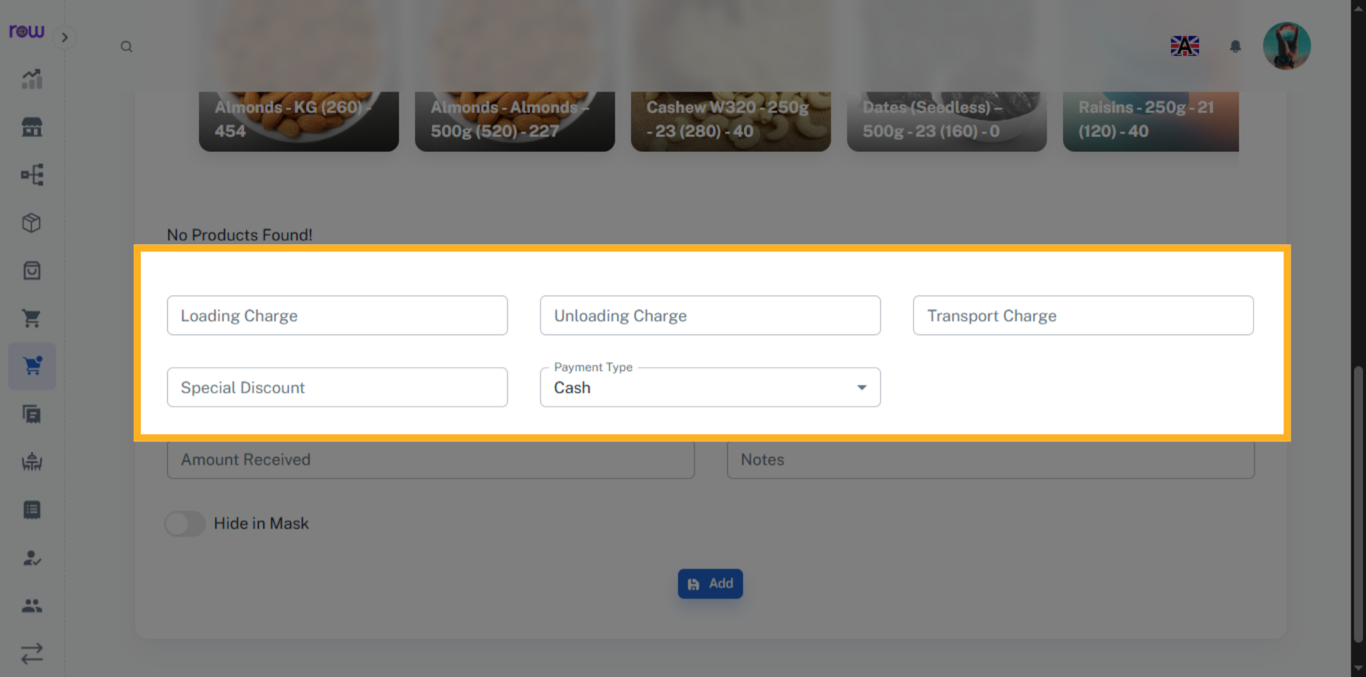

15. Round Off
If the total value has decimal points, you can round it off.
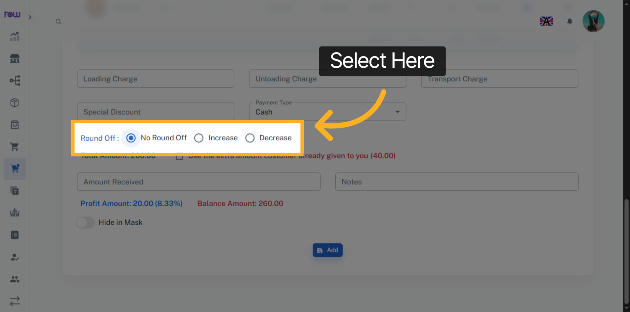

16. Amount Received
Enter the amount received from the customer
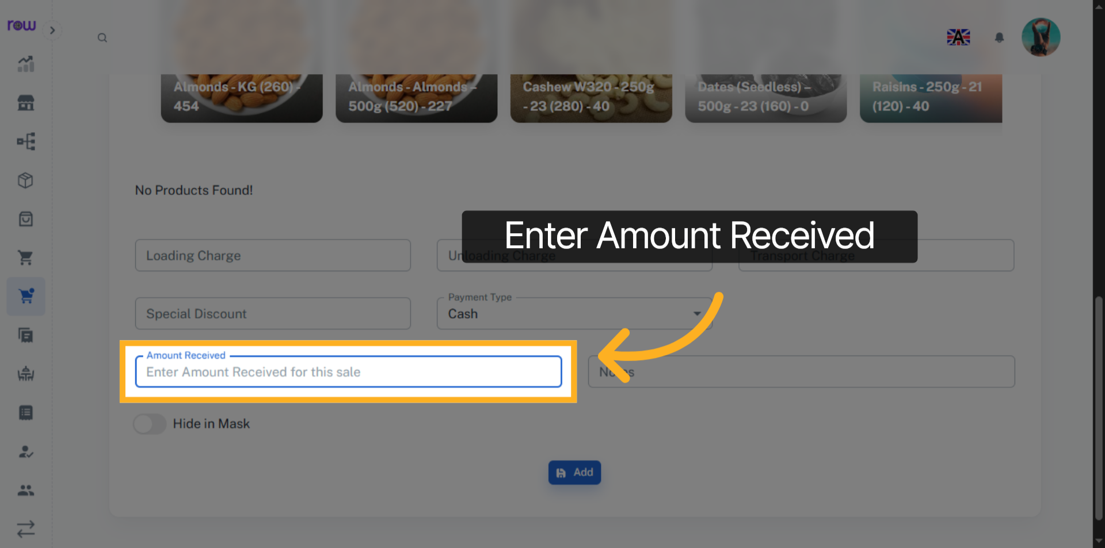

17. Add
Click "Add" to create the Invoice
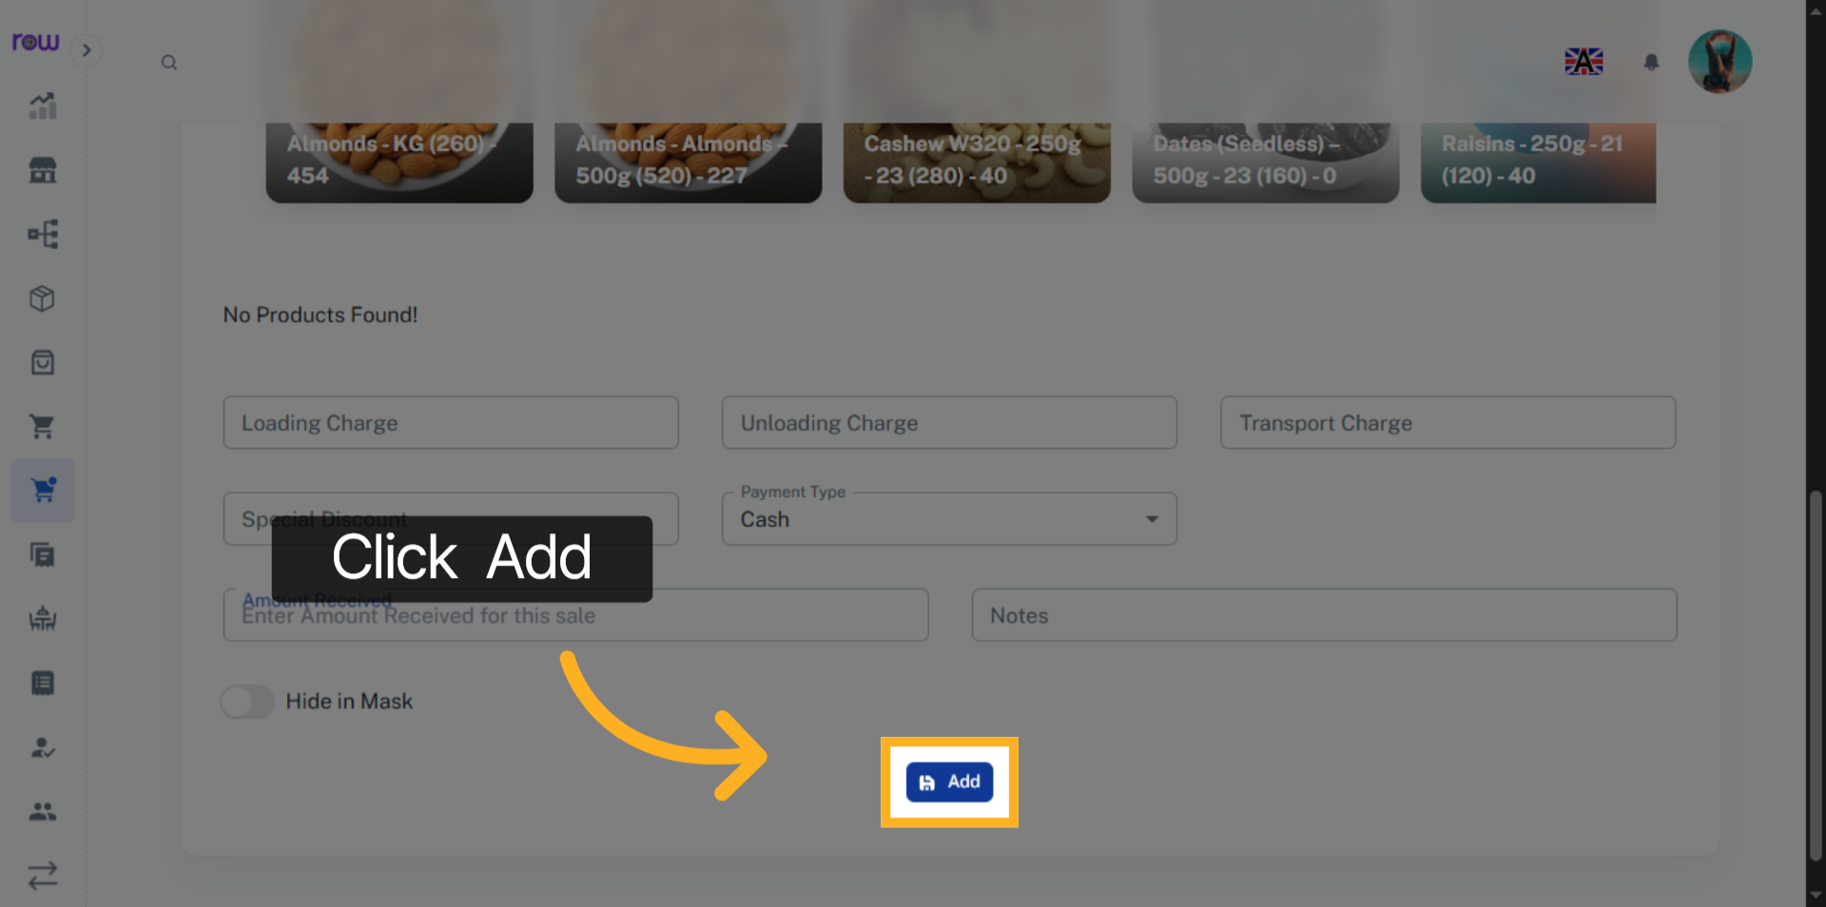

18. Invoices list
You will be redirected to the Invoices list screen after the Invoice is successfully created.
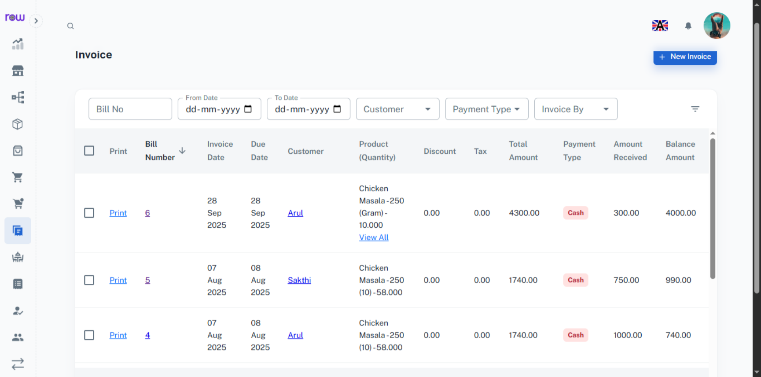

19. Bill Number
Click the bill number to edit the Invoice
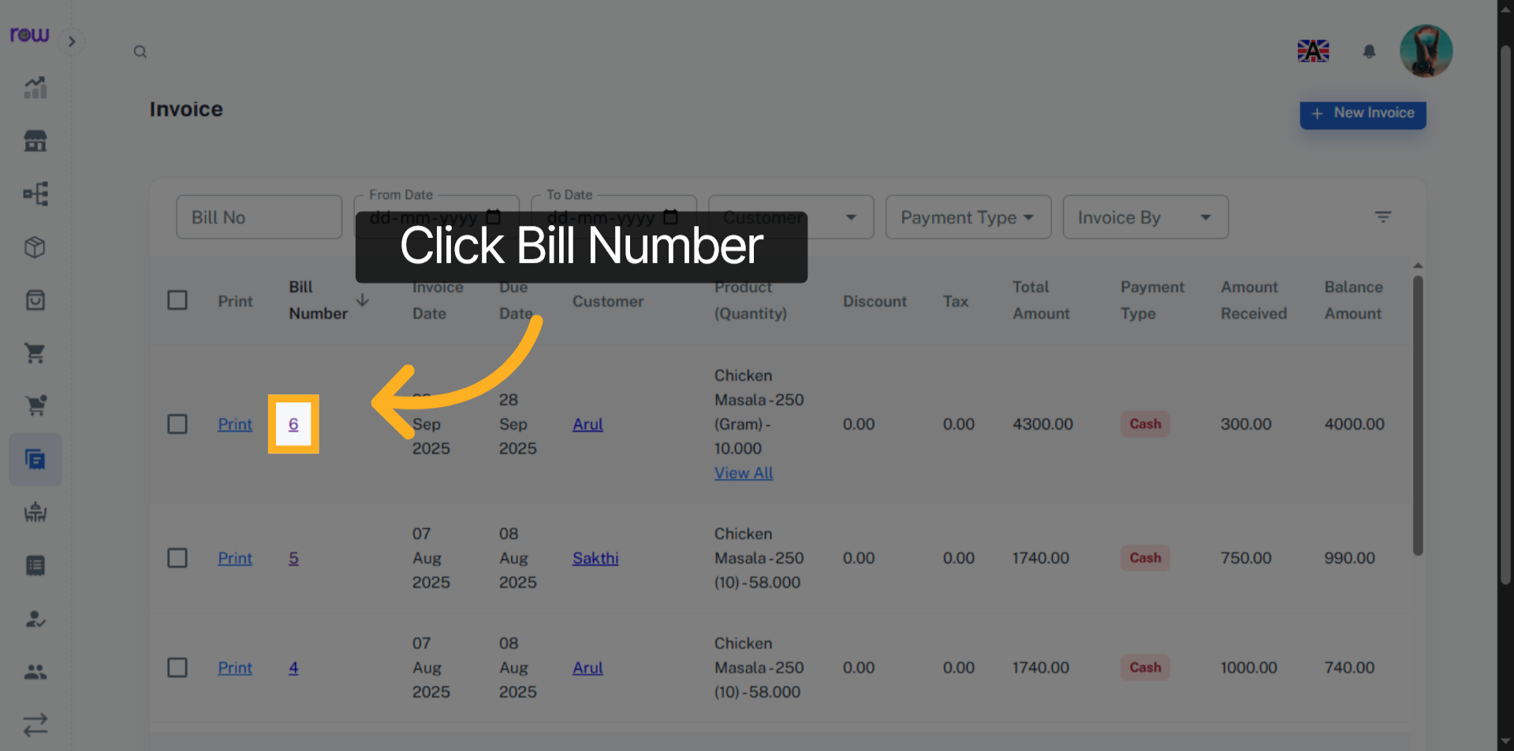

20. Edit Invoices
You may modify all fields except the customer. Additionally, you can add,Update or remove the products during the update process.
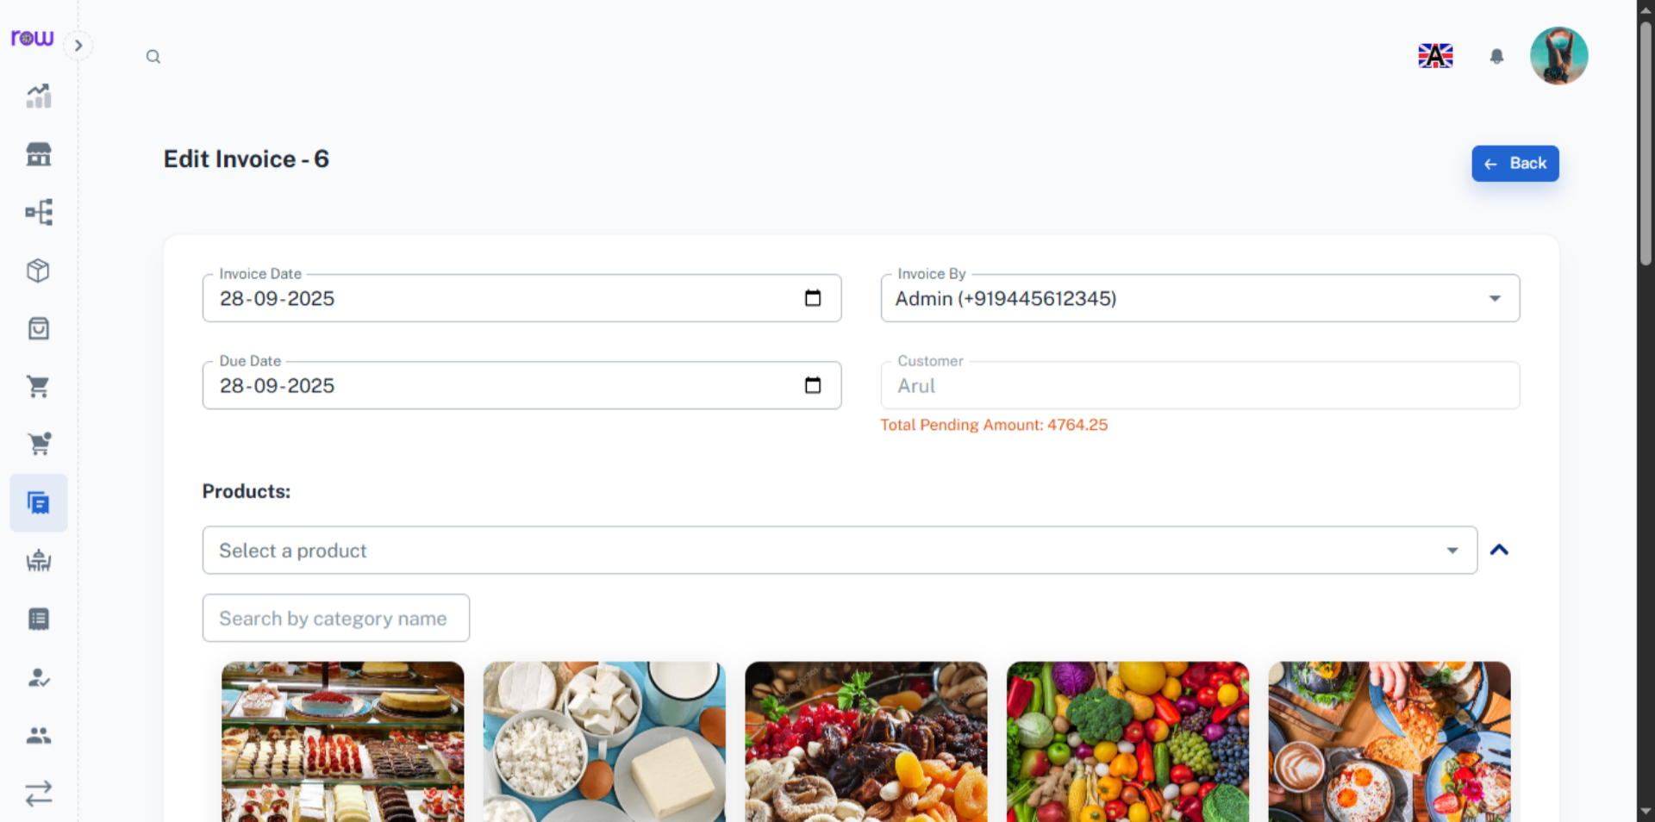

21. Add Pending Amount
Enter the pending amount received from the customer and click add amount button to update the amount received
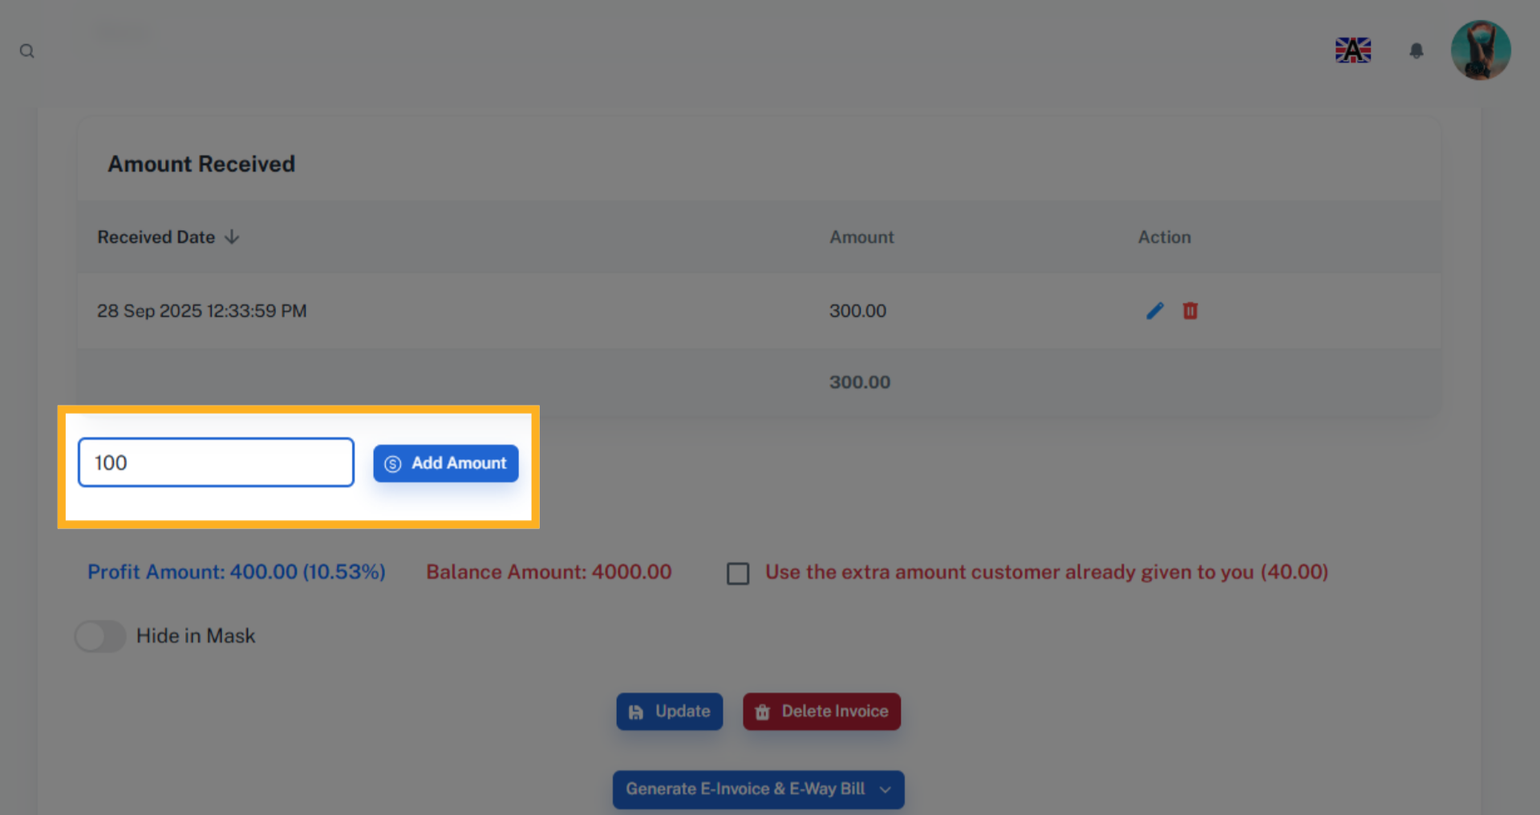

22. Update Invoices
Click Update to save the changes.
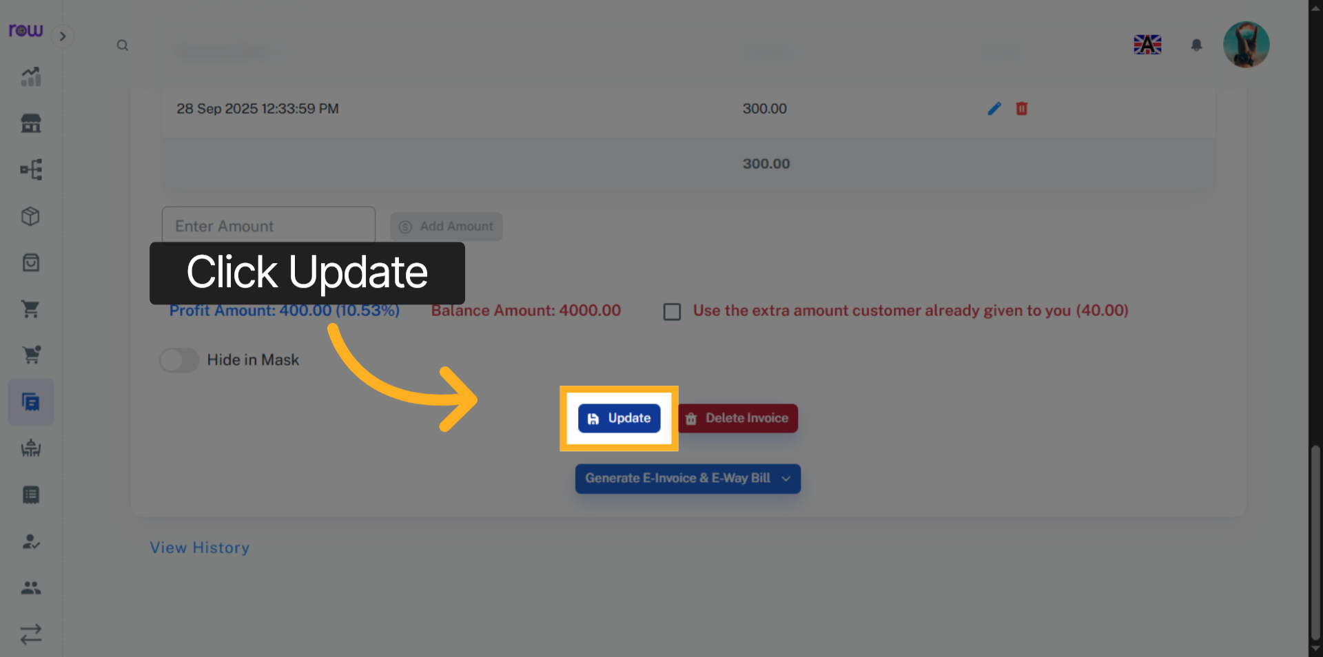

23. Delete Invoice
Click the Delete Invoice button to Delete the Invoice.
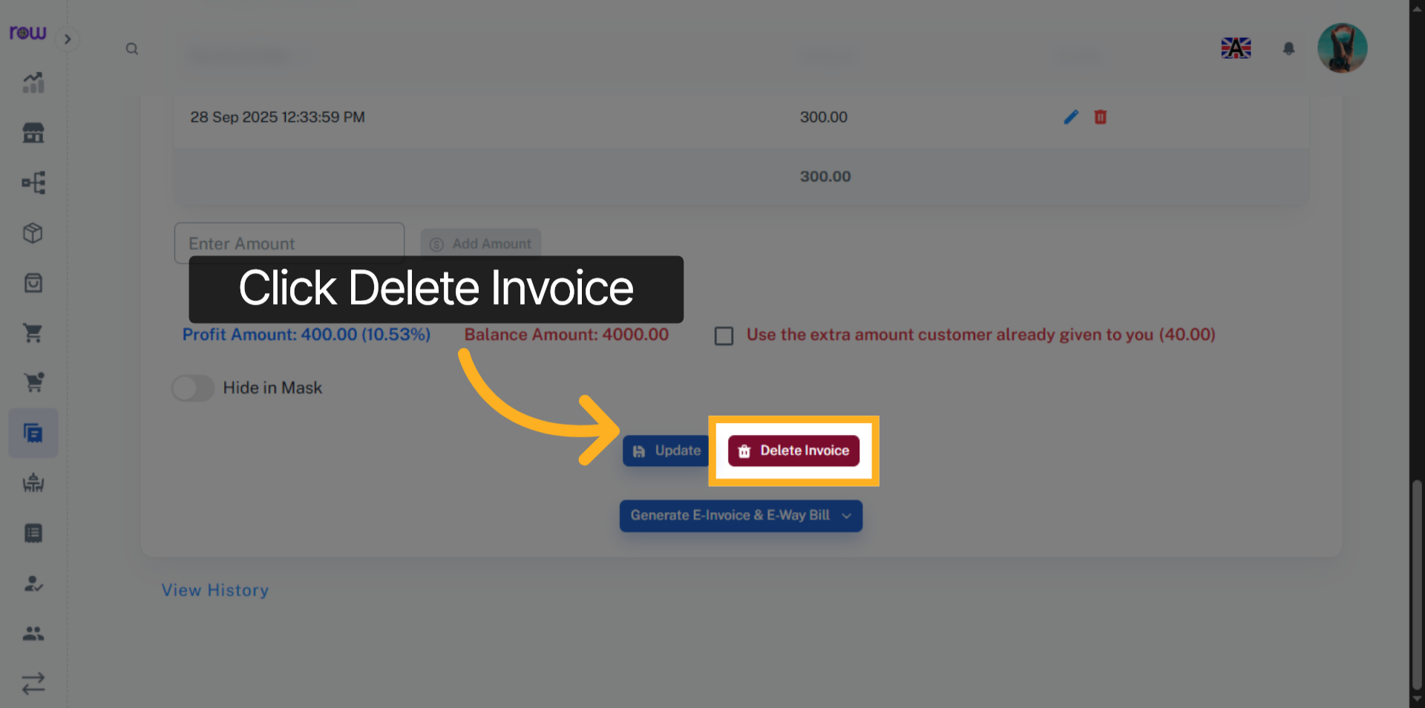

24. Generate E-Invoice & E-Way Bill
Click this button to Generate E-Invoice & E-Way Bill.
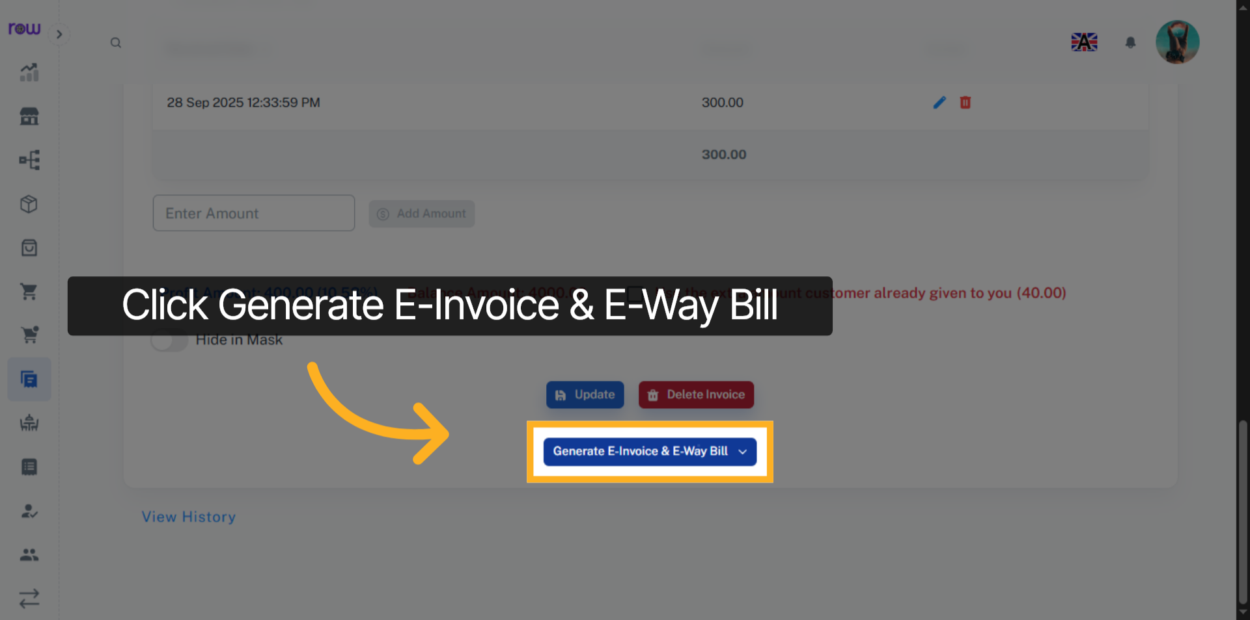

25. E-Invoice & E-Way Bill Options
Select the options according to your requirements.
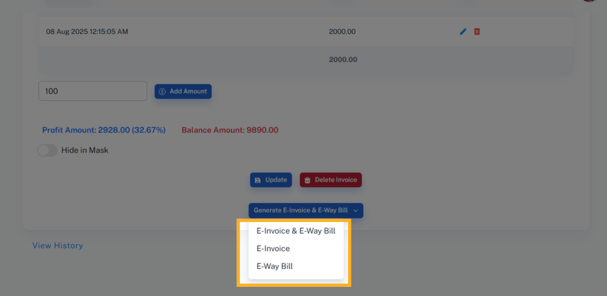

26. E-Way Bill
Please enter the transportation details if you have selected an e-way bill.
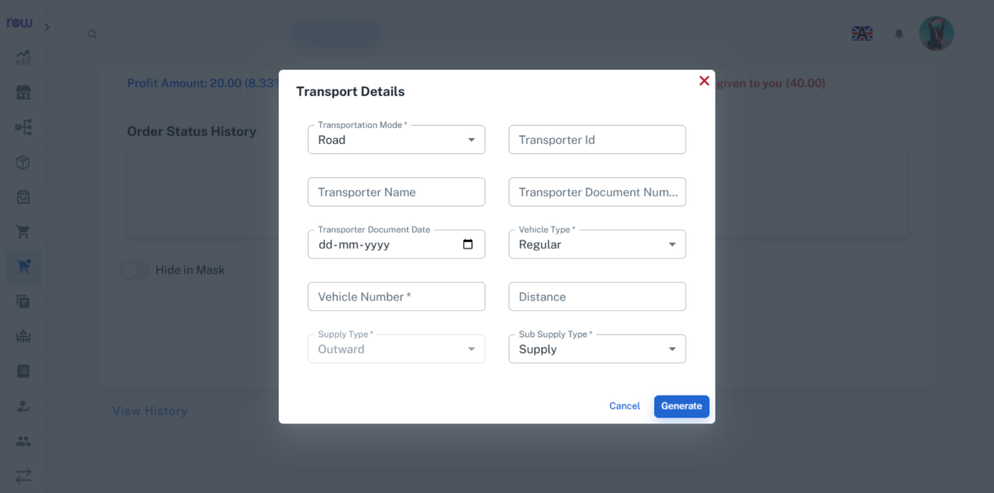

27. View History
Click the View History link to see the work history of this Invoice performed by the employees.
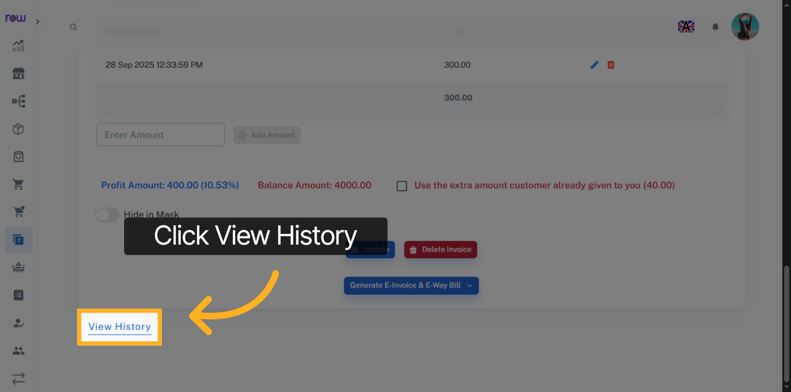

28. History
You can see who performed which actions and when in the history.
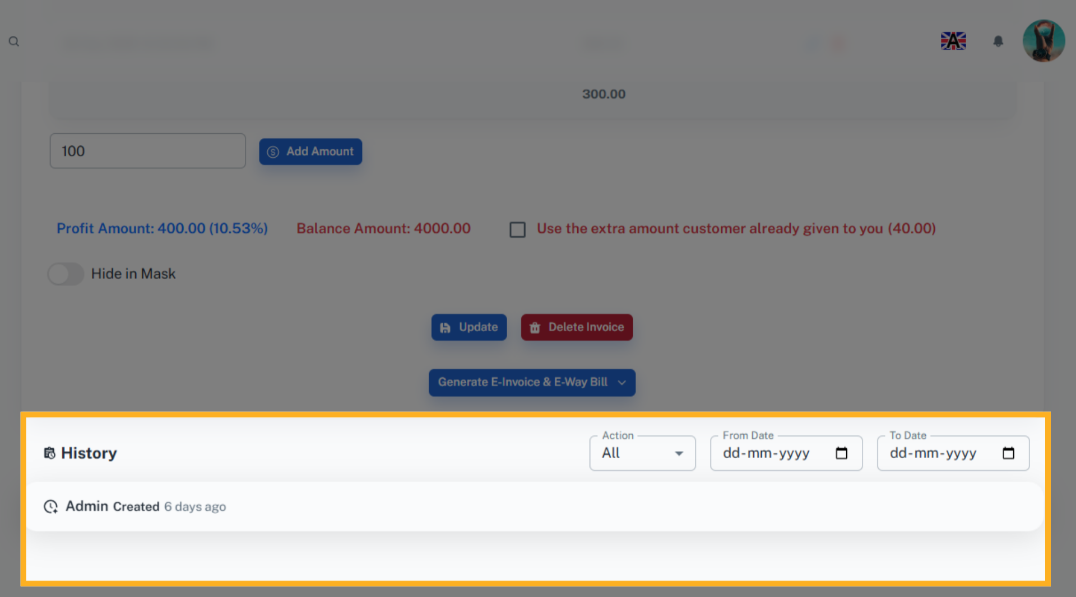

29. Print
Click Print to generate and view the bill.
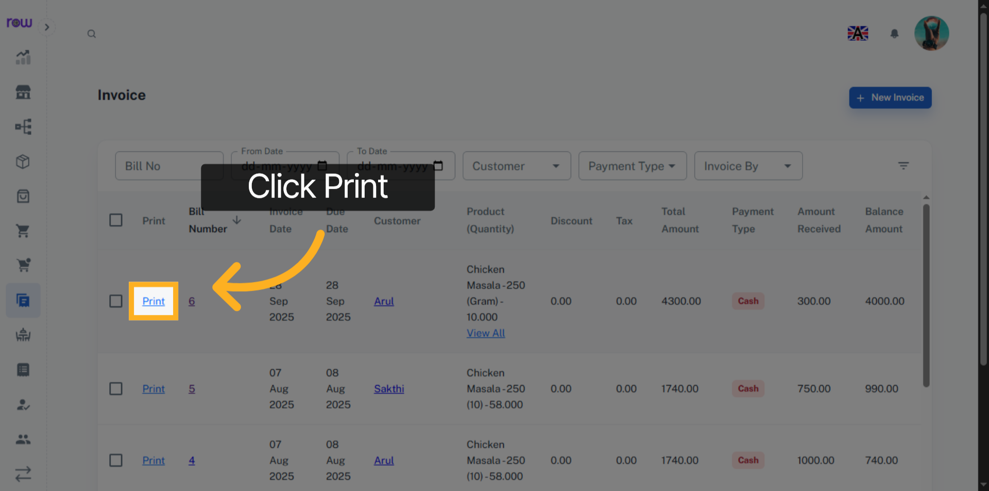

30. Download and Print Bill
You can print and download the bill.
