Create and Manage Orders in RunOnweb

Go to runonweb.com

1. Introduction
In this tutorial, you will learn how to create, update, and cancel an order, as well as generate an e-invoice and an e-way bill for the order.

2. Orders Menu
Select the Order menu to open the orders list screen.
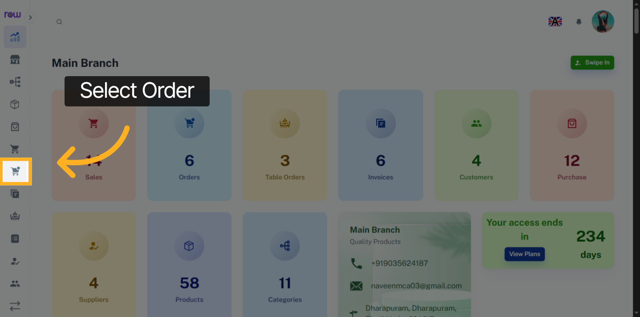

3. New Order Button
Click the New Order button to start creating an order.
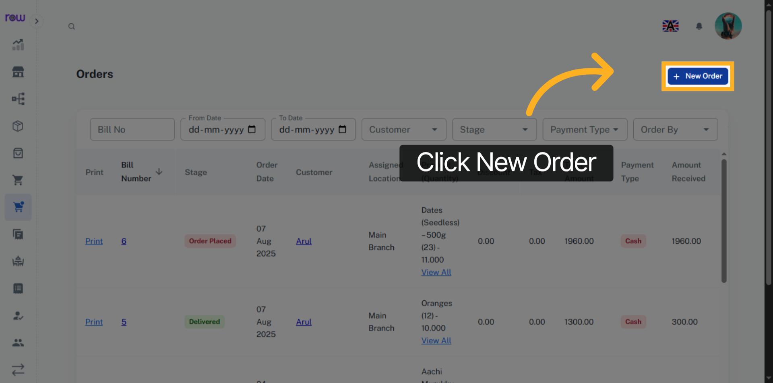

4. New Order
Order date, Order by ,Stage and Assigned Location are already filled in. You can update them if needed.
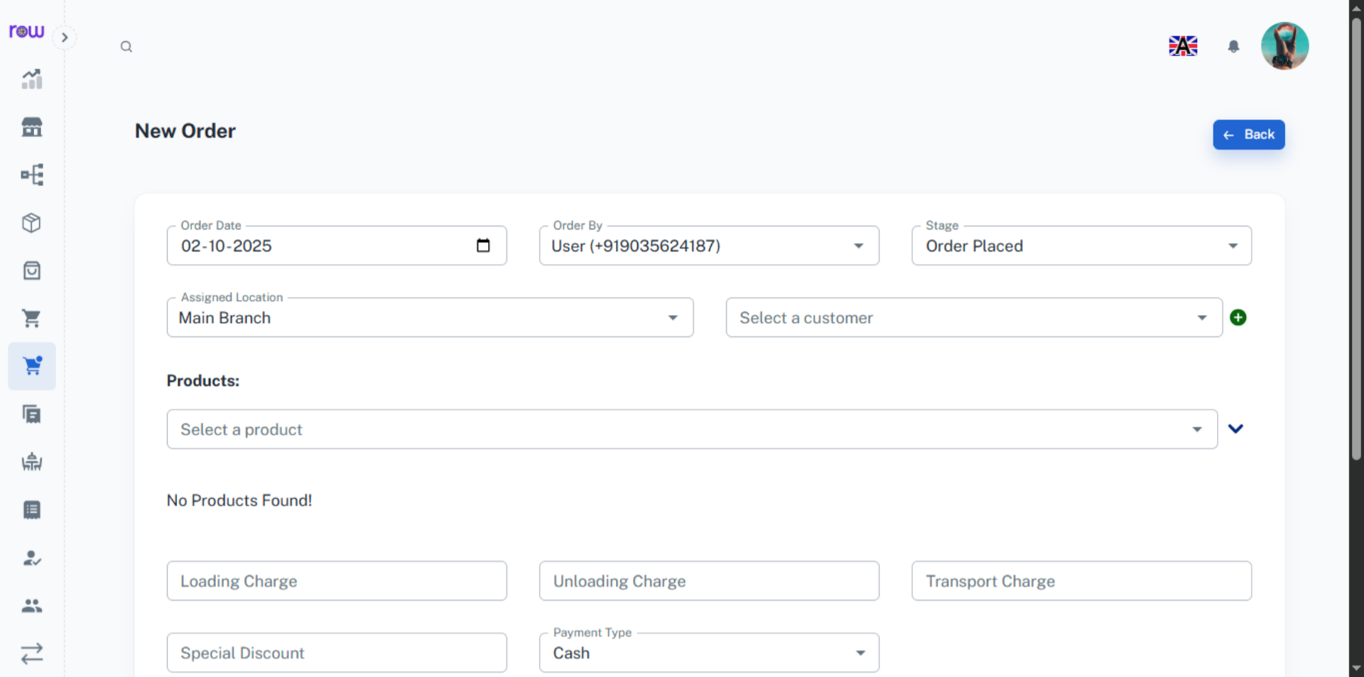

5. Order Status
You may update the order status by tracking the shipment.
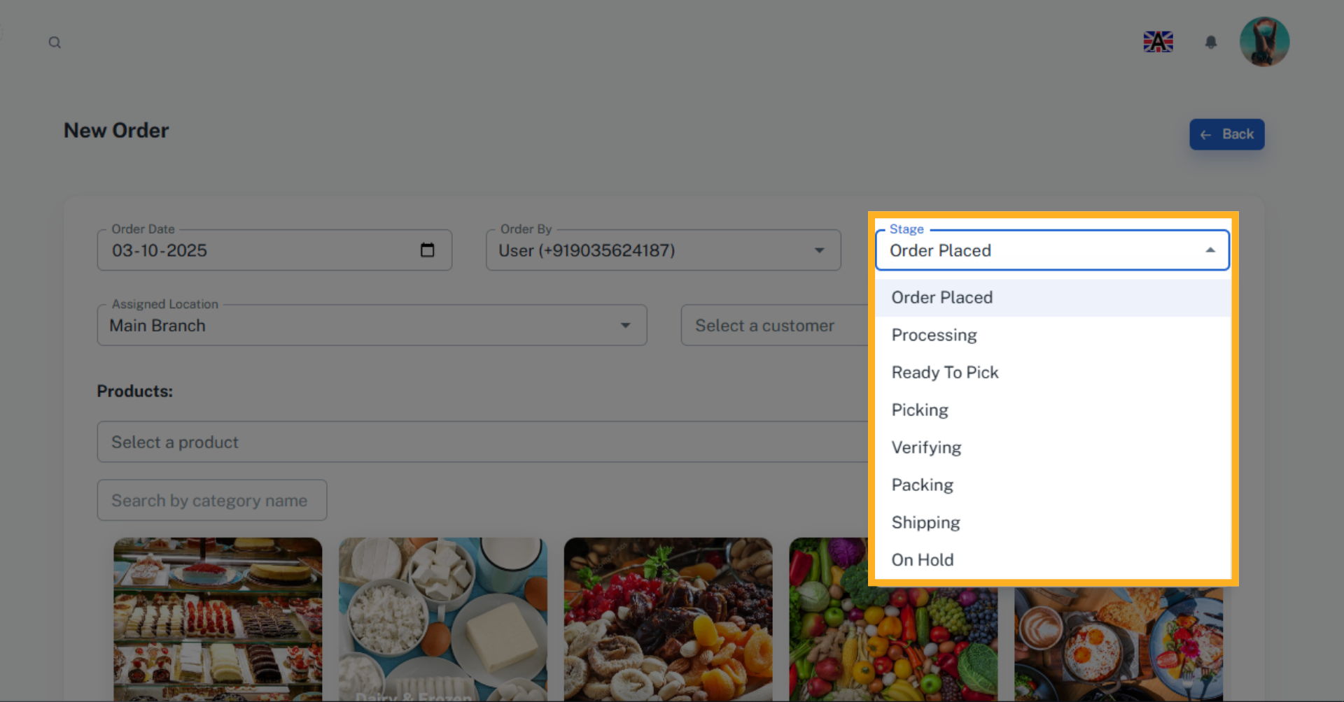

6. Select a customer
Search and select an existing customer.
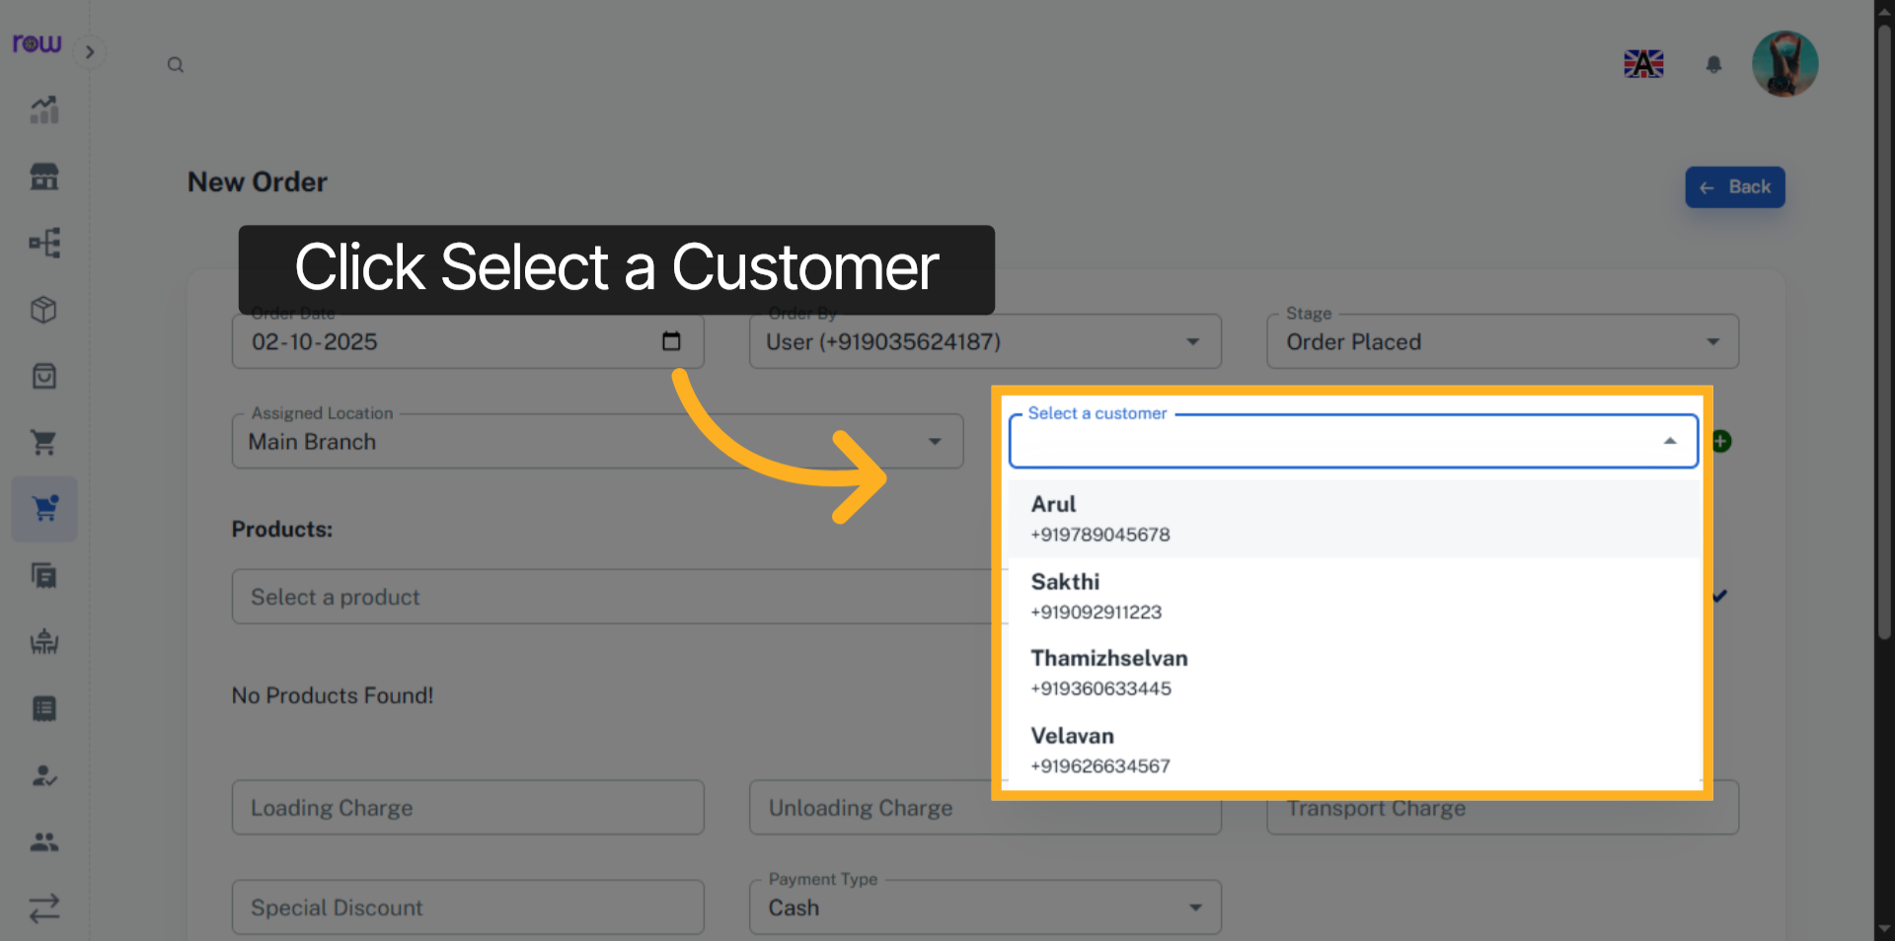

7. Create new customer
Click + icon to add a new customer
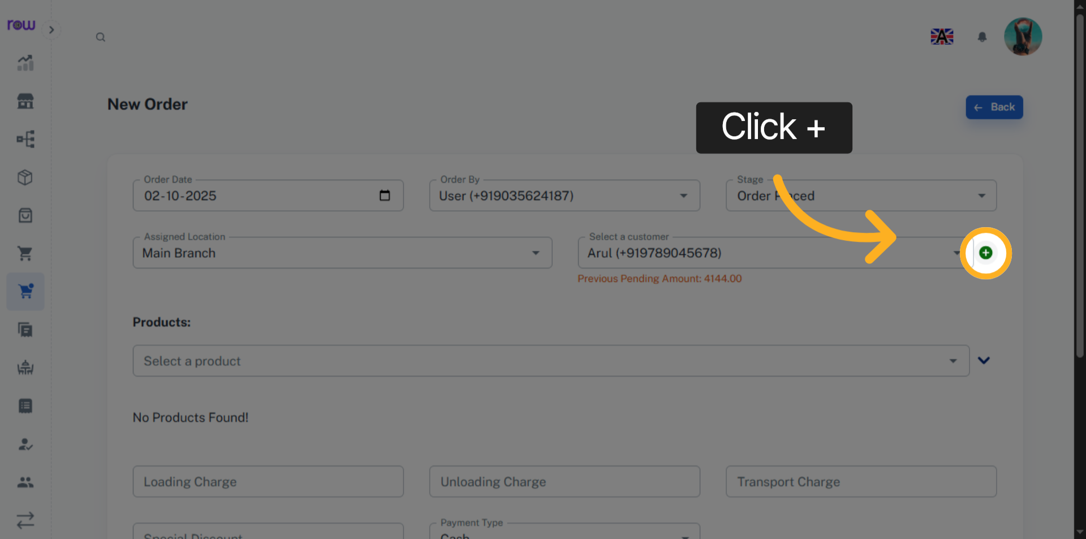

8. New Customer Page
Enter the new customer details and click Add to save and select the customer.
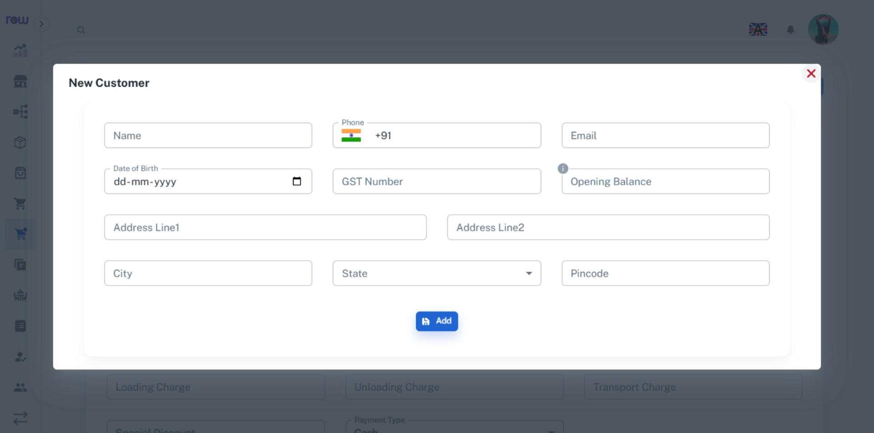

9. Select a product
Select a product from the dropdown. You can search by product name or code.
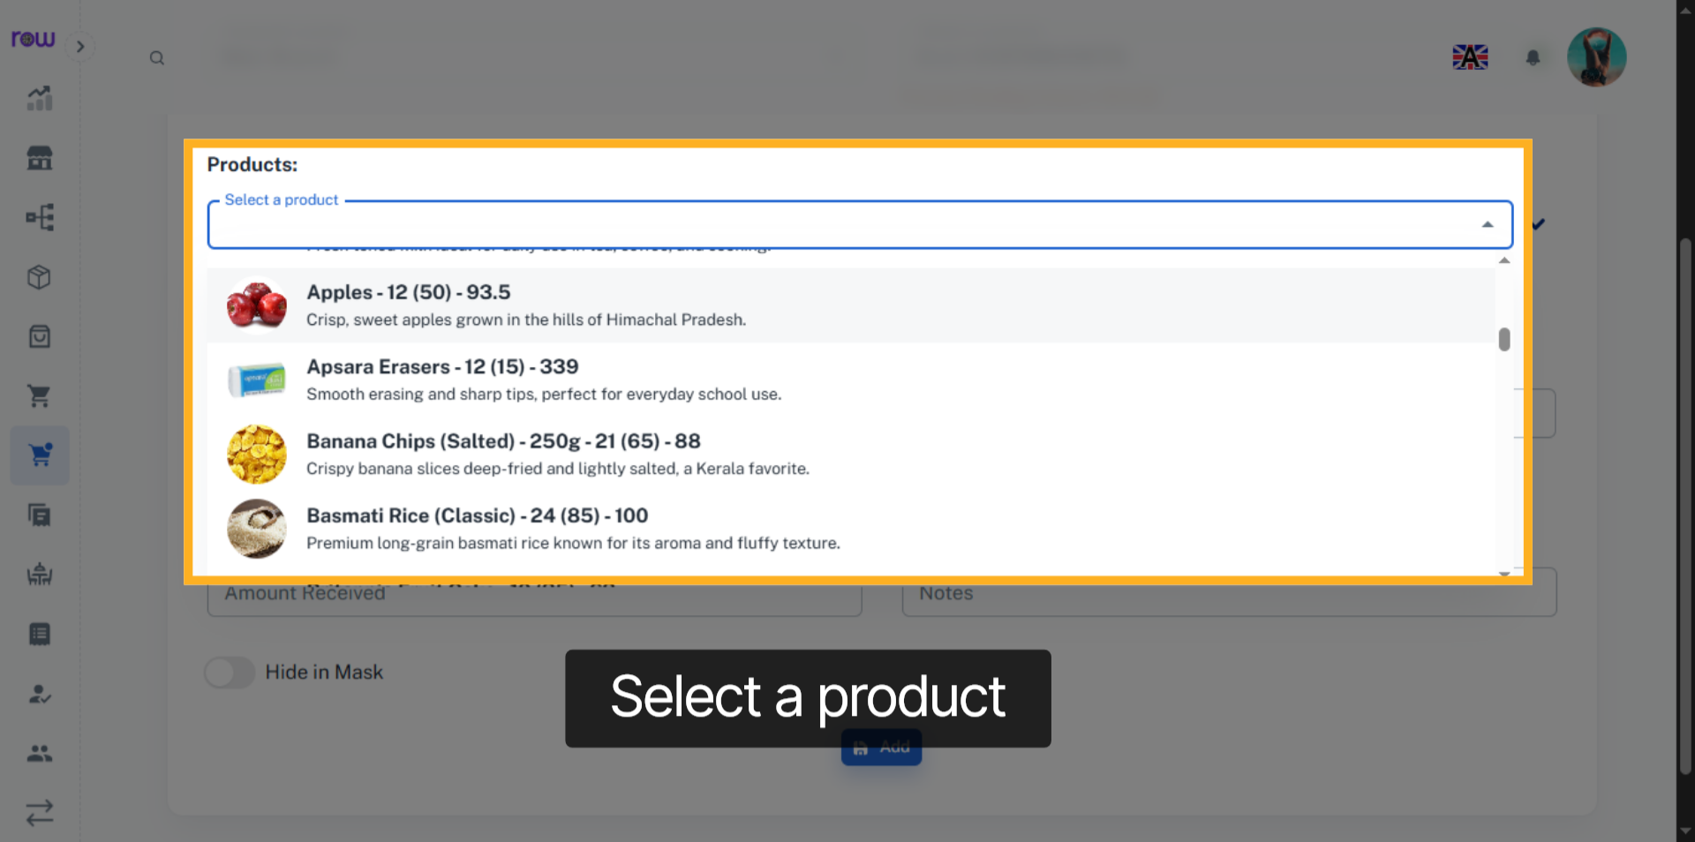

10. Product Selection Dropdown
Or click the arrow to find a product by its category.
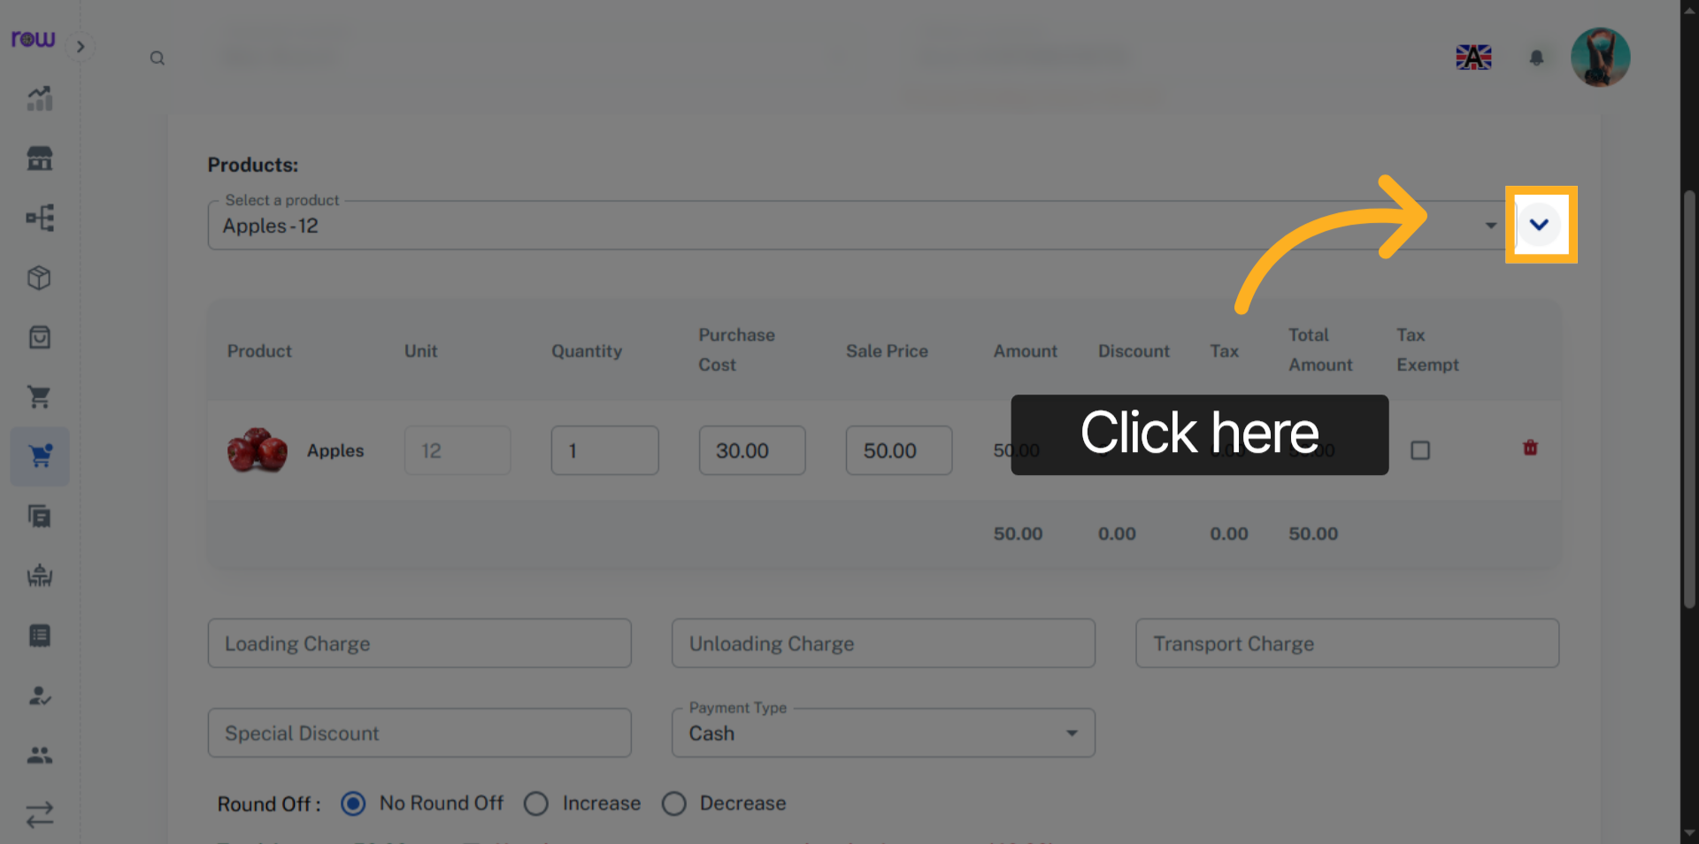

11. Select the product category
select the product by its category
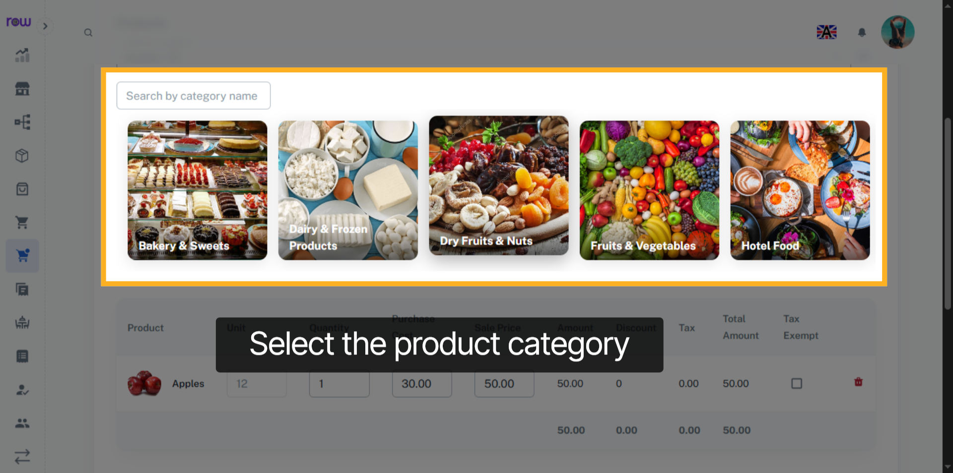

12. Select Product
Select Product
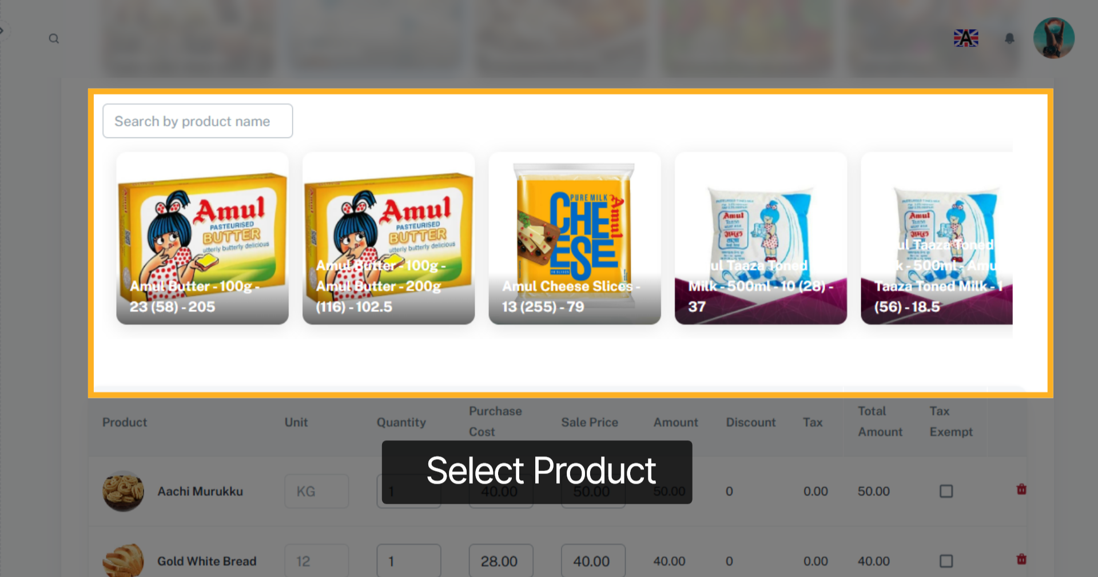

13. Selected Product List
After product selection you can update the quantity, Purchase cost and Sale price of the products.
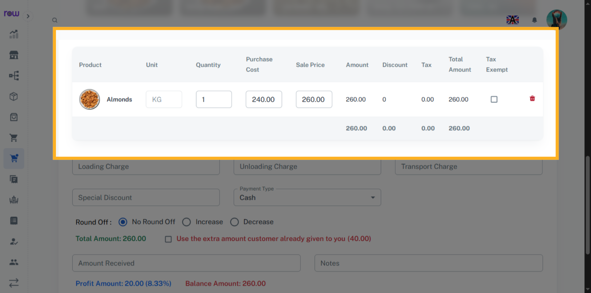

14. Tax Exempt Checkbox
Select the checkbox to exempt the tax for a product.
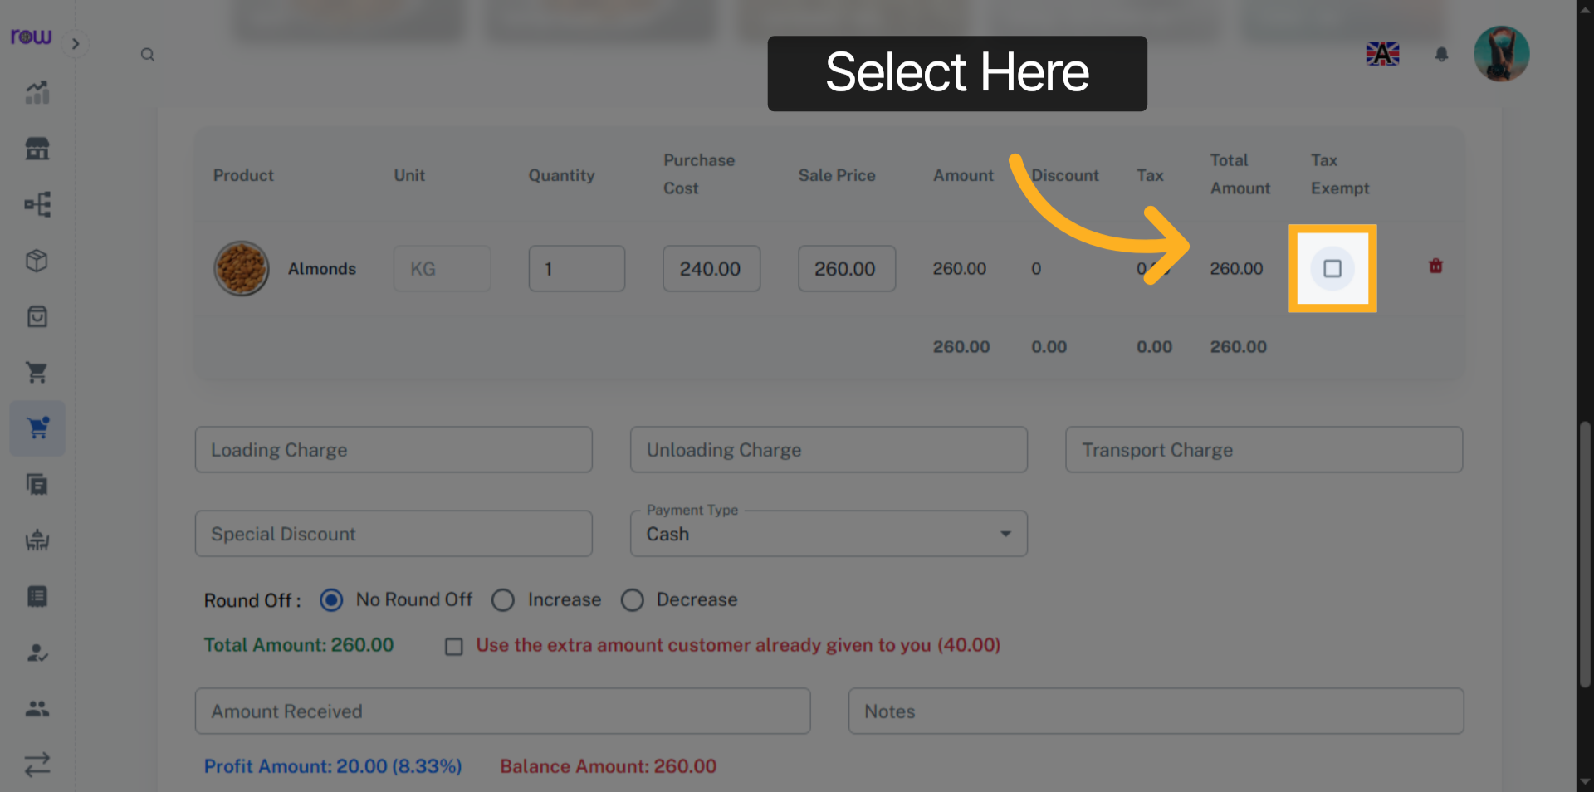

15. Other Optional Fields
Enter loading charge, unloading charge, transport charge and Special discount if applicable.
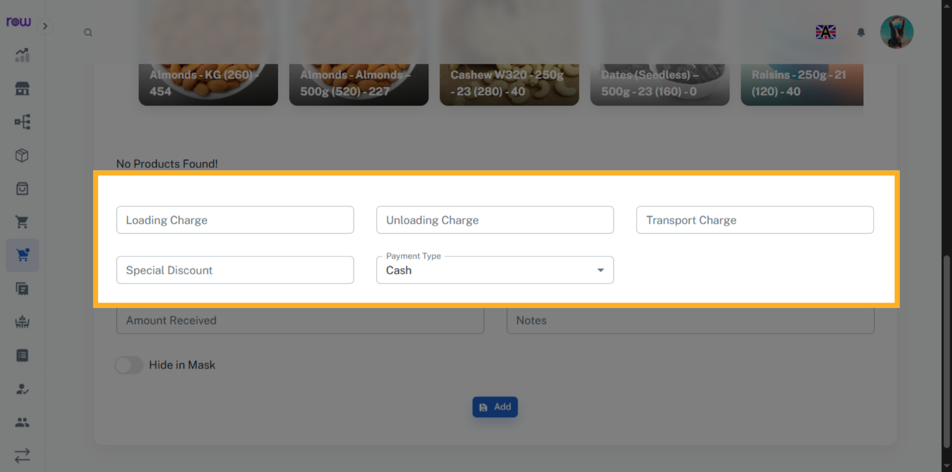

16. Round Off
If the total value has decimal points, you can round it off.
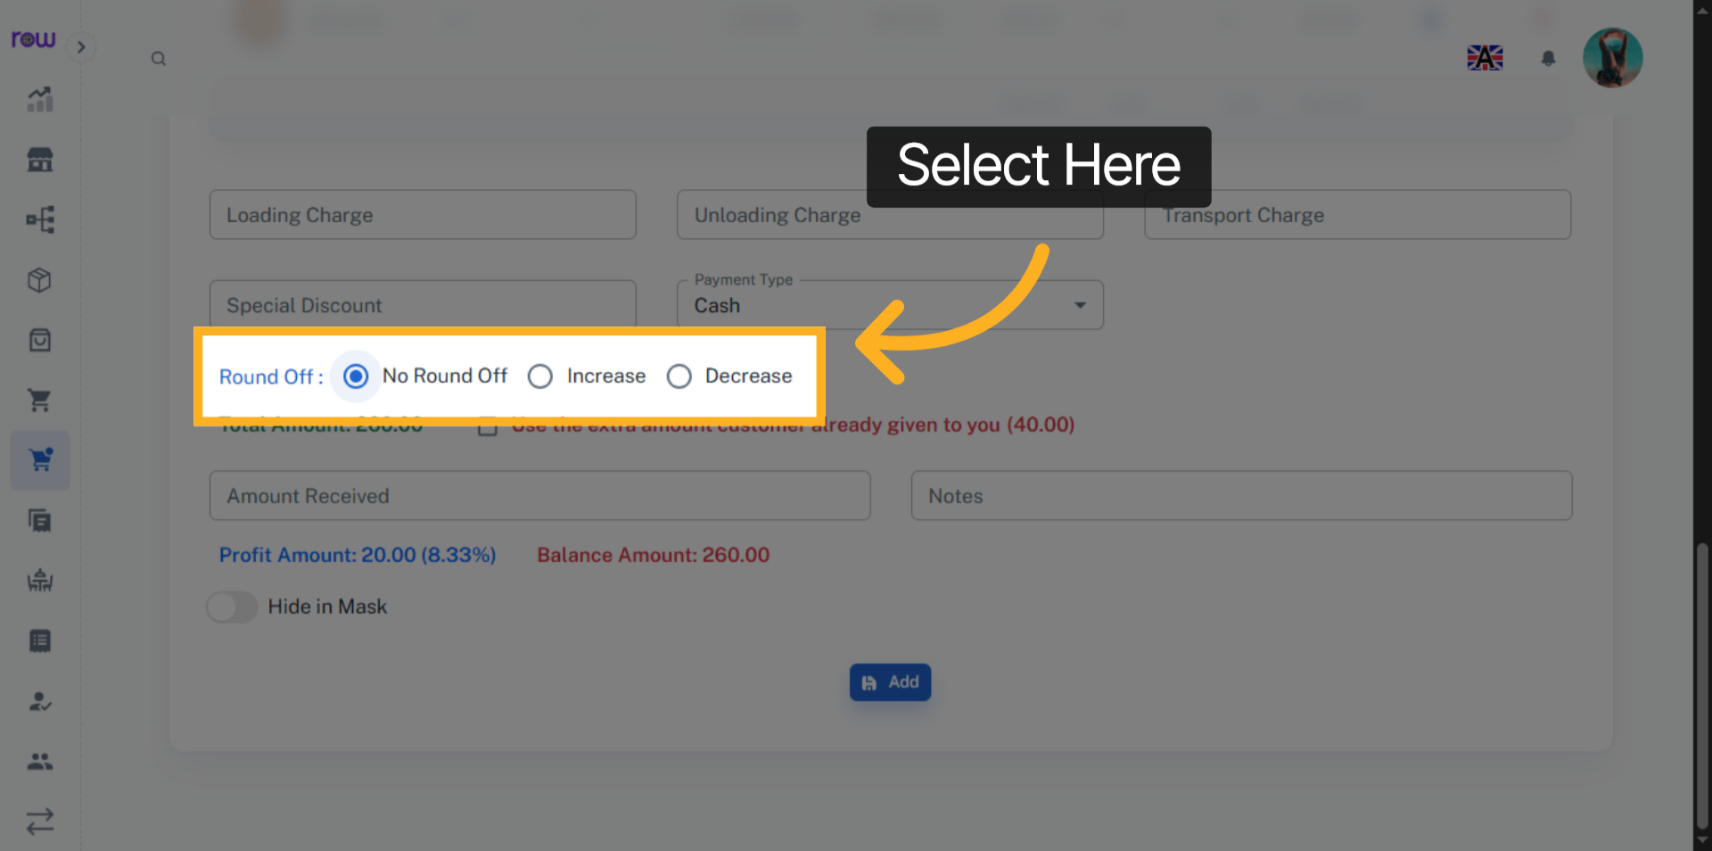

17. Amount Received
Enter the amount received from the customer
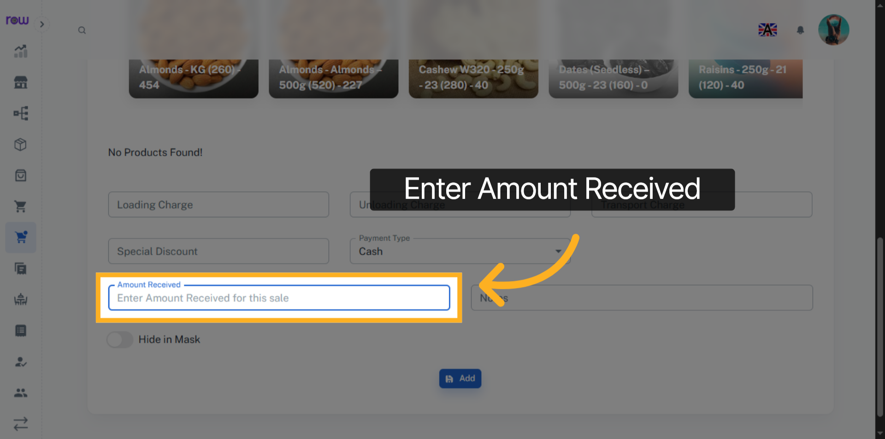

18. Add
Click "Add" to create the order
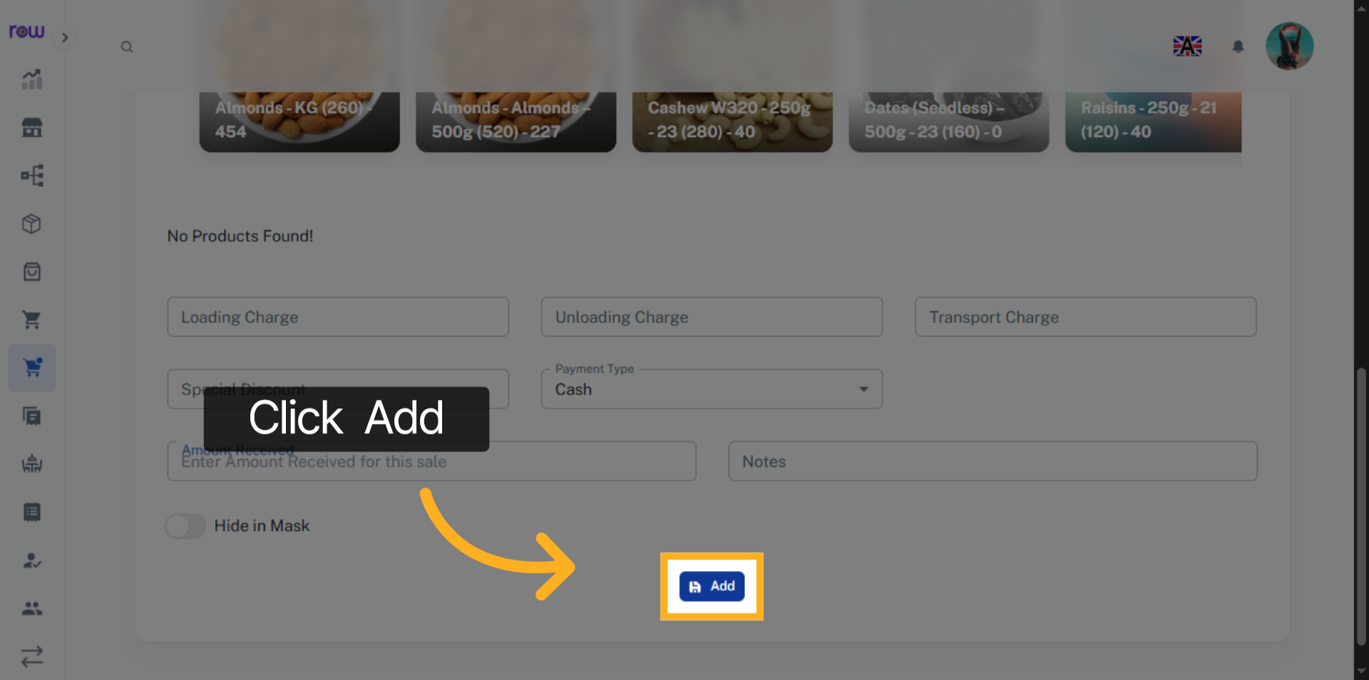

19. Orders List
You will be redirected to the orders list screen after the order is successfully created.
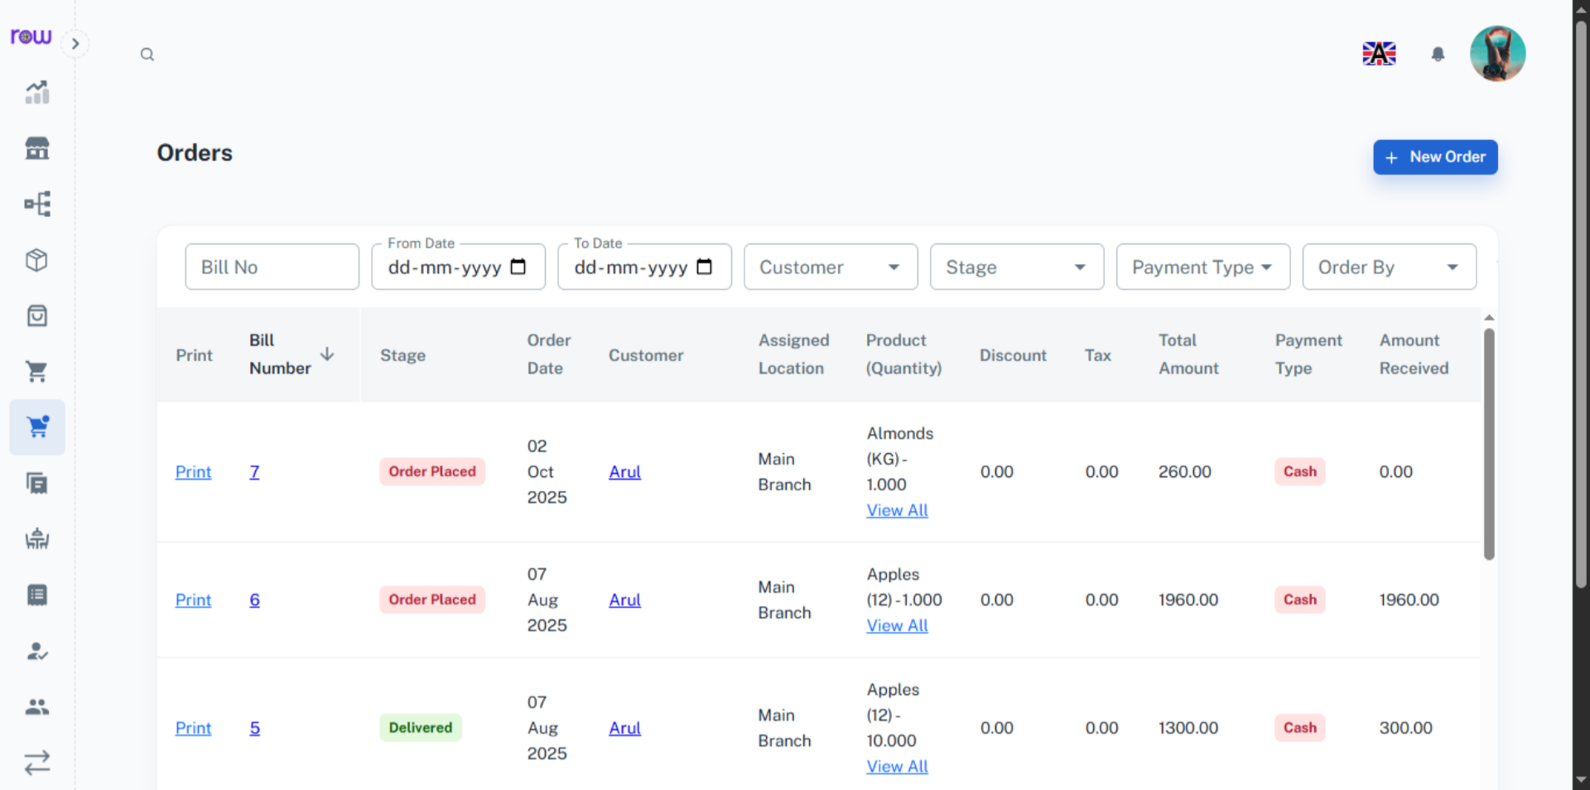

20. Bill Number
Click the bill number to edit the order.
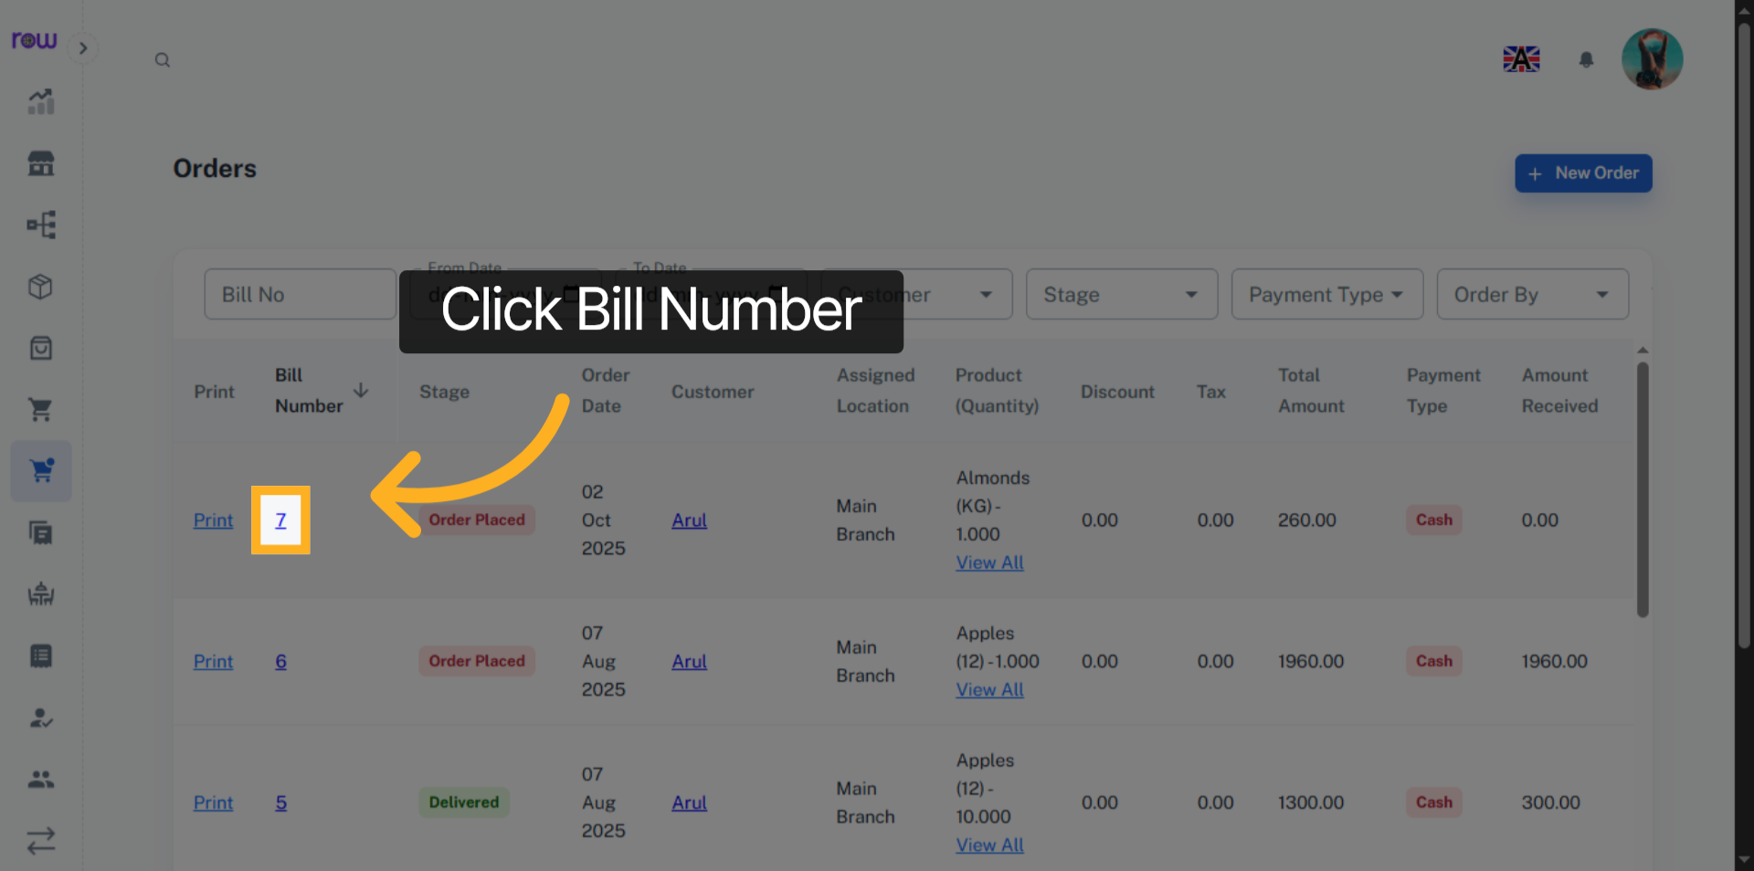

21. Edit Orders
You may modify all fields except the customer and the assigned location. Additionally, you can add, Update or remove the products during the update process.
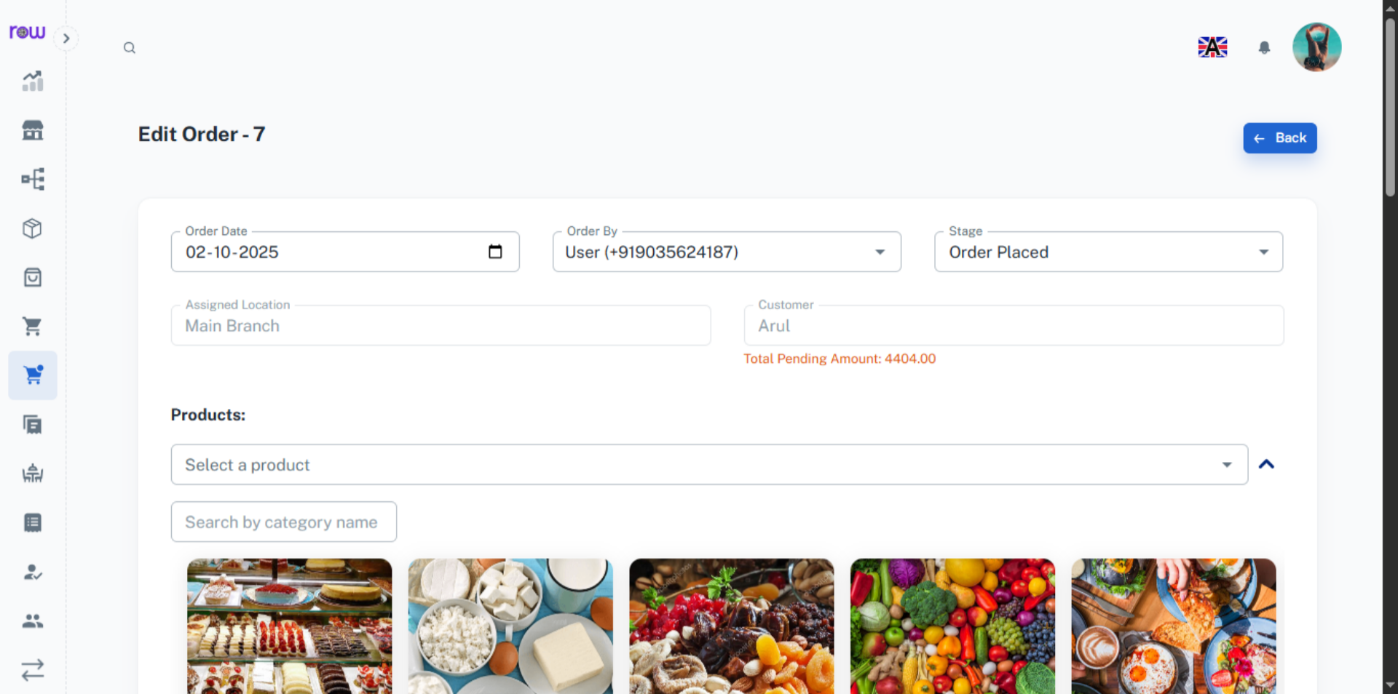

22. Return Order
you may return the products after they have been delivered, and the returned products will be added back to stock
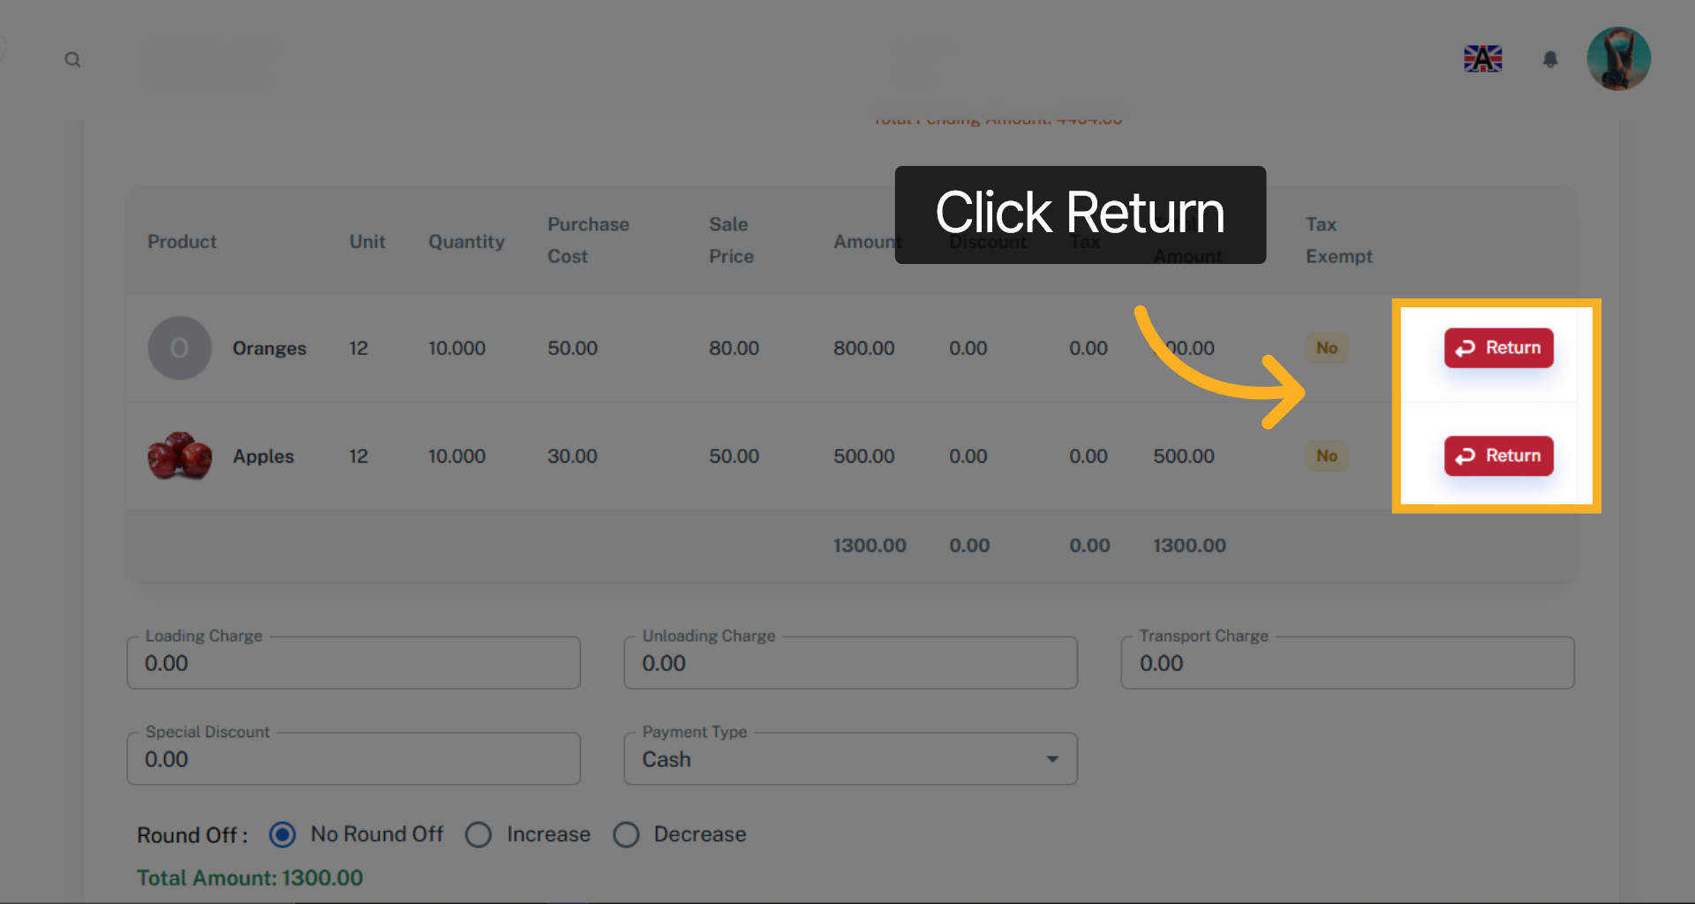

23. File Name
Upload the file related to this order, if available.
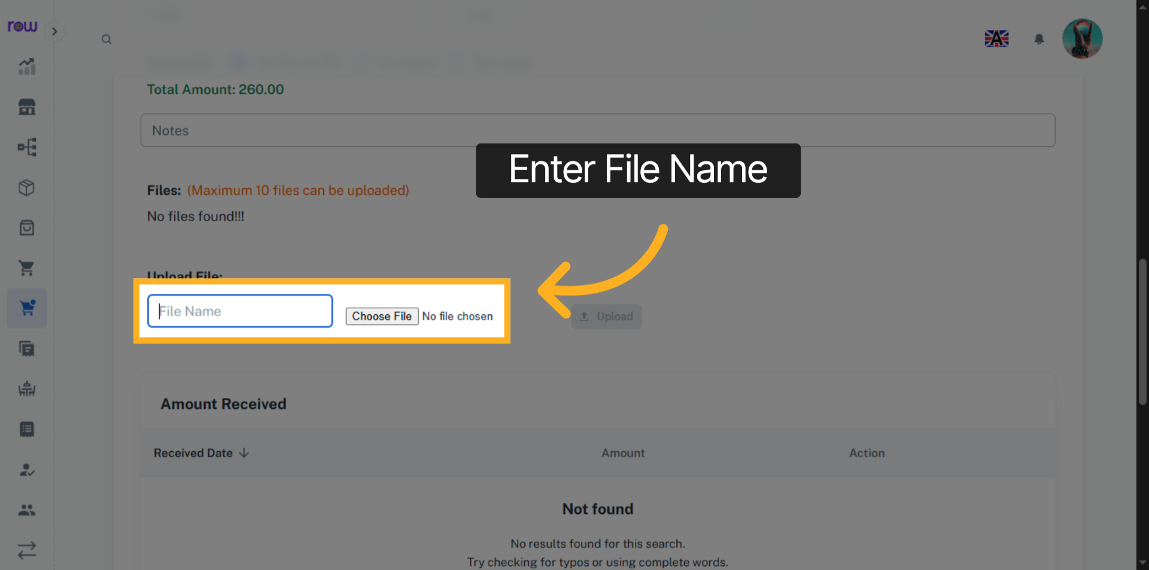

24. File
You may view the uploaded file and also delete it, if necessary.
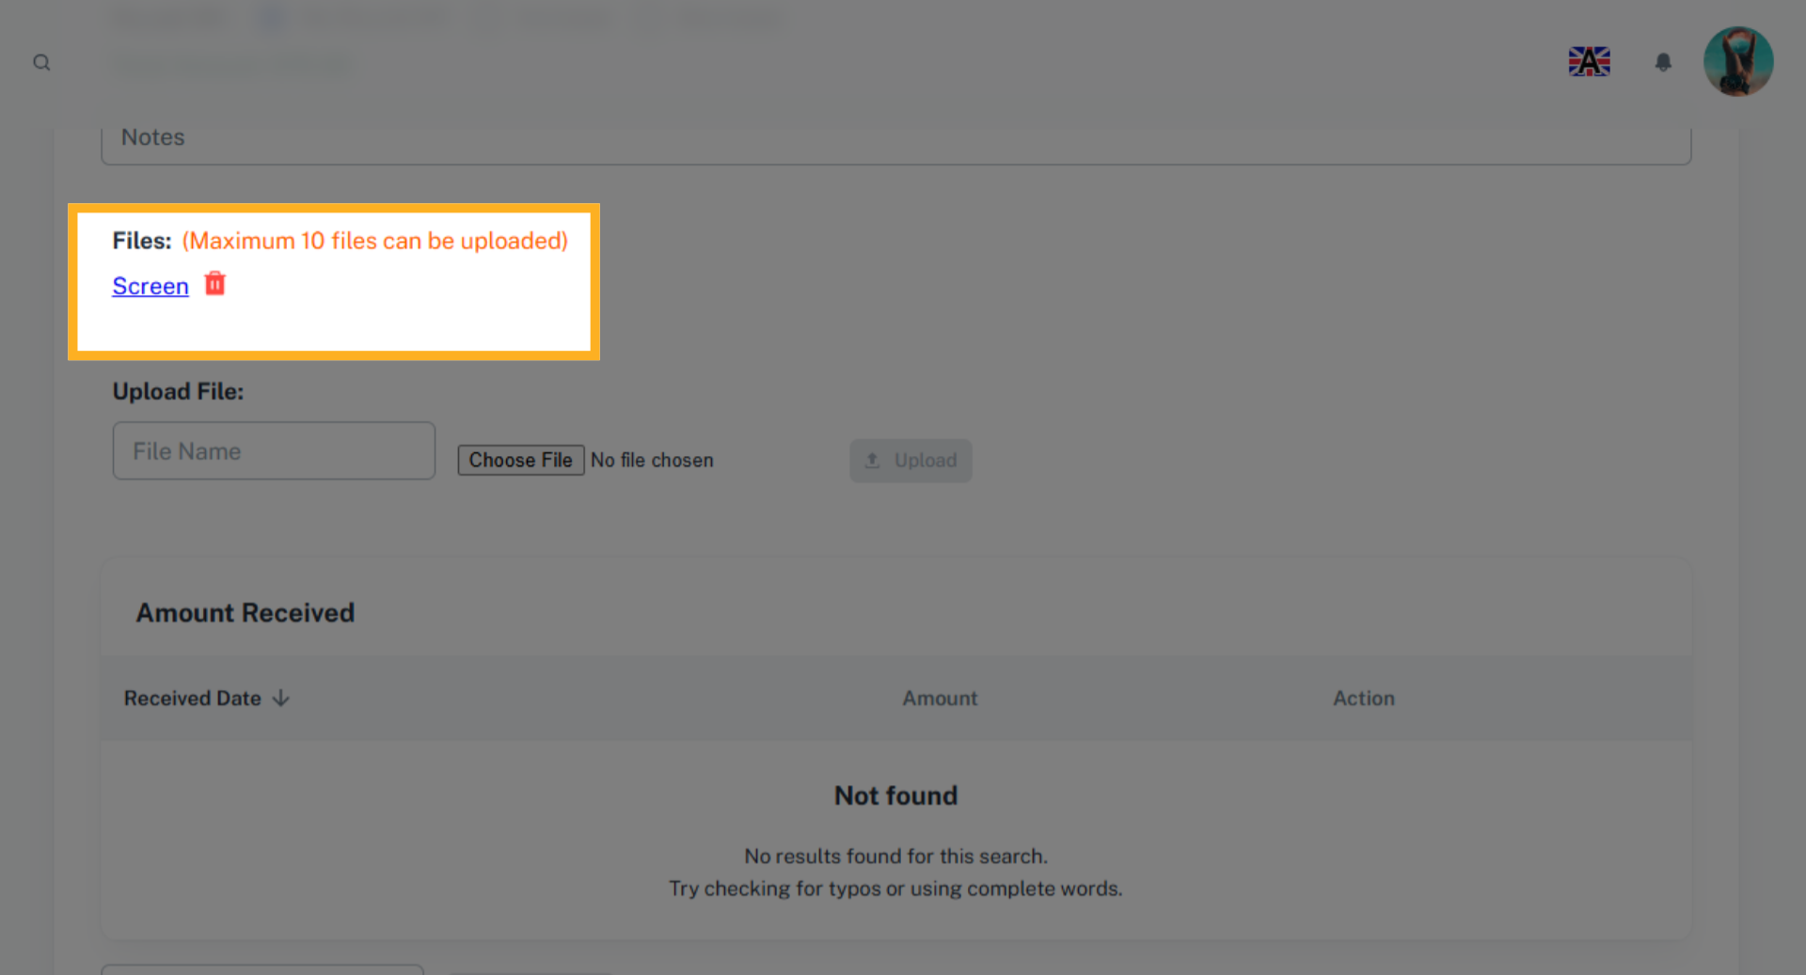

25. Add Pending Amount
Enter the pending amount received from the customer and click add amount button update the amount received
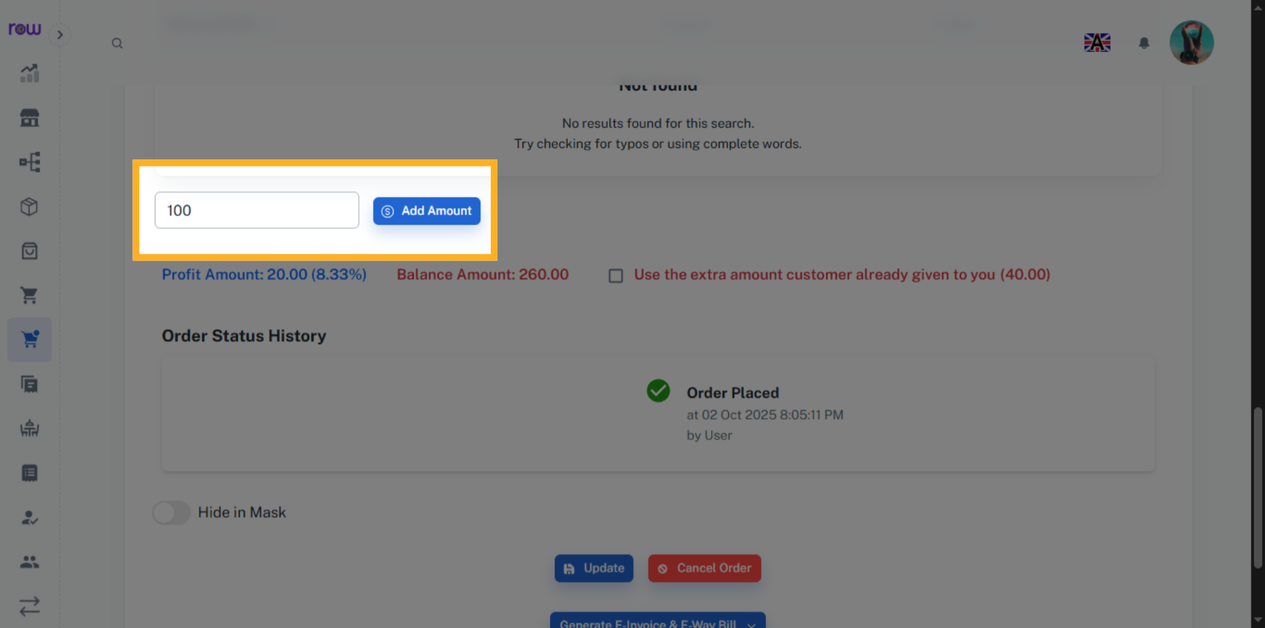

26. Order Status History
You can view the Order status history here.
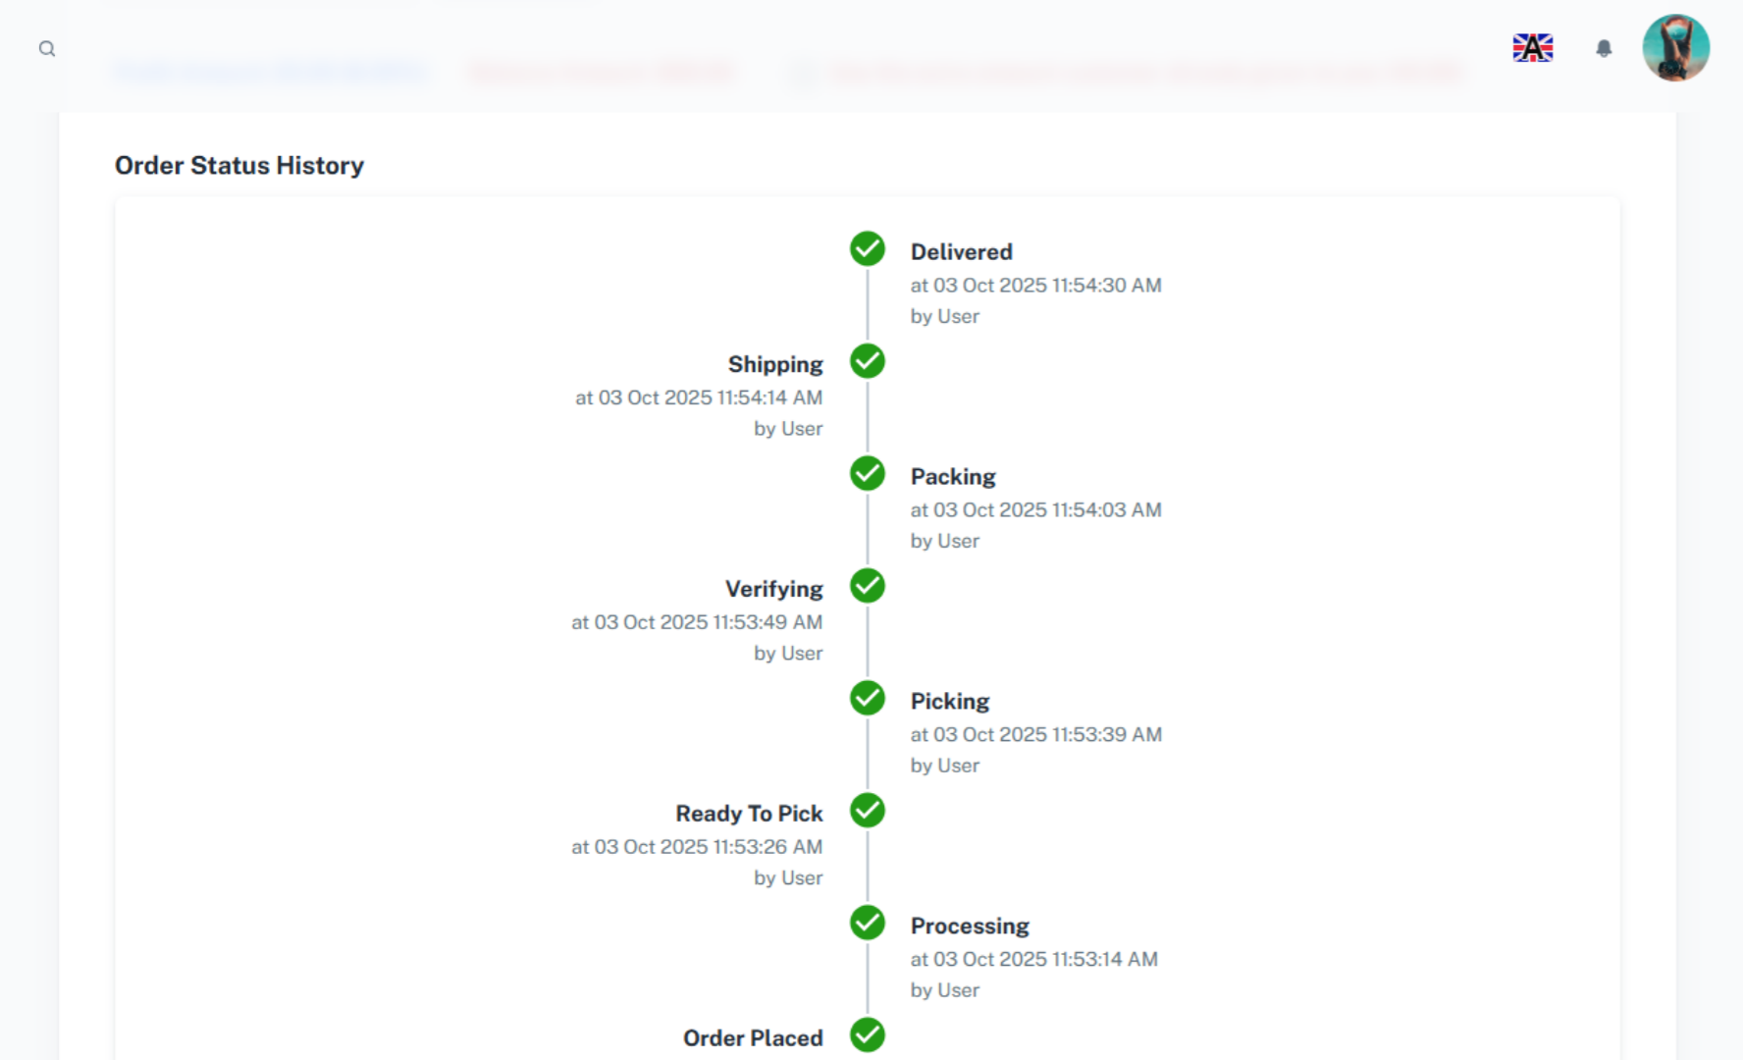

27. Update Order
Click Update to save the changes.
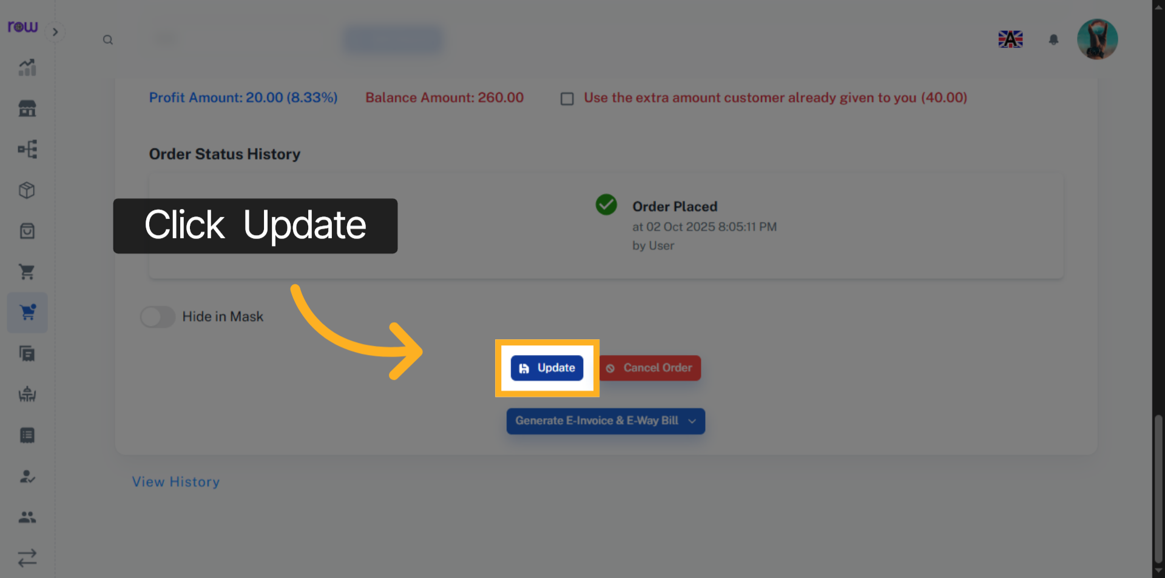

28. Cancel Order
Click the Cancel Order button to cancel the order. If canceled, the product quantities will be updated in stock if delivered.
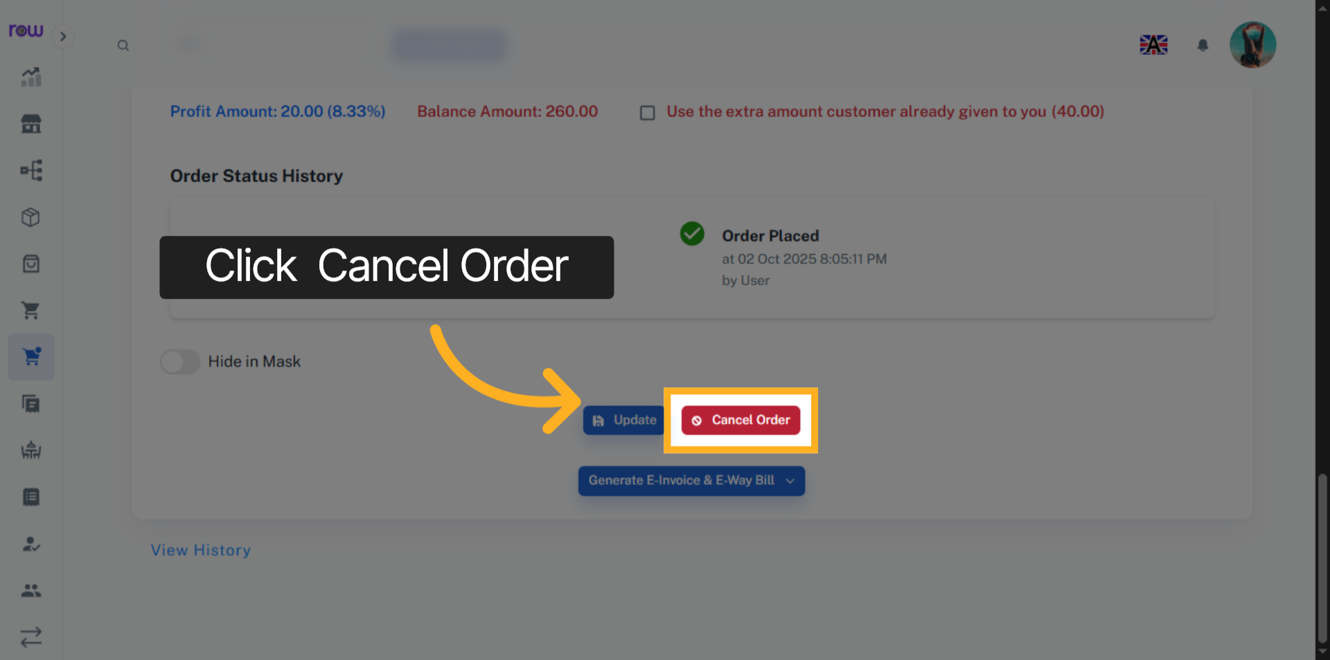

29. Generate E-Invoice & E-Way Bill
Click this button to Generate E-Invoice & E-Way Bill.
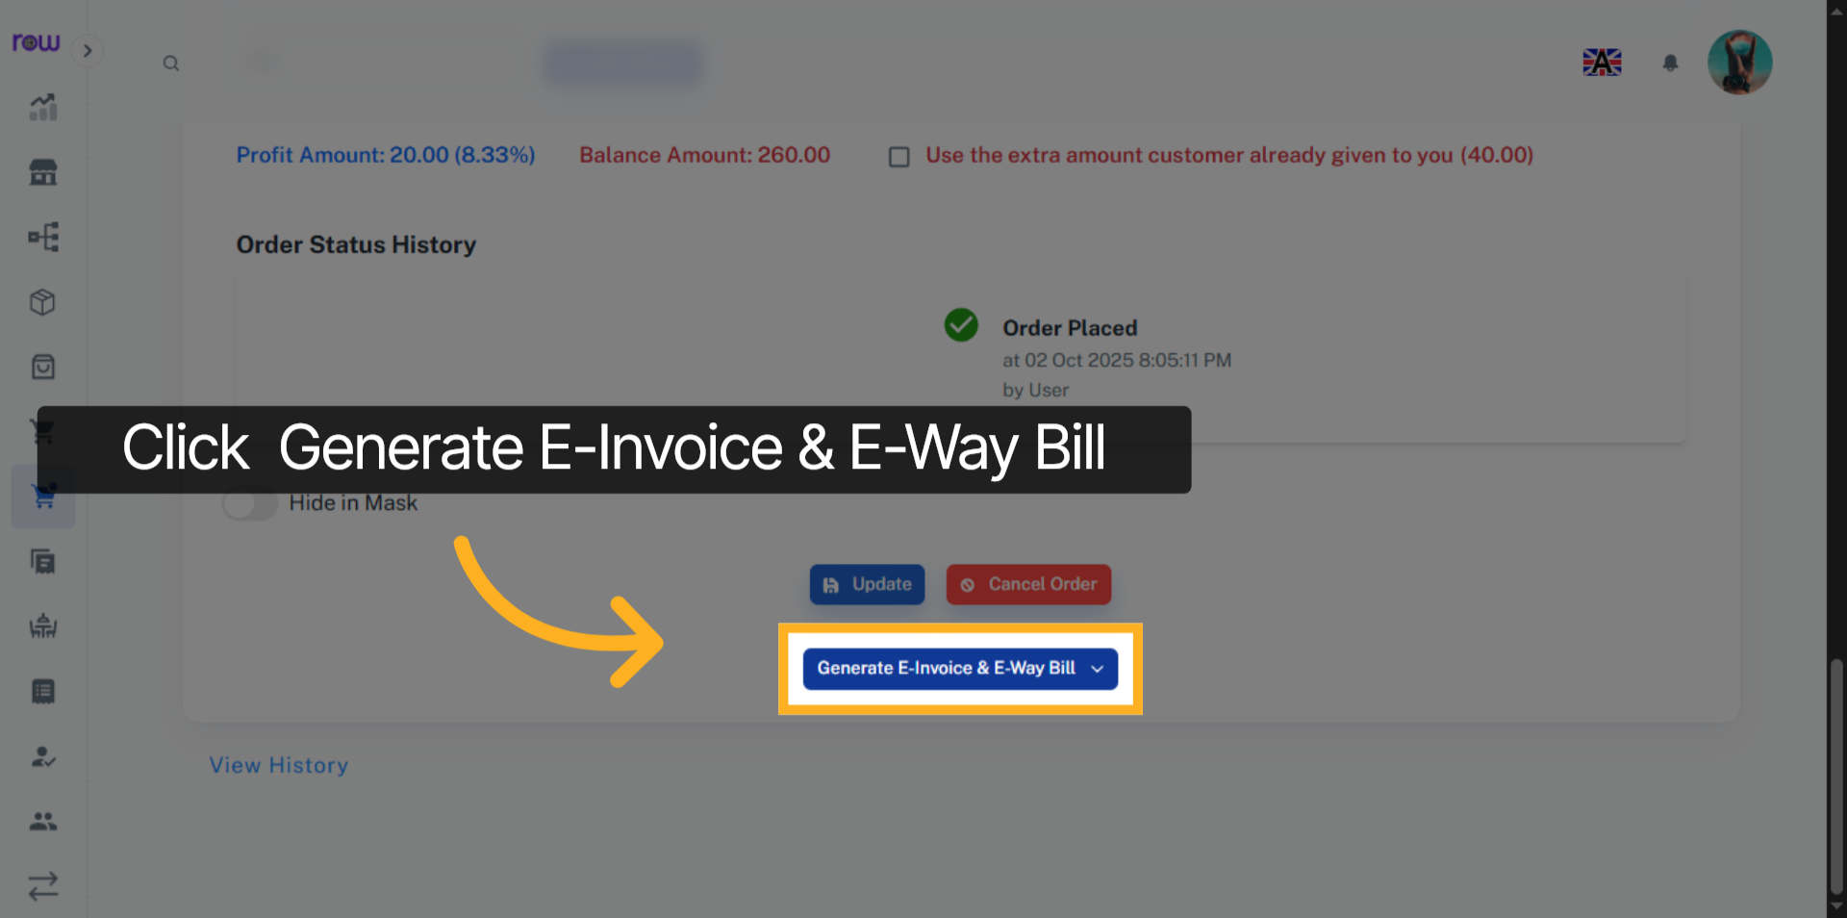

30. E-Invoice & E-Way Bill Options
Select the options according to your requirements.
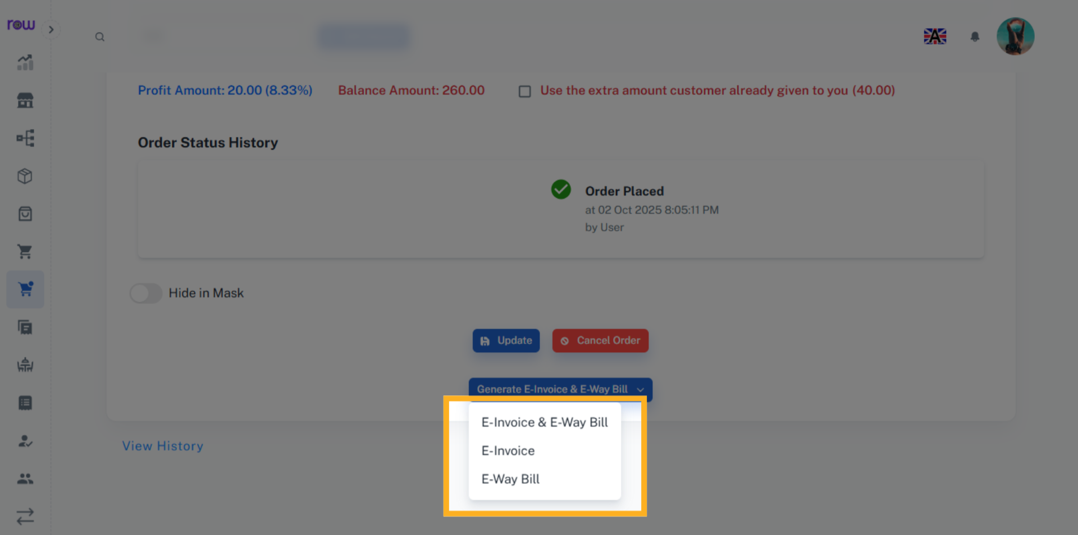

31. E-Way Bill
Please enter the transportation details if you have selected an e-way bill.
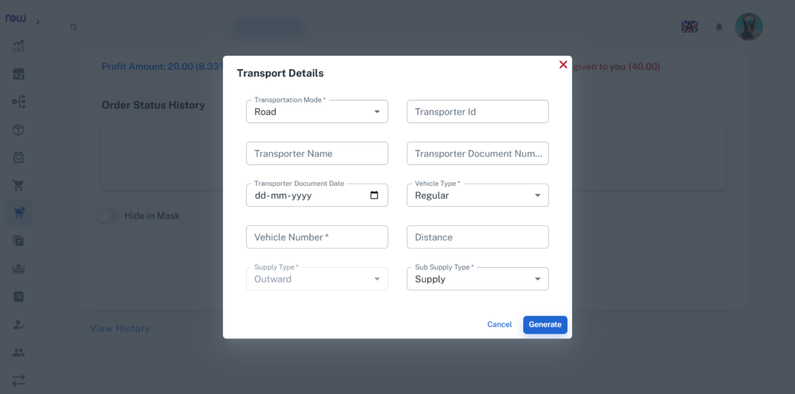

32. View History
Click the View History link to see the work history of this order performed by the employees.
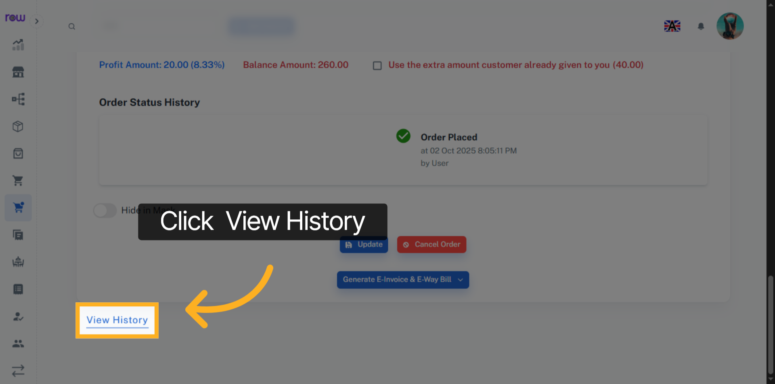

33. History
You can see who performed which actions and when in the history.
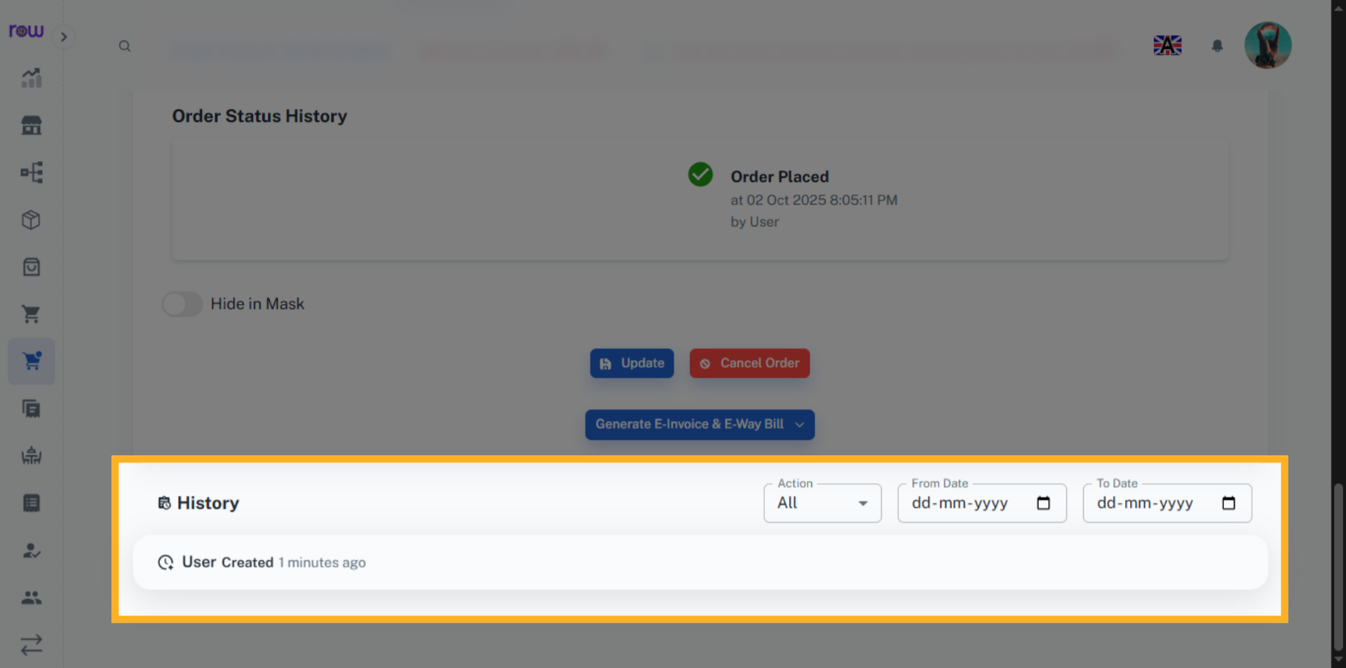

34. Print Bill
Click Print to generate and view, the bill.
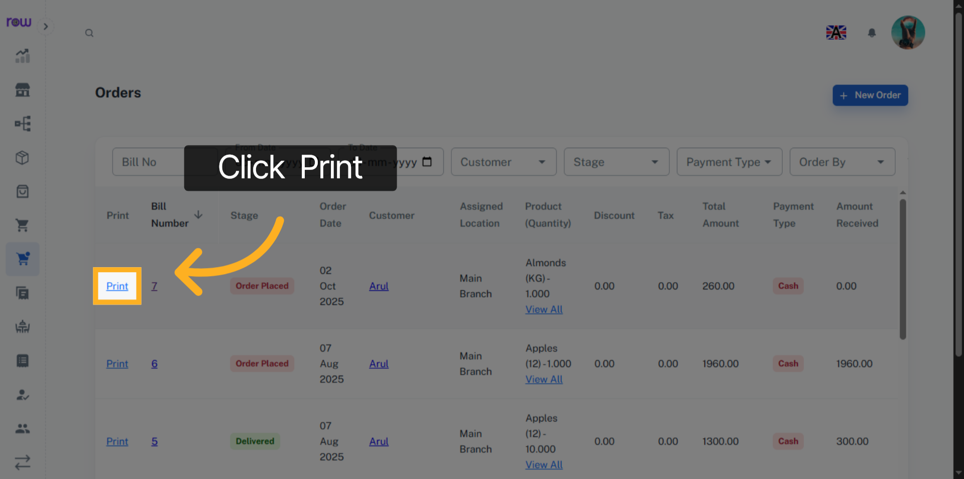

35. Download and Print Bill
You can print and download the bill.
