Create and Manage Sales in RunOnWeb

Go to runonweb.com

1. Introduction
In this tutorial, you will learn how to create, update, and cancel a sale, as well as generate an e-invoice and an e-way bill for the sale.

2. Sales Menu
Select the Sale menu to open the sales list screen.
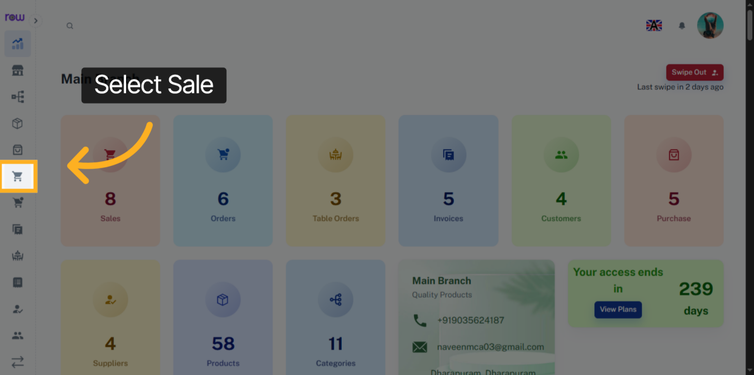

3. New Sale Button
Click the New Sale button to start creating a sale.
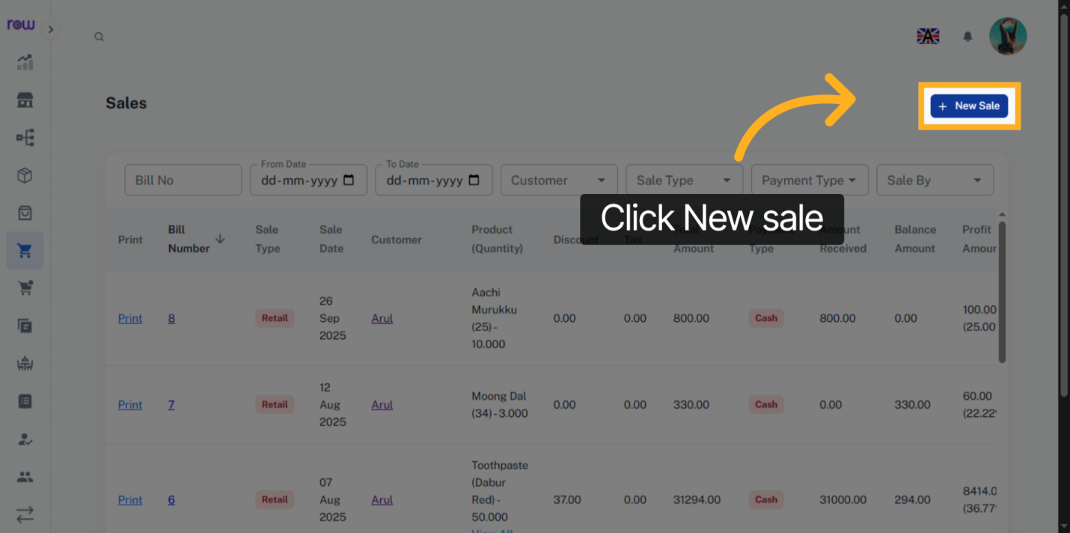

4. New Sale
sale date, sale type, and sale done by are already filled in. You can update them if needed.
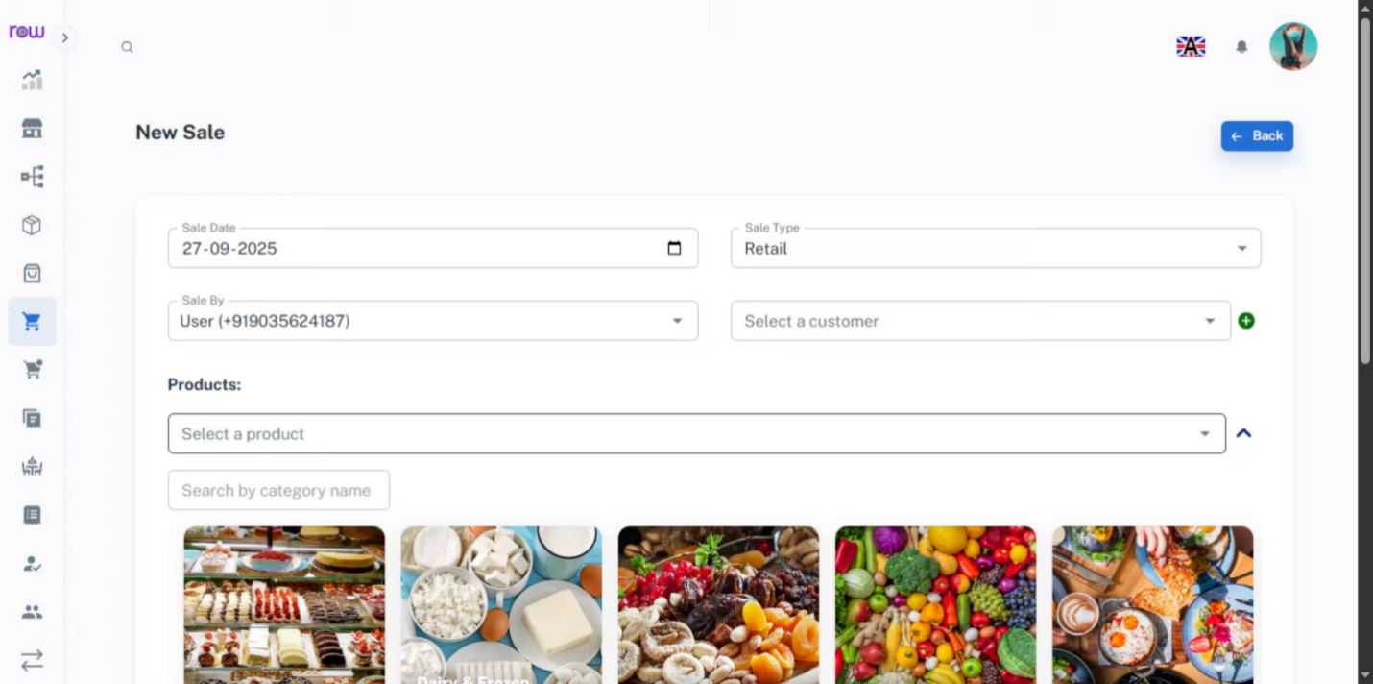

5. Select a customer
Search and select an existing customer.
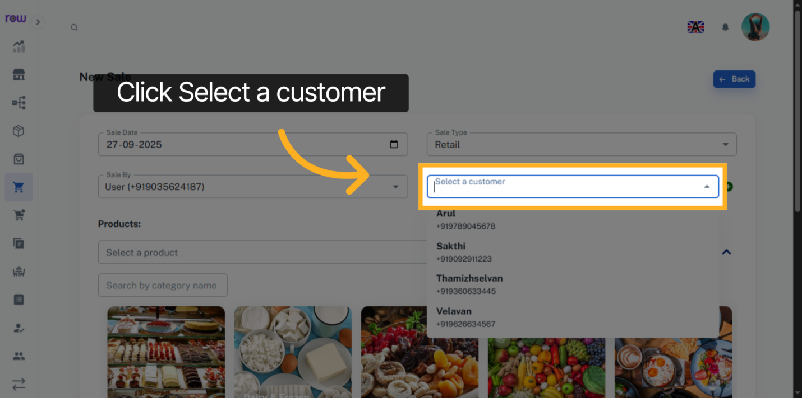

6. Create new customer
Click + icon to add a new customer
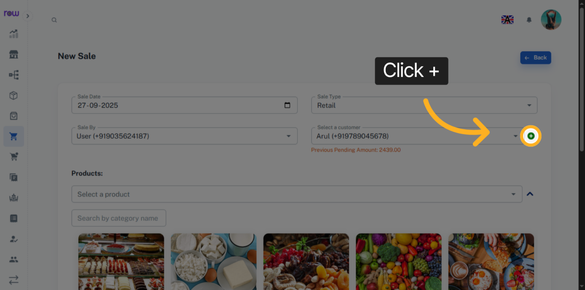

7. New Customer Page
Enter the new customer details and click Add to save and select the customer.
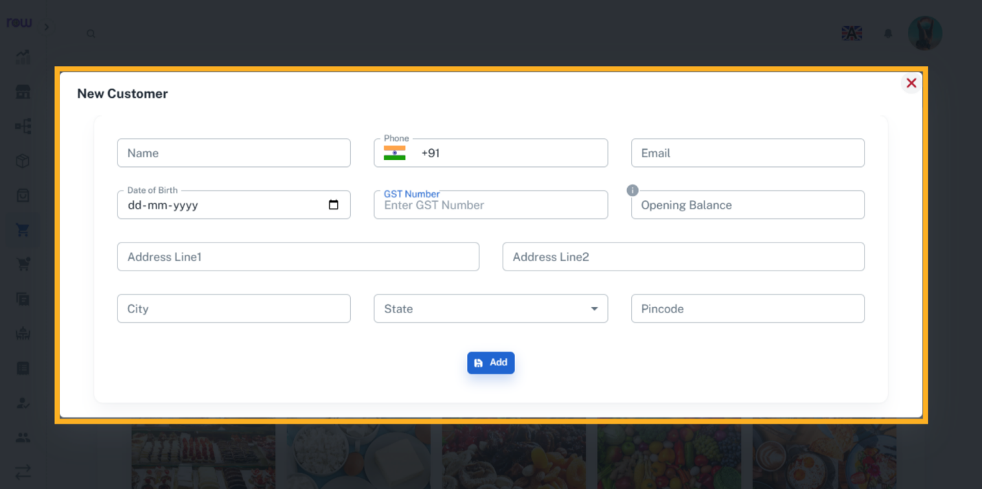

8. Select a product
Select a product from the dropdown. You can search by product name or code.
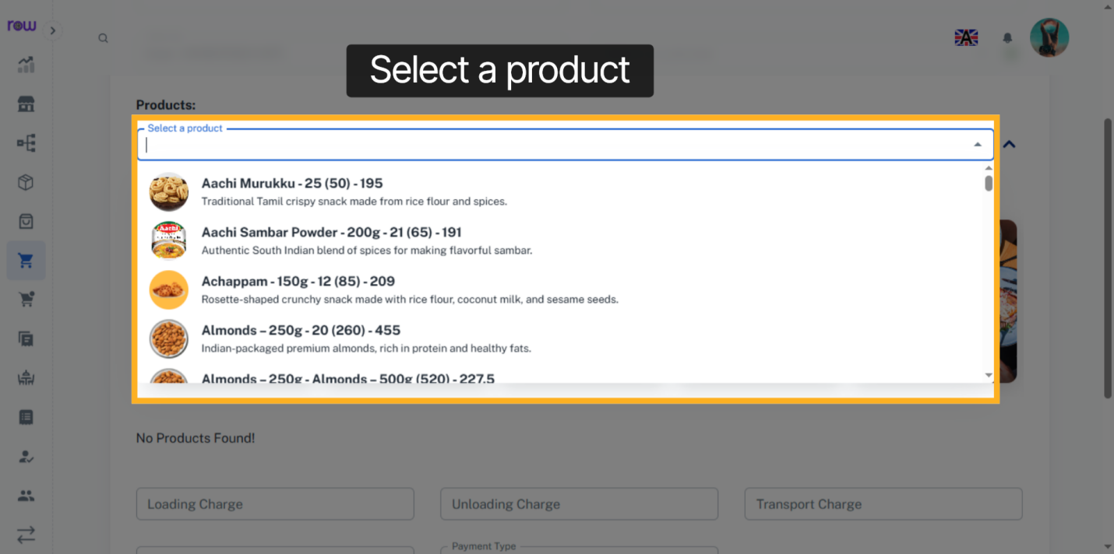

9. Product Selection Dropdown
Or click the arrow to find a product by its category.
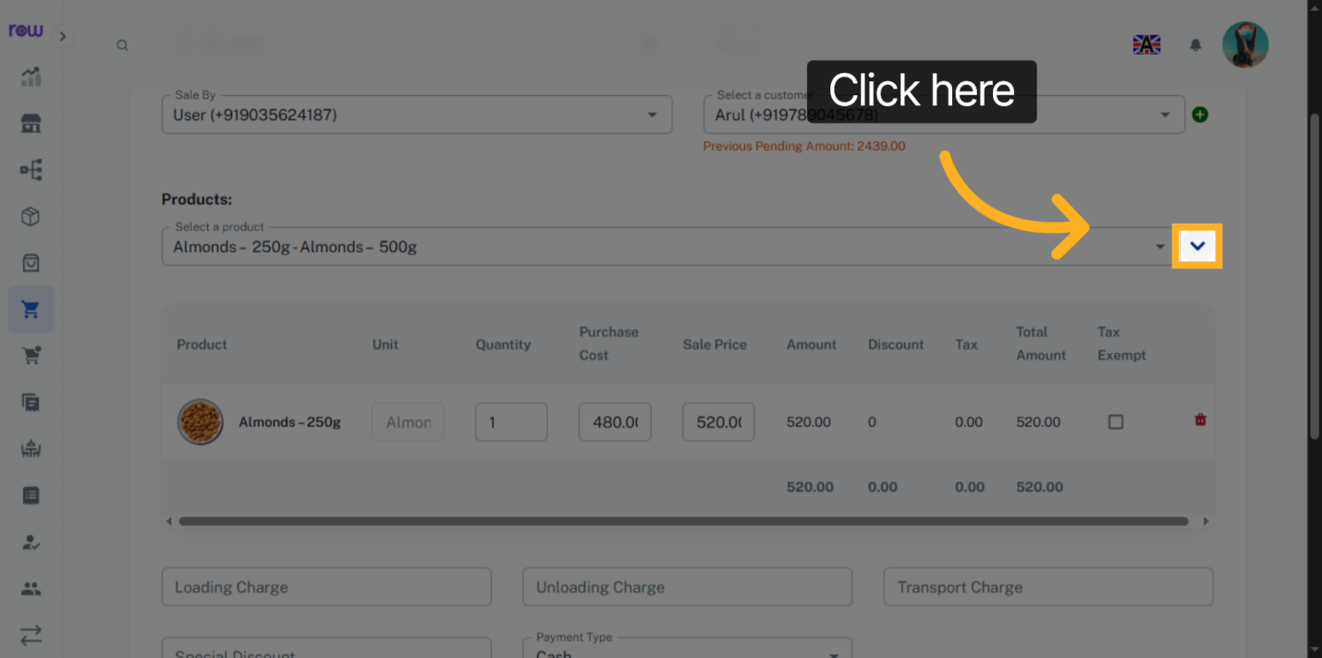

10. Select the product category
select the product by its category
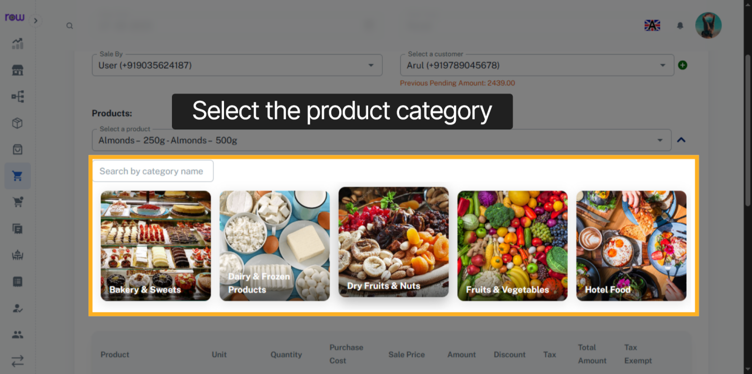

11. Select Product
Select product.
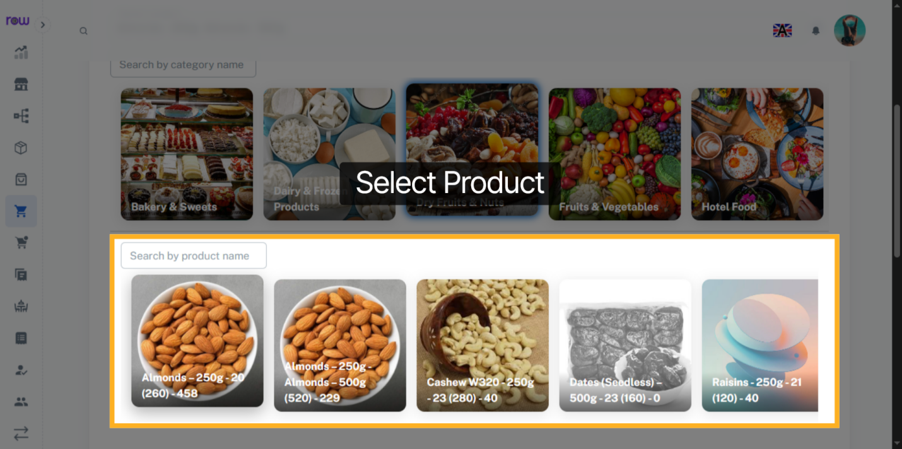

12. Selected Product List
After product selection you can update the quantity, Purchase cost and Sale price of the products.
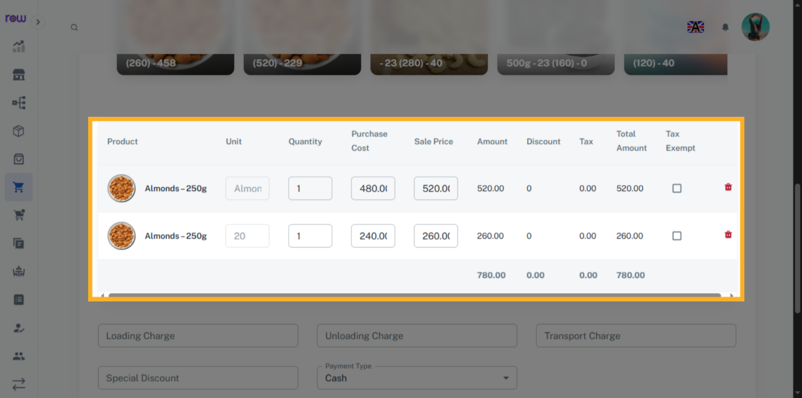

13. Tax Exempt Checkbox
Select the checkbox to exemp the tax for a product.
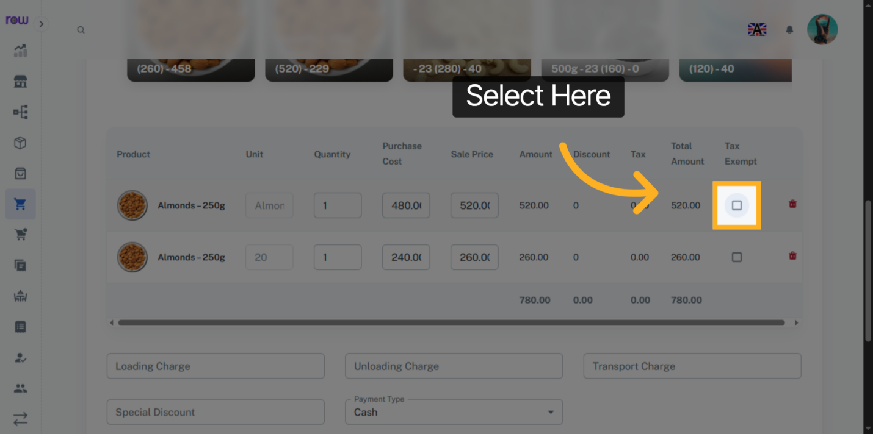

14. Other Optional Fields
Enter loading charge, unloading charge, transport charge and Special discount if applicable.
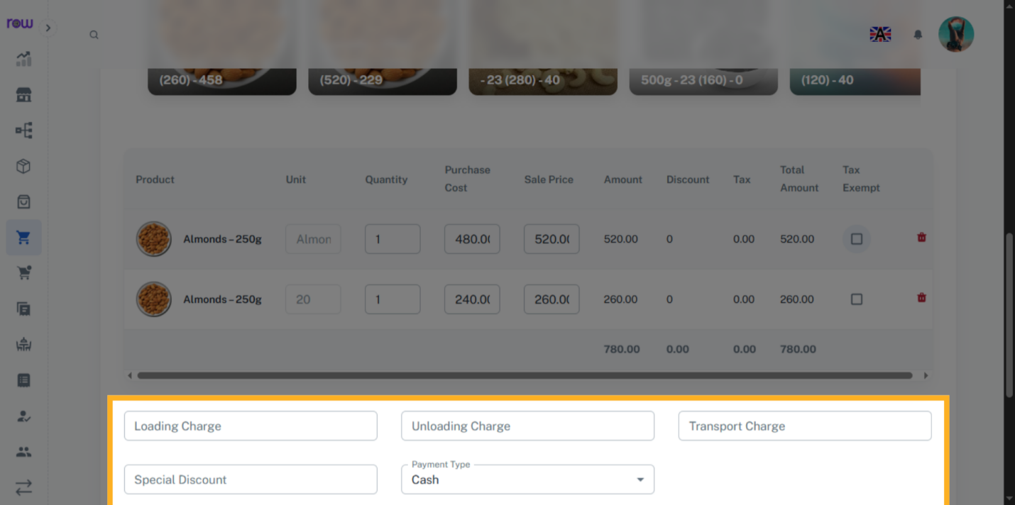

15. Round Off
If the total value has decimal points, you can round it off.
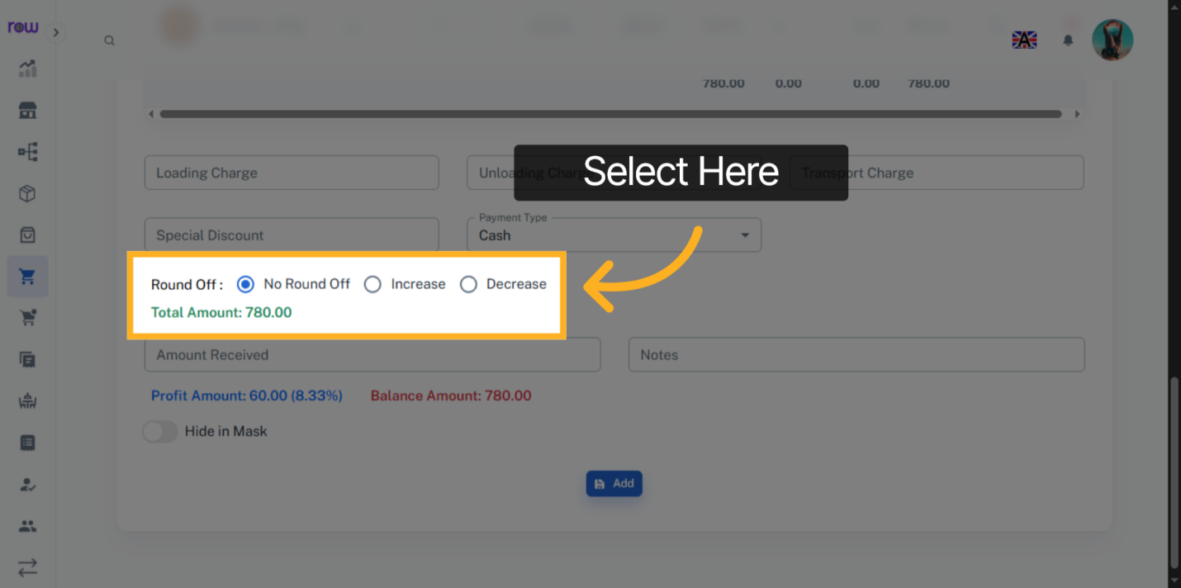

16. Amount Received
Enter the amount received from the customer
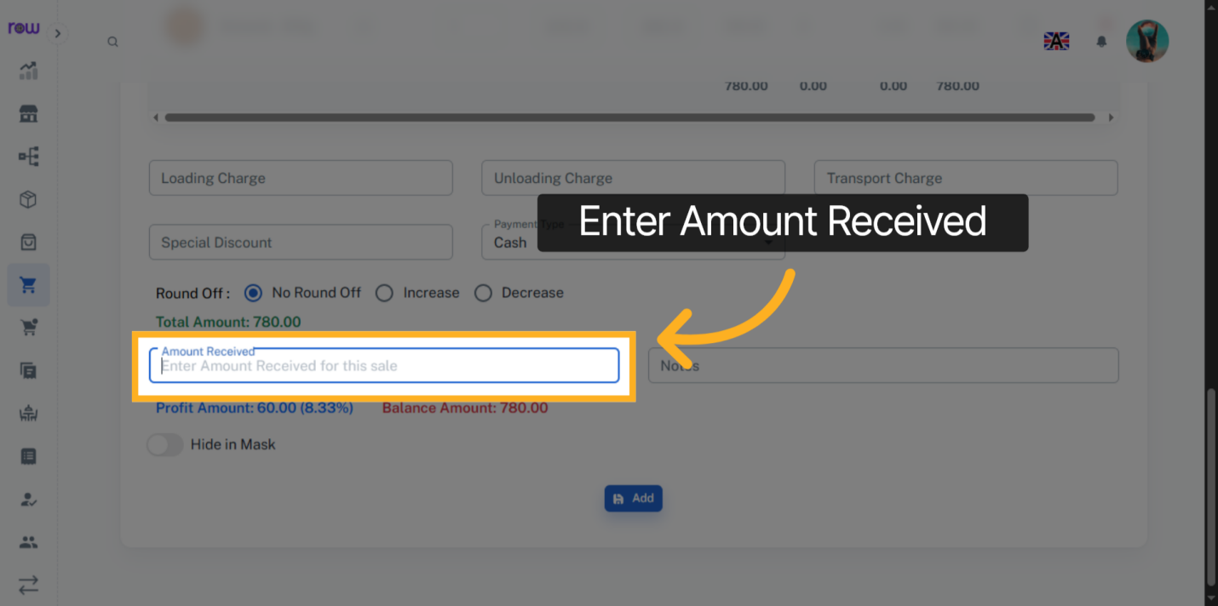

17. Add
Click "Add" to create the sale
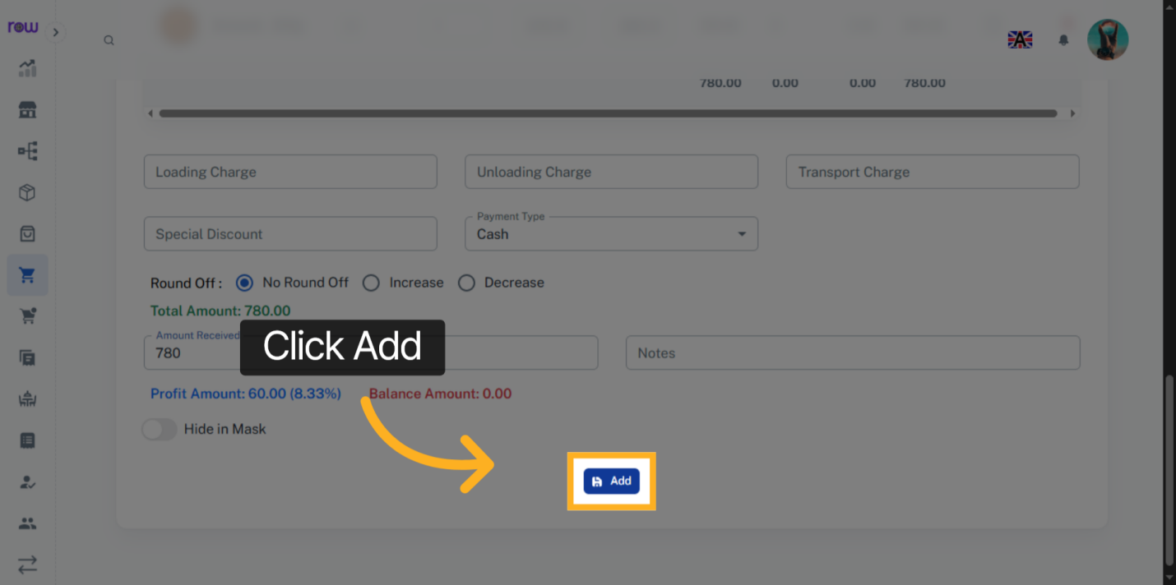

18. Sales List
You will be redirected to the sales list screen after the sale is successfully created.
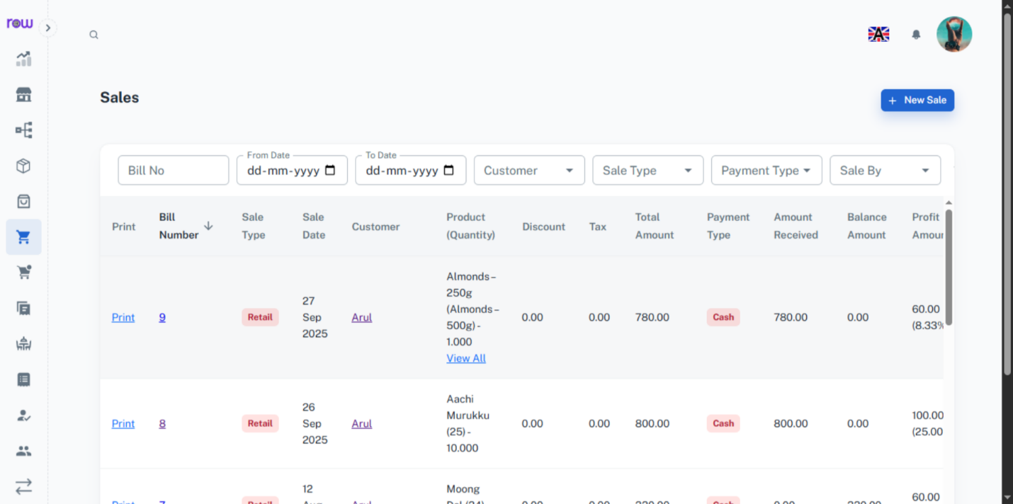

19. Bill Number
Click the bill number to edit the sale.
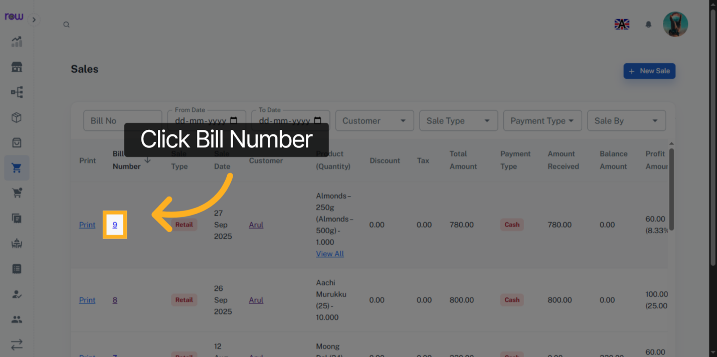

20. Edit Sales
You can change all the fields except the customer and products.
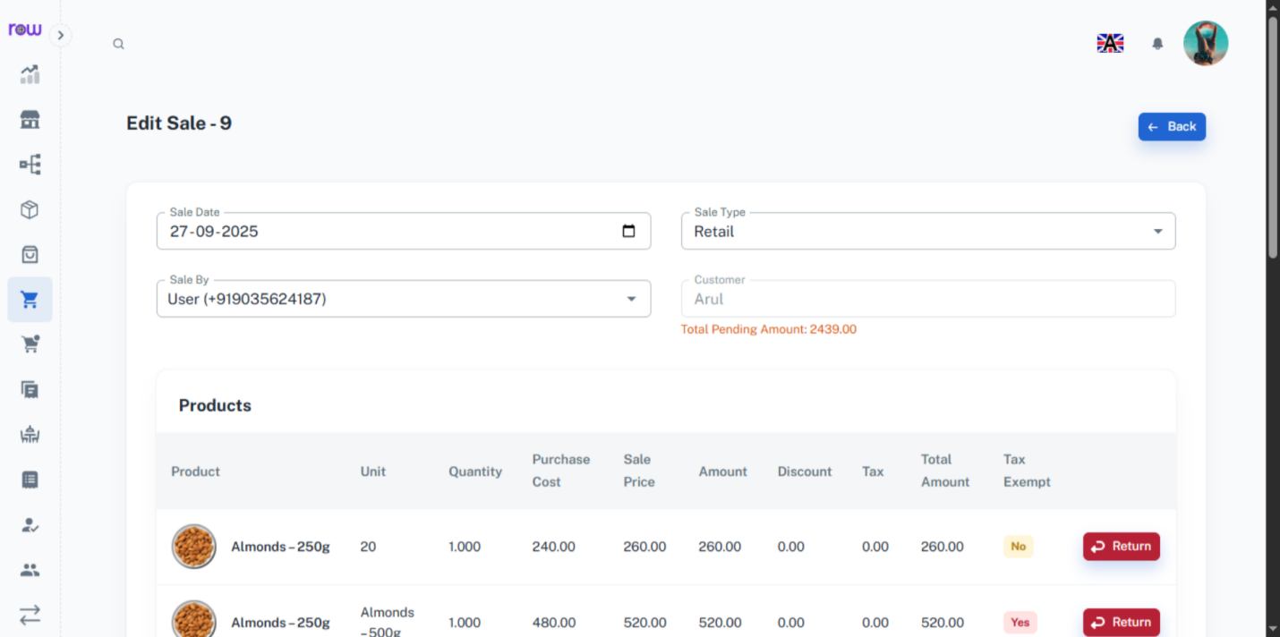

21. Return a Product
Click the Return button if the customer wants to return a product.
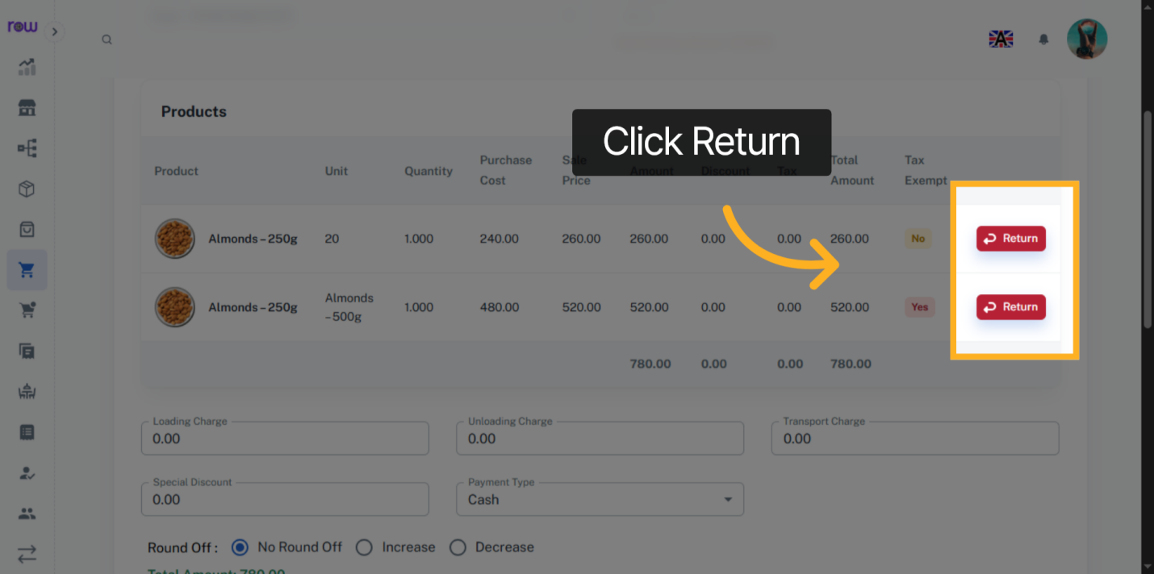

22. Add Pending Amount
Enter the pending amount received from the customer and click add amount button update the amount received
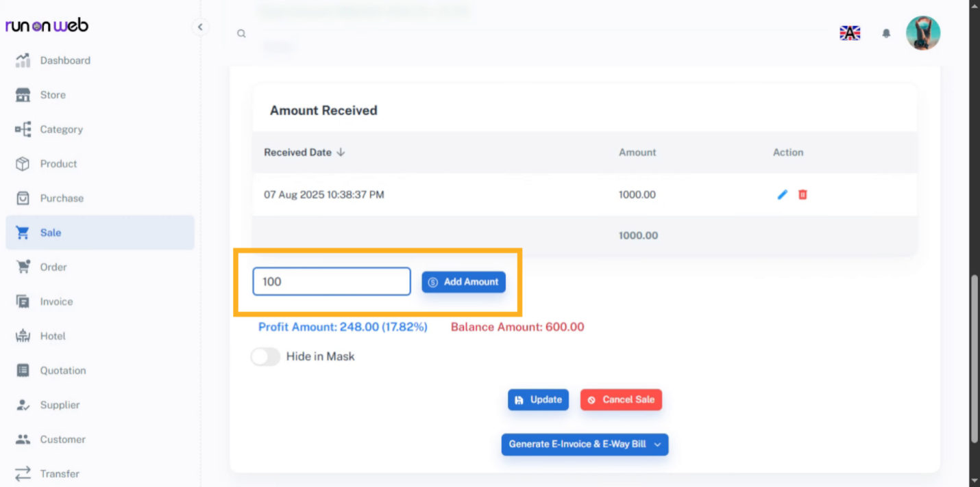

23. Update Sale
Click Update to save the changes.
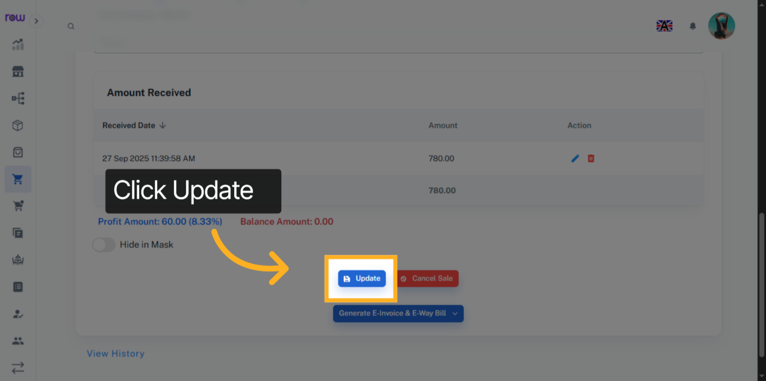

24. Cancel sale
Click the Cancel Sale button to cancel the sale. If canceled, the product quantities will be updated in stock.
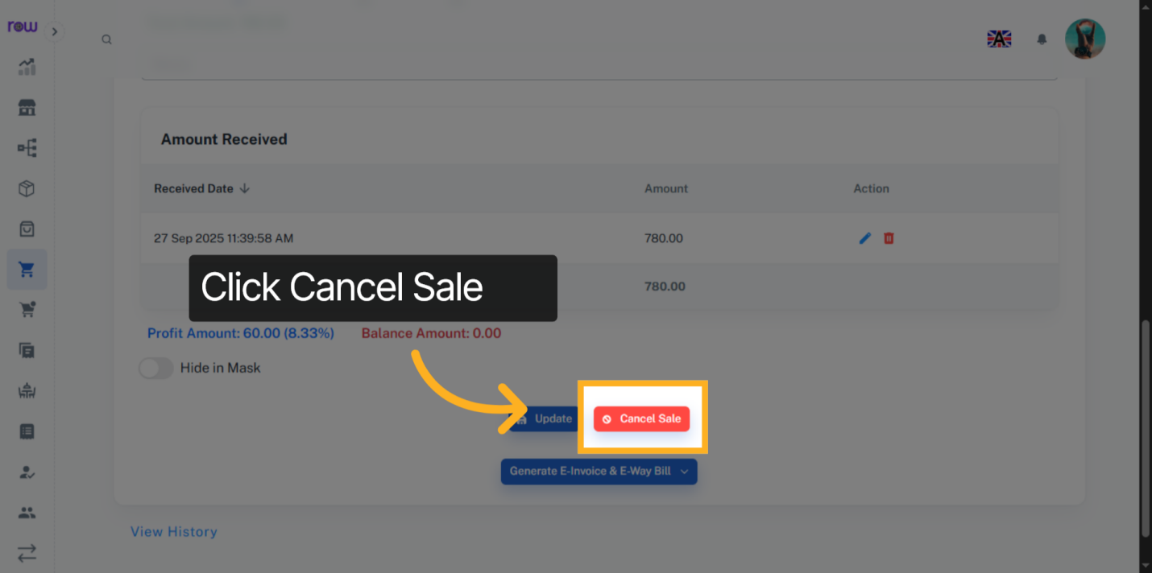

25. Generate E-Invoice & E-Way Bill
Click this button to Generate E-Invoice & E-Way Bill.
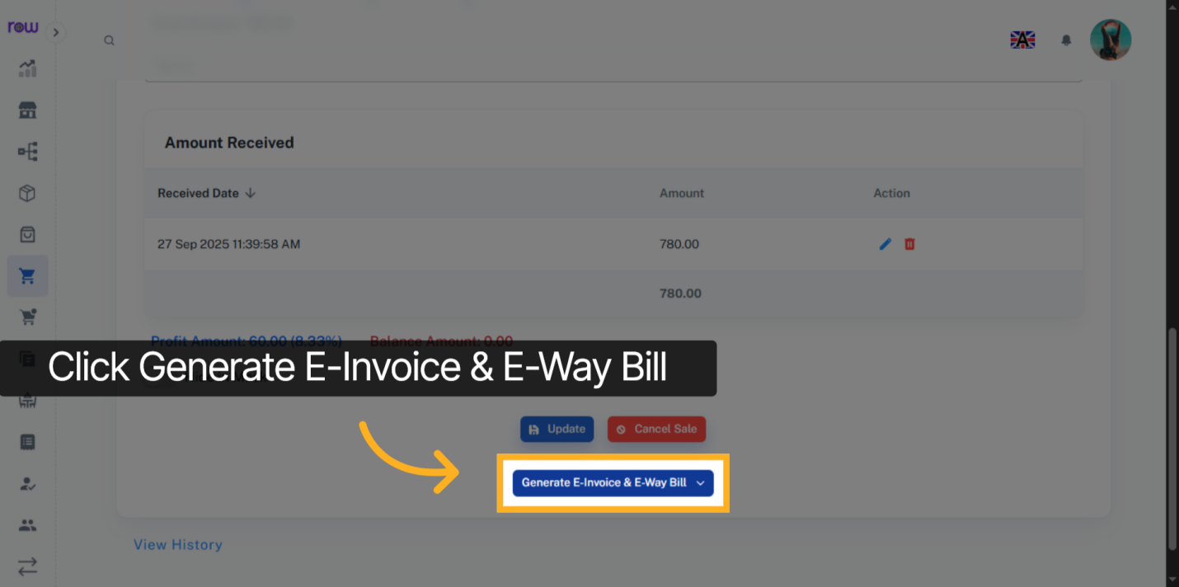

26. E-Invoice & E-Way Bill Options
Select the options according to your requirements.
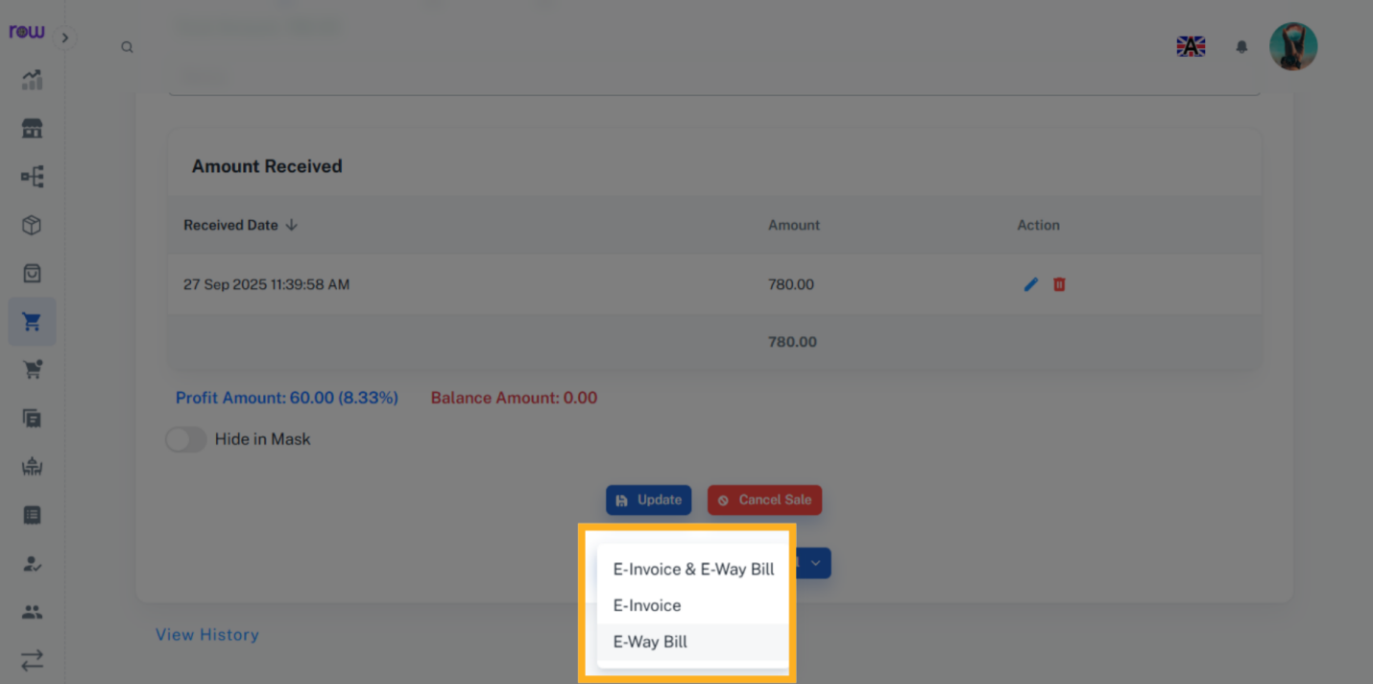

27. E-Way Bill
Please enter the transportation details if you have selected an e-way bill.
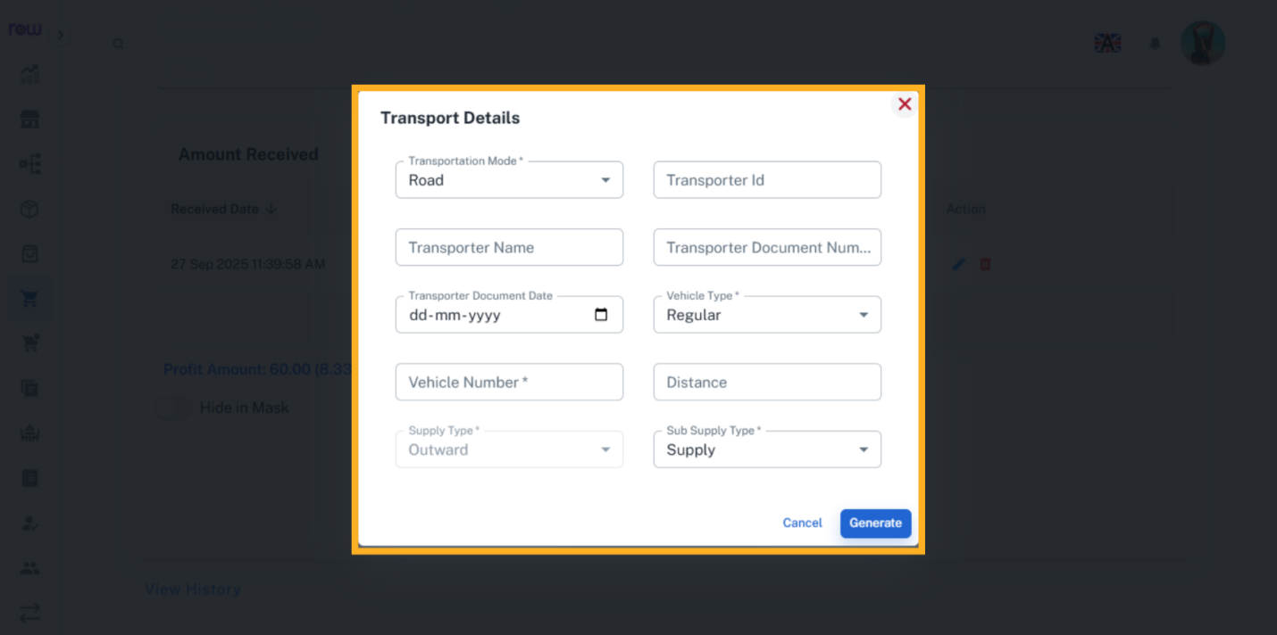

28. View History
Click the View History link to see the work history of this sale performed by the employees.
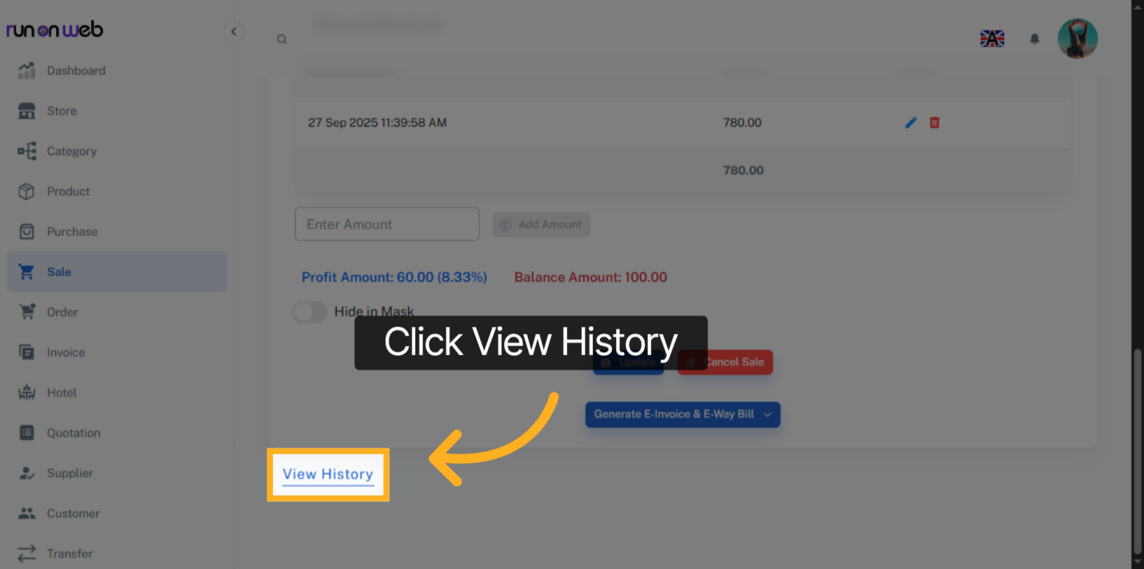

29. History
You can see who performed which actions and when in the history.
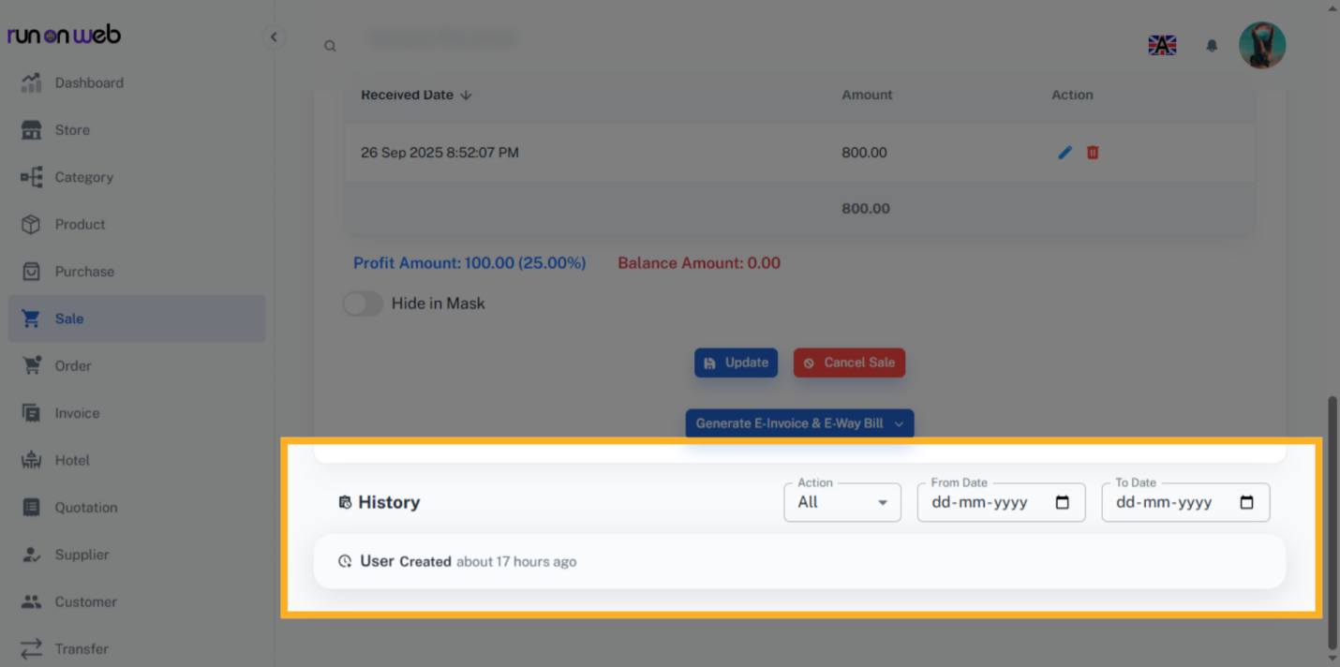

30. Print Bill
Click Print to generate and view, the bill.
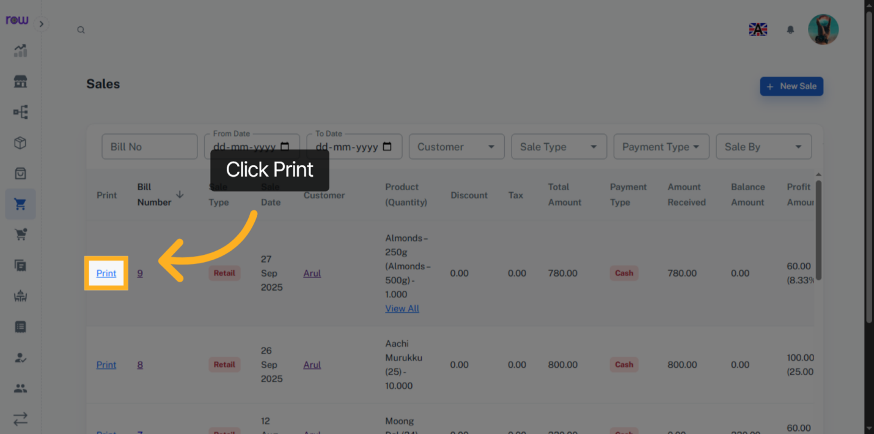

31. Download and Print Bill
You can print and download the bill.
