Create and Manage Suppliers in RunOnWeb

Go to runonweb.com

1. Introduction
In this tutorial you learn how to create and Manage a Supplier.

2. Supplier Menu
Select supplier menu to open the Supplier list Screen.
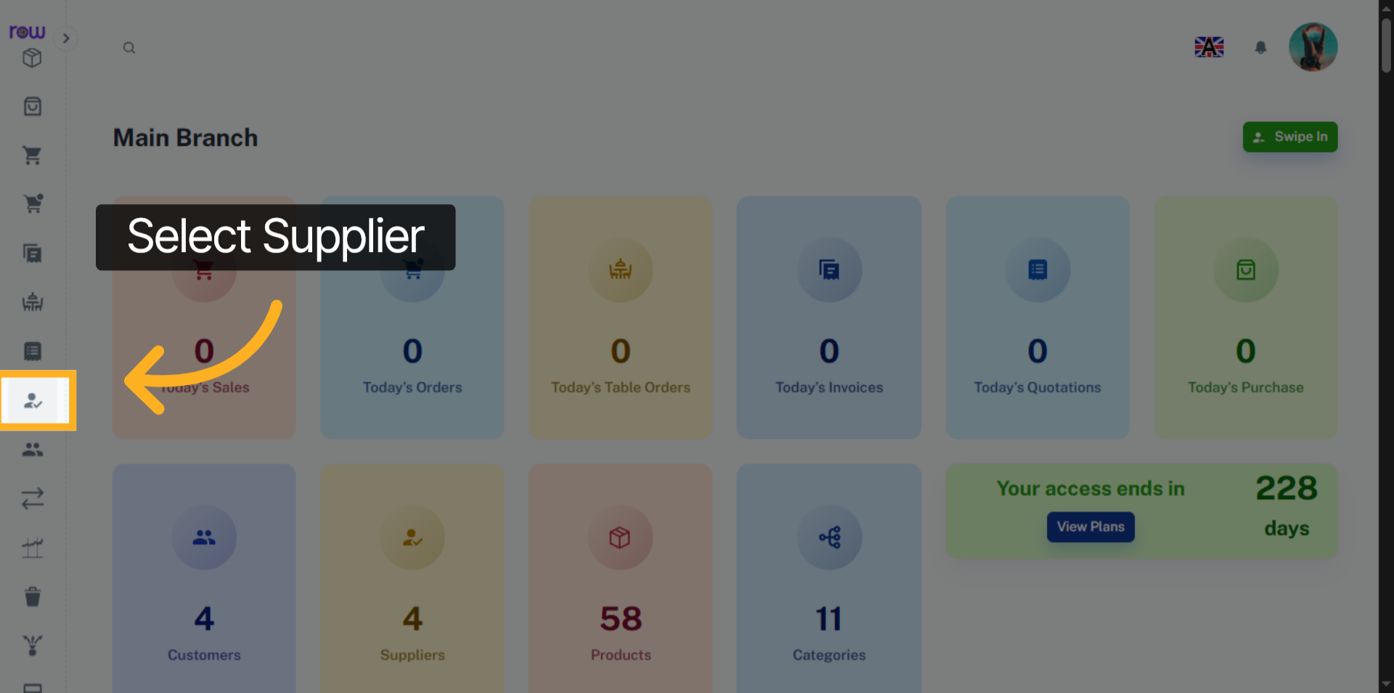

3. New Supplier Button
Click the New Supplier button to create a new supplier.
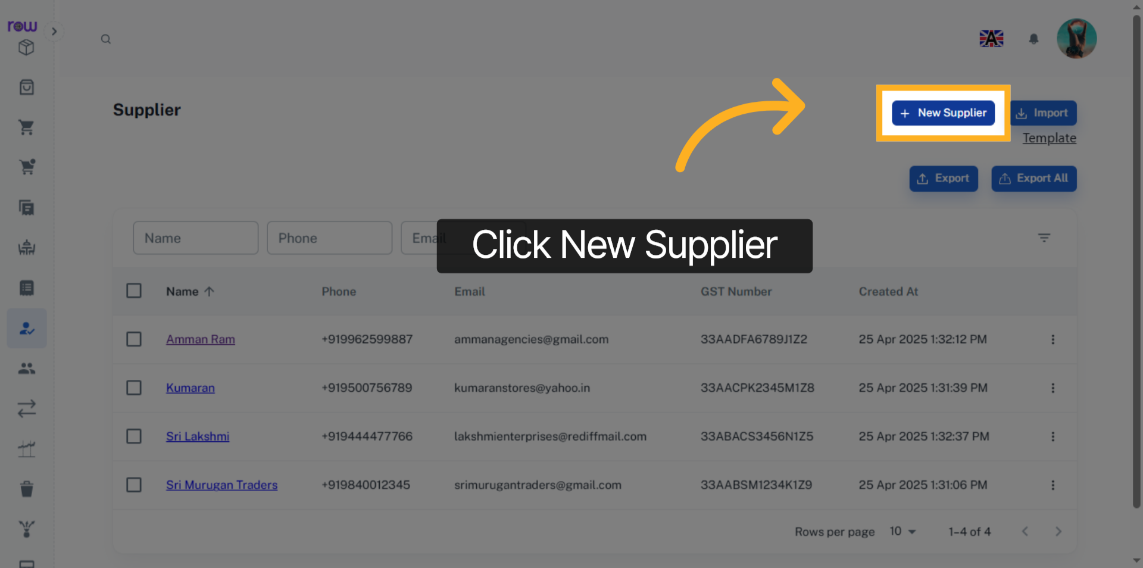

4. Necessary Fields
Please enter the new supplier details.
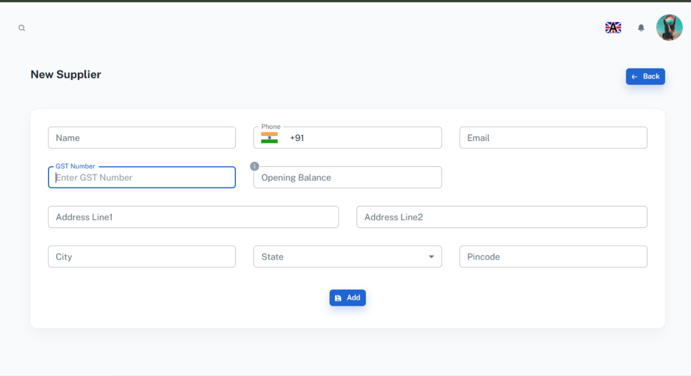

5. Add
Click Add button to create the new supplier.
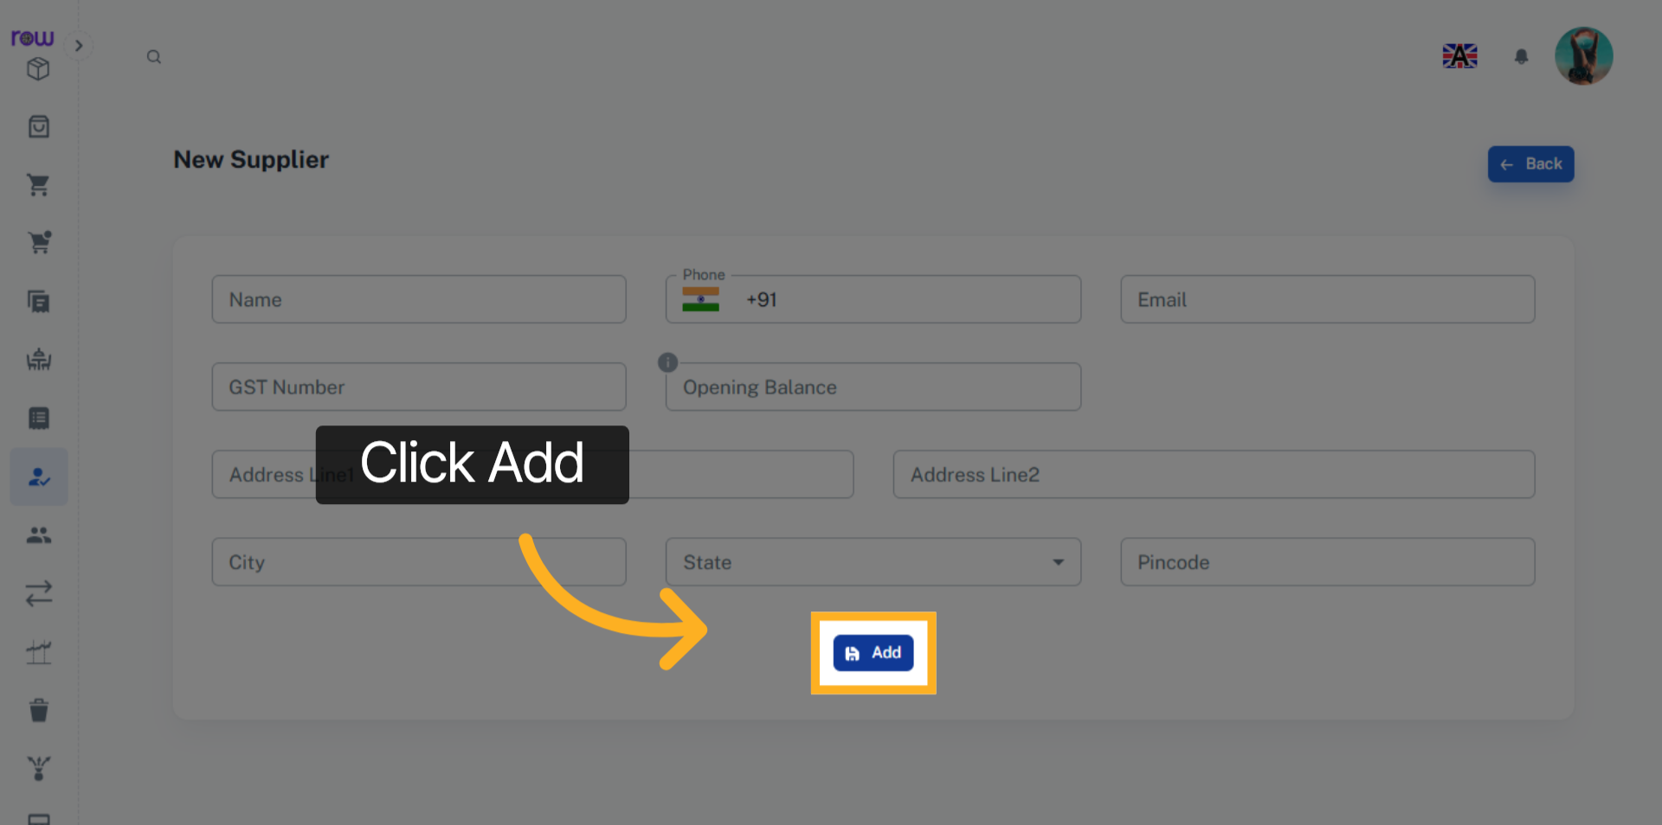

6. Supplier Screen
You will be redirected to the Suppliers List screen after a new supplier is successfully created.
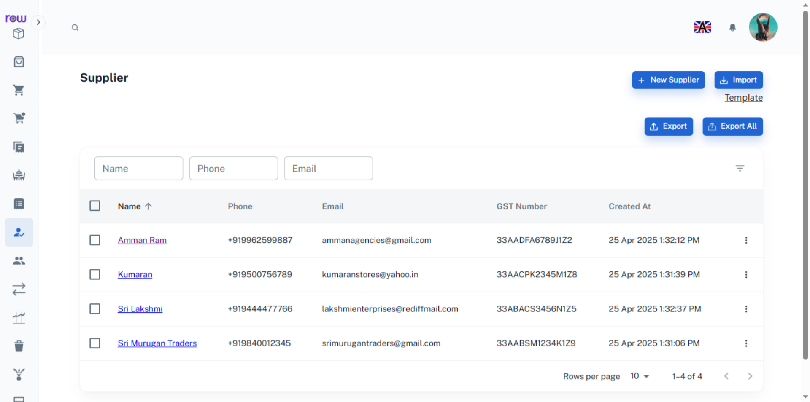

7. Supplier Details
Click the supplier’s name to view and edit the supplier’s details.
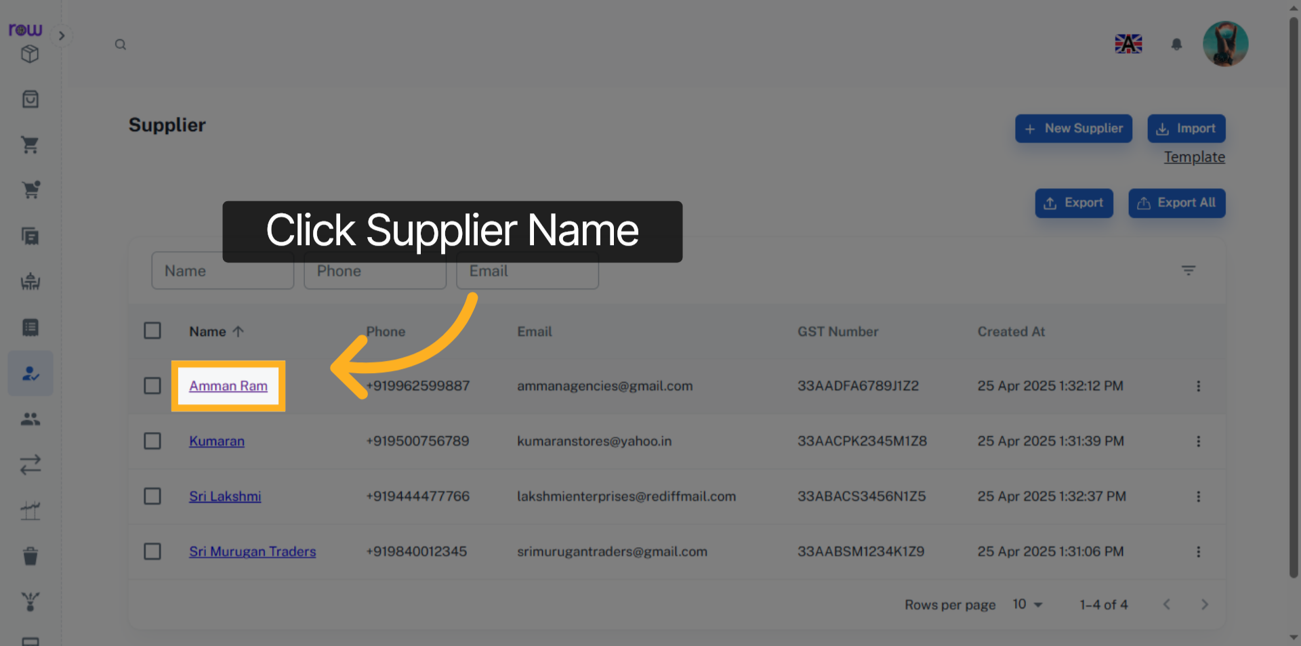

8. Supplier
You can view the supplier’s email, phone number, GST number, Address and balance amount on this page.
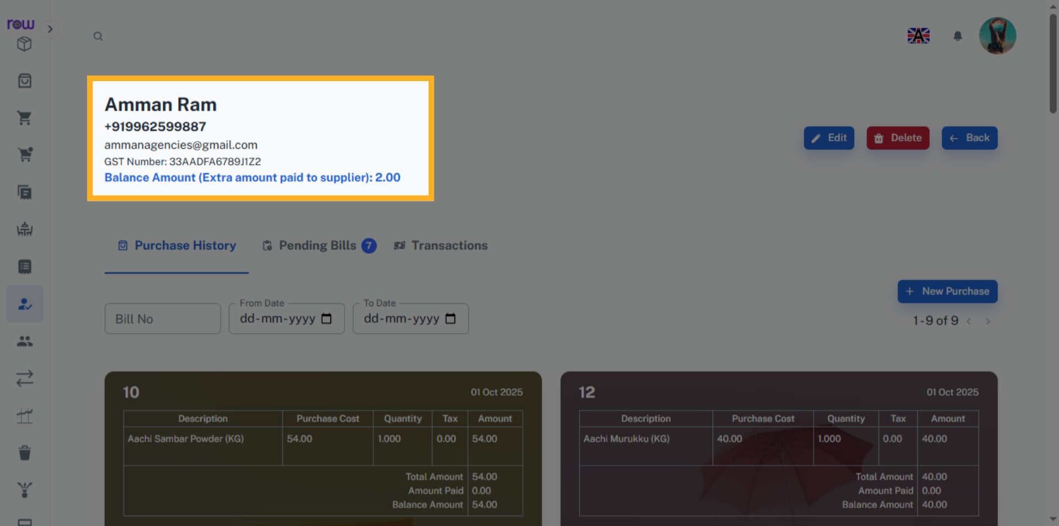

9. Edit Supplier
Click the Edit button to edit the supplier details.
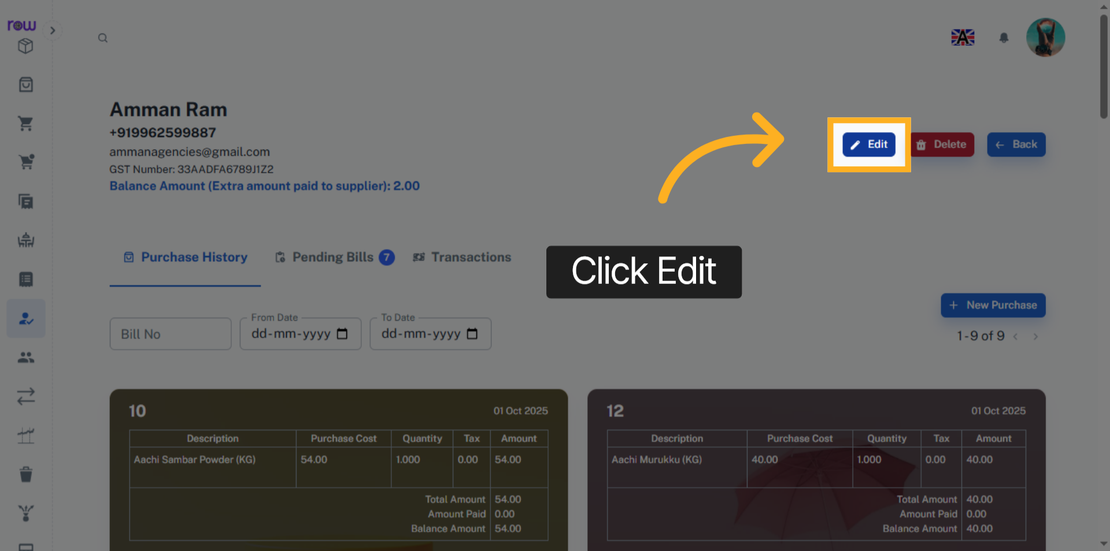

10. Edit Supplier Details
You can edit the supplier’s details here.
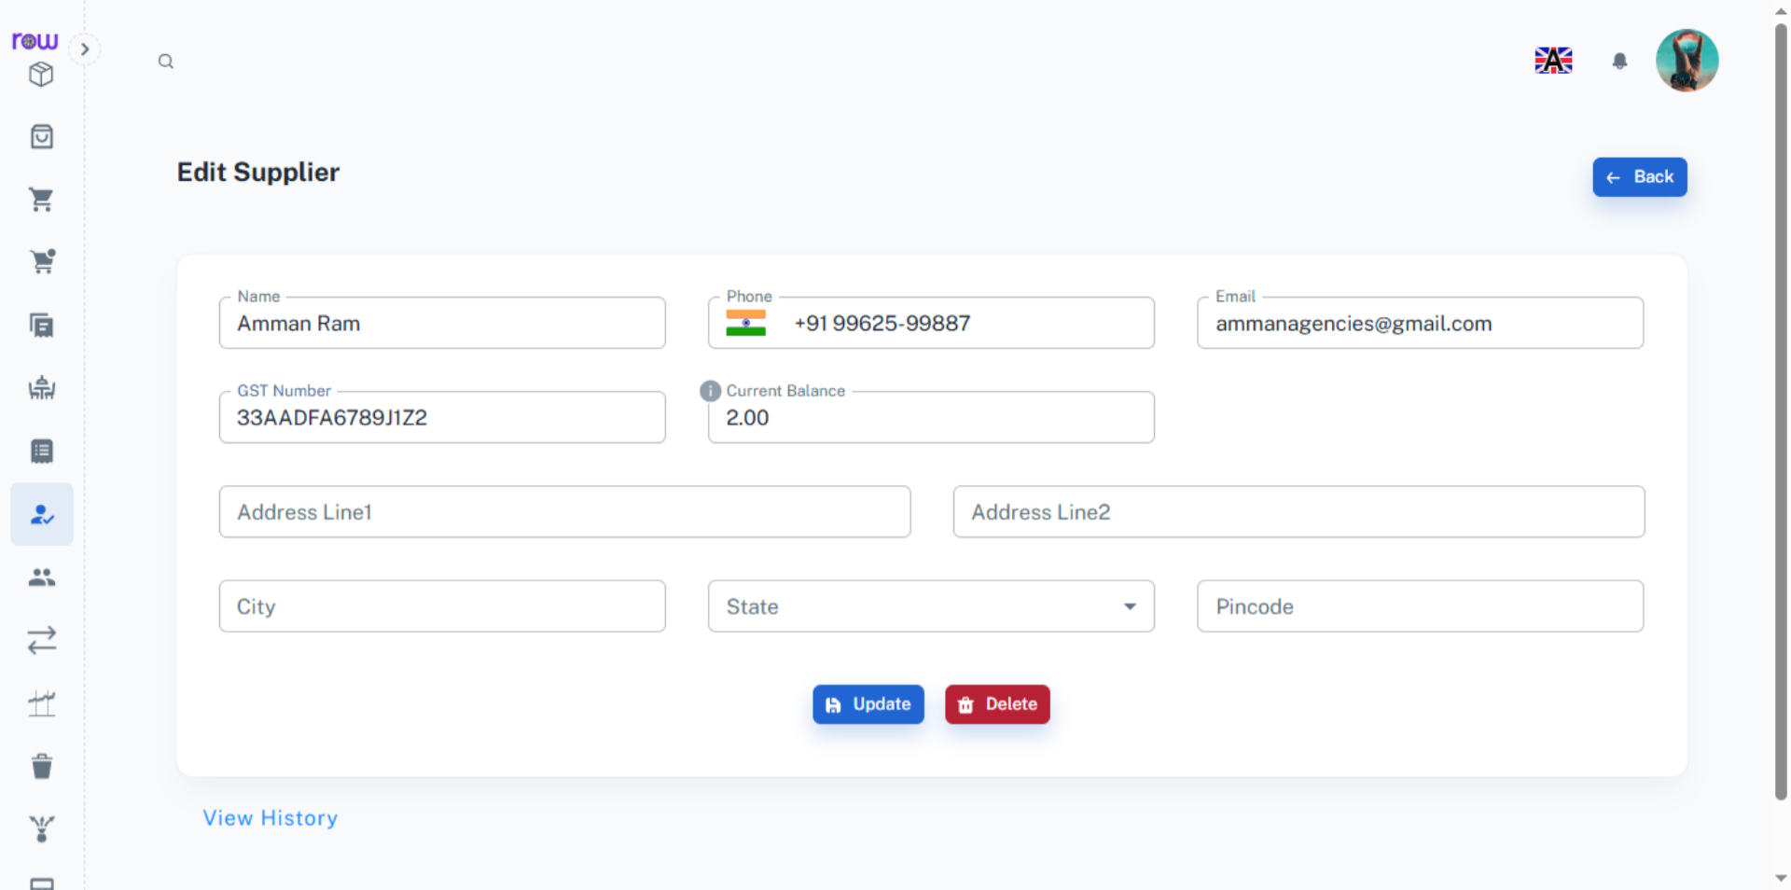

11. Update Supplier Data
Click Update to save the Changes.
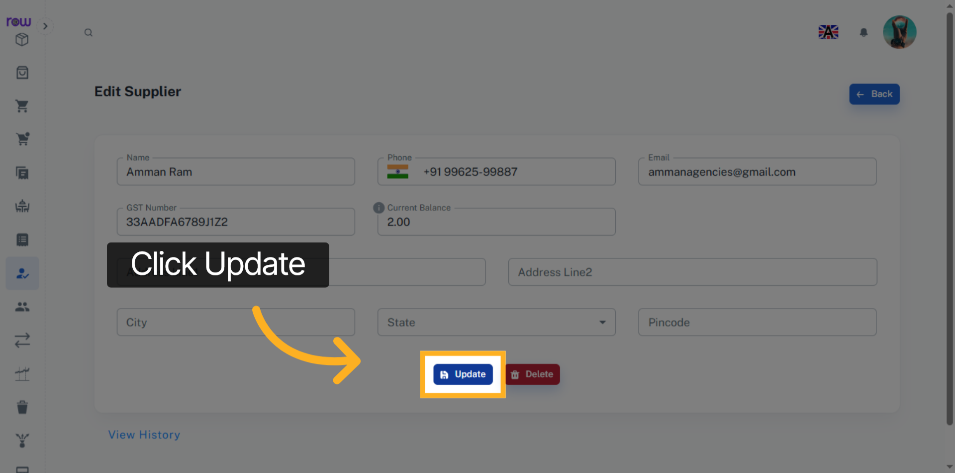

12. Delete Supplier
Click the Delete button to delete the supplier.
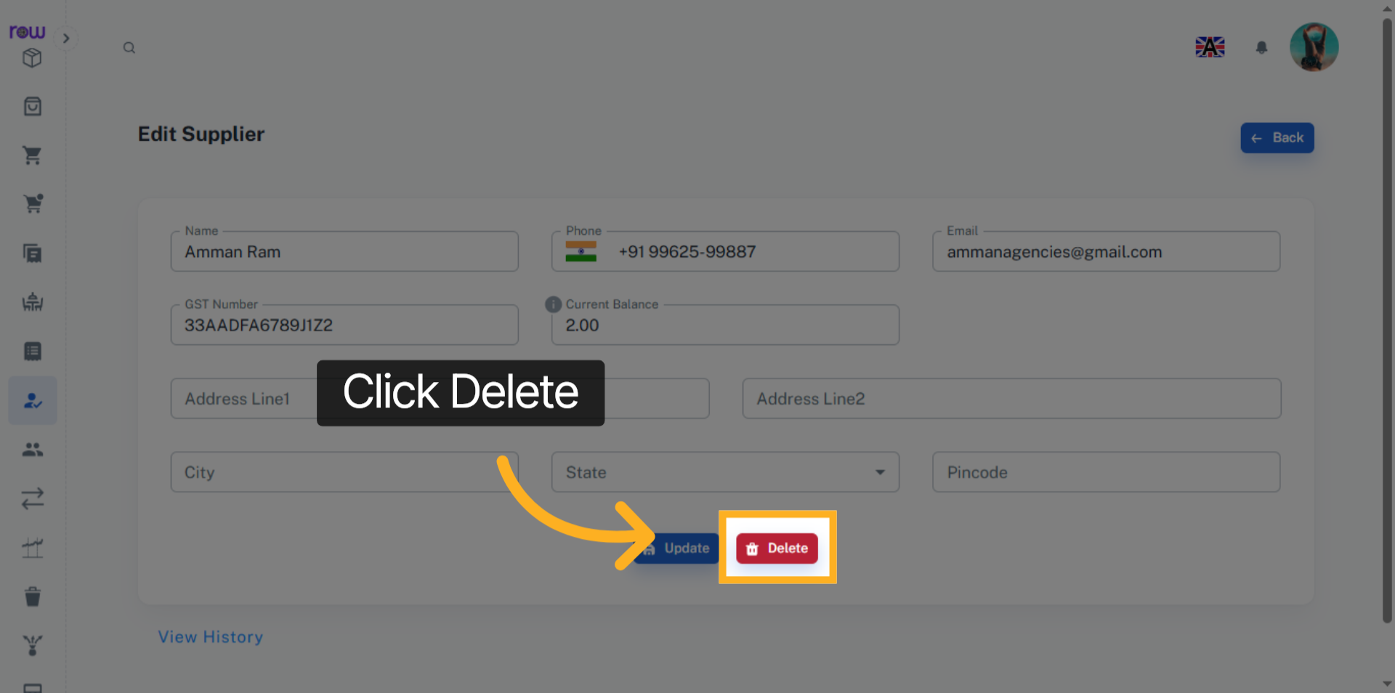

13. View History
Click the View History link to see the supplier’s history.
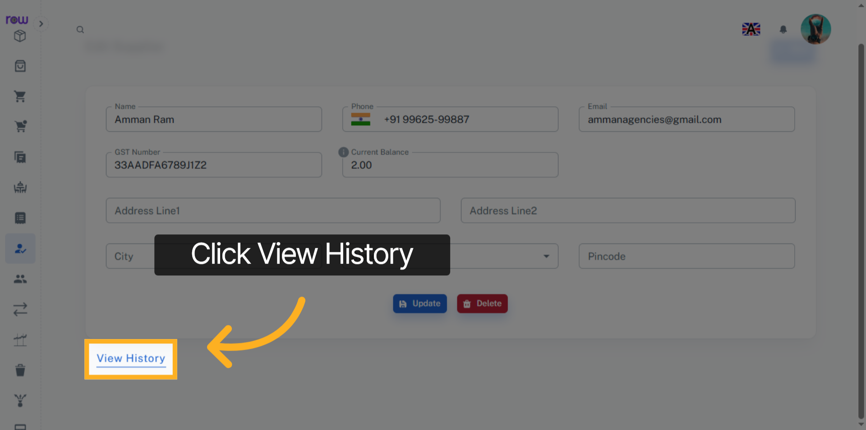

14. Purchase History
Click Purchase History to view the supplier’s purchase history.
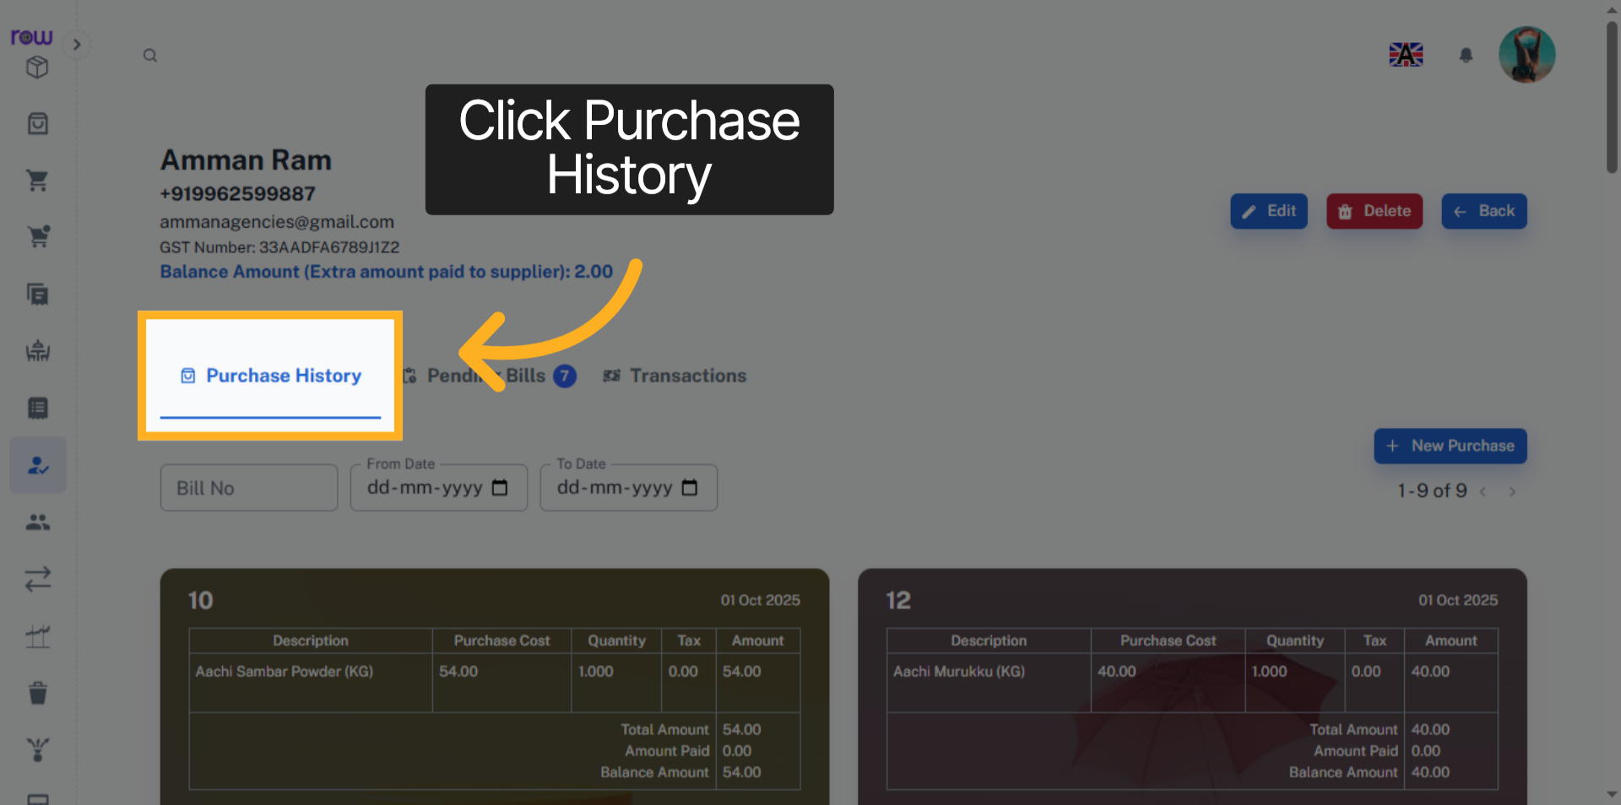

15. Purchases
You can view the purchase history here.
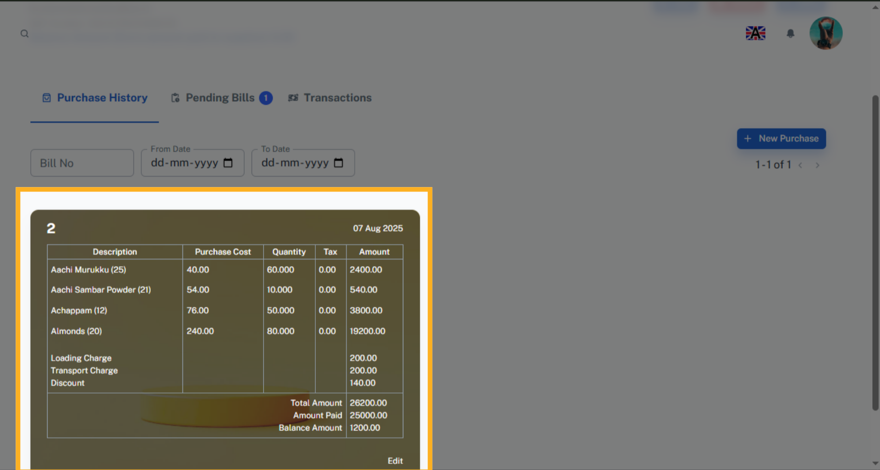

16. New Purchase
You can also initiate a new purchase by clicking New Purchase.
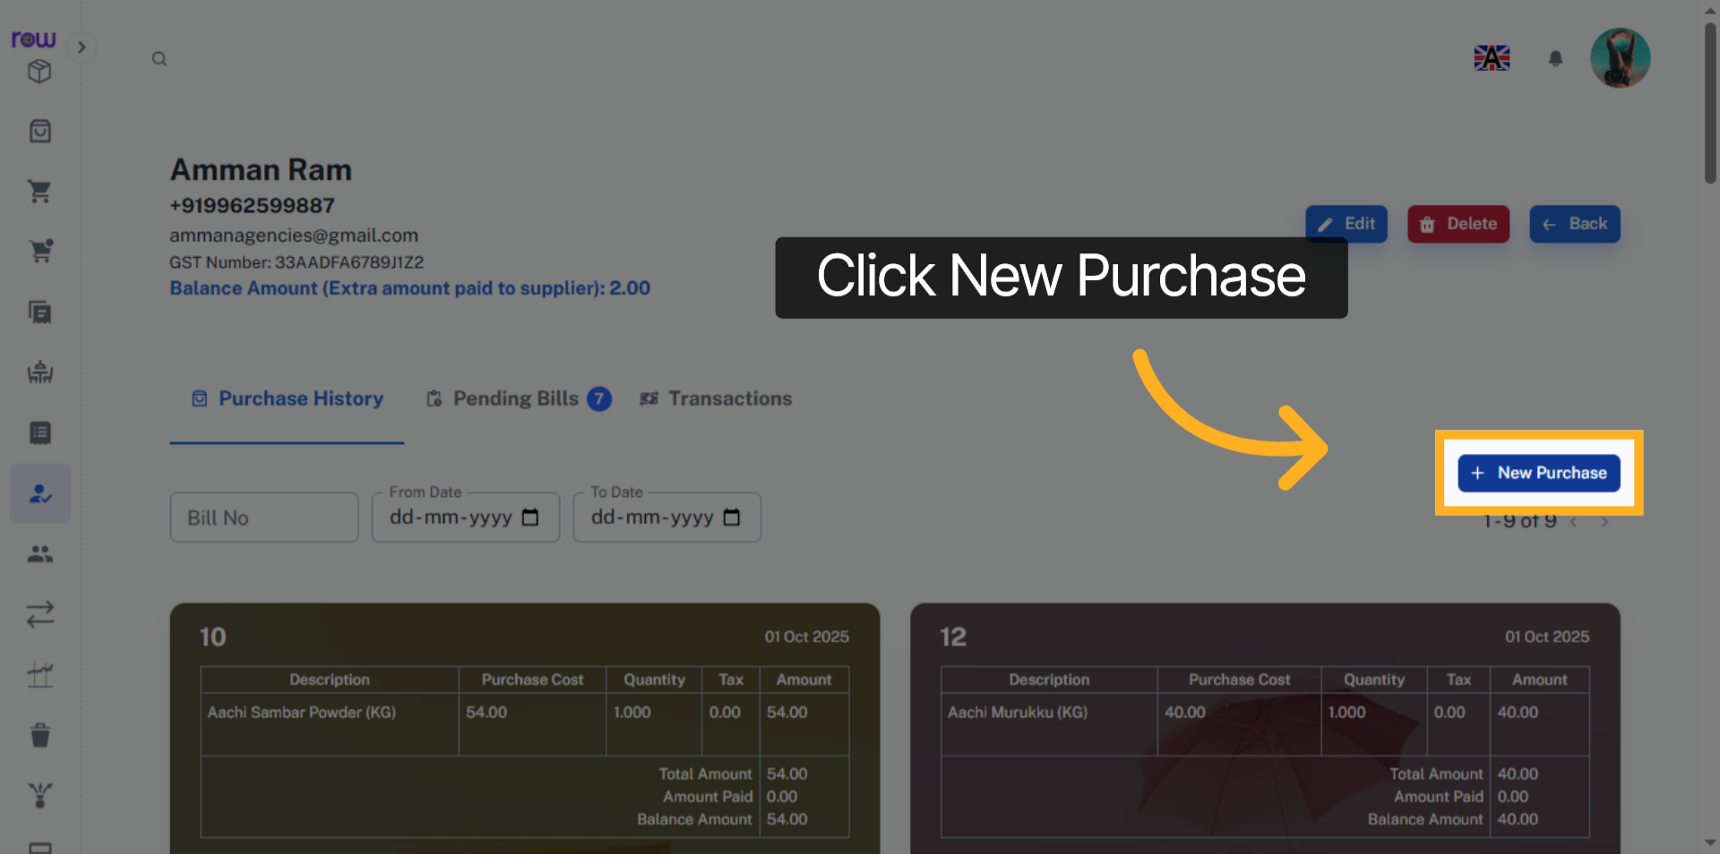

17. Purchase List Screen
You will be redirected to the new Purchase screen after clicking New Purchase.
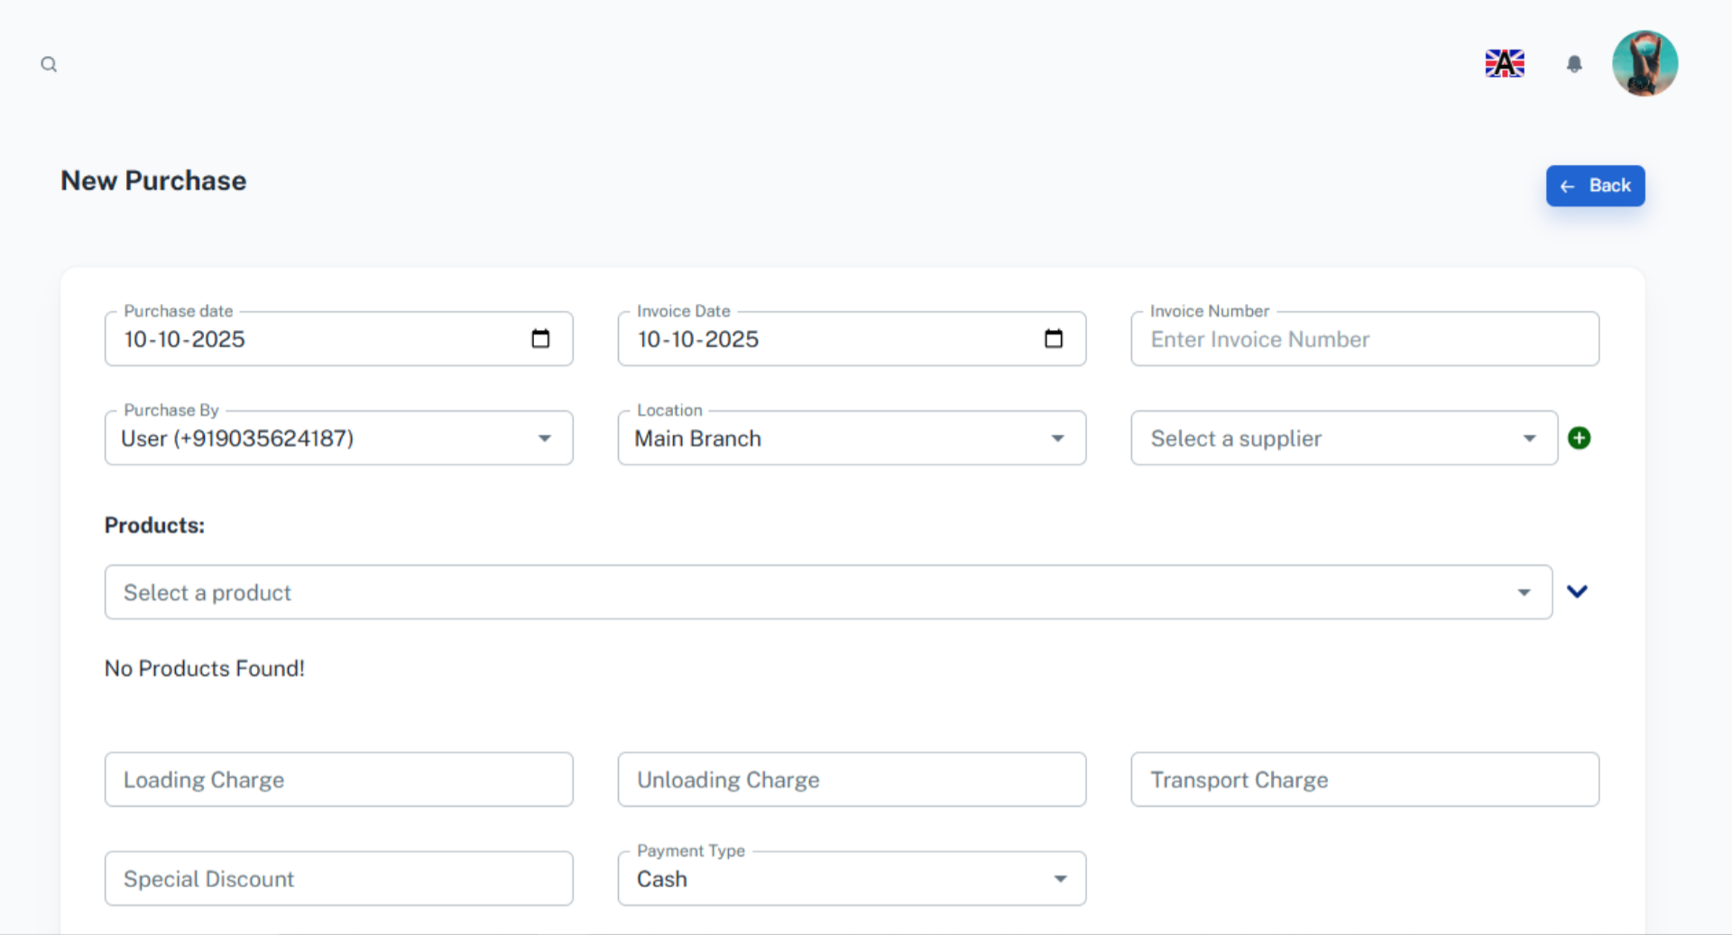

18. Check Pending Bills
Click Pending Bills to view the pending amounts of a supplier.
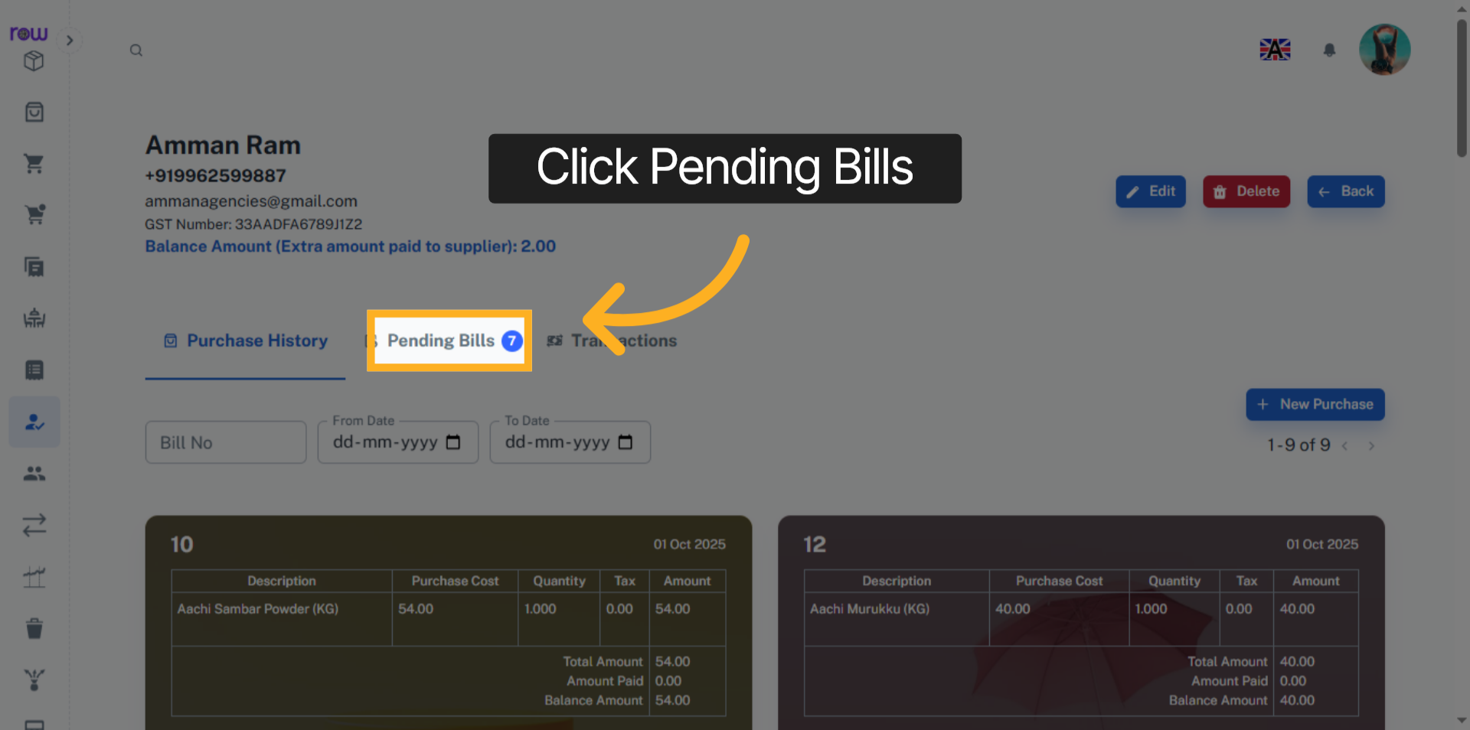

19. Pending Bills
Here, you can view the pending bills of a supplier.
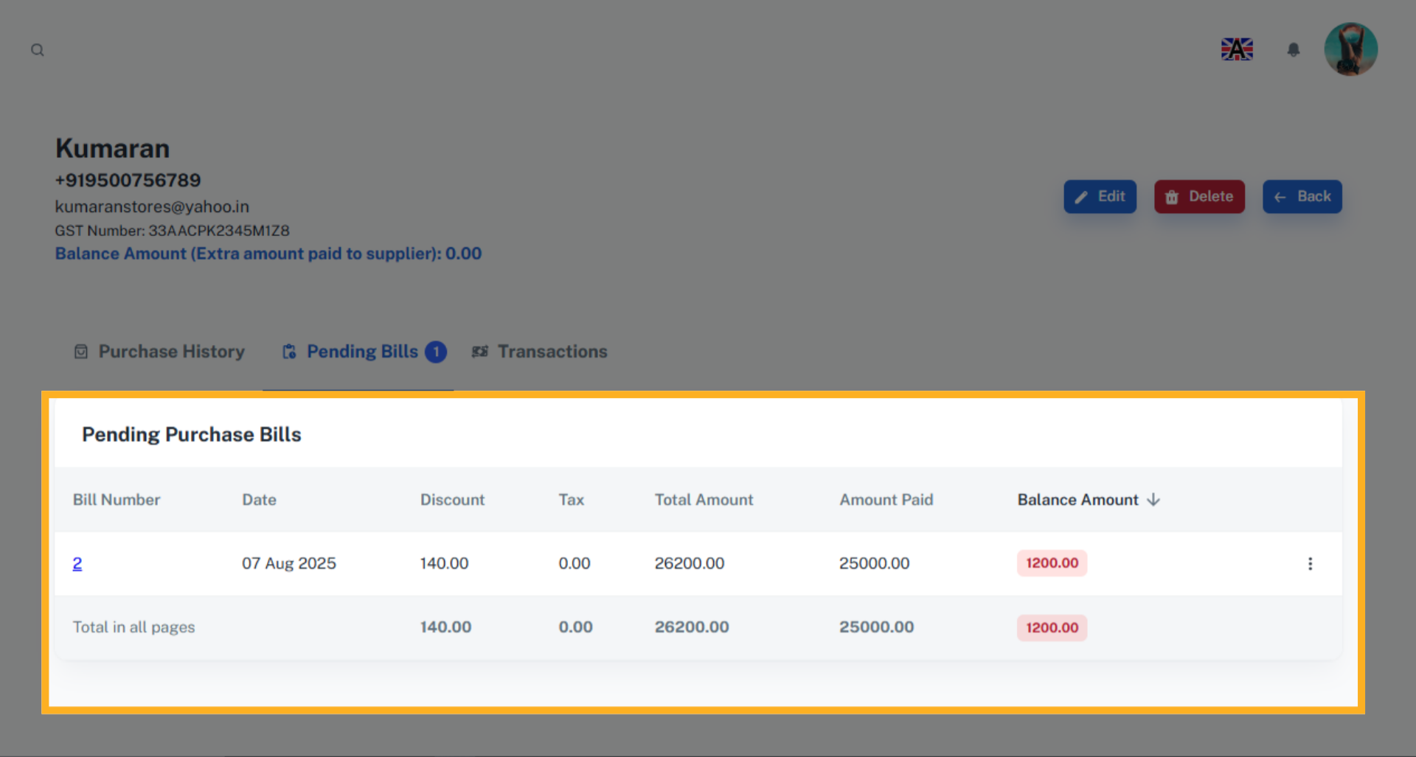

20. Transaction Records
Click Transaction to view the transactions made by the supplier.
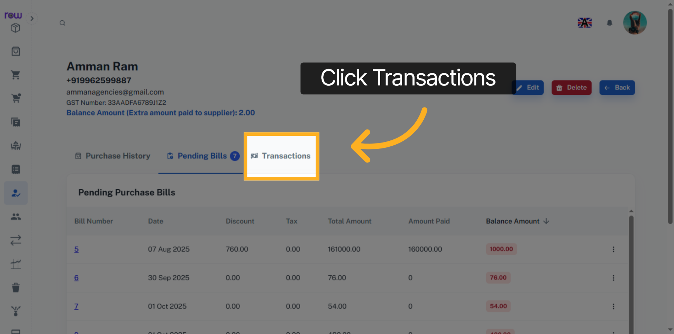

21. Transaction
You can view the transactions of a supplier.
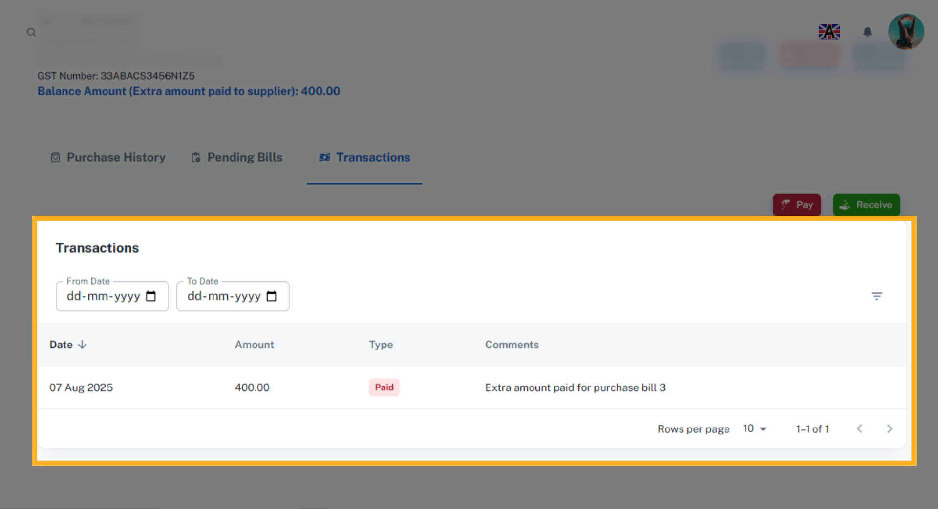

22. Pay
Click Pay to make payments in the Transactions list Screen.
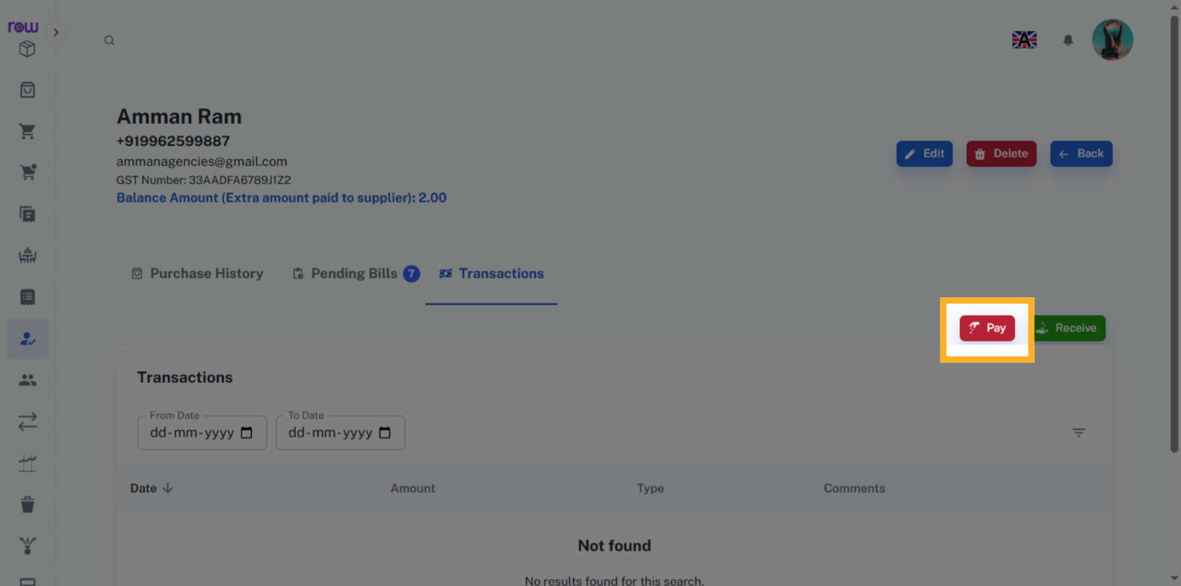

23. Payment Options
Enter the amount to be paid to a supplier. You may also clear pending bills by selecting them. The amount will be automatically allocated, and the pending bills will be cleared from the Pending Bills List. The Extra amount paid will be added to the supplier's balance.
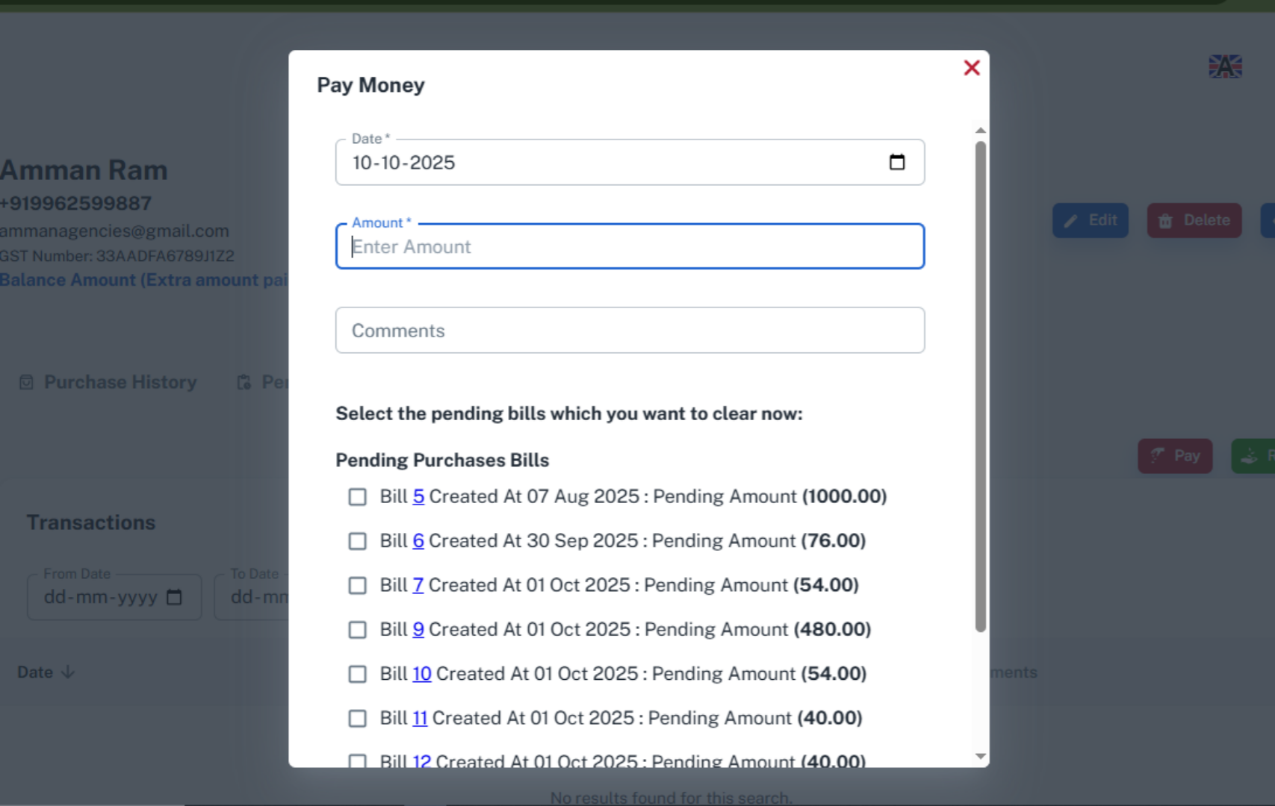

24. Receive
Click Receive to receive payments in the Transactions list Screen.
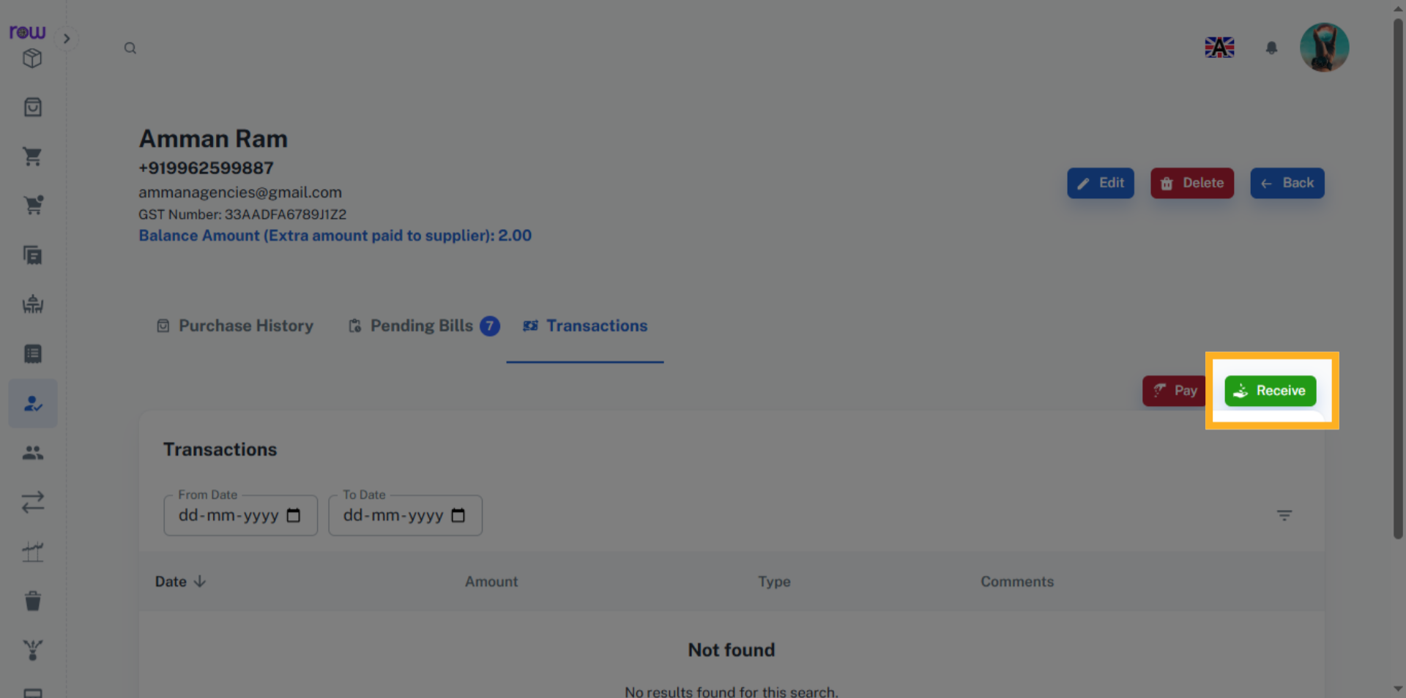

25. Payment Options
Enter the amount to be received from the Supplier.
