Create And Manage Transfers In RunOnweb

Go to runonweb.com

1. Introduction
In this tutorial, you will learn how to create and manage a transfer.

2. Transfer Menu
Select the Transfer menu to open the Transfer List screen.
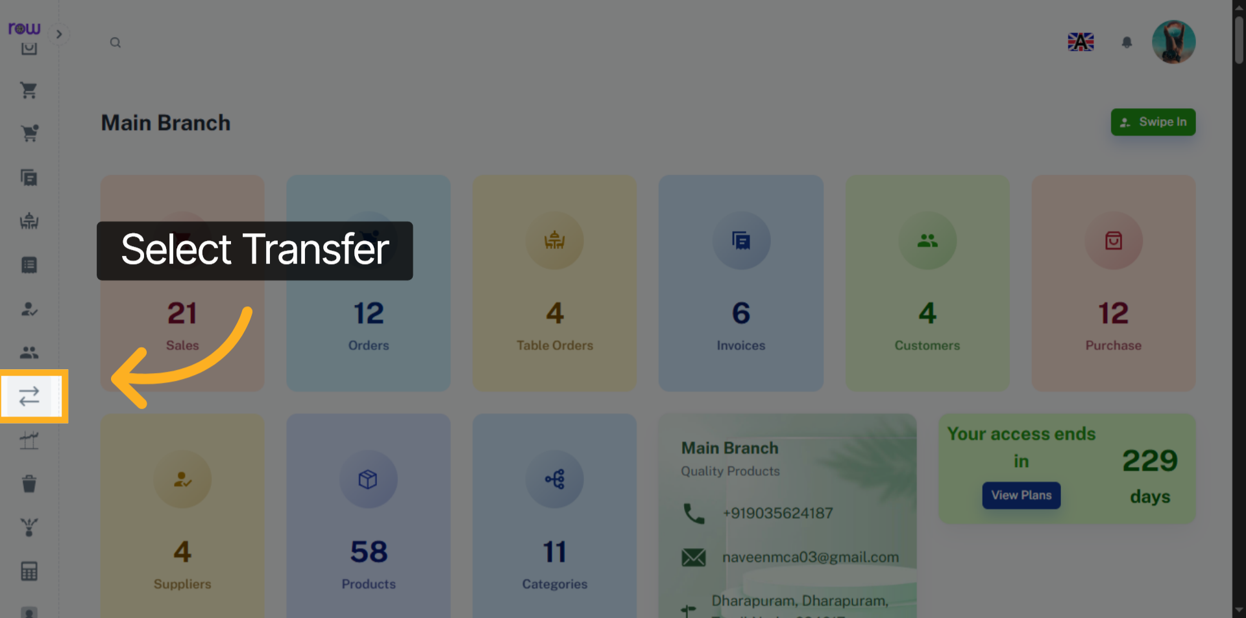

3. New Transfer Button
Click the "New Transfer" button to begin creating a new transfer.
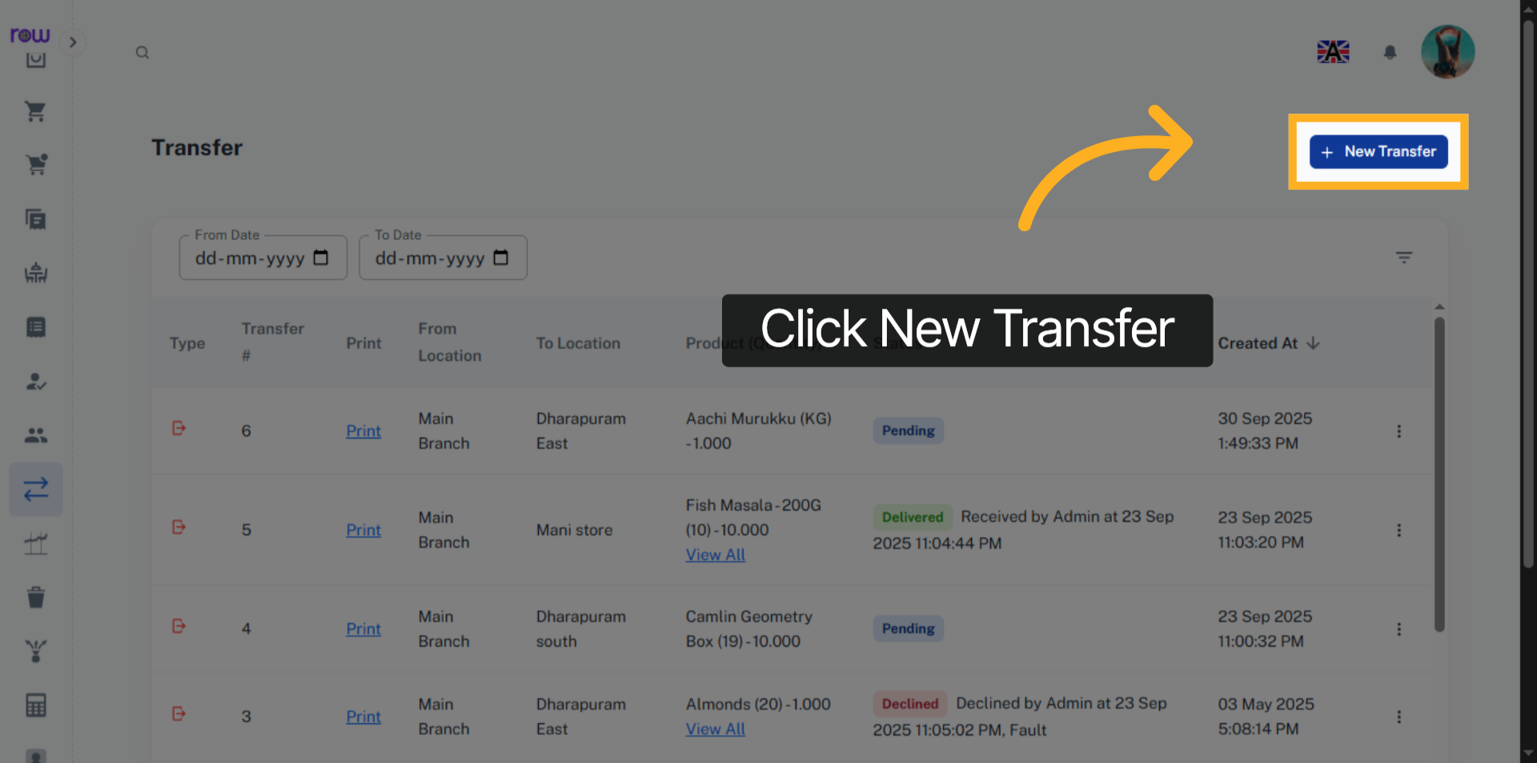

4. New Transfer
If you’re in top level management, you can choose both the From Location and To Location. If you’re in a specific branch, the From Location refers to your current branch (which cannot be Changed), and the To Location is the branch you’re transferring to.
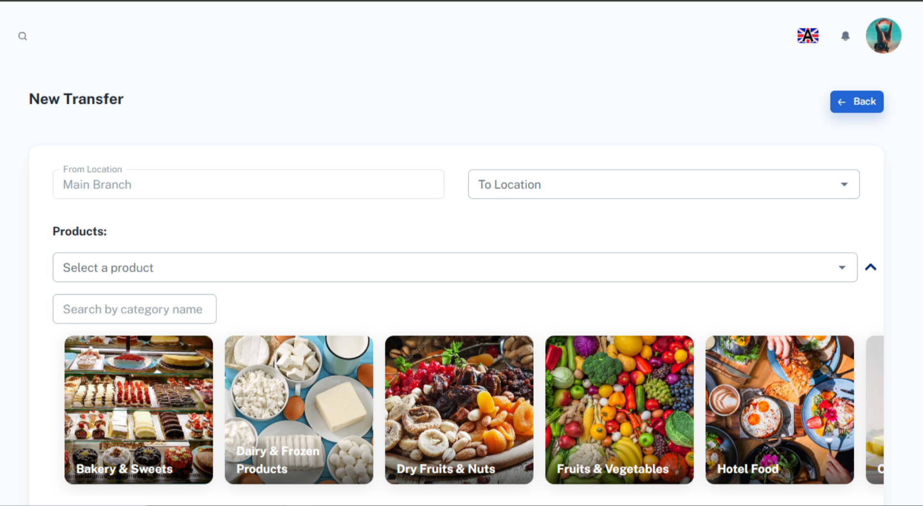

5. Select To Location
Search and select the To Location.
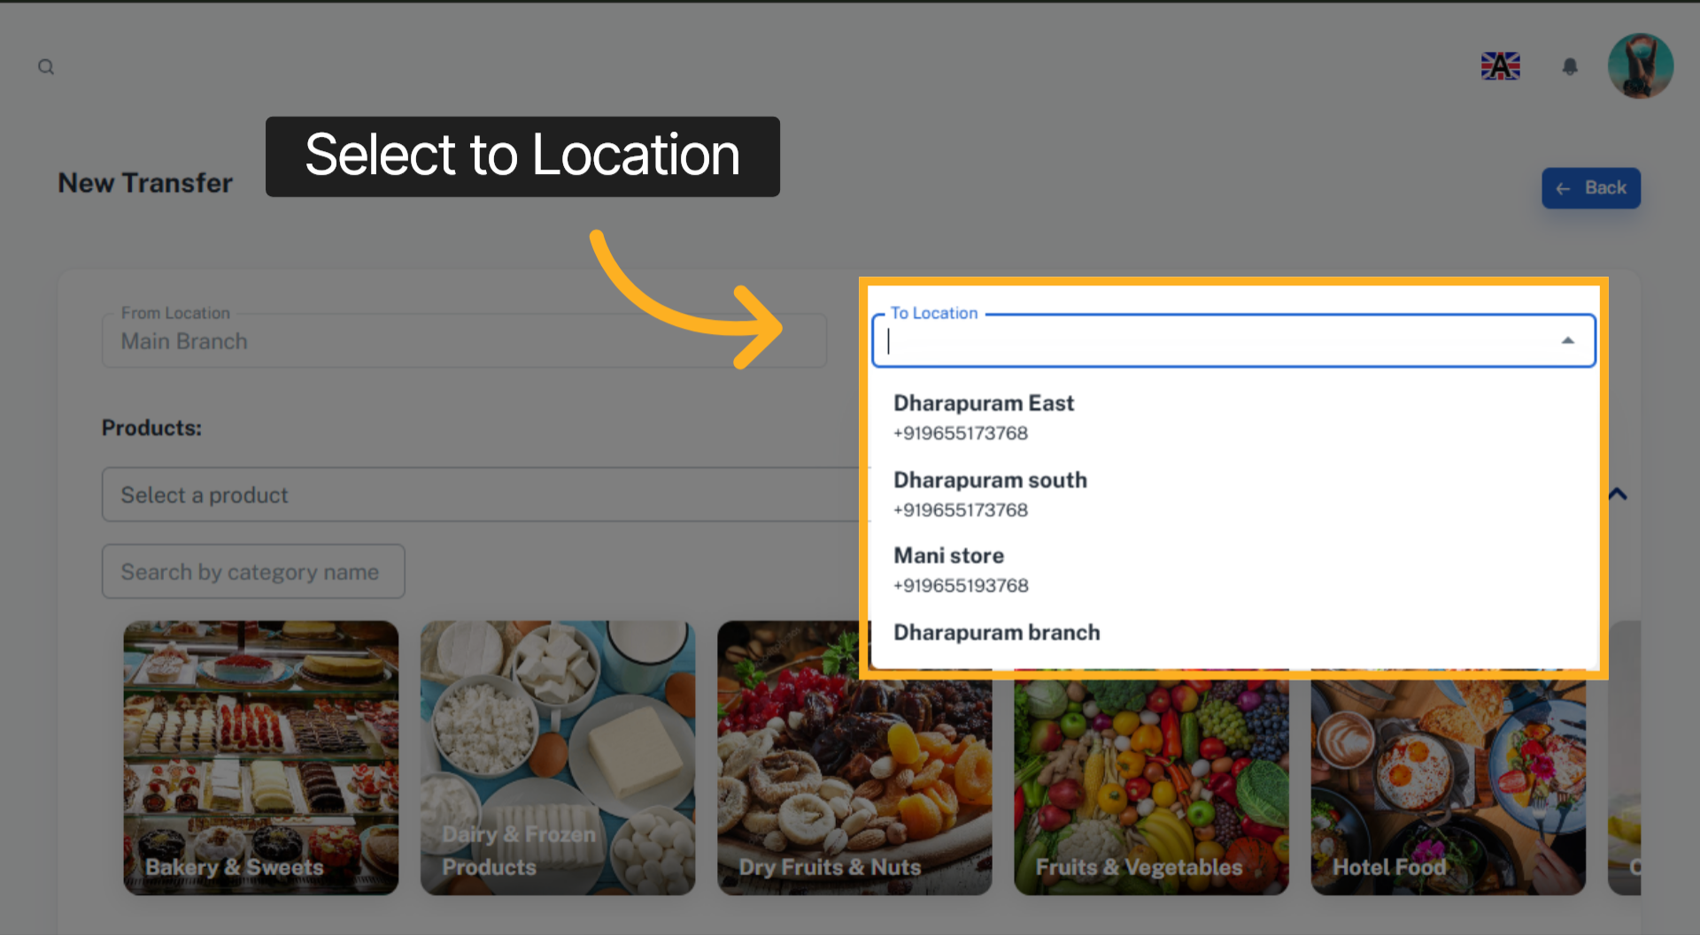

6. Select a product
Select a product from the dropdown. You can search by product name or code.
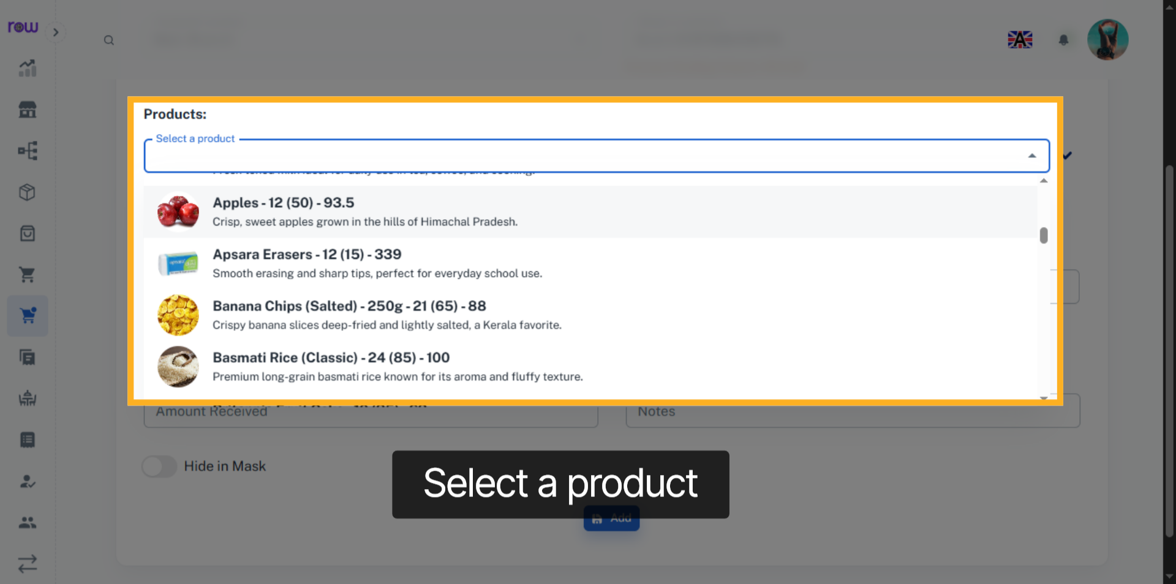

7. Product Selection Dropdown
Or click the arrow to find a product by its category.
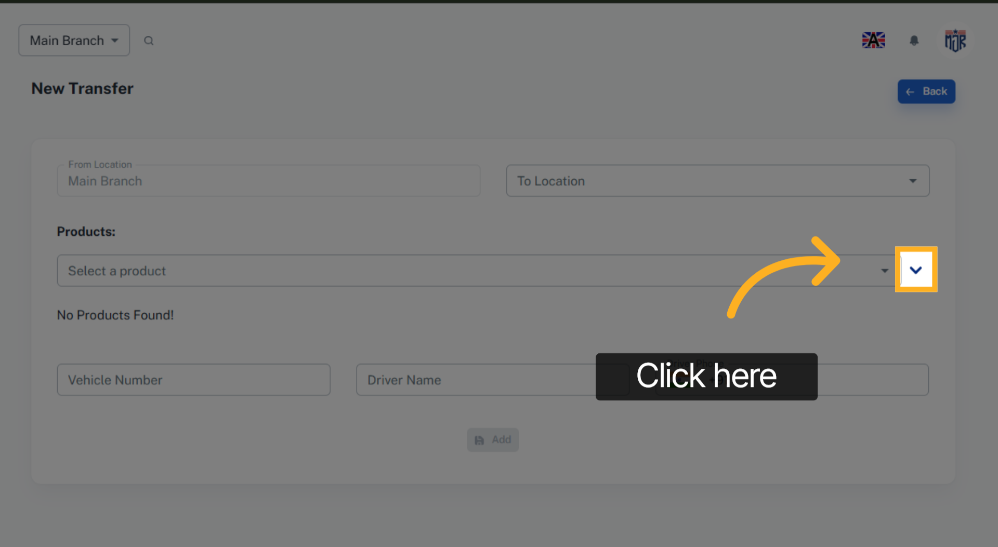

8. Select the product category
select the product by its category
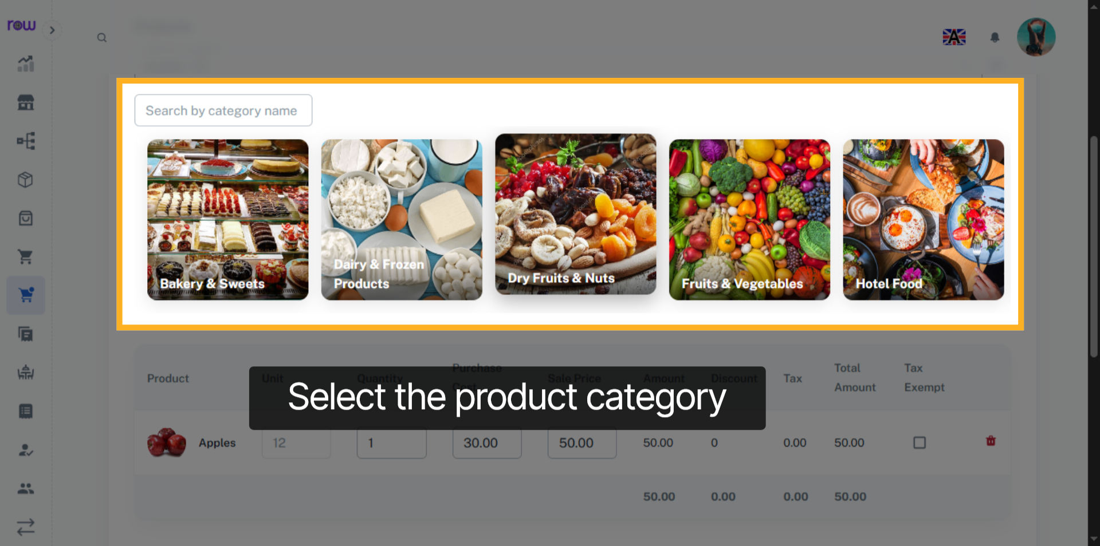

9. Select Product
Select Product
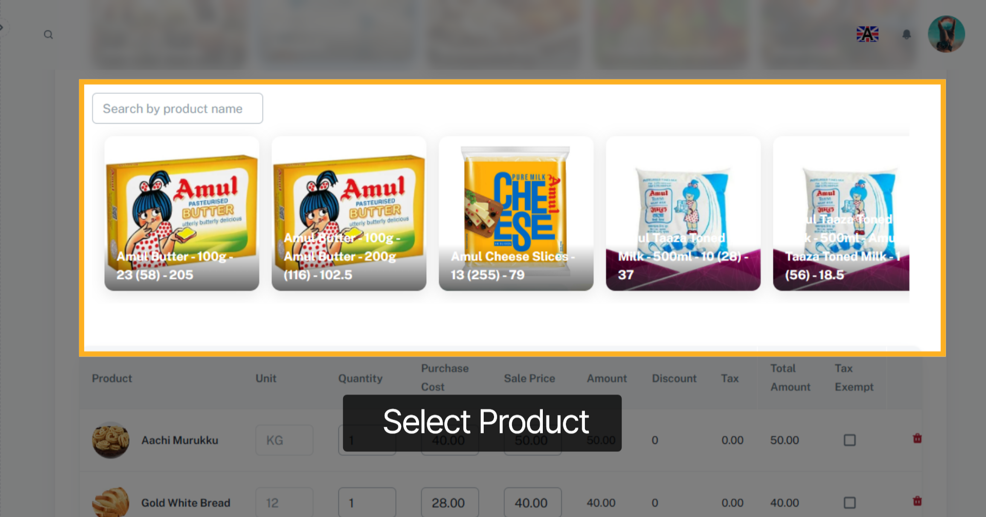

10. Product
You can view the unit and also update quantity of each product.
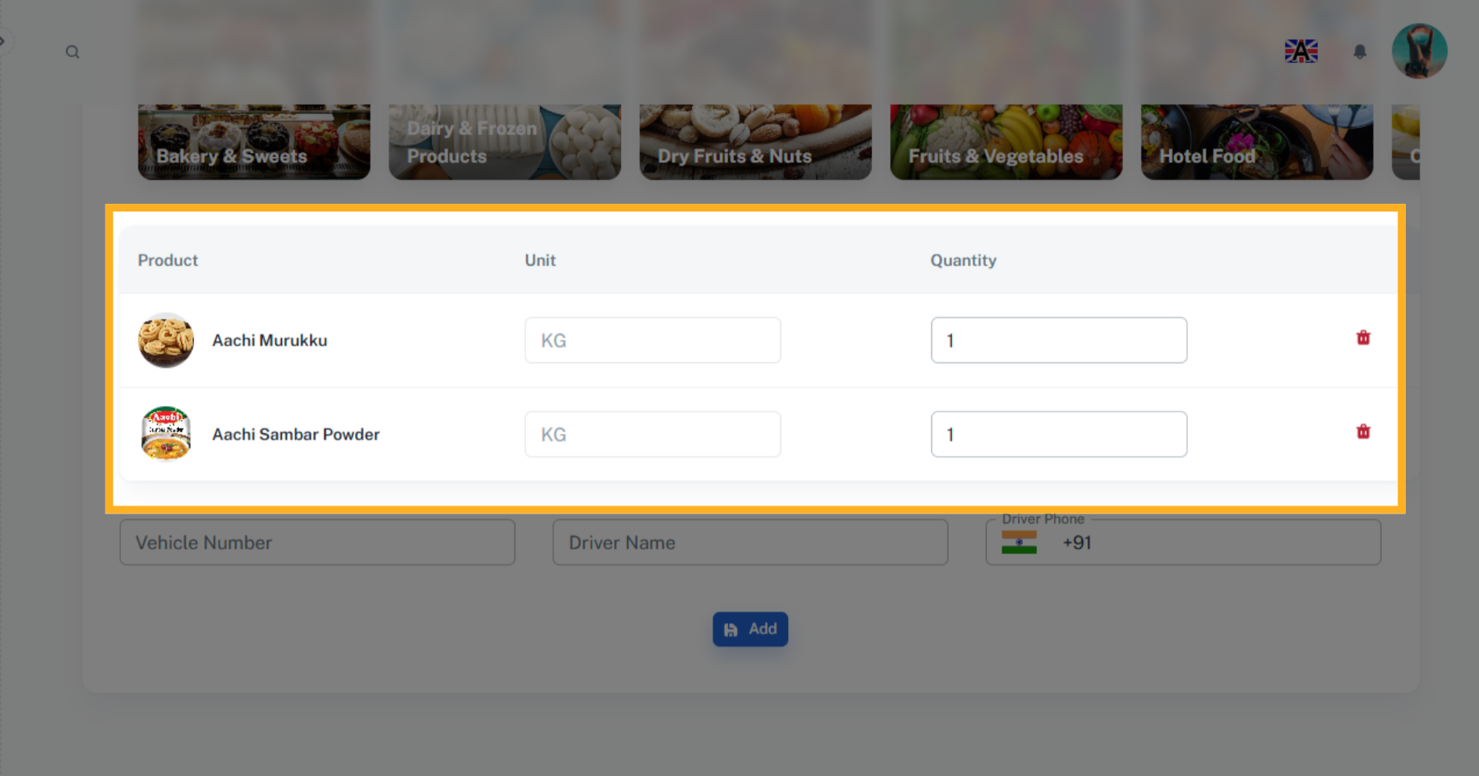

11. Fields
Enter the vehicle number, driver’s name, and driver’s phone number.
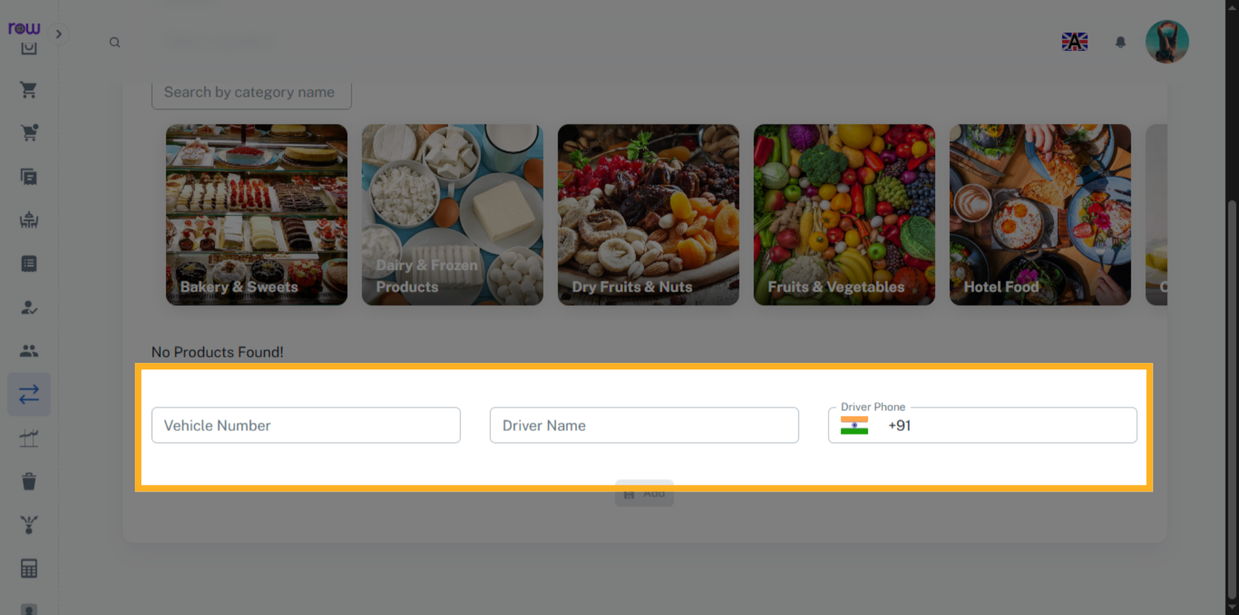

12. Add
Click Add to create a Transfer
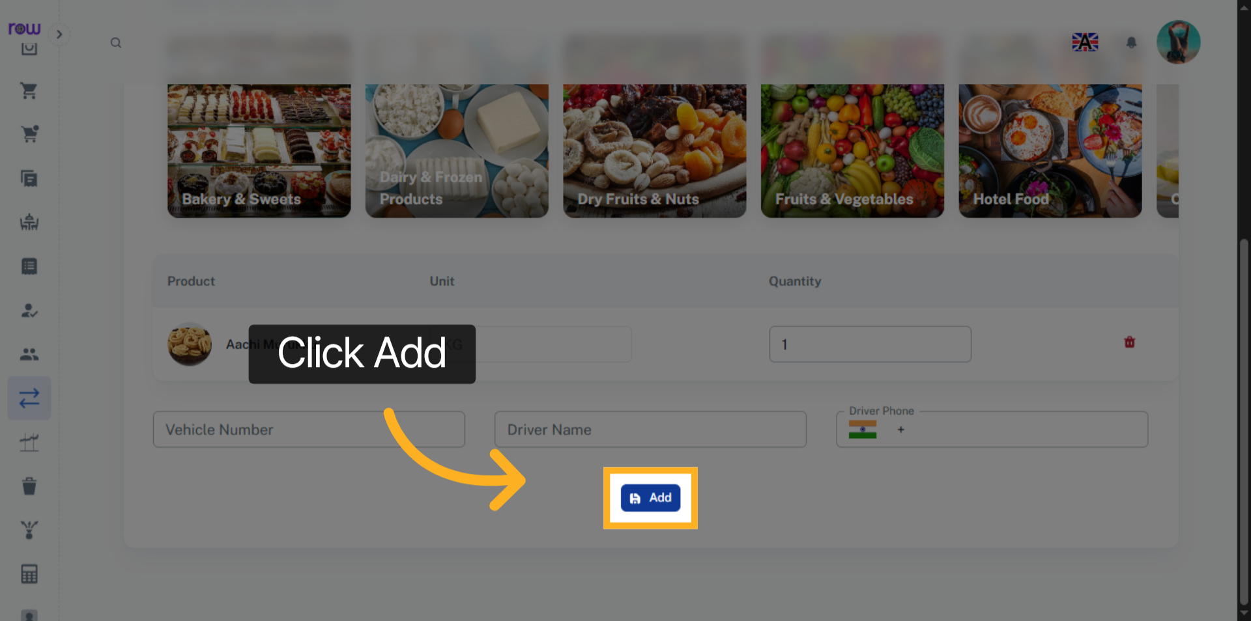

13. Transfer List Screen
You will be redirected to the Transfer List screen after the transfer is successfully created.The created transfer will be listed under the Pending Inward Transfers list and will be waiting for approval in the To Location dashboard.
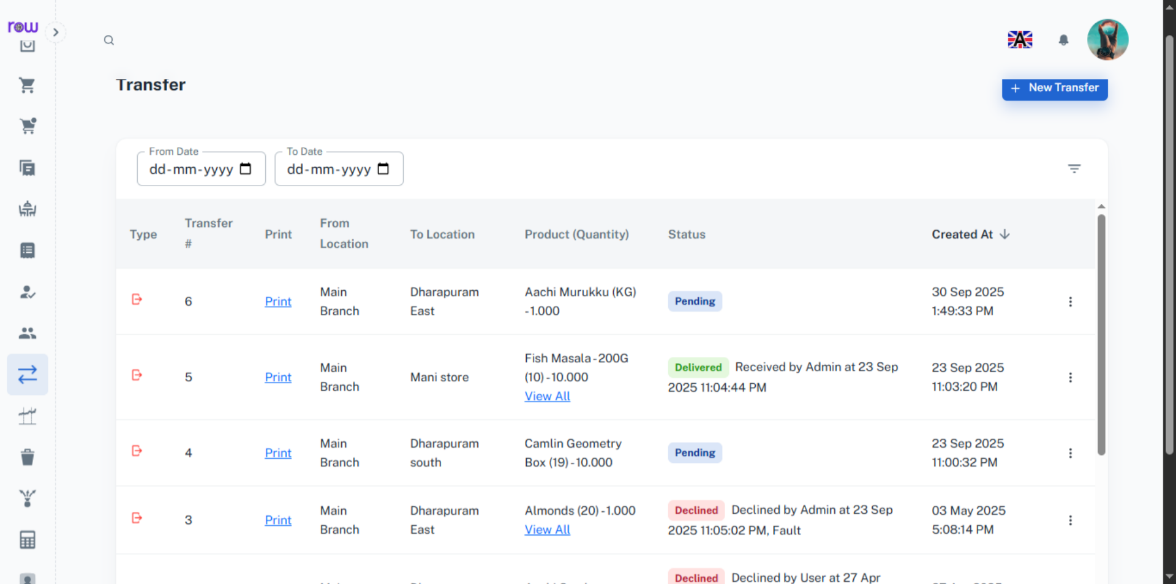

14. Pending Inward Transfers
You can approve or decline a transfer that comes to your branch. If you approve the transfer, the products will be added to your stock. If you decline it, the transfer will be returned to the branch it was sent from.
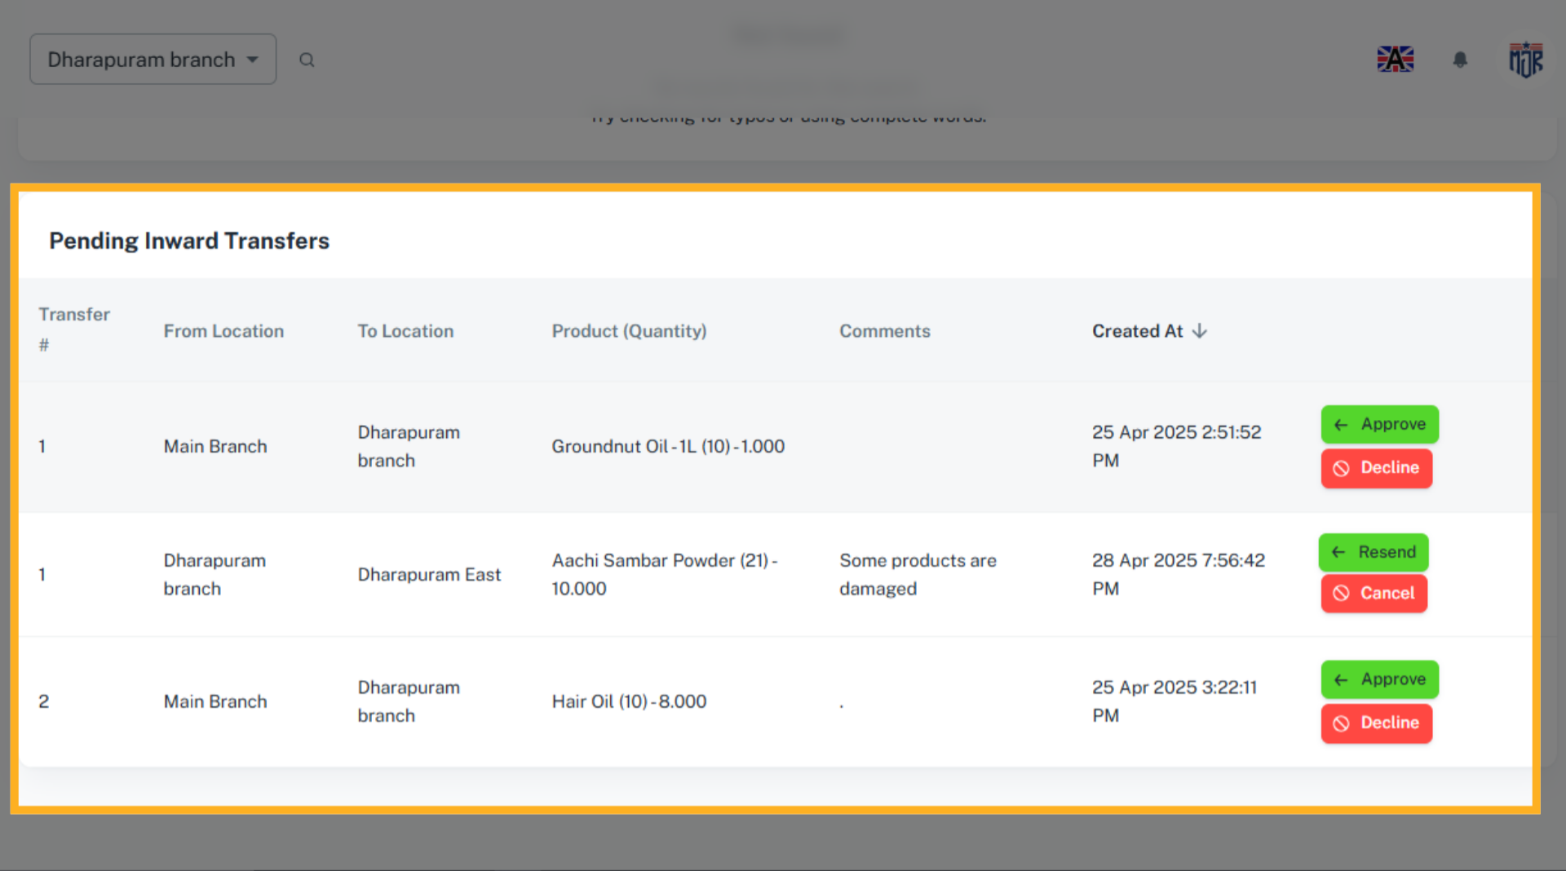

15. Return Transfer
If the transfer is declined by the receiving branch, it will be returned to the branch it was sent from. From there, you can resend the transfer or cancel it. If you cancel the transfer, the products will be added back to your stock.
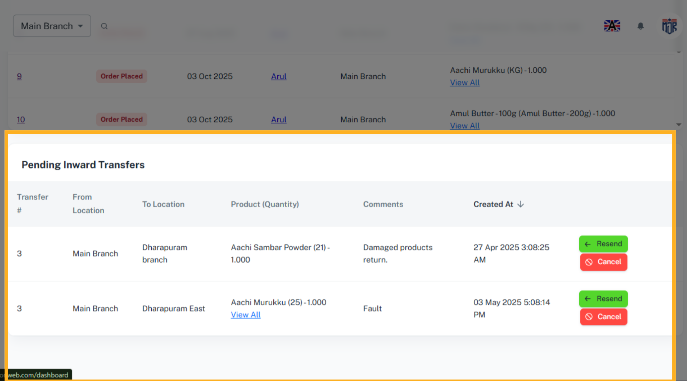

16. Print
Click Print to generate and view, the bill.
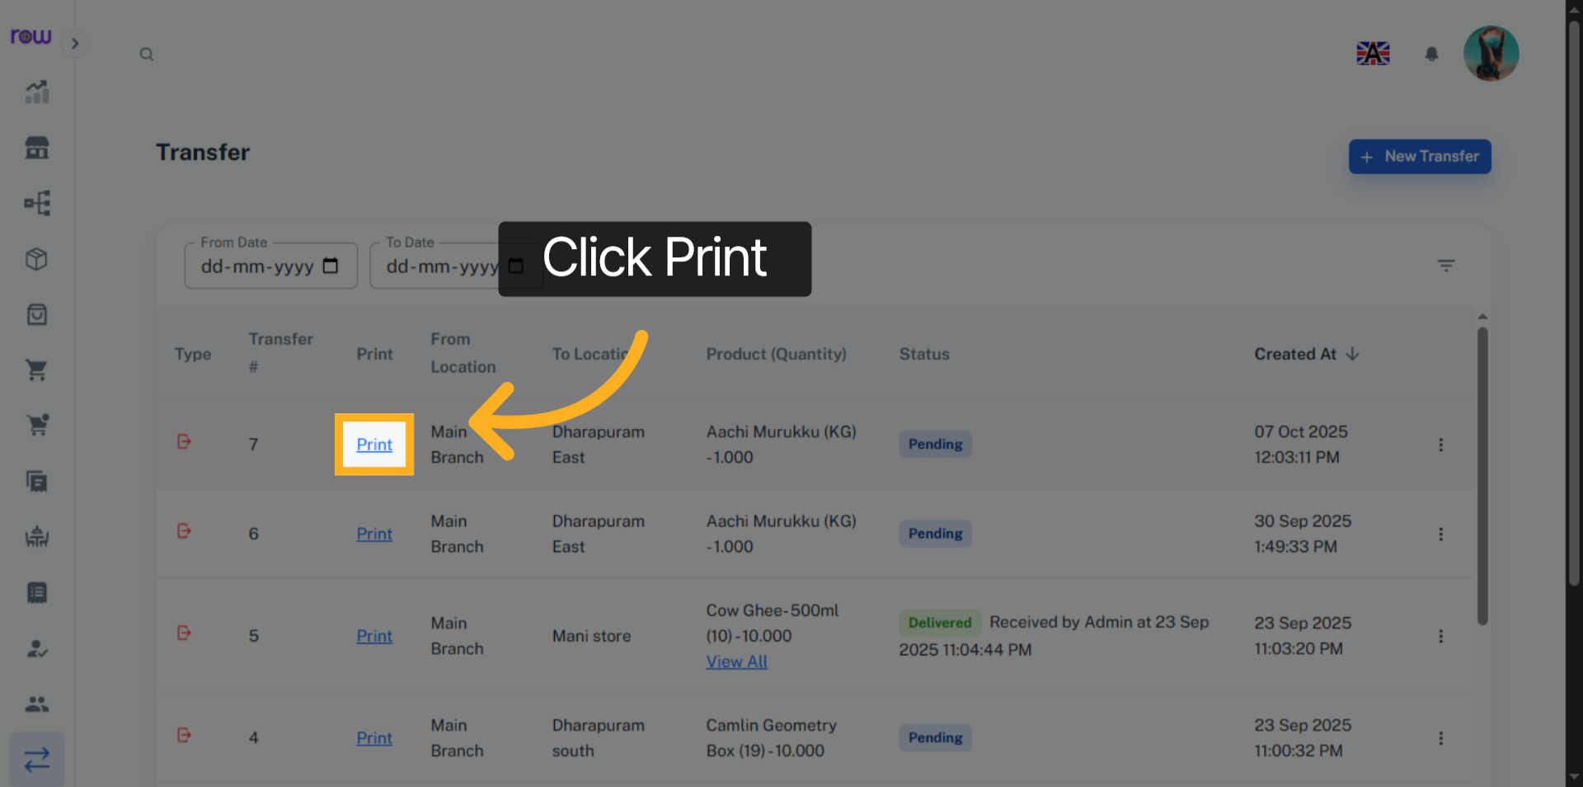

17. Download and print the bill.
You can print and download the bill.
