Create Usages in Run On Web

Go to runonweb.com

1. Introduction
In this tutorial, you will learn how to create an usage.
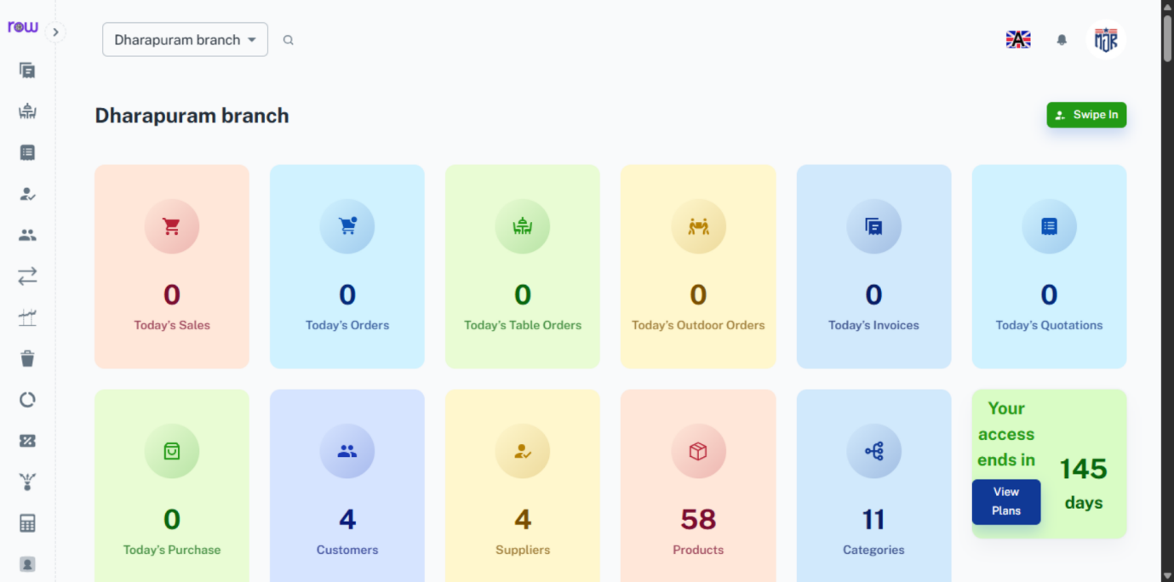

2. Select Usage
Select Usage
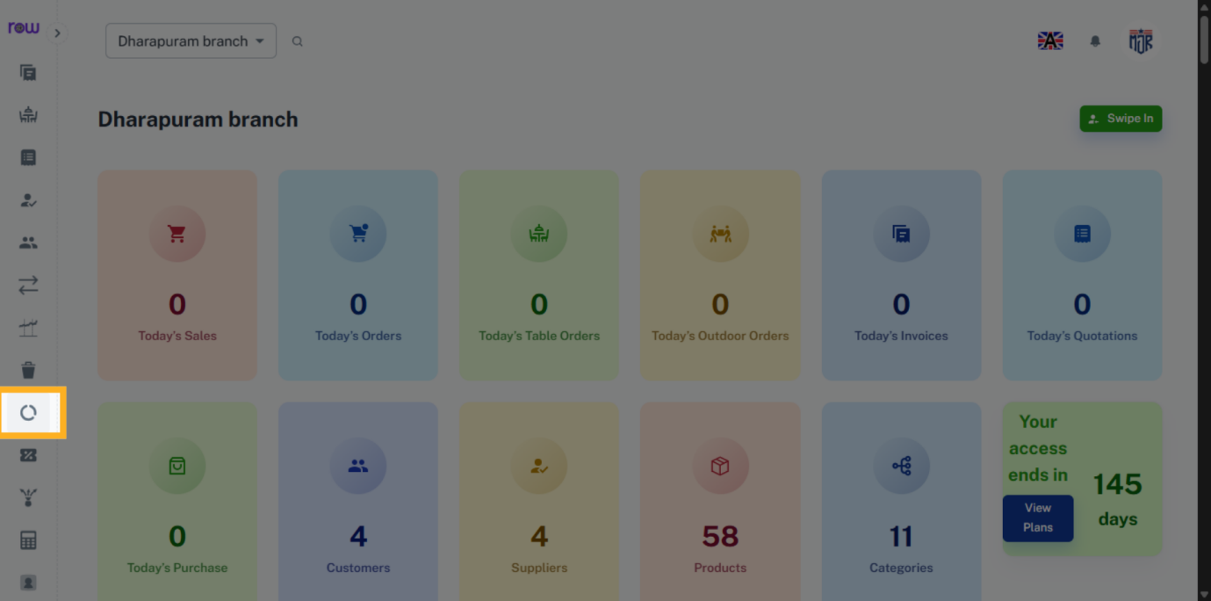

3. Click new Usage
Click new Usage
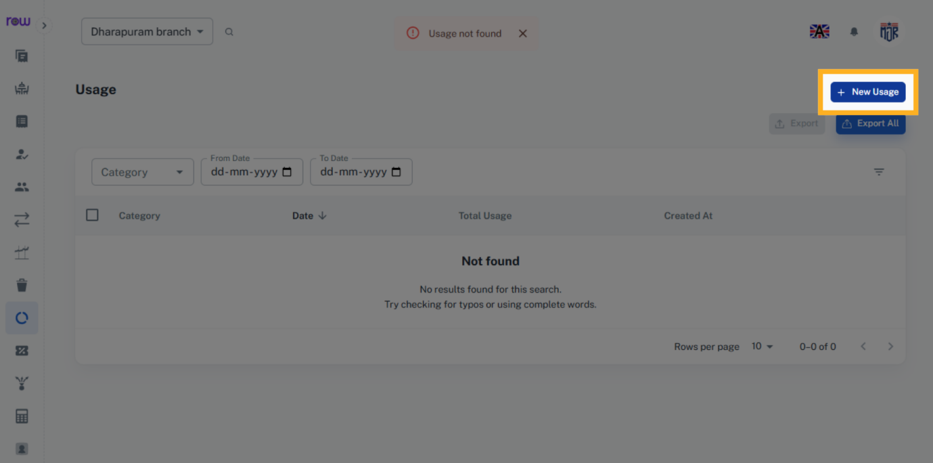

4. New Usage Screen
You can now see the new usage screen.
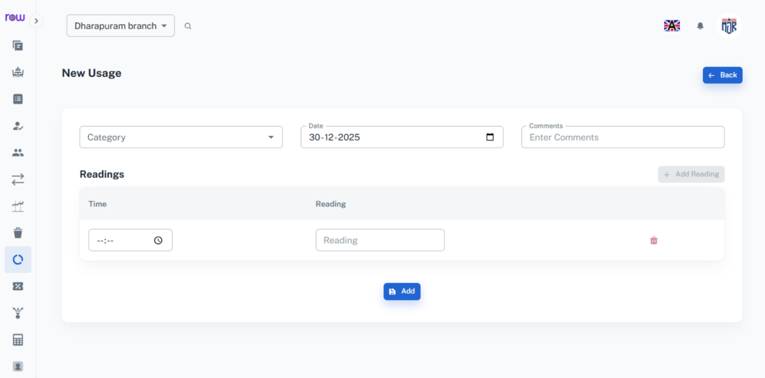

5. Enter Category
Enter Category
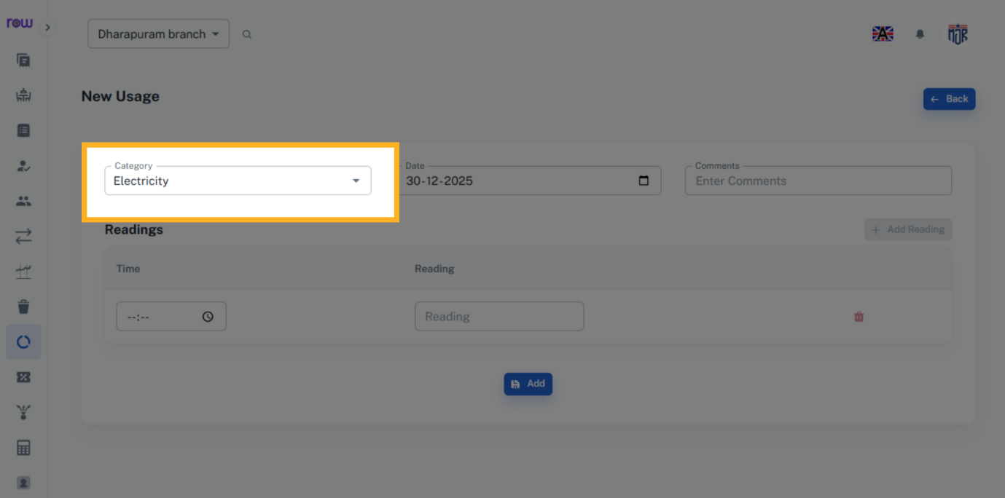

6. Select Date
Select Date
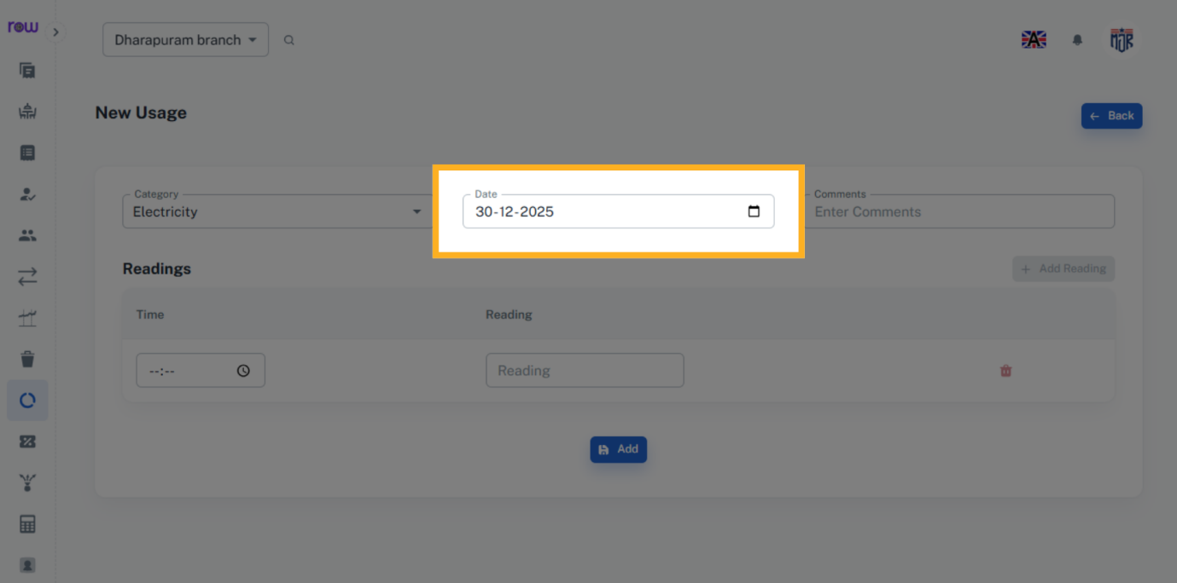

7. Comments Field
Enter Comments if needed.
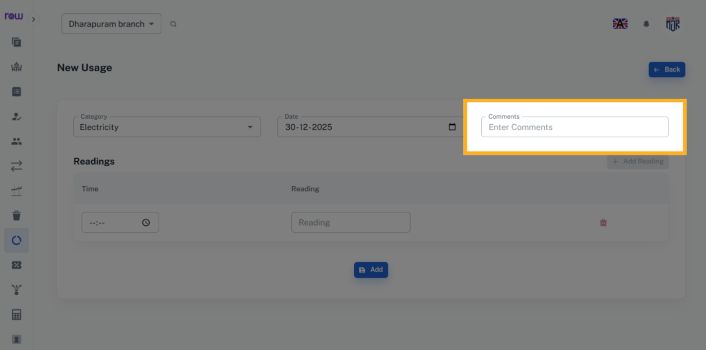

8. Open Time Field
Select Time field
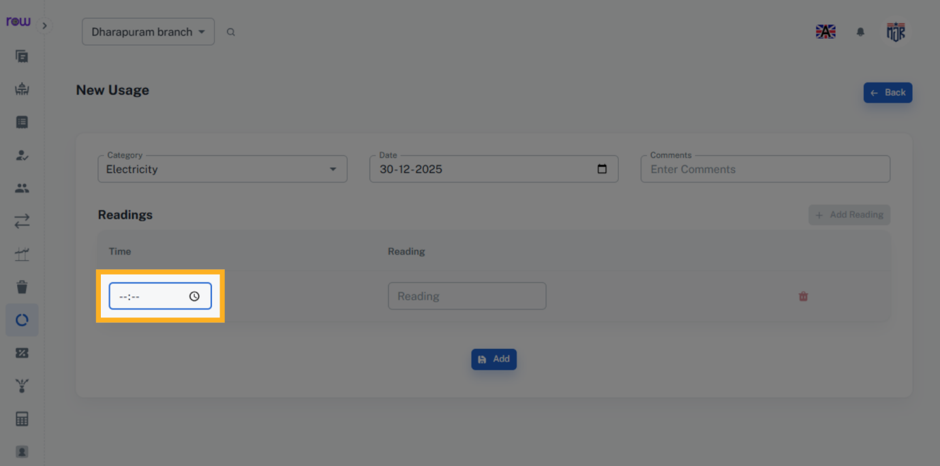

9. Select Time
Select Time
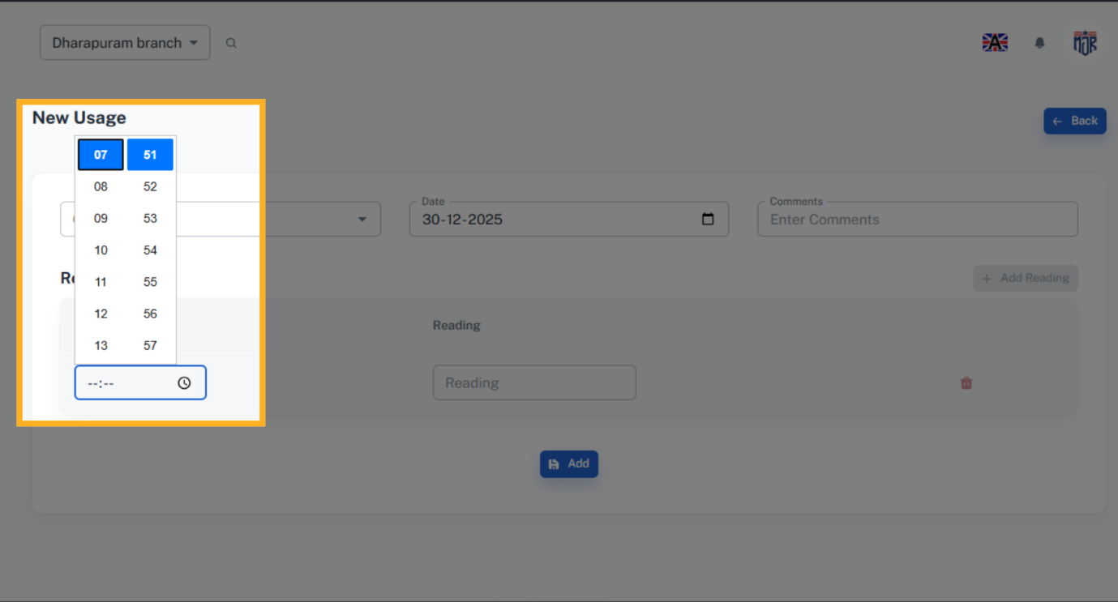

10. Enter Reading
Enter Reading
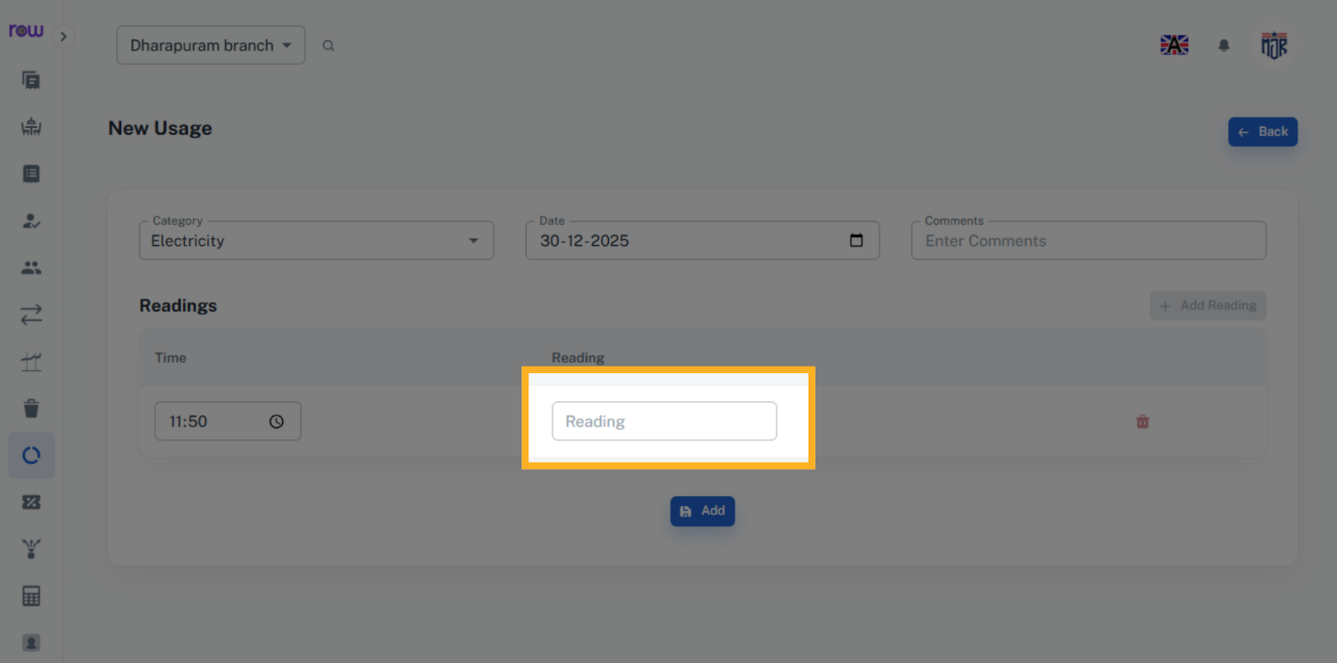

11. Add Additional Reading
Click Add Reading to add more reading.
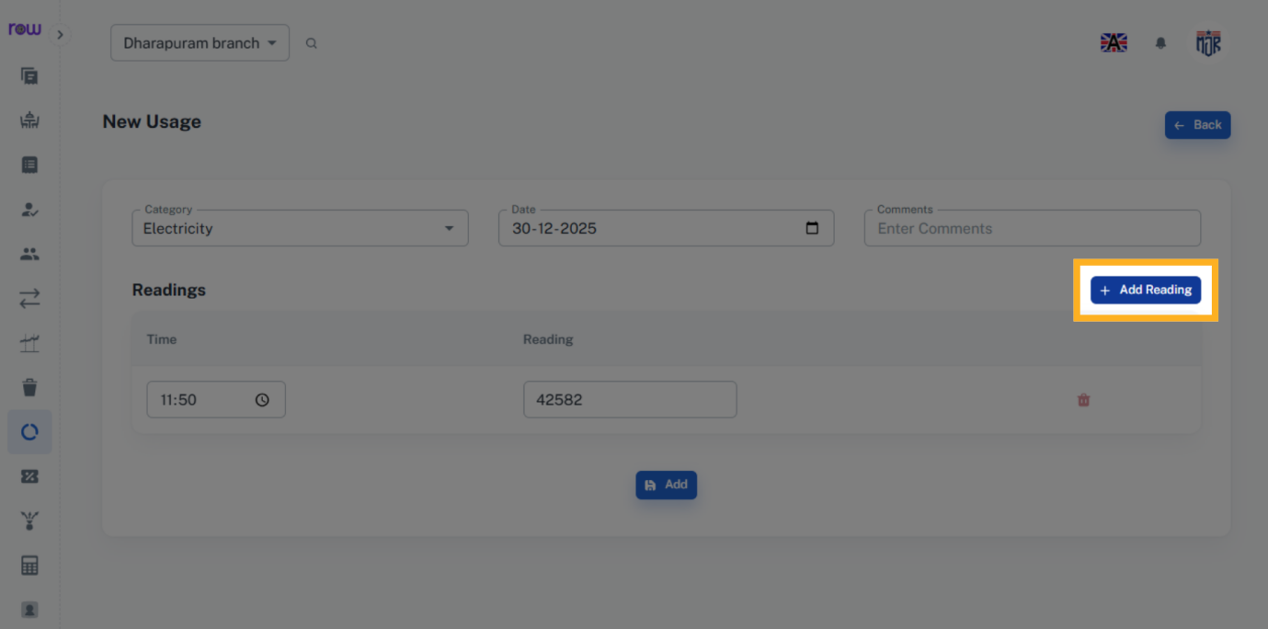

12. Reading Difference
You can see the difference between the first and last readings, and you can also add all readings. This way, you can calculate usage details for Electricity, gas, water, etc.
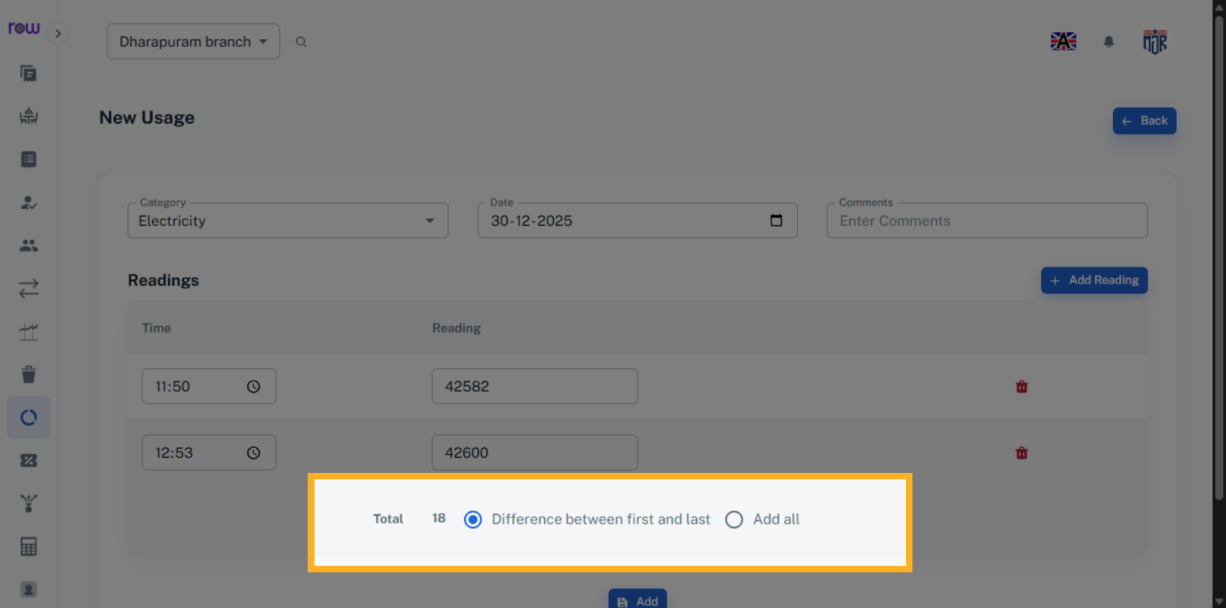

13. Add
Click Add to create new Usage.
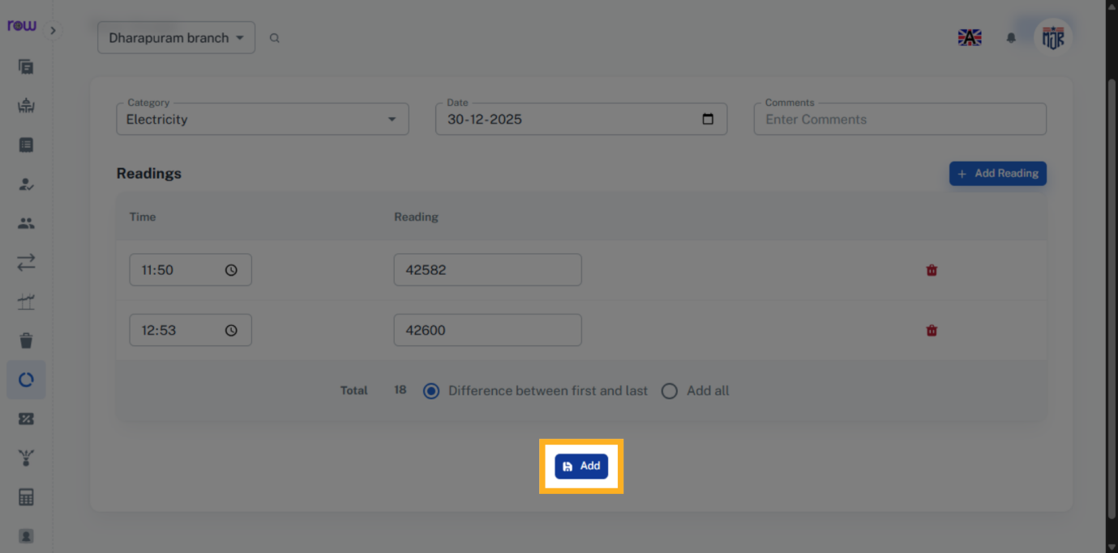

14. Usage List Screen
You will be redirected to the usage list screen after the new usage is successfully created.
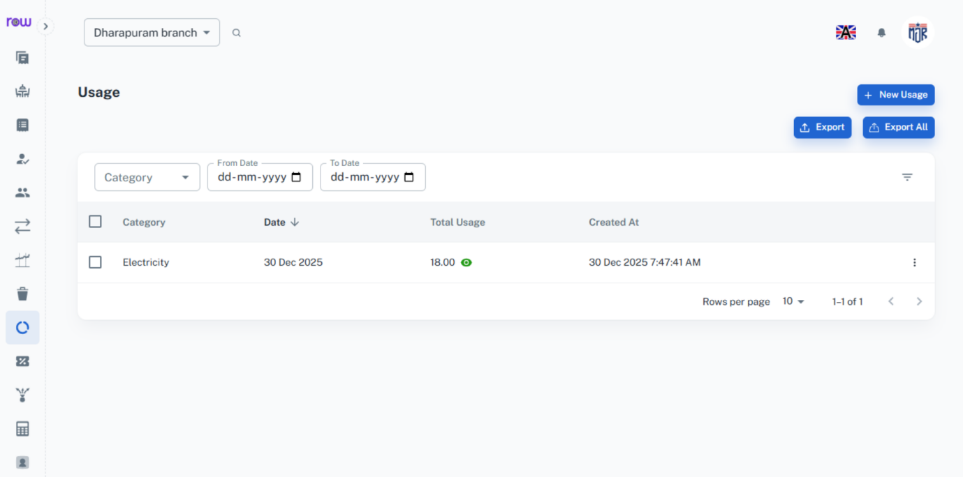

15. Click Eye Icon
Click Eye Icon to view the usage details.
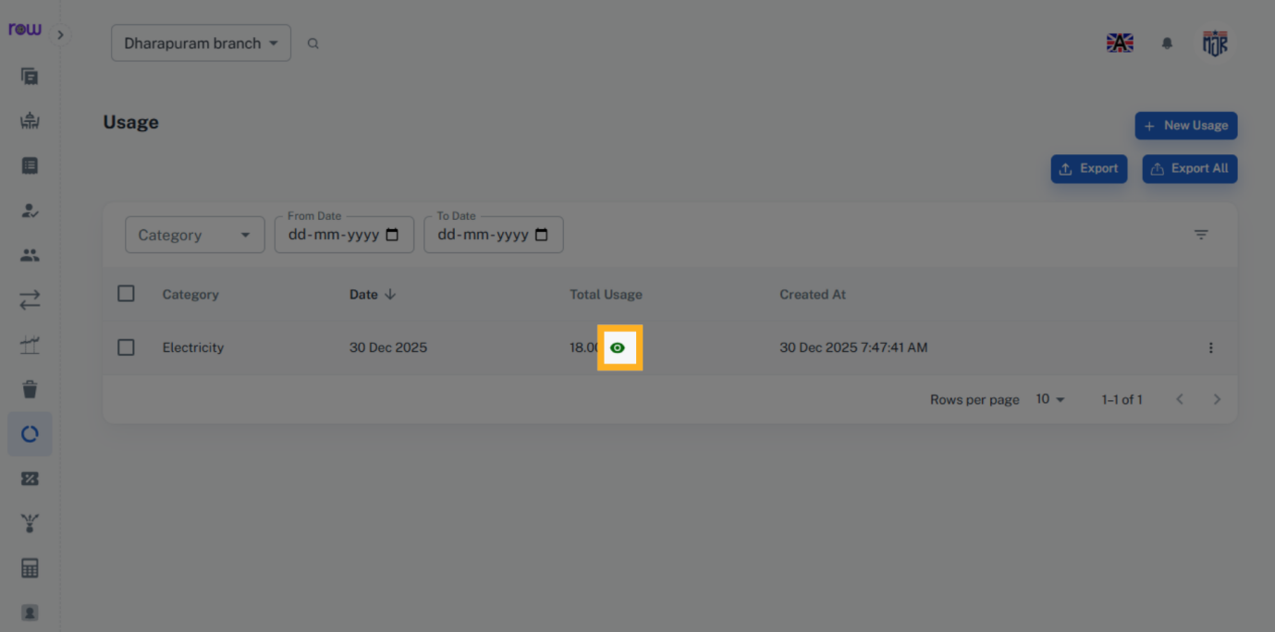

16. Readings Tab
You can see the usage details here.
