Create and Manage Wastages in RunOnWeb

Go to runonweb.com

1. Introduction
In this tutorial you learn how to create and manage wastage.

2. Wastage Menu
Click the wastage menu to open the wastage list screen.
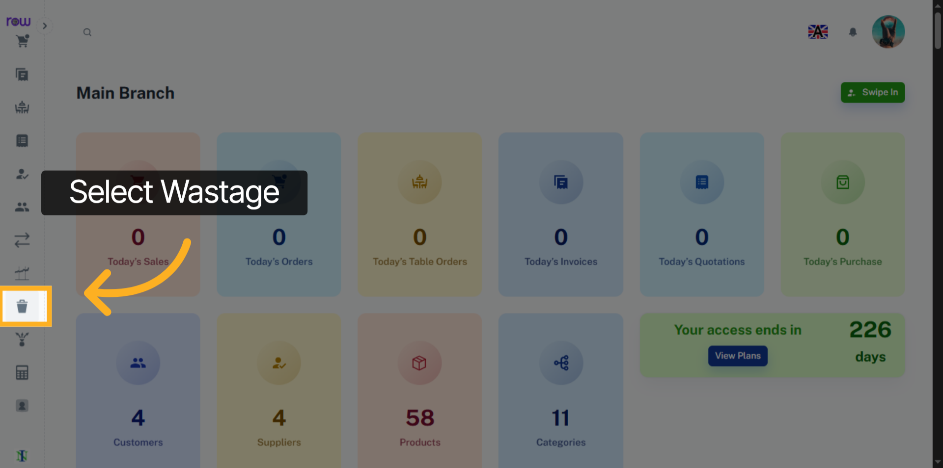

3. New Wastage Button
Click Add button to start creating the new Wastage.
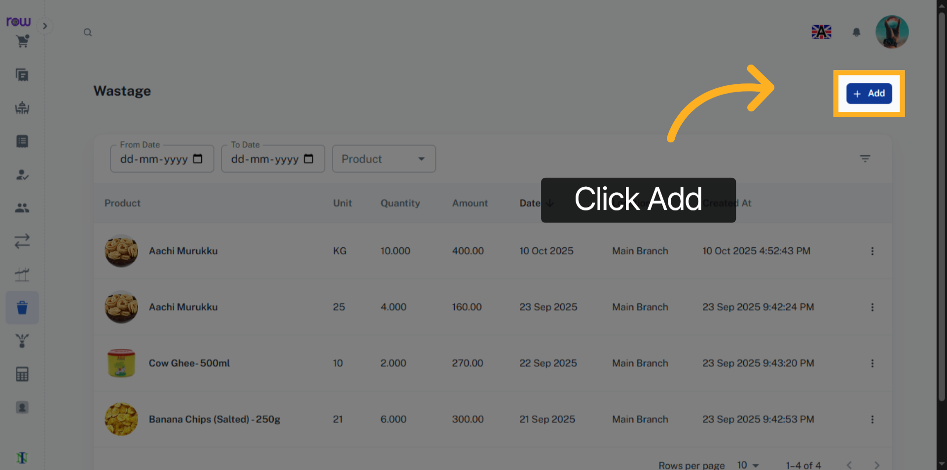

4. Wastage Screen
The Date and Location fields are already filled in. The Location cannot be changed.
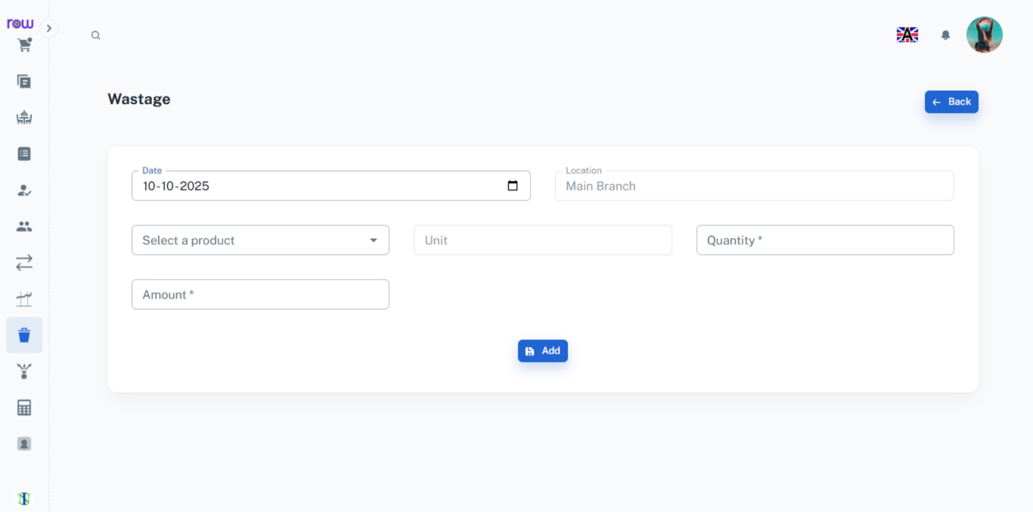

5. Select Product
Select a product from the dropdown. You can search by product name or code.
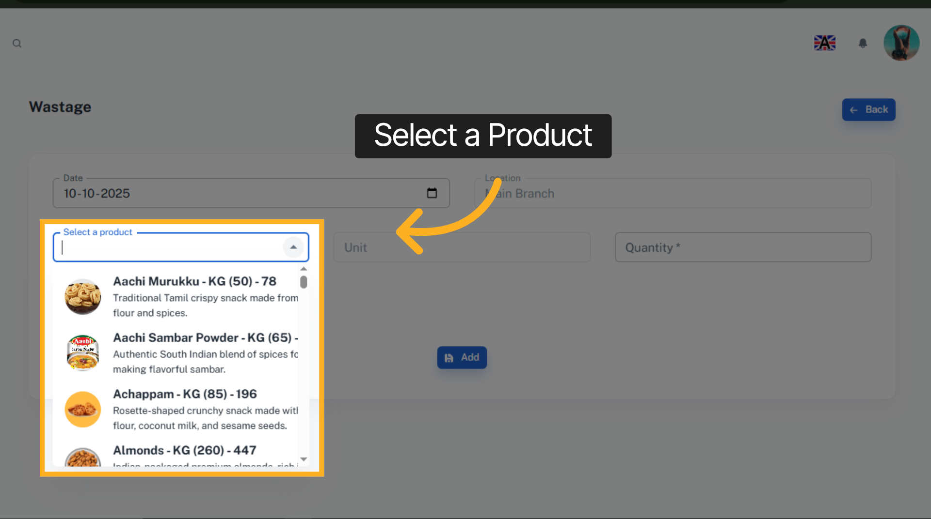

6. Product Quantity
Enter Product Quantity.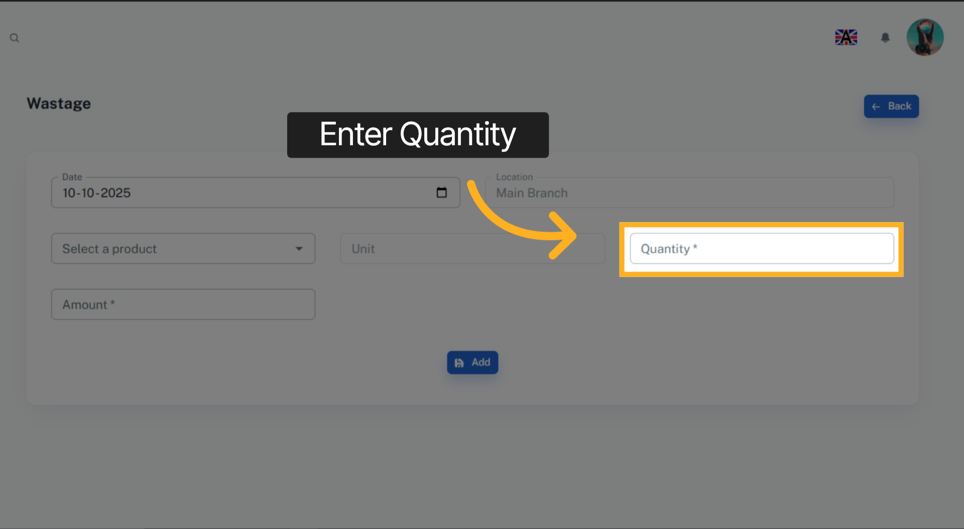

7. Amount
The Amount will be automatically calculated based on the products and quantities you select. You may modify it if necessary.
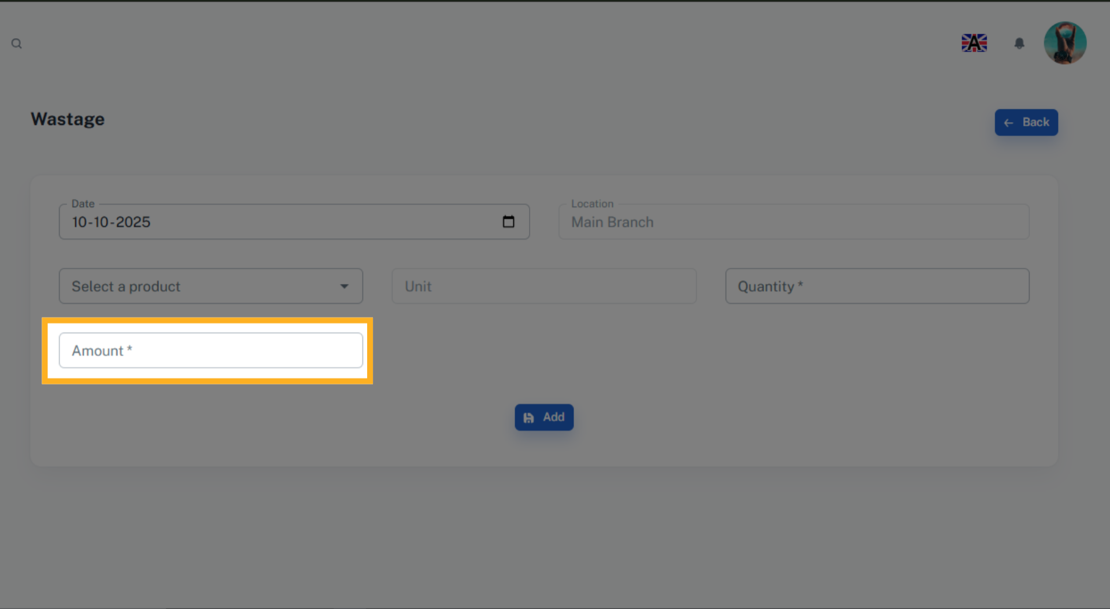

8. Add
Click Add Button to create a wastage.
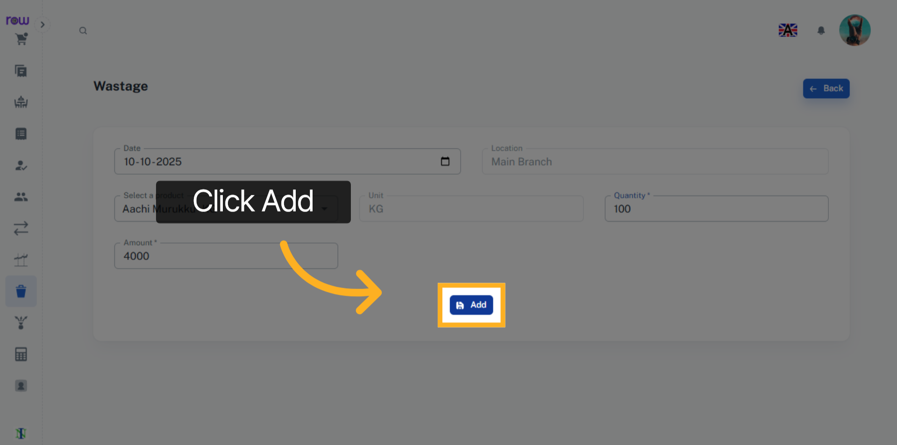

9. Wastage List Screen
You will be redirected to the Wastage List screen after the Wastage is successfully created.
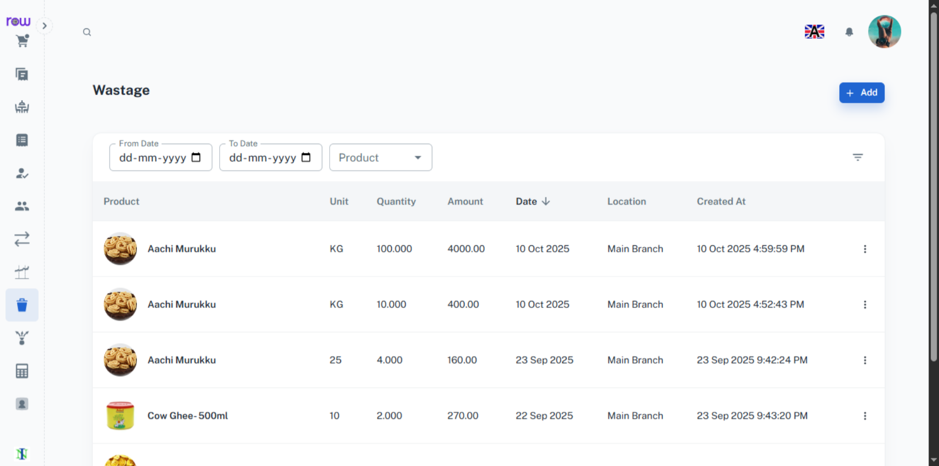

10. Accounts Menu
The wastages are recorded in the Accounts section. You can view their reflection in the Day Book, Ledger, Balance Sheet, Trial Balance, Profit Loss, etc,.
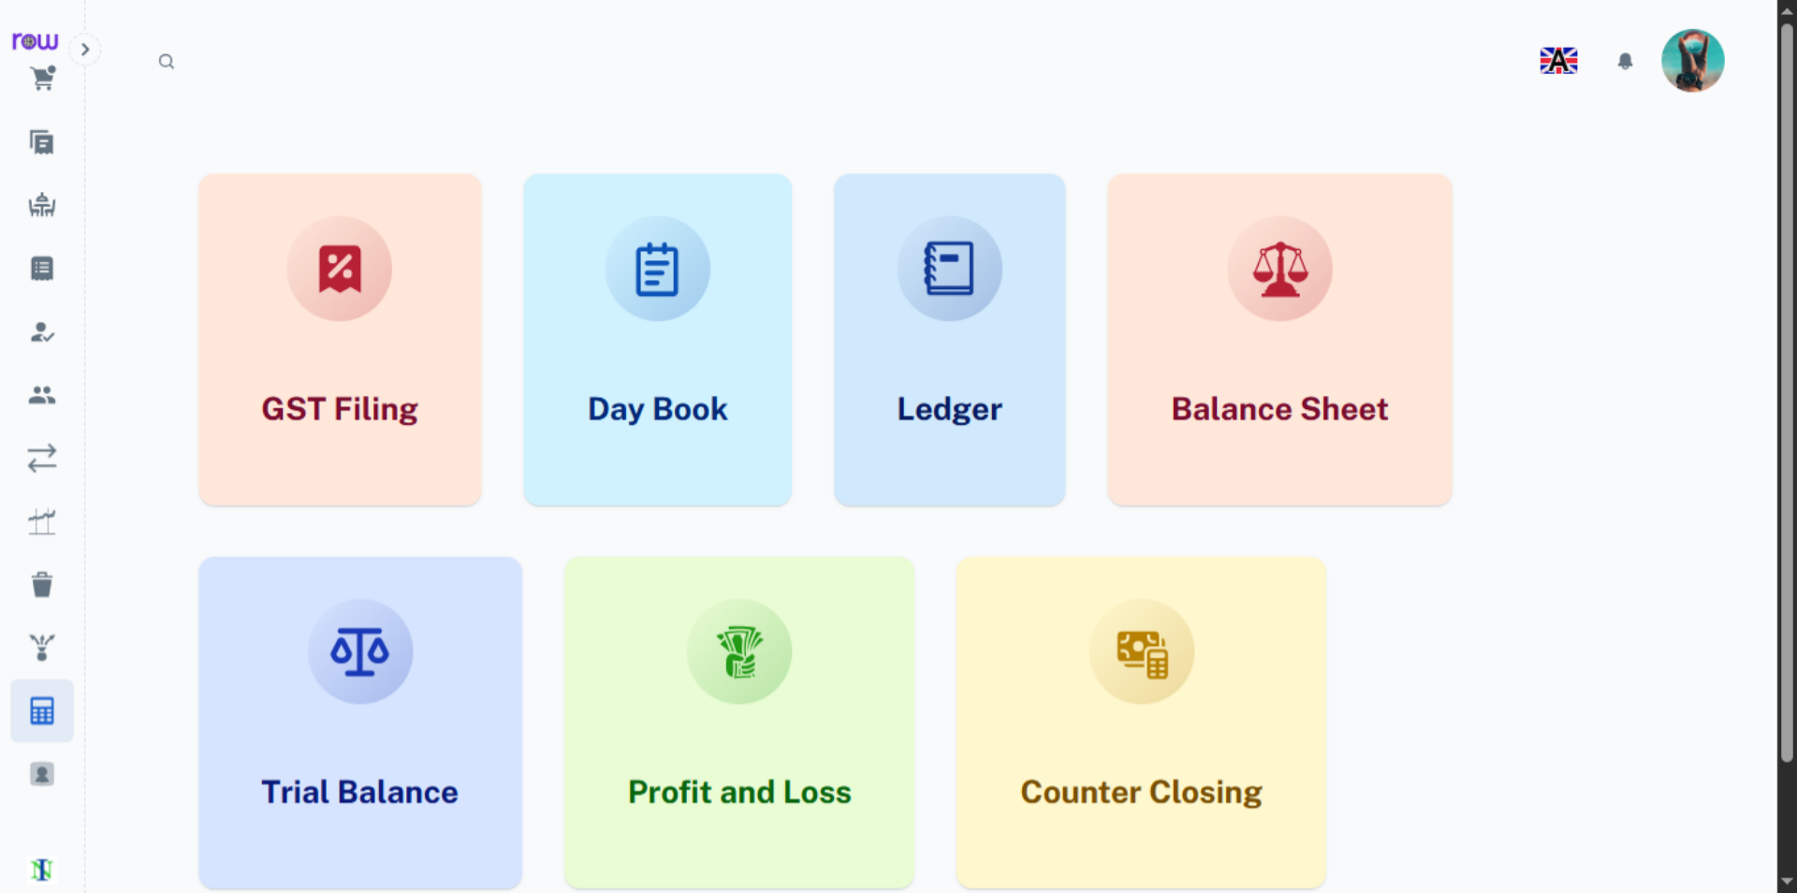

11. Day Book
You can see the wastage record in Day Book.
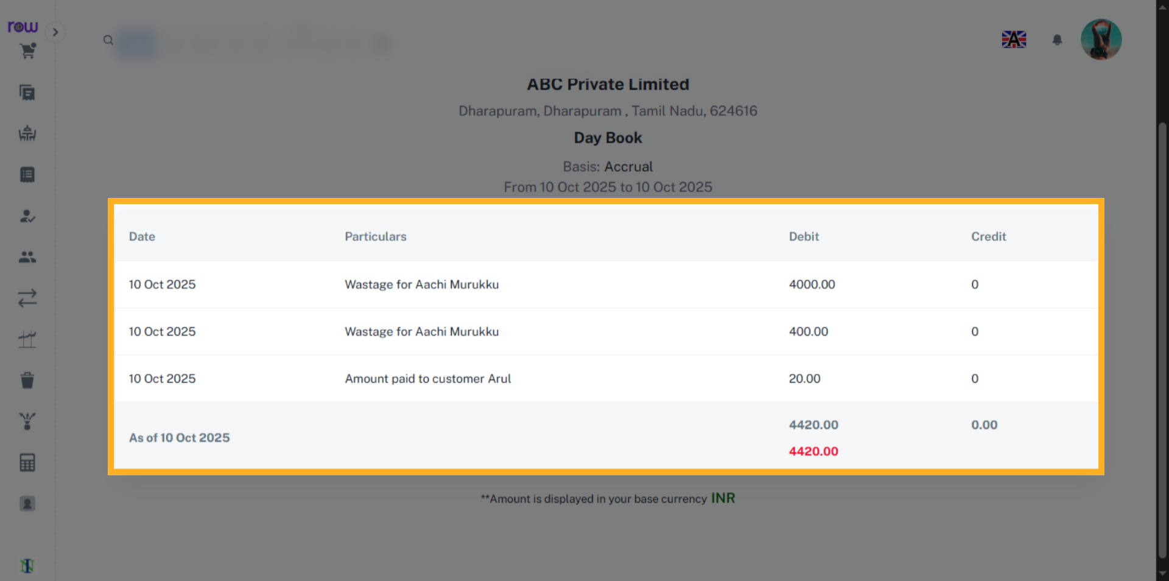

12. Ledger
You can see the wastage record in Ledger.
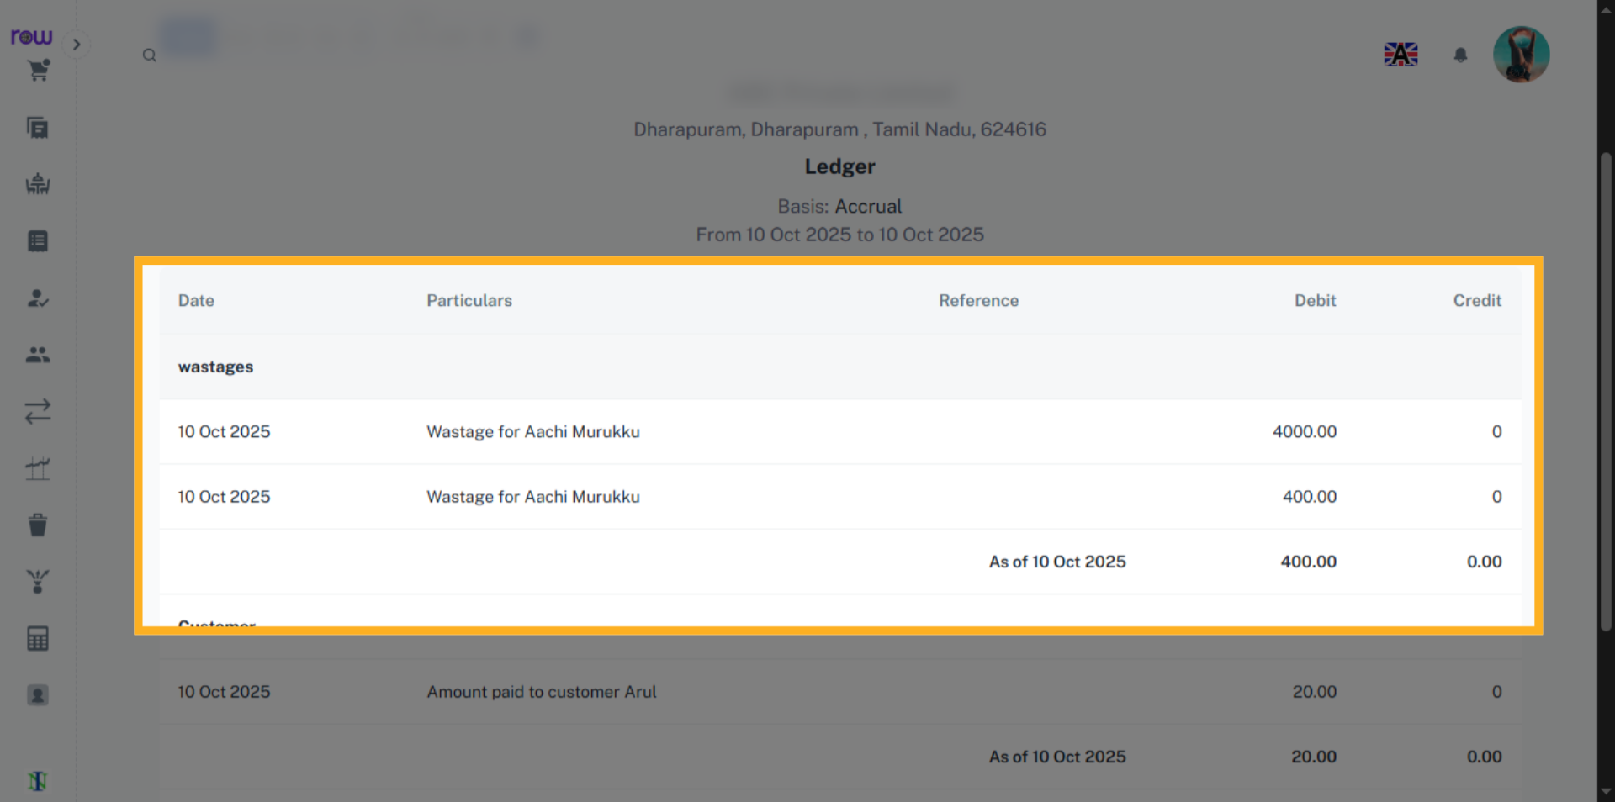

13. Profit and Loss
You can see the wastage record in Profit and Loss.
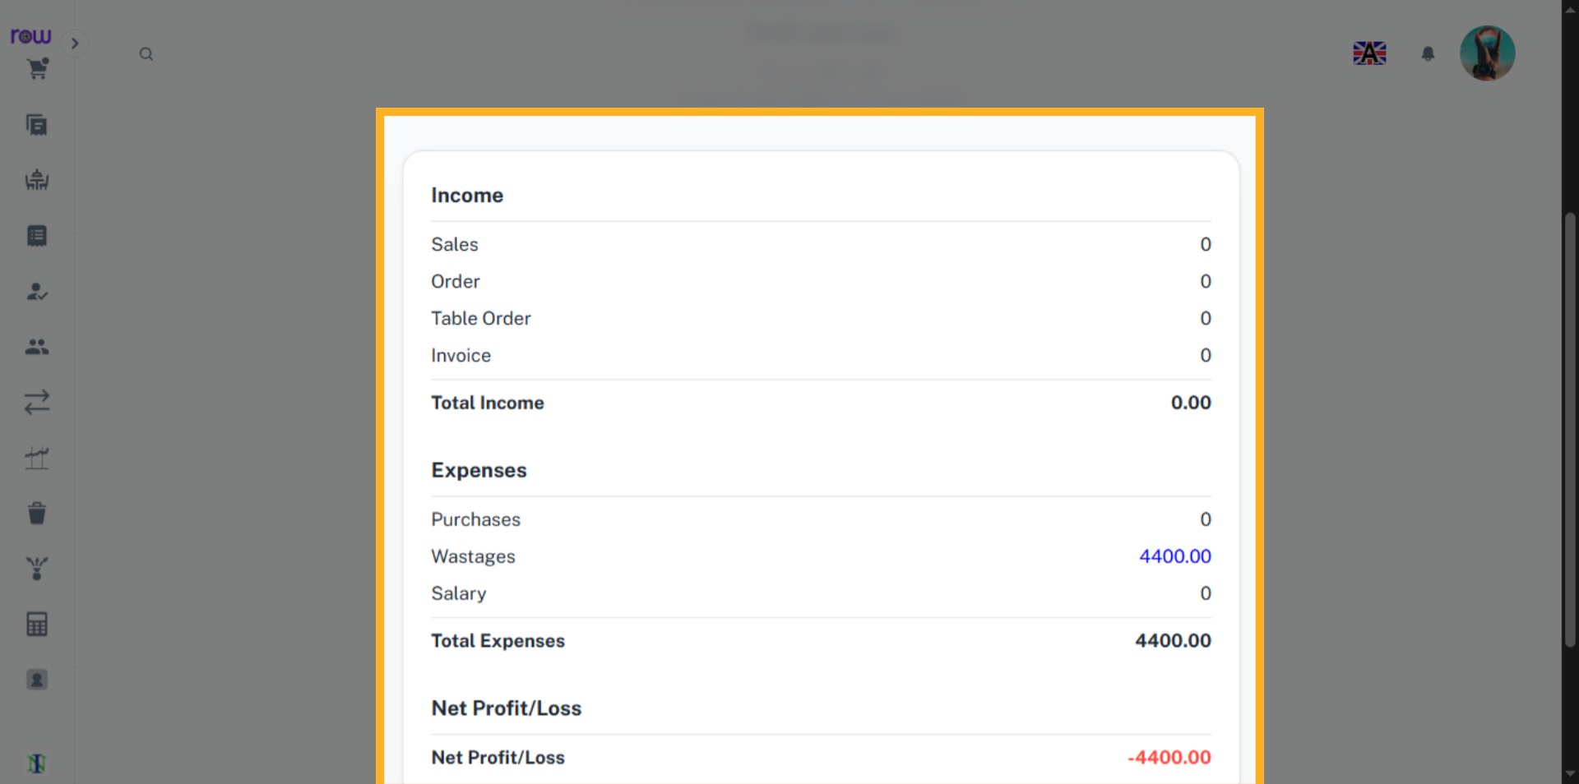

14. Trial Balance
You can see the wastage record in Trial Balance and in all other accounts.
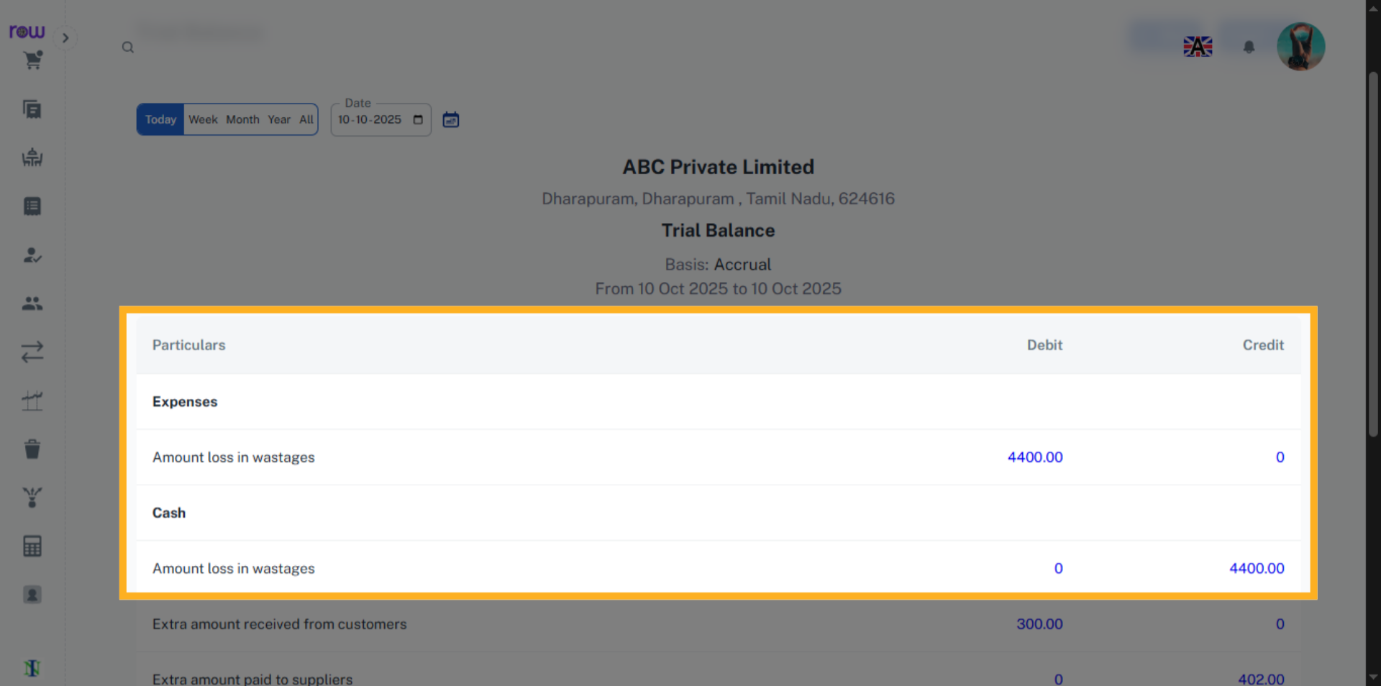

Wastage will be recorded in all the accounting sections.



