Employee work history In RunOnweb

Go to runonweb.com

1. Introduction
In this tutorial, you will learn how to view the work history.

2. Click Profile
Click profile to view the options.
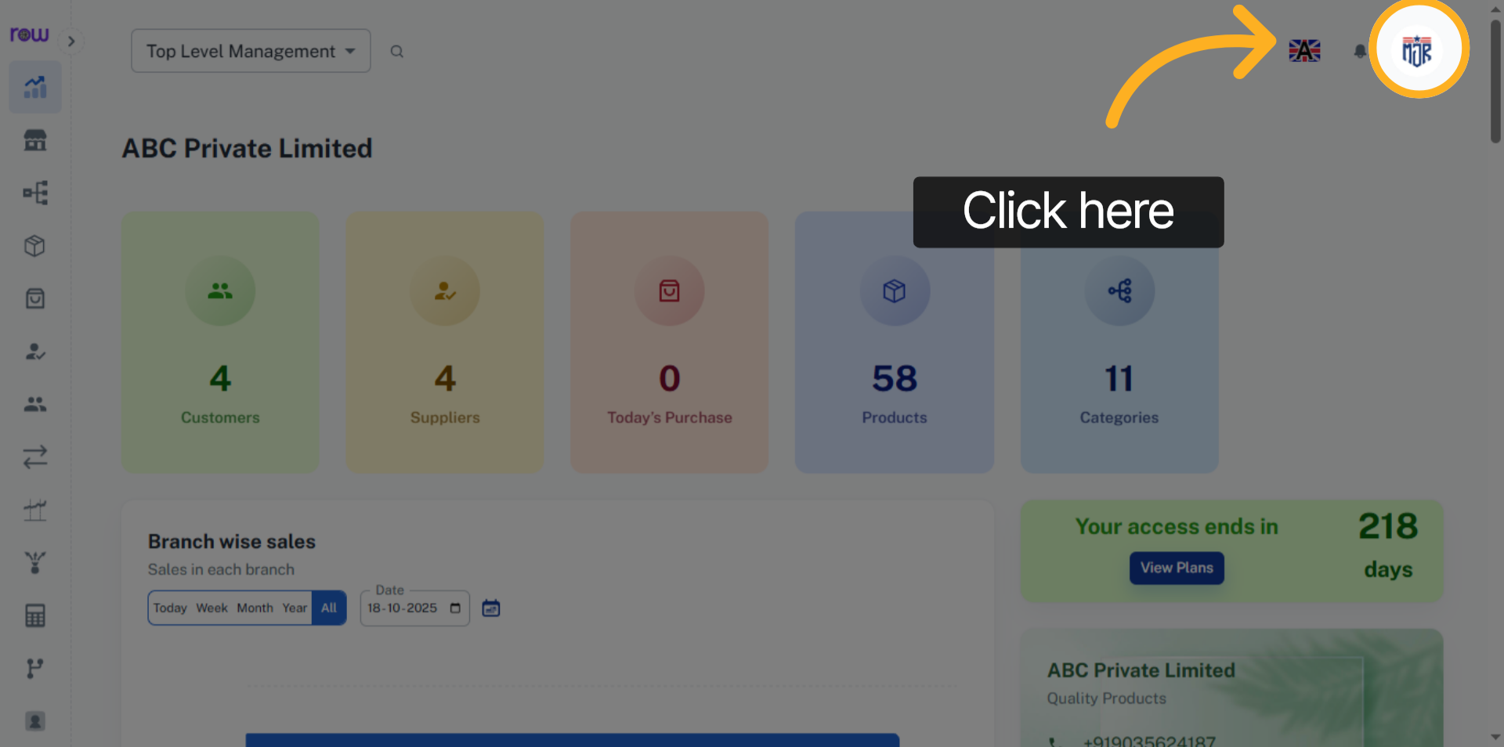

3. Options
Click the setting to open settings menu.
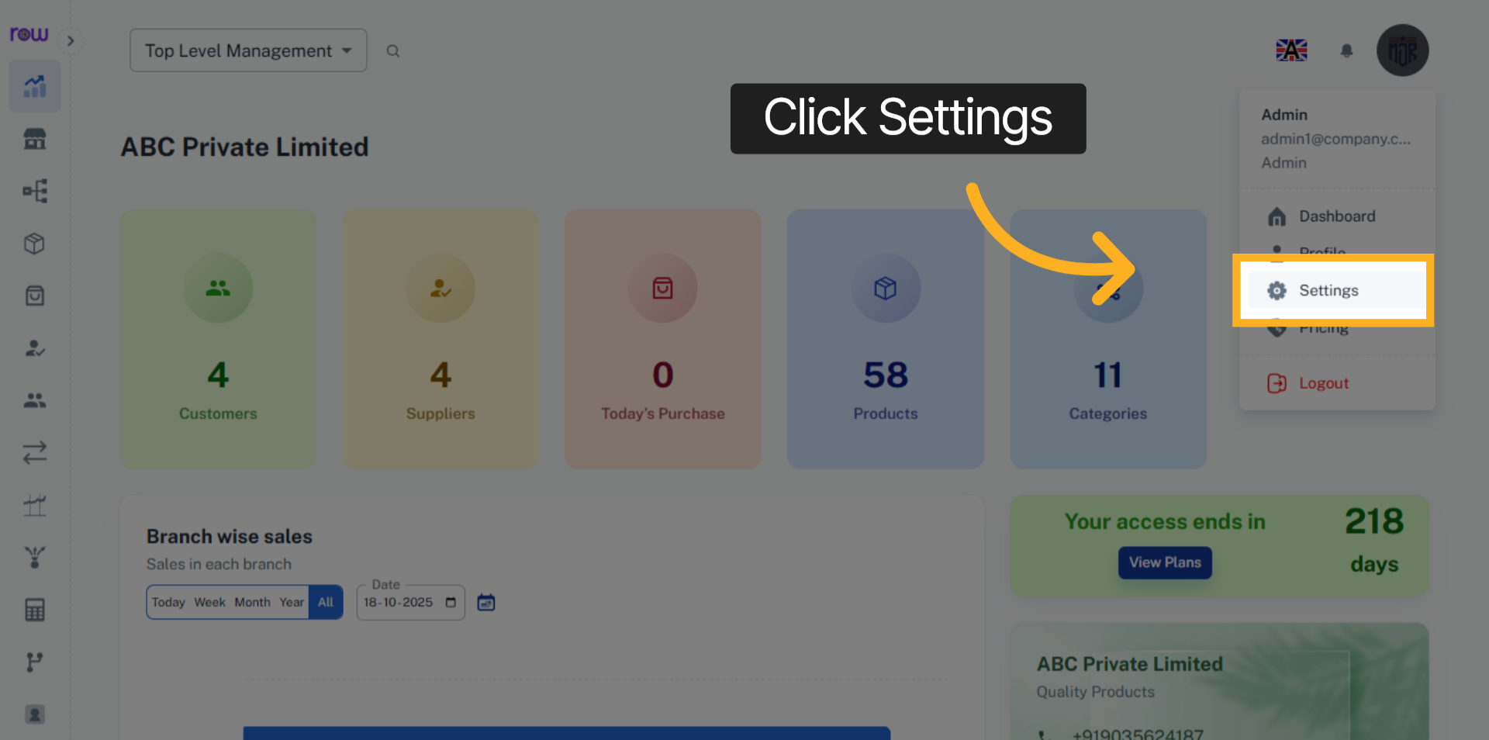

4. View History
Click View History to see the history of the branch.
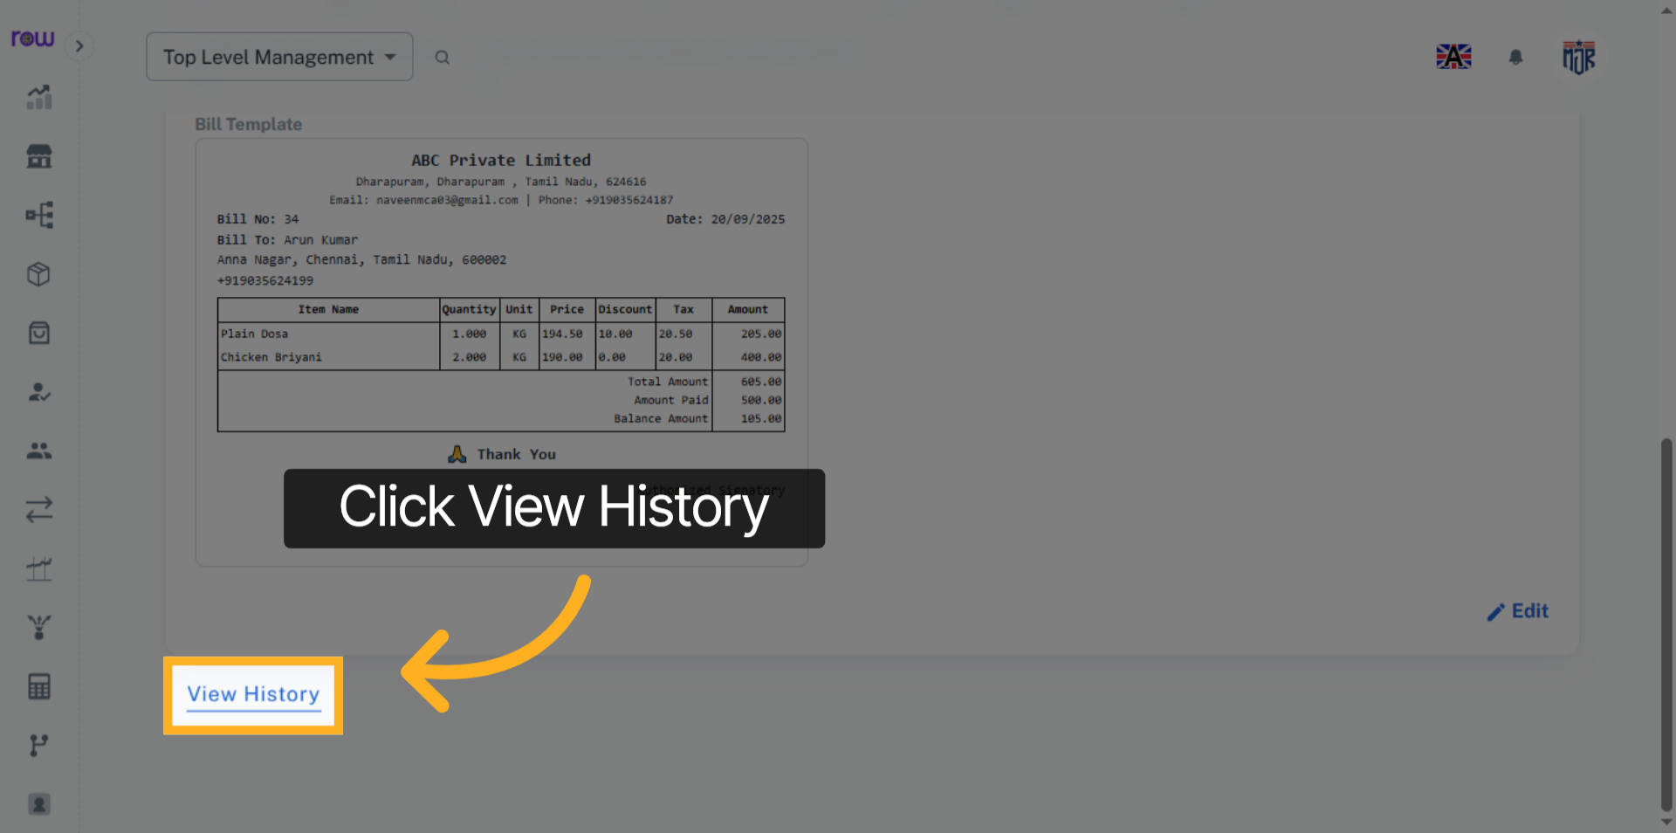

5. History
In View History, you can see who created it and when it was created, who updated it and when it was updated, and which fields were updated.
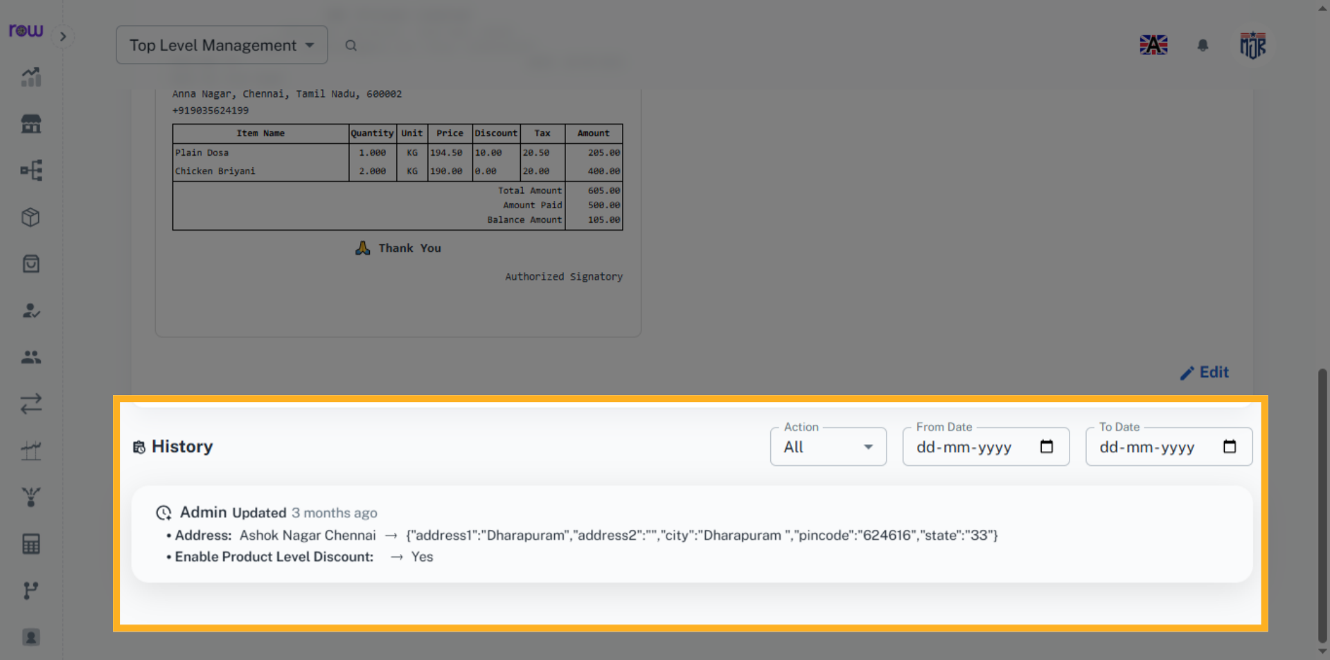

6. Product list Screen
Go to the Product List screen and click the product name.
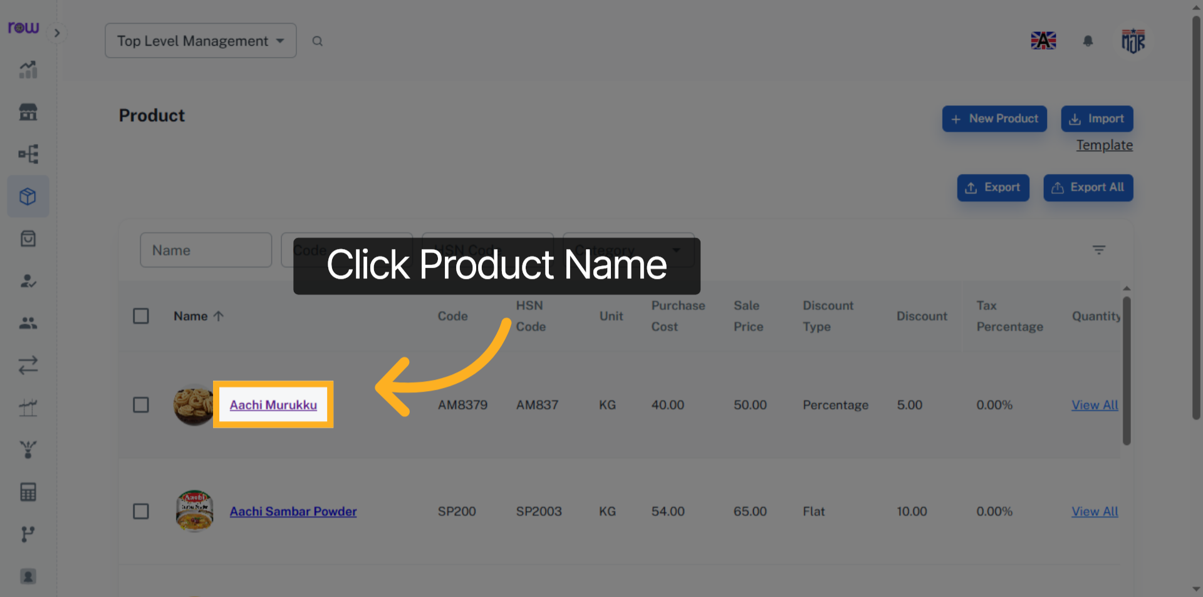

7. view History
Click View History to see the product history.
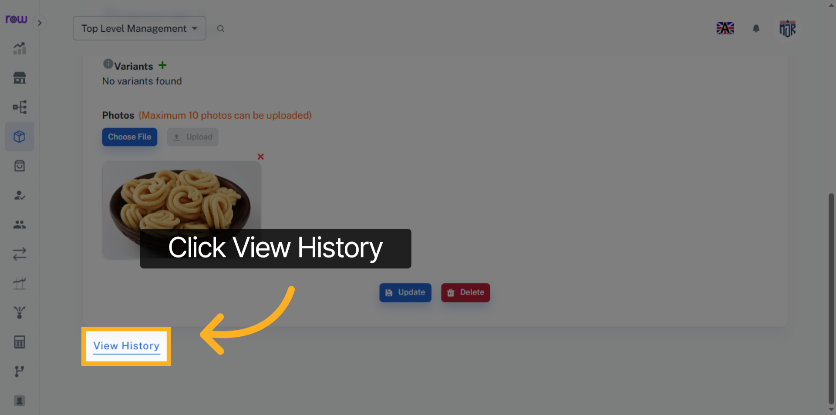

8. History
In View History, you can see who created it and when it was created, who updated it and when it was updated, and which fields were updated.
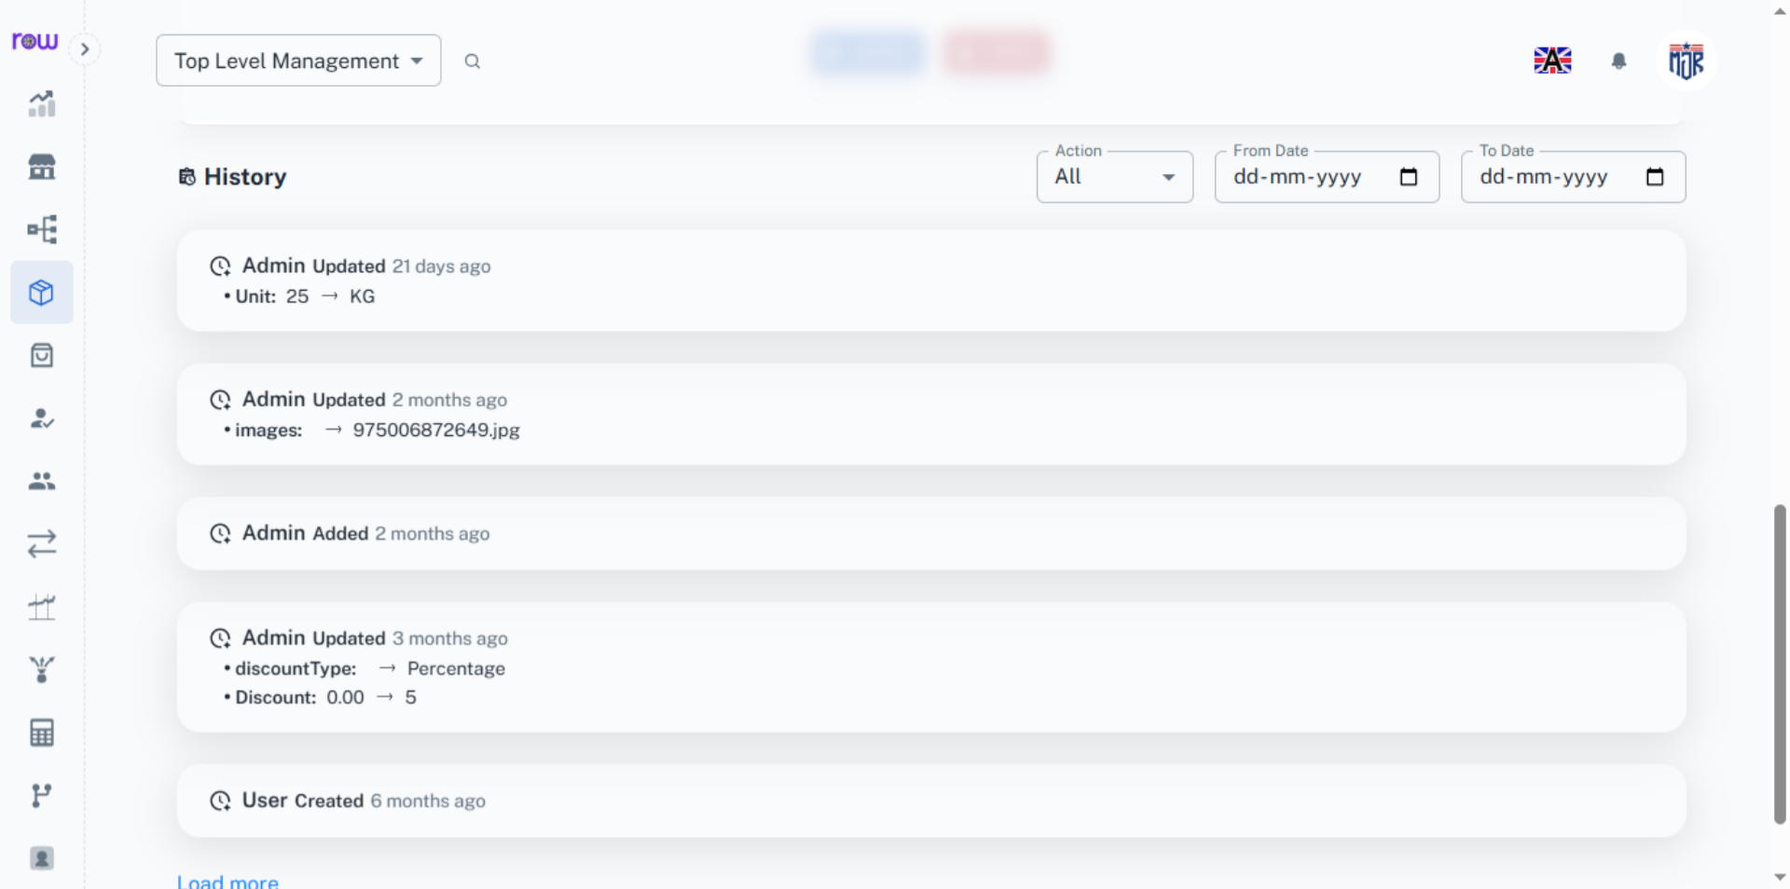

9. Orders List Screen
Go to the Orders List screen and click the bill number.
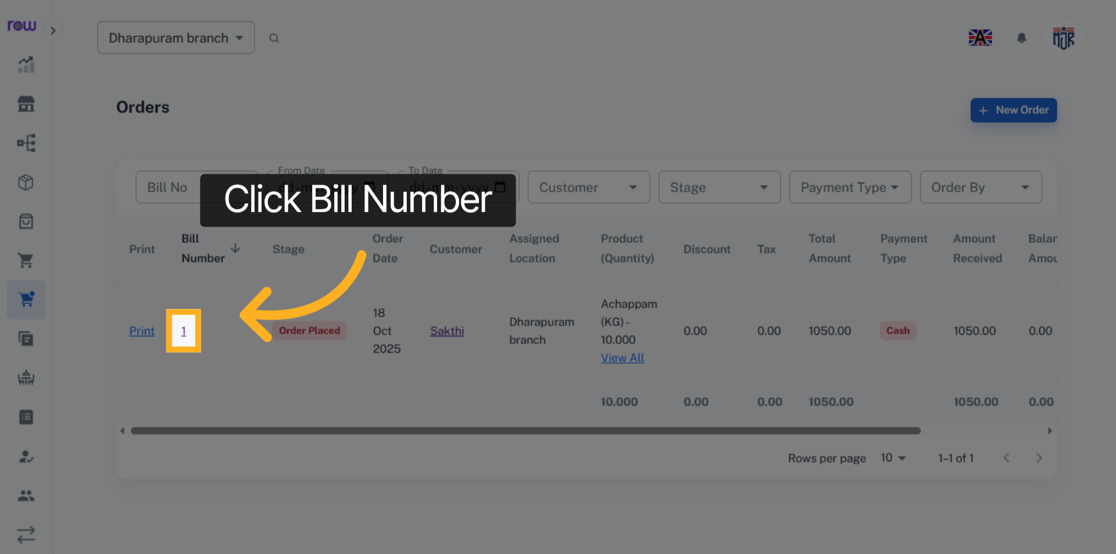

10. View History
Click View History to view the order history.
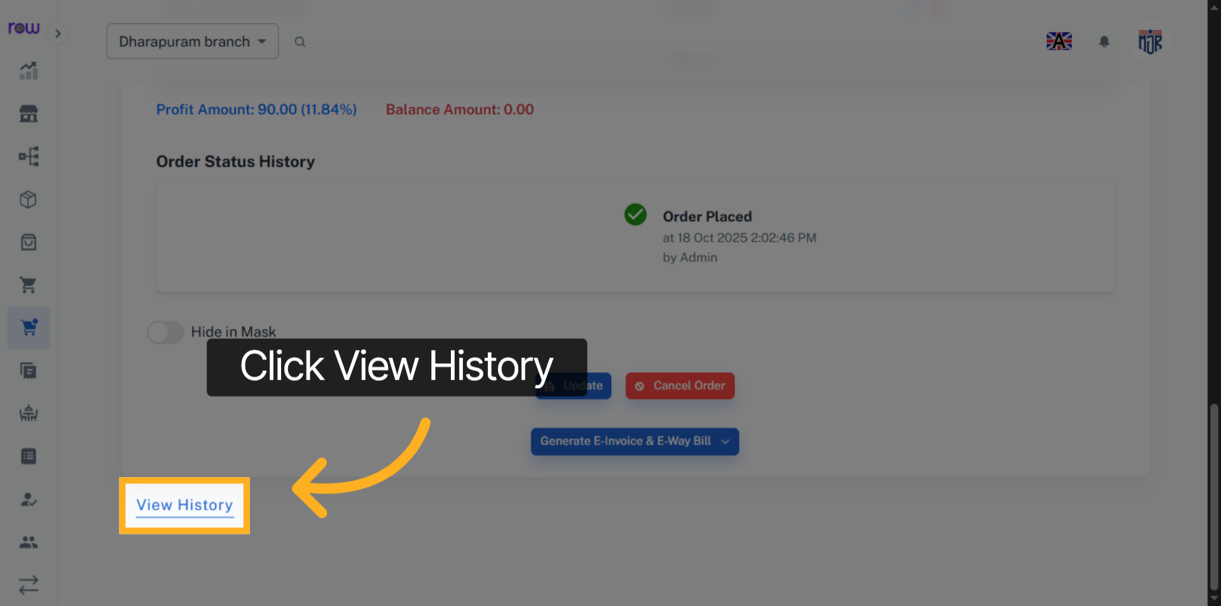

11. History
In View History, you can see who created it and when it was created, who updated it and when it was updated, and which fields were updated. Similarly, you can also see the history of purchases, sales, invoices, quotations, stores, branches, categories, wastage, expenses, transfers, hotels, and more. Any changes, such as creation, updates, or deletions made by a Employee, will be recorded and displayed in the history.
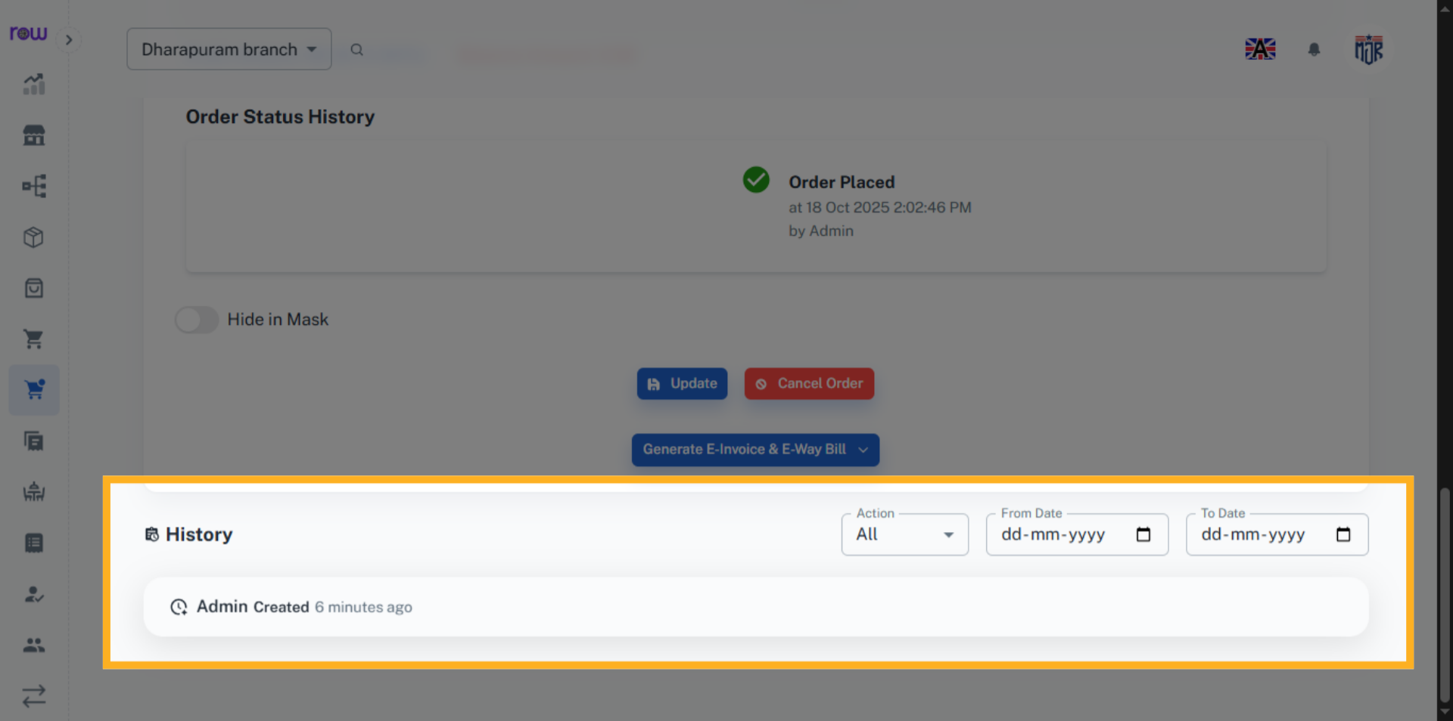

12. Click Employee Name
You can view the details of the Employee by clicking the Employee name. you can also view the work history in the employee menu
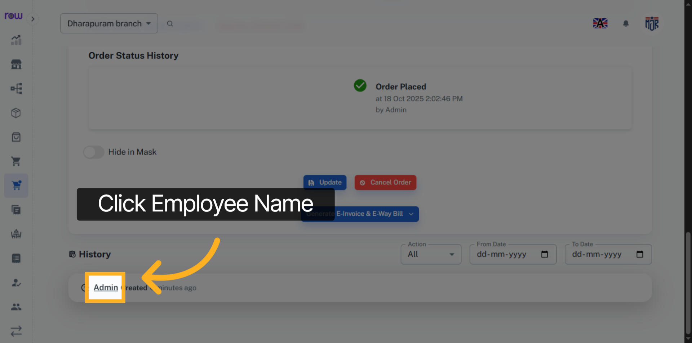

13. Employee Name
Go to Employee menu. You can view the employee list here.
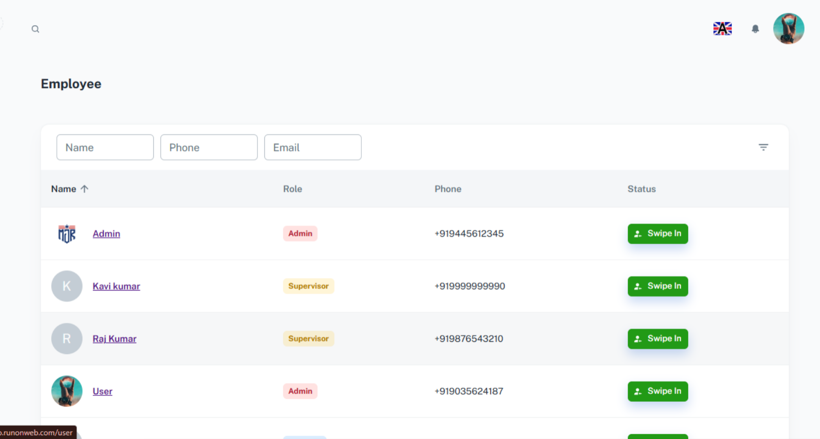

14. Click Employee name
Click the Employee name to see the details and history of the Employee.
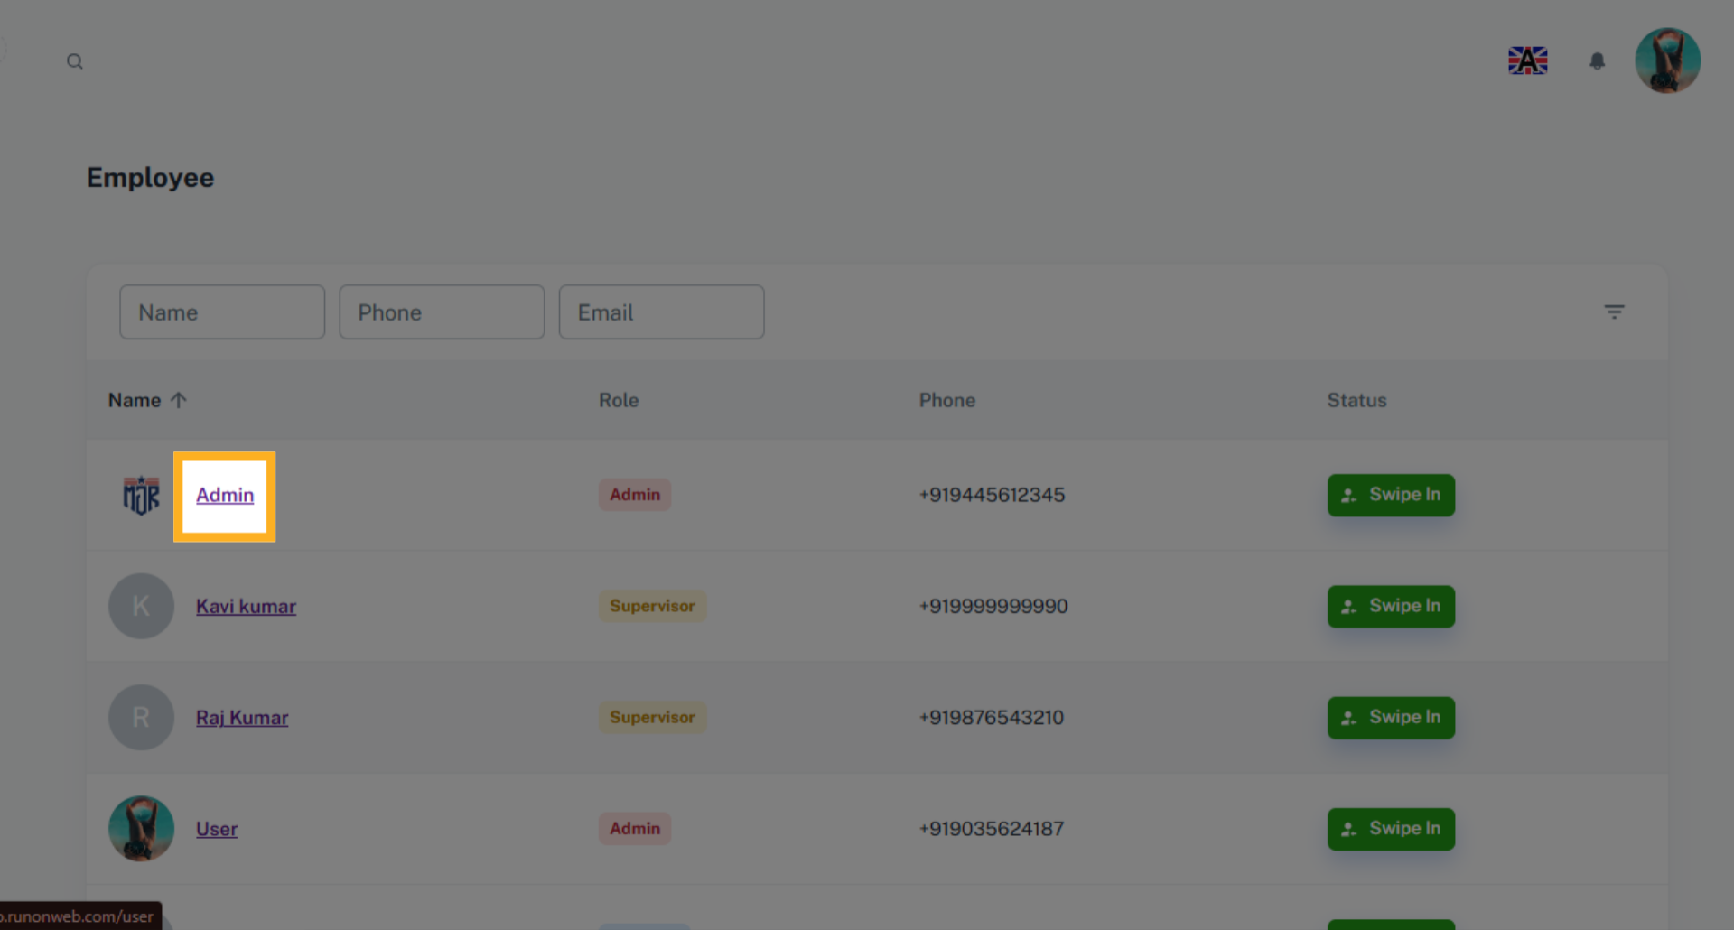

15. Employee Work History
Go to history tab.
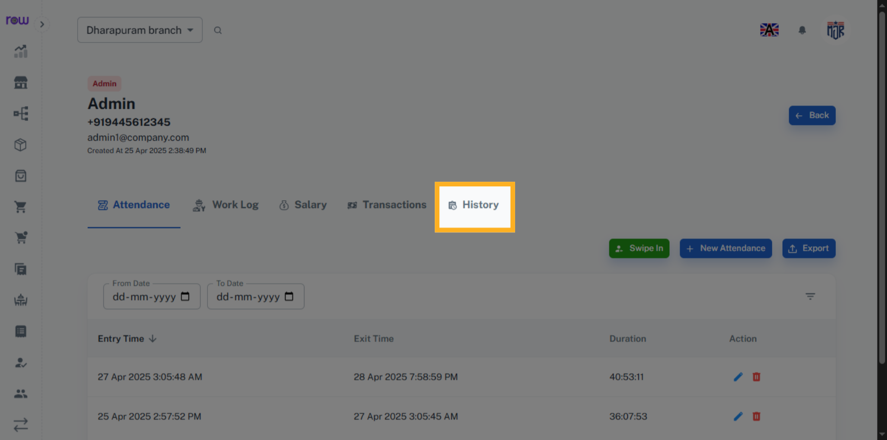

16. History
The changes made by this Employee, such as create, update, and delete, are recorded and can be viewed in the history.
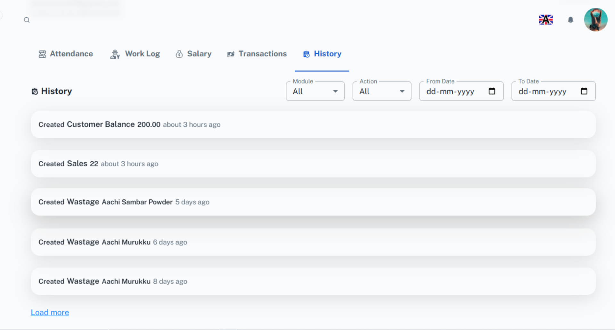

17. Filter History
You can filter the employee history by module, action, from date, and to date.
